1. **Design a Java program to implement a Collection Management System that manages different types of collections such as lists, sets, and maps. The program should allow users to perform the following operations for each type of collection:**

List :

package Question5;

import java.util.ArrayList;

import java.util.List;

import java.util.Scanner;

public class ListManager {

private List<String> list;

public ListManager() {

list = new ArrayList<>();

}

// Add an element to the list

public void addElement(String element) {

list.add(element);

System.out.println("Element added: " + element);

}

// Remove an element from the list

public void removeElement(String element) {

if (list.remove(element)) {

System.out.println("Element removed: " + element);

} else {

System.out.println("Element not found in the list.");

}

}

// Display all elements in the list

public void displayElements() {

if (list.isEmpty()) {

System.out.println("The list is empty.");

} else {

System.out.println("Elements in the list:");

for (String element : list) {

System.out.println(element);

}

}

}

public static void main(String[] args) {

ListManager listManager = new ListManager();

Scanner scanner = new Scanner(System.in);

int choice;

do {

System.out.println("\nList Management System Menu:");

System.out.println("1. Add an element(String)");

System.out.println("2. Remove an element(String)");

System.out.println("3. Display all elements(String)");

System.out.println("4. Exit");

System.out.print("Enter your choice: ");

choice = scanner.nextInt();

switch (choice) {

case 1:

System.out.print("Enter the element to add (String) : ");

String addElement = scanner.next();

listManager.addElement(addElement);

break;

case 2:

System.out.print("Enter the element to remove (String) : ");

String removeElement = scanner.next();

listManager.removeElement(removeElement);

break;

case 3:

listManager.displayElements();

break;

case 4:

System.out.println("Exiting...");

break;

default:

System.out.println("Invalid choice. Please enter a number from 1 to 4.");

}

} while (choice != 4);

scanner.close();

}

}

Output :

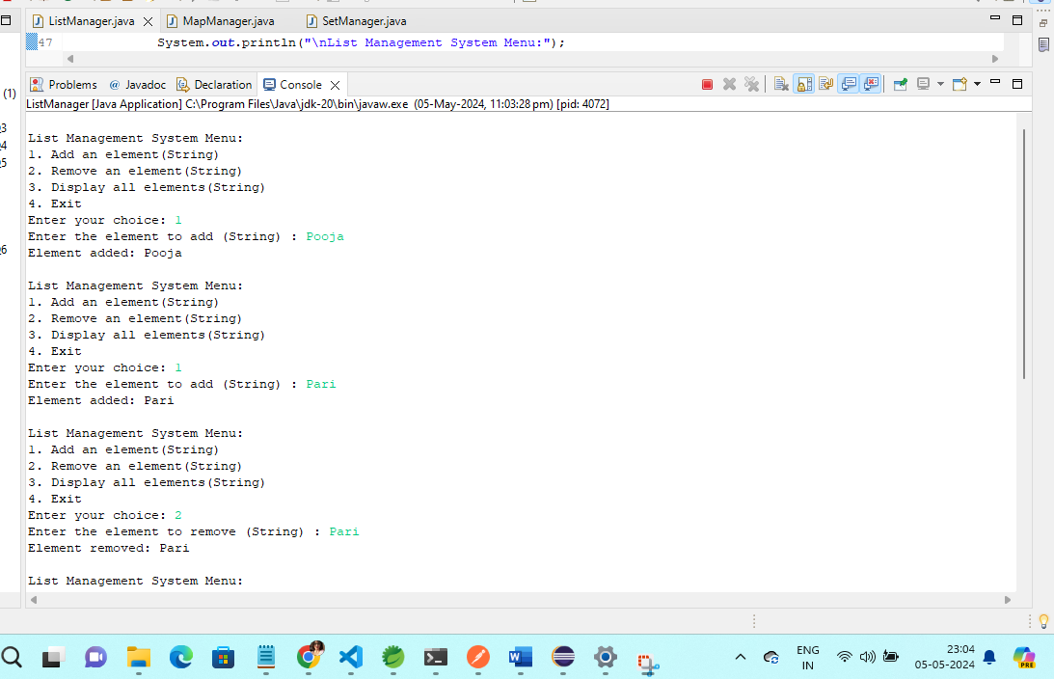

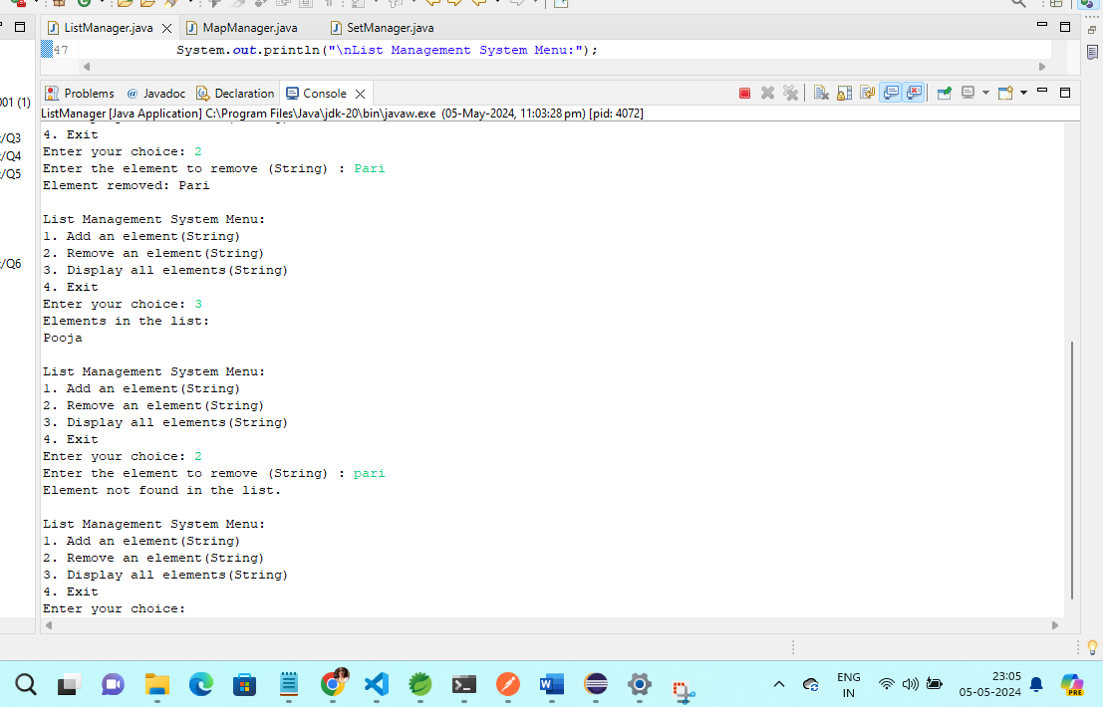

Map :

package Question5;

import java.util.HashMap;

import java.util.Map;

import java.util.Scanner;

public class MapManager {

private Map<Integer, String> map;

public MapManager() {

map = new HashMap<>();

}

// Add a key-value pair to the map

public void addKeyValuePair(int key, String value) {

if (map.containsKey(key)) {

System.out.println("Key already exists in the map. Updating the value.");

}

map.put(key, value);

System.out.println("Key-value pair added: Key = " + key + ", Value = " + value);

}

// Remove a key-value pair from the map

public void removeKeyValuePair(int key) {

if (map.containsKey(key)) {

String value = map.remove(key);

System.out.println("Key-value pair removed: Key = " + key + ", Value = " + value);

} else {

System.out.println("Key not found in the map.");

}

}

// Display all key-value pairs in the map

public void displayKeyValuePairs() {

if (map.isEmpty()) {

System.out.println("The map is empty.");

} else {

System.out.println("Key-Value pairs in the map:");

for (Map.Entry<Integer, String> entry : map.entrySet()) {

System.out.println("Key = " + entry.getKey() + ", Value = " + entry.getValue());

}

}

}

public static void main(String[] args) {

MapManager mapManager = new MapManager();

Scanner scanner = new Scanner(System.in);

int choice;

do {

System.out.println("\nMap Management System Menu:");

System.out.println("1. Add a key-value pair");

System.out.println("2. Remove a key-value pair");

System.out.println("3. Display all key-value pairs");

System.out.println("4. Exit");

System.out.print("Enter your choice: ");

choice = scanner.nextInt();

switch (choice) {

case 1:

System.out.print("Enter the key: ");

int key = scanner.nextInt();

System.out.print("Enter the value (String) : ");

String value = scanner.next();

mapManager.addKeyValuePair(key, value);

break;

case 2:

System.out.print("Enter the key to remove: ");

int removeKey = scanner.nextInt();

mapManager.removeKeyValuePair(removeKey);

break;

case 3:

mapManager.displayKeyValuePairs();

break;

case 4:

System.out.println("Exiting...");

break;

default:

System.out.println("Invalid choice. Please enter a number from 1 to 4.");

}

} while (choice != 4);

scanner.close();

}

}

Output :

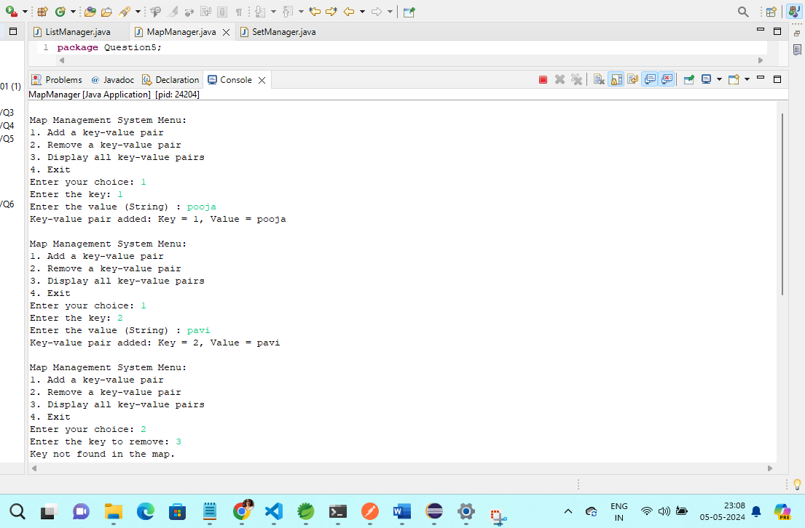

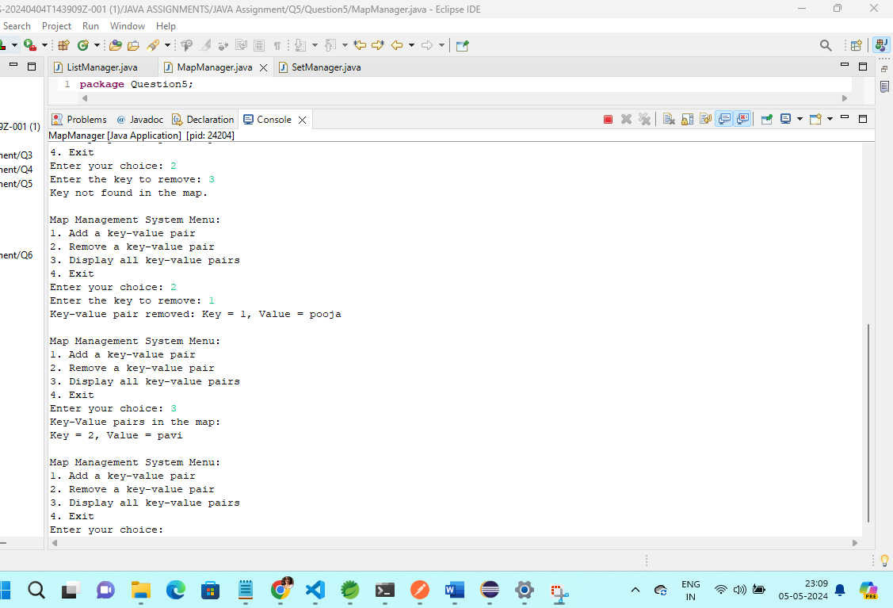

Set :

package Question5;

import java.util.HashSet;

import java.util.Scanner;

import java.util.Set;

public class SetManager {

private Set<String> set;

public SetManager() {

set = new HashSet<>();

}

// Add an element to the set

public void addElement(String element) {

if (set.add(element)) {

System.out.println("Element added: " + element);

} else {

System.out.println("Element already exists in the set.");

}

}

// Remove an element from the set

public void removeElement(String element) {

if (set.remove(element)) {

System.out.println("Element removed: " + element);

} else {

System.out.println("Element not found in the set.");

}

}

// Display all elements in the set

public void displayElements() {

if (set.isEmpty()) {

System.out.println("The set is empty.");

} else {

System.out.println("Elements in the set:");

for (String element : set) {

System.out.println(element);

}

}

}

public static void main(String[] args) {

SetManager setManager = new SetManager();

Scanner scanner = new Scanner(System.in);

int choice;

do {

System.out.println("\nSet Management System Menu:");

System.out.println("1. Add an element");

System.out.println("2. Remove an element");

System.out.println("3. Display all elements");

System.out.println("4. Exit");

System.out.print("Enter your choice: ");

choice = scanner.nextInt();

switch (choice) {

case 1:

System.out.print("Enter the element to add (String) : ");

String addElement = scanner.next();

setManager.addElement(addElement);

break;

case 2:

System.out.print("Enter the element to remove (String) : ");

String removeElement = scanner.next();

setManager.removeElement(removeElement);

break;

case 3:

setManager.displayElements();

break;

case 4:

System.out.println("Exiting...");

break;

default:

System.out.println("Invalid choice. Please enter a number from 1 to 4.");

}

} while (choice != 4);

scanner.close();

}

}

Output :

