Performance Testing

Date | 30 September 2026
Team ID | SWTID-2026-5011
Project Name | LegalEase AI
Maximum Marks | 5 Marks
Team Members: Yogeswari M,Sharmila K,Sujitha praba S,Shailaja S

Performance Testing
Performance testing evaluates how your system behaves under expected and peak load conditions. Complete the sections below to document your testing approach, tools used, and results obtained.

Step 1: Testing Overview

Field | Details
Testing Tool Used | Not provided in the LegalEase project document
Type of Testing | End-to-end / functional verification is documented; formal load/stress performance testing is not documented
Target Module / API | FastAPI POST /generate endpoint and LegalEase document generation flow
Test Environment | Local deployment (FastAPI backend + Streamlit frontend)
Test Date | Not provided in the LegalEase project document

Step 2: Test Scenarios

S.No | Test Scenario / Description | No. of Virtual Users | Duration (sec) | Expected Outcome
1 | Generate a legal document using document type, parties, terms and dates | Not provided | Not provided | Generated legal content returned for preview
2 | Preview and edit generated legal document in Streamlit | Not provided | Not provided | Editable generated content displayed
3 | Export generated document as TXT, DOCX and PDF | Not provided | Not provided | Requested document formats generated/downloaded
4 | End-to-end local flow from Streamlit input through FastAPI/Gemini to document output | Not provided | Not provided | End-to-end functionality verified as documented

Step 3: Performance Test Results

S.No | Metric | Target Value | Actual Value | Status (Pass / Fail) | Remarks
1 | Response Time (Avg) | Not measured / not provided | Not verified | No performance benchmark was supplied in LegalEase.pdf.
2 | Response Time (Max) | Not measured / not provided | Not verified | No performance benchmark was supplied in LegalEase.pdf.
3 | Throughput (Req/sec) | Not measured / not provided | Not verified | No performance benchmark was supplied in LegalEase.pdf.
4 | Error Rate | Not measured / not provided | Not verified | No performance benchmark was supplied in LegalEase.pdf.
5 | CPU Utilization | Not measured / not provided | Not verified | No performance benchmark was supplied in LegalEase.pdf.
6 | Memory Utilization | Not measured / not provided | Not verified | No performance benchmark was supplied in LegalEase.pdf.

Step 4: Observations & Analysis
The LegalEase project document confirms local deployment using FastAPI as the backend and Streamlit as the frontend and describes end-to-end testing of Gemini integration, document generation and downloads. However, it does not report formal performance-test measurements such as average/max response time, throughput, error rate, CPU utilization, or memory utilization. Therefore, these values are not fabricated in this report.
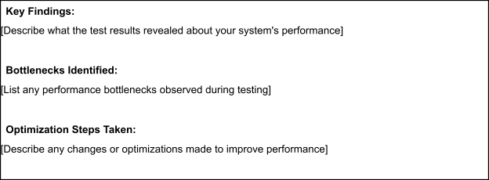

Step 5: Screenshots / Evidence
No JMeter, Locust, k6, or other performance-testing screenshots/results were included in the supplied project document. If available, attach the actual test report or screenshots here.
Attach screenshots of your performance testing tool results below (e.g., JMeter report, Locust graphs, k6 output):


