AI STUDYBUDDY API

Submitted By:
Team ID : SWTID-2026-8209
Team Size : 4
Team Leader : POOJA K
Team member : PADMAPRIYA S
Team member : DIVYA R
Team member : DEEPALAKSHMI M
INTRODUCTION

AI StudyBuddy is a backend-oriented educational application designed to make study preparation more organized and convenient. Students normally work with notes, PDF files, classroom material and other documents, and it can be difficult to revise all of them in a short period.
The project provides a single backend service through which study-related operations can be handled. The system is intended to support activities such as managing study materials, obtaining useful learning content, and connecting the application with AI-based services.
Instead of treating each learning activity as a separate task, AI StudyBuddy brings the major study-support functions together through an API-based structure. This makes the project suitable for integration with a web interface or other client application.

PROJECT DESCRIPTION

AI StudyBuddy works as the backend layer of a student-focused learning application. A client sends a request to the server, the server validates and processes the request, and the required result is returned to the client.
The backend is developed with Node.js and Express.js, while MongoDB can be used for storing application data. Postman can be used during development to send API requests and inspect the responses.
The project structure is kept modular so that authentication, material handling and AI-related services can be maintained separately. This also makes it easier to add new learning features later.
- Handles requests coming from the client side.
- Processes study material related operations.
- Provides a structured API for learning features.
- Connects the application with database and AI services.
- Can be tested using API testing tools.

MOTIVATION AND REQUIREMENTS

Motivation
Students often spend extra time arranging notes, searching through files and preparing revision material. A study-support system can reduce this effort by keeping important operations in one place.
User Requirements
- Simple access to study materials.
- A way to send and receive learning-related requests.
- Support for AI-assisted study operations.
- Secure handling of user-related information.
- Quick testing and verification of backend services.

Functional Requirements
- User registration and login.
- Study material upload and retrieval.
- AI-assisted content generation.
- API request validation.
- Database connectivity.
- Error response handling.

OBJECTIVES

The main objectives of AI StudyBuddy are focused on creating a useful and maintainable backend for student learning support.
- To organize study-related operations through a single backend.
- To provide an API-based method for handling learning requests.
- To manage uploaded study materials in a structured manner.
- To connect learning features with AI services.
- To store required application information using a database.
- To make the backend easy to test and integrate with a client application.
- To provide a foundation for future personalized learning features.

SOFTWARE REQUIREMENTS

- Operating System- Windows / Linux / macOS
- Code Editor- Visual Studio Code
- Runtime- Node.js
- Backend Framework- Express.js
- Database- MongoDB
- API Testing- Postman
- AI Service- AI API / model service

TECHNOLOGY STACK

Node.js
Node.js provides the execution environment for the backend. It is suitable for handling asynchronous operations and building server-side API applications.
- Express.js
Express.js is used to create the server and define API routes. It helps the project receive HTTP requests, apply middleware and send responses.
- MongoDB
MongoDB is used as the database layer for application information such as user records and study-material related data.
- Postman
Postman is useful for testing API endpoints without requiring a complete frontend application.
- AI Service
The AI service can process relevant study content and return generated learning assistance according to the request sent by the backend.
- VISUAL STUDIO CODE
Visual Studio Code is used as the primary development environment for writing,organizing ,and debugging the backend source code.

SYSTEM DESIGN

- Client Side
The client or testing application starts the communication by sending an HTTP request to the backend.
- API Controller
The API layer receives the request and directs it to the required operation. Routes can be separated according to authentication, materials and AI services.
- Processing Layer
The processing layer contains the application logic. It validates data, performs the required operation and communicates with the database or external AI service.
- Data Layer
The data layer manages information that needs to be stored and retrieved from MongoDB.
- Response Flow
After processing, the backend sends a structured response to the client. Errors are returned with suitable status information so that they can be identified during testing.

PROJECT SETUP AND EXECUTION

- Opening the Project
The project should be opened in Visual Studio Code from the folder that contains the package.json file and the backend source files.
- Installing Dependencies
Open the terminal inside the correct project folder and run:
npm install
- Starting the Server
After the dependencies are installed and the required environment settings are available, the backend can be started with the project's configured start command.
npm start
- Local Testing
The running server can be checked through Postman by sending requests to the local API address configured by the project.
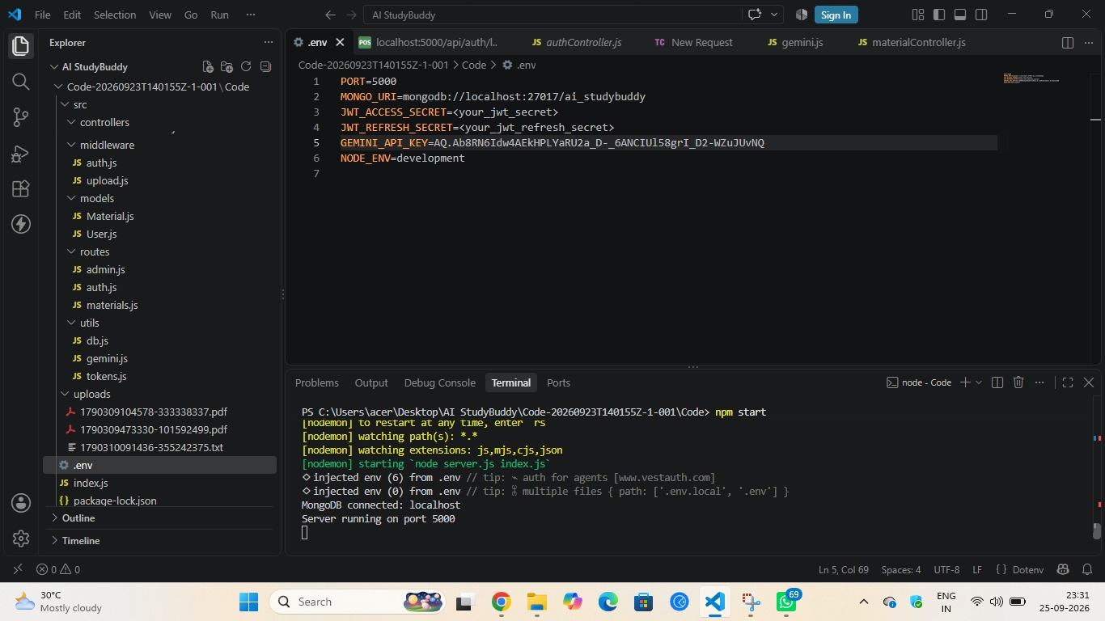

USER ACCESS MODULE

- Registration
The registration operation accepts the required user information and stores the account details in the database. Password information should be handled securely rather than being stored as plain text.
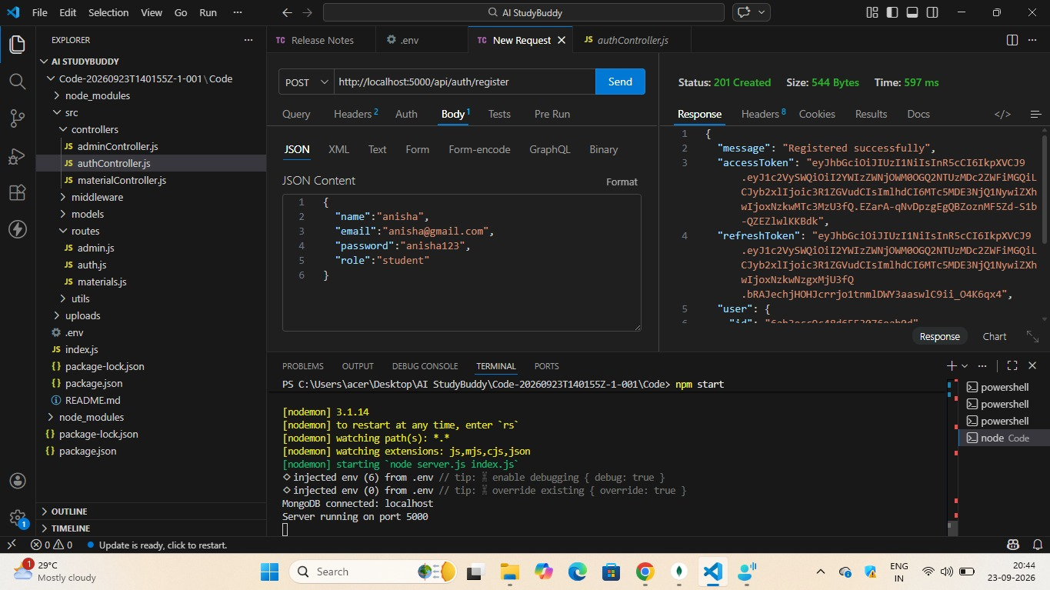

- Login
The login operation checks the submitted credentials and provides an authentication result for a valid user. Protected operations can then use the returned authentication information.
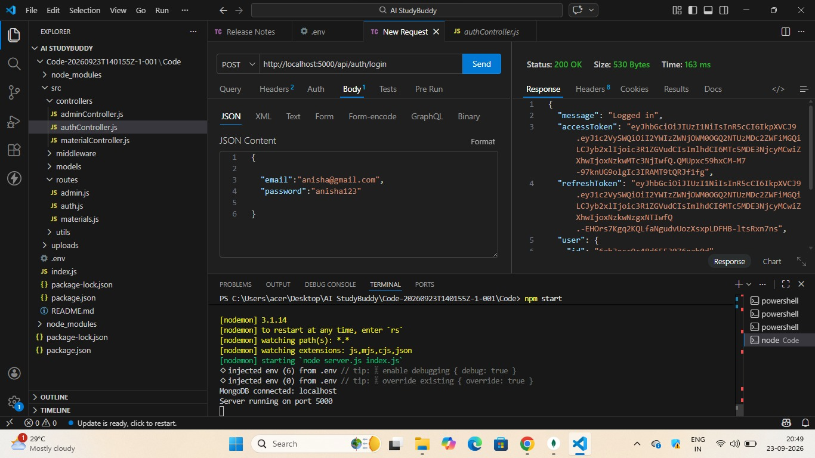

- Validation
Input validation is important in both registration and login so that incomplete or invalid data does not enter the application.
- Authentication Flow
- User submits registration or login details.
- Backend validates the received information.
- Database is checked when authentication is required.
- The server returns a success or error response.
- Authenticated requests can access protected operations.

STUDY MATERIAL MANAGEMENT

- Uploading Material
The material module is responsible for receiving study content from an authenticated user. The uploaded information can be associated with the user and stored for later processing.

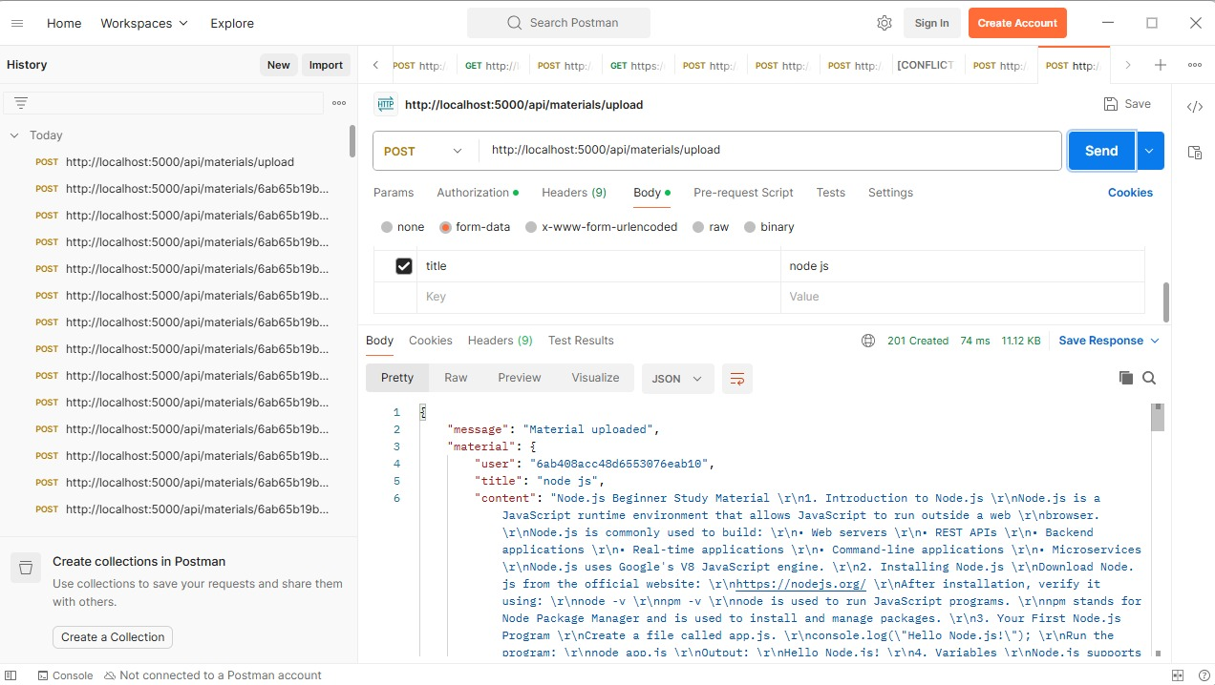

- Viewing Stored Materials
The application can retrieve available study materials and return their details through an API response.

- Material Processing
Once a study material is available, it can become the input for AI-assisted operations such as summarization, question generation or revision support.

- Data Handling
The backend should validate the received material information before saving or processing it. This helps reduce invalid requests and makes the system more reliable.

AI-ASSISTED LEARNING FEATURES

Summary Generation
A study material can be sent to an AI service to produce a shorter version of the important information. This can help students revise large content more quickly.

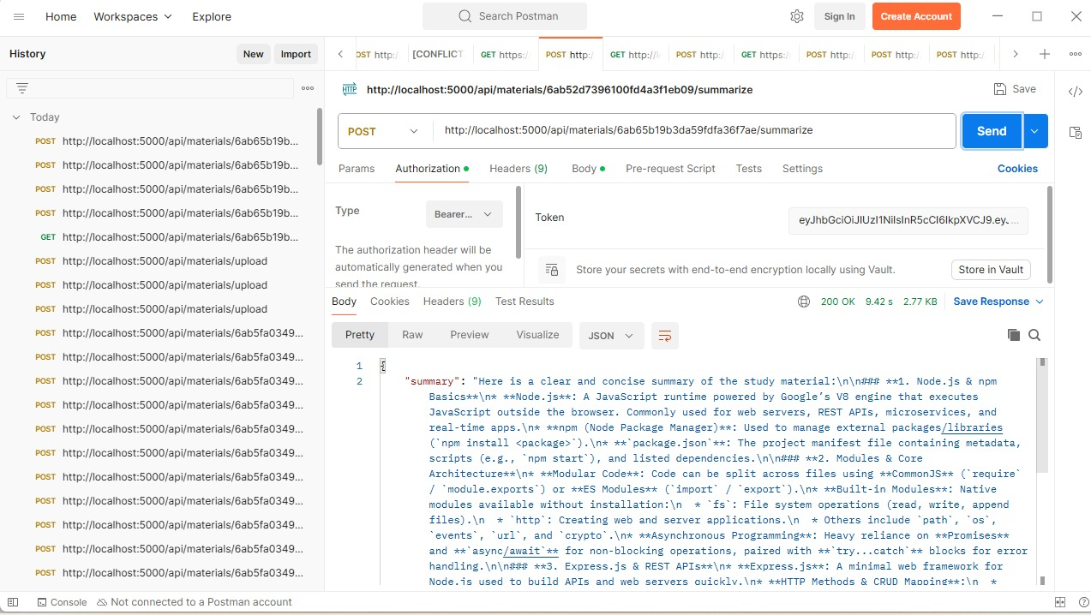

Flashcard Creation
The system can use study material to create question-and-answer style flashcards for revision.

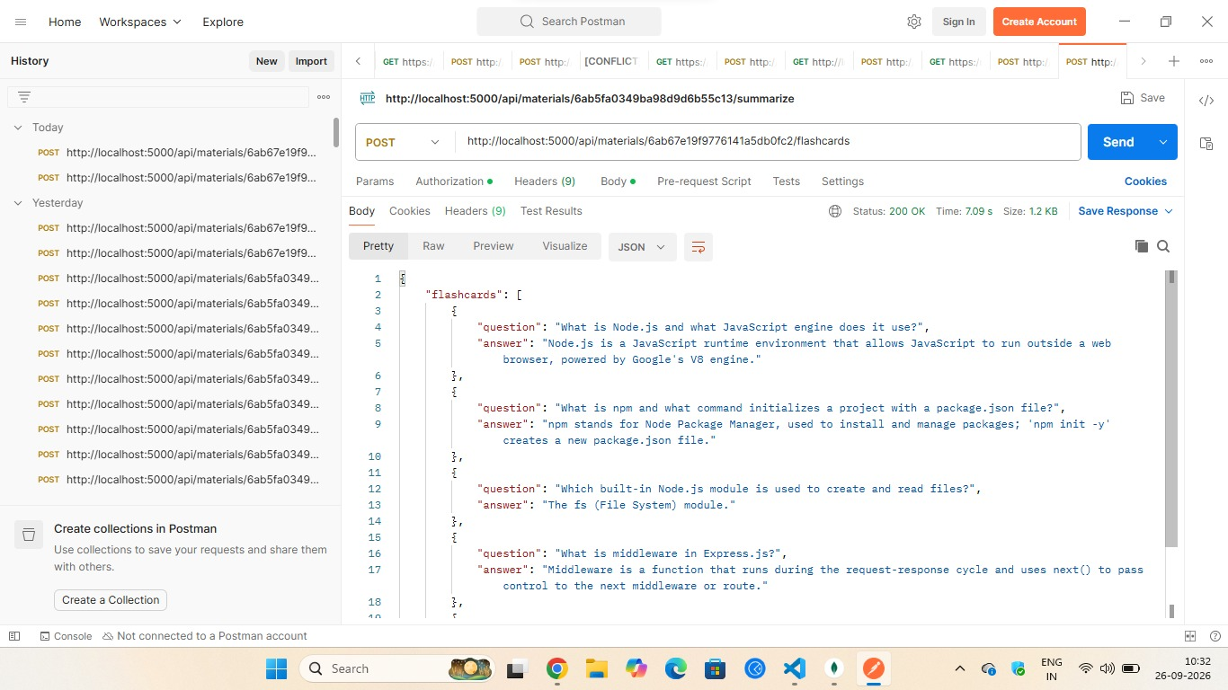

Quiz Generation
The AI service can generate practice questions from the available study content. Such questions can be used to check understanding.
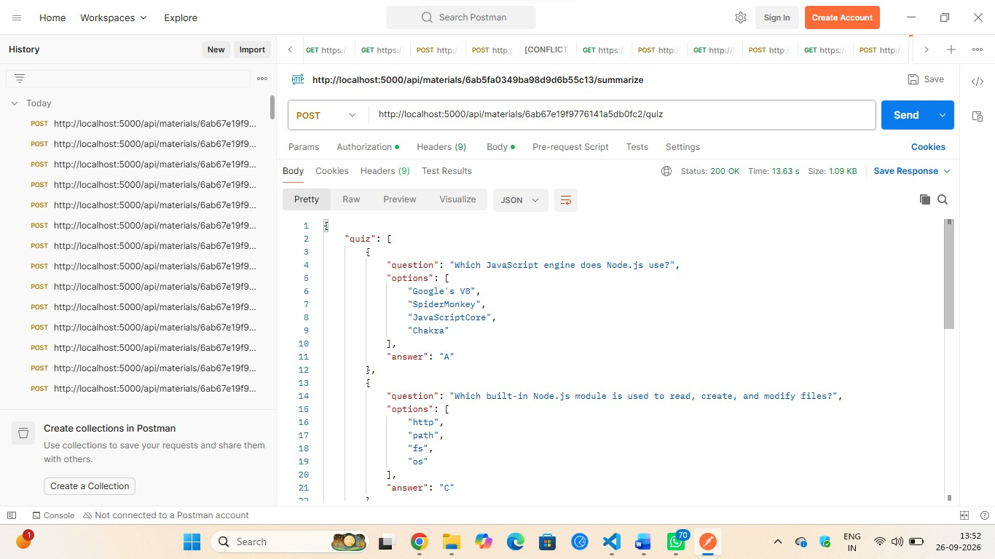

Study Planning
A study-planning feature can use the learner's goals and available time to produce a structured schedule.

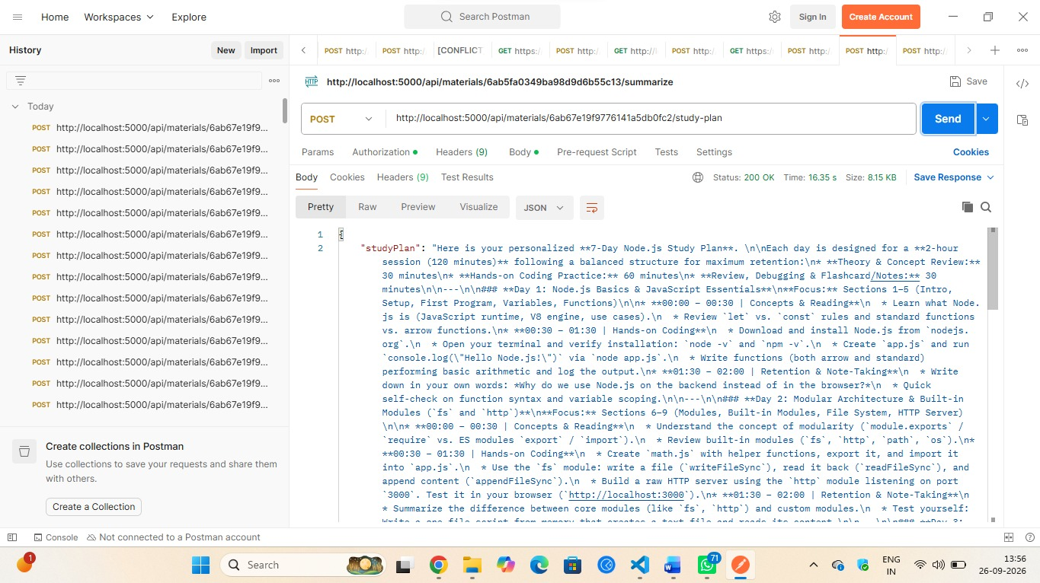

Question Answering
The backend can also support AI-based responses to study-related questions when the required content and AI service are available.

Demo video link:

https://drive.google.com/file/d/1tH1fSmI0zJcy0AujOVSM5bABLzxFpp5m/view?usp=drivesdk

BENEFITS

- Combines several study-support operations in one backend.
- Reduces repetitive manual preparation of revision resources.
- Provides a structured API that can be connected to different clients.
- Supports AI-assisted learning operations.
- Makes backend services easier to test using Postman.
- Can be extended with additional educational features

.

LIMITATIONS

- AI output depends on the quality of the provided study material.
- Generated information may need academic verification.
- External AI features may require internet connectivity.
- Large documents can take additional processing time.
- Supported file types and features may depend on the current implementation.

FUTURE DEVELOPMENT

The current project can be expanded with additional features as the application grows. Possible improvements include:
- Voice-based study interaction.
- Support for multiple languages.
- Image and diagram based question answering.
- A dedicated mobile application.
- Learning analytics and progress tracking.
- Adaptive study schedules based on learning progress.
- Automatic recommendations for useful study materials.
- Support for additional AI models and educational resources.

CONCLUSION

AI StudyBuddy provides a structured backend approach for supporting students with study-material management and AI-assisted learning. The project brings authentication, material handling, database operations and AI-related processing into a single API-oriented system.
The use of Node.js and Express.js provides a suitable environment for building the backend, while MongoDB can manage application data. Postman helps verify the APIs during development and testing.
The project can be developed further by adding multilingual support, voice interaction, learning analytics, mobile integration and more personalized learning functions. These additions can extend the system from a basic study-support backend into a broader educational platform.

