**Laser Burglar Alarm**

1. **Objective**:

The objective of this project is to generate an efficient alarm system using LDR and a laser beam.

The other main objective is to generate a working PCB design and layout by using the Ki Cad/Altium designing tool.

1. **Approach:**
2. **Breadboard Testing:**

The components are connected as per the circuit diagram. The buzzer is setoff is there is no laser beam falling on it. This proves that the 2N222 acts as a switch and when the circuit is complete the alarm beeps and if not that is when laser beam is falling on the LDR the alarm does not beep.

**2.PCB Design**

Once the design is tested on the breadboard it is etched on the PCB.

The components are then soldered along with the tracks and it is tested using a 9V battery and buzzer.

1. **EDA Technology used:**

The schematic and PCB tracks were routed using altium design tool.

Altium is a special software used for designing a PCB and it is easy to use.

1. **Schematic Work:**

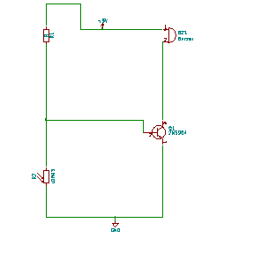

1. **Simulation Results:**
2. **When the laser beam is not pointing towards the LDR the buzzer goes off.**

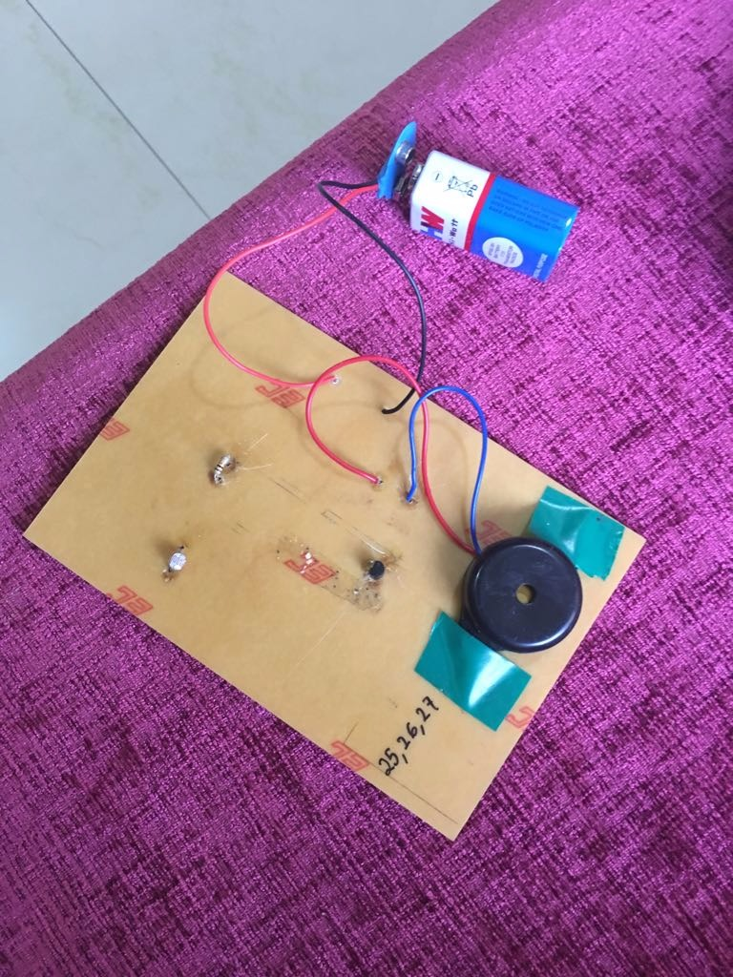

1. **When the laser beam is pointing towards the LDR the buzzer is not making any noise i.e the circuit is complete**

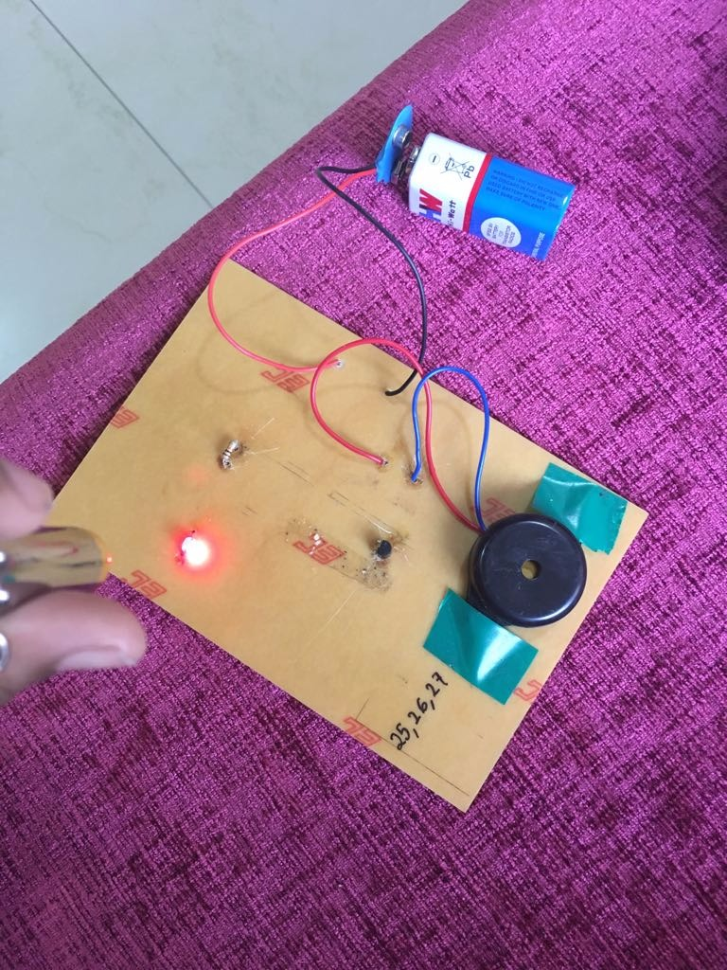

1. **Bill of Materials (BOM) Generated:**

|  |  |  |  |  |
| --- | --- | --- | --- | --- |
| **Components** | **Cost(Rs.)** | **Quantity** | | **Total(rs.)** |
| 2n222 | 15 | 1 | | 15 |
| Resistor | 1 | 1 | | 1 |
| LDR | 5 | 1 | | 5 |
| Buzzer | 10 | 1 | | 10 |
| Battery | 10 | 1 | | 10 |
| PCB | 30 | 1 | | 30 |
| Total |  |  | | 76 |
|  |

1. **PCB layout:**

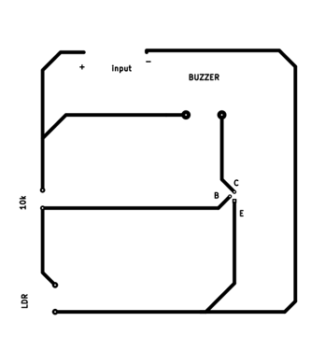

1. **References/ Materials /Books used:**

1.http://www.slideshare.net/lasersystems

2. [www.instructables.com/id/Extremely-simple-laser-alarm](http://www.instructables.com/id/Extremely-simple-laser-alarm).

3. [www.electroschematics.com/4929/laser-based-door-alarm](http://www.electroschematics.com/4929/laser-based-door-alarm)

1. **Conclusion:**
2. By using a line laser and LDR we were able to make a simple laser circuit that detects objects passing through it.
3. Laser technology products will calculate distance by measuring the time of flight of very short infrared light.
4. It has a wide number of applications some of them are mentioned below.
5. **Application:**

