**R&RC Triggering**

***Abstract***— **The aim of this project is to obtain output** **for R and RC triggering.**

I. OBJECTIVE

The objective of this project is to study the SCR turn on method by R & RC triggering method and to understand its

working completely. The other main objective is to generate a working PCB design and layout by using the Ki Cad/Altium designing tool.

II. APPROACH

**1. General Purpose Board testing:**

The circuit is connected as per circuit diagram on the GPB and then tested using a 40-60V A.C. voltage. When the switch is operated due to either R or RC triggering the SCR is turned on and the bulb starts glowing. The pot is used to control the gate voltage of the SCR. A CRO is connected at the load terminal to observe the waveforms.

**2.PCB design:**

Once the circuit is tested on the GPB it is implemented using the PCB design. The tracks are etched on the PCB board. The components are then placed on the other side and soldered with the tracks. Once the circuit is made it is tested the output waveforms are measured by connecting the CRO probes at the load terminal.

III. EDA TOOLS USED

The schematic and PCB tracks were routed using altium design tool. Altium is a special software used for designing a PCB and it is easy to use.

IV. Schematic

1. The Schematic for R trigger is as follows:

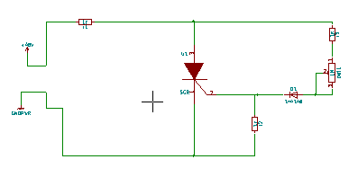

1. The Schematic for RC trigger is as follows:

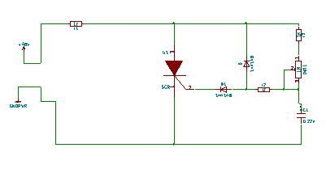

V.OUTPUT RESULTS

When the SCR turns on by the method of R & RC method the bulb starts glowing the voltage at the bulb can be varied with the help of a potentiometer attached to the circuit.

1. The bulb is glowing

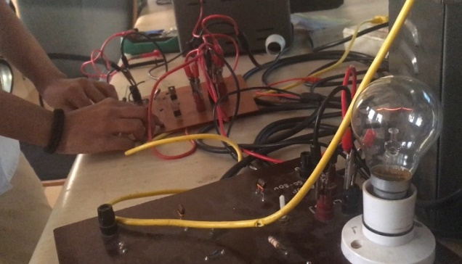

1. The bulb has dimmed due to pot variations:

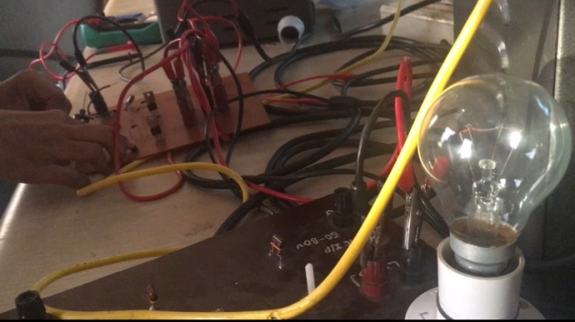

VIII. References/ Materials /Books used:

1. http://www.electronicshub.org/scr-turn-on-methods/

2.http:// www.radio-electronics.com/info/circuits/scr-silicon

3. http://www.circuitstoday.com/scr-applications

IX. Conclusion:

The implemented circuit is a method to turn on SCR using gate triggering. This is verified by observing the load connected to the circuit. The waveforms give information about the firing angle of the SCR.

X .Applications

1. Zero Voltage Switching.

SCR Switching Application In some ac circuits it is necessary to apply the voltage to the load when the instantaneous value of this voltage is going through the zero value. This is to avoid a high rate of increase of current in case of purely resistive loads such as lighting and furnace loads, and thereby reduce the generation of radio noise and hotspot temperatures in the device carrying the load current. The circuit to achieve this is shown in figure. Only half-wave control is used here. The portion of the circuit shown by the dotted lines relates to the negative half cycle. Whatever may be the instant of time when switch S is opened (either during the positive or the negative half cycle), only at the beginning of the following positive half-cycle of the applied voltage SCR1 will be triggered. Similarly, when switch S is closed, SCR1 will stop conducting at the end of the present or previous positive half cycle and will not get triggered again. Resistors R3 and R4 are designed on the basis of minimum base and gate currents required for transistor Q1 and SCR1. Resistors Rl and R2 govern rates of the charging and discharging of capacitor C1 Resistor R5 is used for preventing large discharge currents when switch S is closed.

*2. Over-Voltage Protection.*

SCRs can be employed for protecting other equipment from over-voltages owing to their fast switching action. The SCR employed for protection is connected in parallel with the load. Whenever the voltage exceeds a specified limit, the gate of the SCR will get energized and trigger the SCR. A large current will be drawn from the supply mains and voltage across the load will be reduced. Two SCRs are used—one for the positive half-cycle and the other for negative half-cycle, as shown in figure. Resistor R1 limits the short-circuit current when the SCRs are fired. Zener diode D5 in series with resistors Rx and R2 constitutes a voltage-sensing circuit.

3. *Pulse Circuits.*

SCR-Pulse Circuit SCRs are used for producing high voltage/current pulses of desired waveform and duration. The capacitor C is charged during the positive half cycle of the input supply and the SCR

is triggered during the negative half-cycle. The capacitor will discharge through the output circuit, and when the *SCR forward current* becomes zero, it will turn-off. The output circuit is designed to have discharge current of less than a milli-second duration. The capacitor will again get charged in

the following positive half-cycle and the SCR will be triggered again in the negative half-cycle. Thus the frequency of the output pulse will be equal to the frequency of the input supply. For limiting the charging current resistor R is used. High voltage/current pulses can be used in spot welding, electronic ignition in automobiles, generation of large magnetic fields of short duration, and in testing of insulation.