*Liver Segmentation using The Unet++ model*

Pooja Atulkumar Modi  
Master’s in Artificial Intelligence  
Long Island UniversityNew York, USA  
poojaatulkumarmodi.modi@my.liu.edu

Sagar Vinod Gour  
Master’s in Artificial Intelligence  
Long Island UniversityNew York, USA  
sagarvinod.gour@my.liu.edu

***Abstract* — *Liver segmentation from medical imaging, particularly CT scans, is a critical task in medical diagnostics and treatment planning, especially for liver cancer. This paper presents a comprehensive review and implementation of the U-Net architecture and its variants for automatic liver and liver tumor segmentation. The U-Net++, with its unique U-shaped structure, has demonstrated exceptional performance in medical image segmentation due to its ability to capture both local and global features through its contracting and expansive paths. We explore various modifications and enhancements to the U-Net, including the integration of attention mechanisms, multi-task learning, and data augmentation techniques, to improve segmentation accuracy and robustness. The proposed methods are evaluated on publicly available datasets such as LiTS, ATLAS, and DECATHLON, achieving high Dice Similarity Coefficients (DSC) and demonstrating their effectiveness in handling the variability in imaging data and complex liver anatomy. The results indicate that the U-Net and its improved versions are highly effective for liver and tumor segmentation, providing a reliable tool for clinical applications in liver disease diagnosis and treatment planning.***

***Keywords—liver segmentation, U-Net++, deep learning, CT scans, medical imaging, tumor segmentation, Dice Similarity Coefficient (DSC)***

# Introduction (*Heading 1*)

Liver segmentation from MRI scans is a critical task in medical imaging, particularly for planning liver surgeries and personalized medicine. The goal is to accurately segment the Couinaud segments, the biliary tree, and the vasculature. This segmentation is essential for precise surgical planning, diagnosis, and treatment of liver diseases. Despite advancements in deep learning, fully automated and accurate segmentation of these liver parts remains challenging due to the liver's complex anatomy and the variability in MRI images.

# State of the art

1. *Deep Learning Models for Liver Segmentation:*

UNet++ has emerged as a powerful architecture for liver and tumor segmentation, building upon the success of U-Net. Key features of UNet++ include:

Nested and dense skip connections that bridge the semantic gap between encoder and decoder features

Redesigned skip pathways with convolution layers for more effective feature fusion

Deep supervision enabling model complexity tuning and flexible inference modes

Improved gradient flow throughout the network

1. *Publicly Available Datasets:*

The availability of diverse, multi-institutional datasets has been crucial for advancing liver segmentation methods:

ATLAS Dataset: 281 contrast-enhanced MRI volumes with liver and tumor annotations

LiTS Dataset: 155 CT scans with liver and lesion segmentations

DECATHLON Dataset: Includes liver and tumor segmentation tasks among its multi-organ challenges

1. *Performance Comparisons and Challenges:*

UNet++ and other models must address:

Variability across imaging modalities (CT and MRI), contrast phases, and institutional protocols

Class imbalance between large liver structures and smaller tumors

Generalization to diverse patient demographics and pathologies

# Dataset table

|  |  |  |  |  |  |
| --- | --- | --- | --- | --- | --- |
| Dataset | Institution | Liver Labels | Vasculature Labels | Biliary Tree Labels | Tumor |
| DECATHLON | Multiple | ✓ | ✓ | ✓ | ✓ |
| LiTS | TUM | ✓ | ✗ | ✗ | ✓ |
| ATLAS | Multiple | ✓ | ✗ | ✗ | ✓ |

|  |  |  |  |  |  |
| --- | --- | --- | --- | --- | --- |
| Dataset | Institution | Liver Labels | Vasculature Labels | Biliary Tree Labels | Tumor |
| DECATHLON | Multiple | ✓ | ✓ | ✓ | ✓ |
| LiTS | TUM | ✓ | ✗ | ✗ | ✓ |
| ATLAS | Multiple | ✓ | ✗ | ✗ | ✓ |

|  |  |  |
| --- | --- | --- |
| Segmentation | #Volumes | Modality |
| ✓ | 300 | CT, MRI |
| ✓ | 155 | CT |
| ✓ | 281 | CT |

# DATASET DESCRIPTION

1. Liver –

The training images contains original liver samples of the patients.

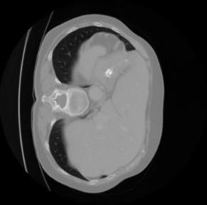

Train Sample Liver label

# DATASET SUMMARY

## A. ATLAS Dataset

#### The ATLAS dataset is a large-scale dataset for abdominal multi-organ segmentation, containing 281 CT volumes with annotations for liver, tumors, and other organs.

#### It was created by combining data from multiple institutions and is intended for developing and evaluating segmentation algorithms.

#### The dataset provides reference and affiliation data, all-payor claims, prescription claims, and information on medical experts.

## DECATHLON Dataset

#### The Medical Segmentation Decathlon is a collection of 10 medical image segmentation datasets across different anatomies and modalities, with a total of 300 3D volumes.

#### It includes datasets for brain, heart, liver, hippocampus, prostate, lung, pancreas, hepatic vessels, spleen, and colon segmentation tasks.

#### The dataset aims to provide a comprehensive benchmark for evaluating the generalizability of segmentation algorithms across diverse tasks.

## LiTS Dataset

#### The Liver Tumor Segmentation (LiTS) dataset is a benchmark dataset specifically focused on liver and liver tumor segmentation .

#### It contains 155 CT scans of the abdomen, with 75 scans containing lesions.

#### The dataset was created in collaboration with seven hospitals and research institutions, providing a diverse set of primary and secondary tumors with varied sizes and appearances.

#### LiTS was organized as a challenge in conjunction with ISBI 2017, MICCAI 2017, and MICCAI 2018, and remains an active benchmark for liver and tumor segmentation research.

# INNOVATING STATE OF THE ART

1. *Multi-Task Learning:*

### Develop a multi-task learning framework that simultaneously segments the Couinaud segments, biliary tree, and vasculature. This approach leverages shared features and improves overall segmentation accuracy.

1. *Attention Mechanisms:*

### Integrate attention mechanisms into the segmentation network to focus on relevant features and enhance the segmentation of complex structures like the biliary tree and vasculature.

1. *Data Augmentation and Transfer Learning:*

### Use extensive data augmentation techniques to increase the diversity of training data. Employ transfer learning from pre-trained models on similar tasks to improve model performance and reduce training time.

1. *Post-Processing Techniques:*

### Implement post-processing techniques such as Conditional Random Fields (CRFs) and morphological operations to refine segmentation boundaries and ensure spatial consistency.

# Model Architecture

1. Encoder Path (Down sampling):

The encoder path consists of a series of convolutional blocks, each followed by a max-pooling operation. For each convolutional block 𝑙in the encoder:

where:

* ​ is the output of the *l-th* convolutional block.
* and are the weights and biases of the *l-th* convolutional block.
* *f* is the activation function (typically ReLU).
* ∗ denotes the convolution operation.

After each convolutional block, a max-pooling operation is applied:

1. Decoder Path (Up sampling):

The decoder path consists of a series of up sampling blocks, each followed by convolutional blocks and nested dense skip connections. For each up sampling block *l* in the decoder:

For each convolutional block mmm in the decoder:

where *l* represents the level and mmm represents the convolutional block within that level.

1. Nested Dense Skip Connections:

U-Net++ introduces nested dense skip connections to improve gradient flow and feature propagation. These connections can be represented as:

For each layer *l* and block *m*:

where:

* is the output from the previous block at the same level.
* are the weights for the skip connections.
* ⊕ denotes the concatenation operation.
* ​ are the outputs from the encoder path used for skip connections.

1. Final Output:

The final segmentation map is produced by applying a final convolutional layer followed by a SoftMax activation function:

where ​ is the output from the last decoder layer.

# MODEL DESCRIPTION

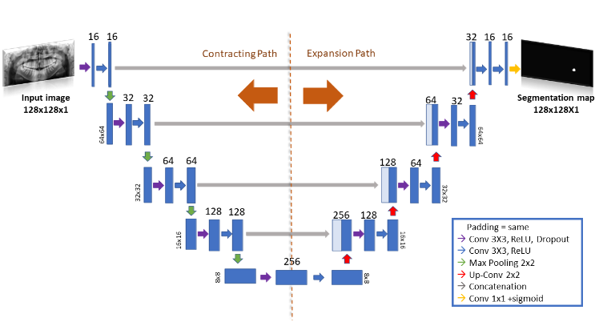

UNet++ is an advanced semantic segmentation architecture that enhances the original U-Net design. It introduces nested and dense skip connections between the encoder and decoder, bridging the semantic gap between feature maps. The redesigned skip pathways include convolution layers, facilitating more effective feature fusion. Dense feature propagation enables flexible multiscale feature combination at decoder nodes. UNet++ incorporates deep supervision, allowing for model complexity tuning and dual operational modes: accurate (averaging all segmentation branches) and fast (selecting one branch). The dense connections improve gradient flow, potentially accelerating convergence. The architecture's flexible depth permits pruning at inference time when trained with deep supervision, enabling performance-speed trade-offs. UNet++ gradually synthesizes segmentation through multiscale feature aggregation, demonstrating improved performance across various medical image segmentation tasks, including electron microscopy, cell imaging, and tumor segmentation.

# IMPLEMENTATION

1. *Data Collection and Preprocessing:*

Collect MRI datasets from publicly available sources like LiTS, Decathlon Liver Dataset, and ATLAS Dataset.

Preprocess the data by normalizing intensity values, resampling to a common voxel size, and applying data augmentation techniques.

1. *Model Development:*

Architecture Design: Design a 3D U-Net++ based architecture with attention mechanisms and multi-task learning capabilities.

Training: Train the model using the collected datasets, employing transfer learning from pre-trained models where applicable.

Loss Functions: Use a combination of Dice Similarity Coefficient (DSC) and Cross-Entropy Loss to handle class imbalance and measure segmentation accuracy.

1. *Model Evaluation:*

Evaluate the model on a separate validation set using metrics such as DSC, Average False Positivity Rate (AFPR), and Mean Absolute Distance (MAD).

Perform cross-validation to ensure robustness and generalizability of the model.

1. *Post-Processing:*

Apply post-processing techniques like CRFs and morphological operations to refine the segmentation results.

Validate the post-processed results against ground truth segmentations to ensure accuracy.

1. *Integration and Testing:*

Integrate the segmentation model into a user-friendly interface for clinical use.

Conduct clinical trials to validate the effectiveness and reliability of the model in real-world settings.

1. *Deployment:*

Deploy the model in clinical environments for liver surgery planning and personalized medicine applications.

Continuously monitor and update the model based on feedback and new data.

# RESULTS

### LIVER SEGMENT –

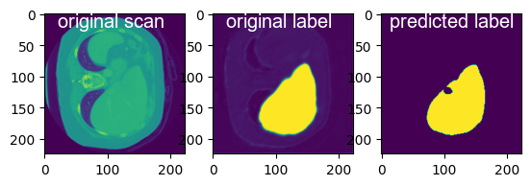

##### Acknowledgment *(Heading 5)*

The preferred spelling of the word “acknowledgment” in America is without an “e” after the “g”. Avoid the stilted expression “one of us (R. B. G.) thanks ...”. Instead, try “R. B. G. thanks...”. Put sponsor acknowledgments in the unnumbered footnote on the first page.

##### References

1. G. Eason, B. Noble, and I. N. Sneddon, “On certain integrals of Lipschitz-Hankel type involving products of Bessel functions,” Phil. Trans. Roy. Soc. London, vol. A247, pp. 529–551, April 1955. *(references)*
2. J. Clerk Maxwell, A Treatise on Electricity and Magnetism, 3rd ed., vol. 2. Oxford: Clarendon, 1892, pp.68–73.
3. I. S. Jacobs and C. P. Bean, “Fine particles, thin films and exchange anisotropy,” in Magnetism, vol. III, G. T. Rado and H. Suhl, Eds. New York: Academic, 1963, pp. 271–350.
4. K. Elissa, “Title of paper if known,” unpublished.
5. R. Nicole, “Title of paper with only first word capitalized,” J. Name Stand. Abbrev., in press.
6. Y. Yorozu, M. Hirano, K. Oka, and Y. Tagawa, “Electron spectroscopy studies on magneto-optical media and plastic substrate interface,” IEEE Transl. J. Magn. Japan, vol. 2, pp. 740–741, August 1987 [Digests 9th Annual Conf. Magnetics Japan, p. 301, 1982].
7. M. Young, The Technical Writer’s Handbook. Mill Valley, CA: University Science, 1989.