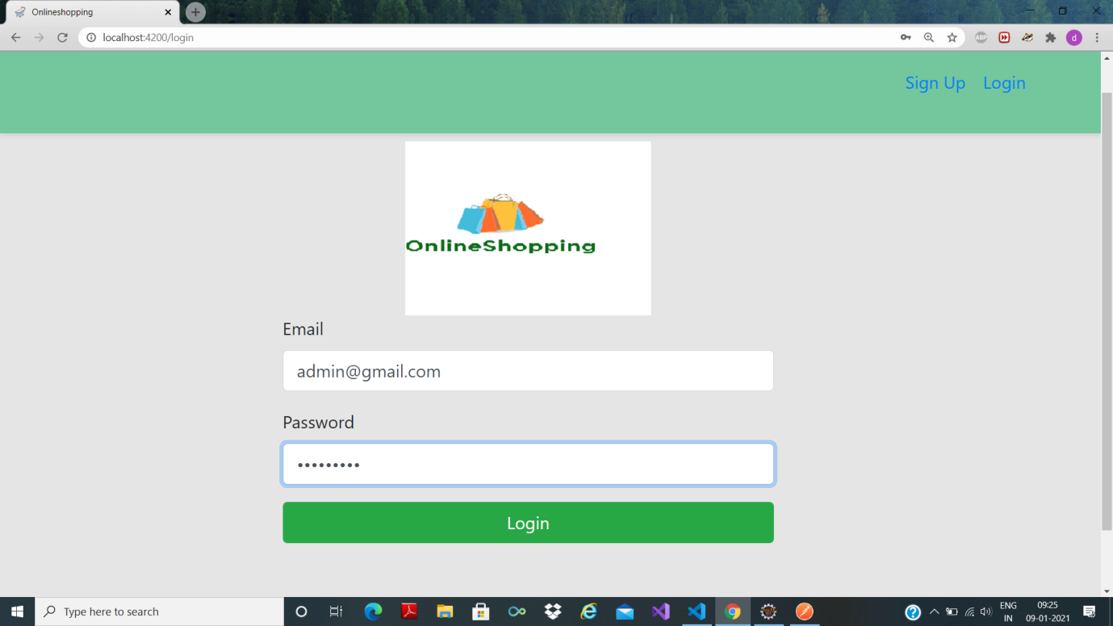

1. Login as admin

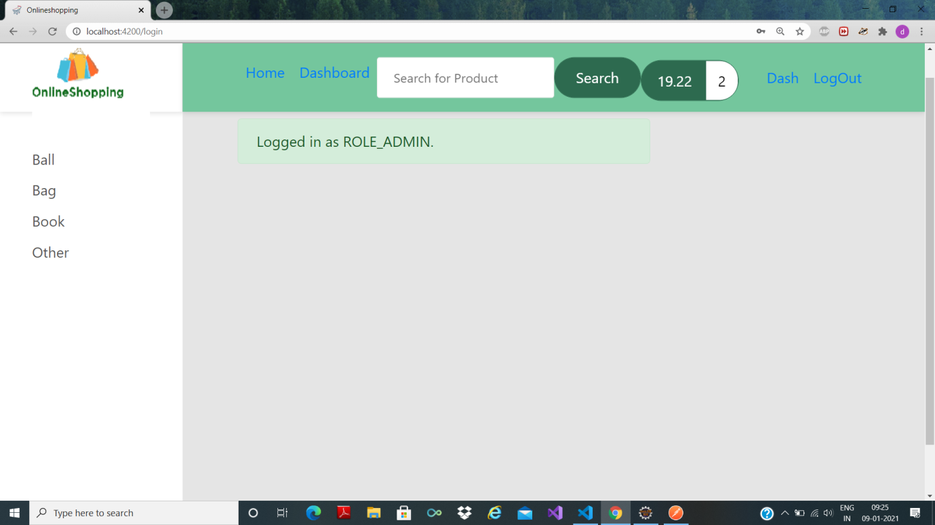

2. Logged in as admin

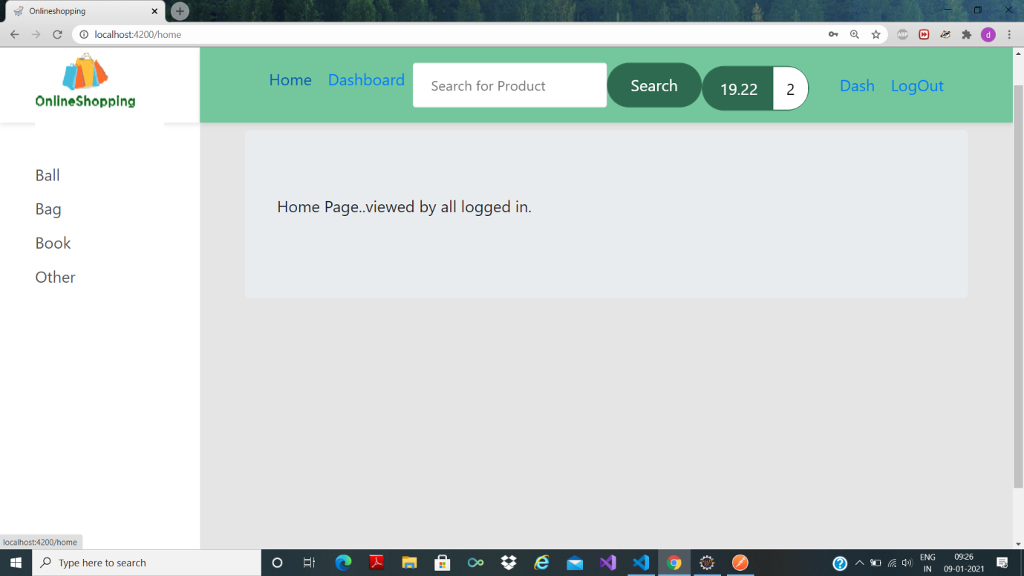

3. Home page: visible to admin ---(dummy page)—stitch original in place of this

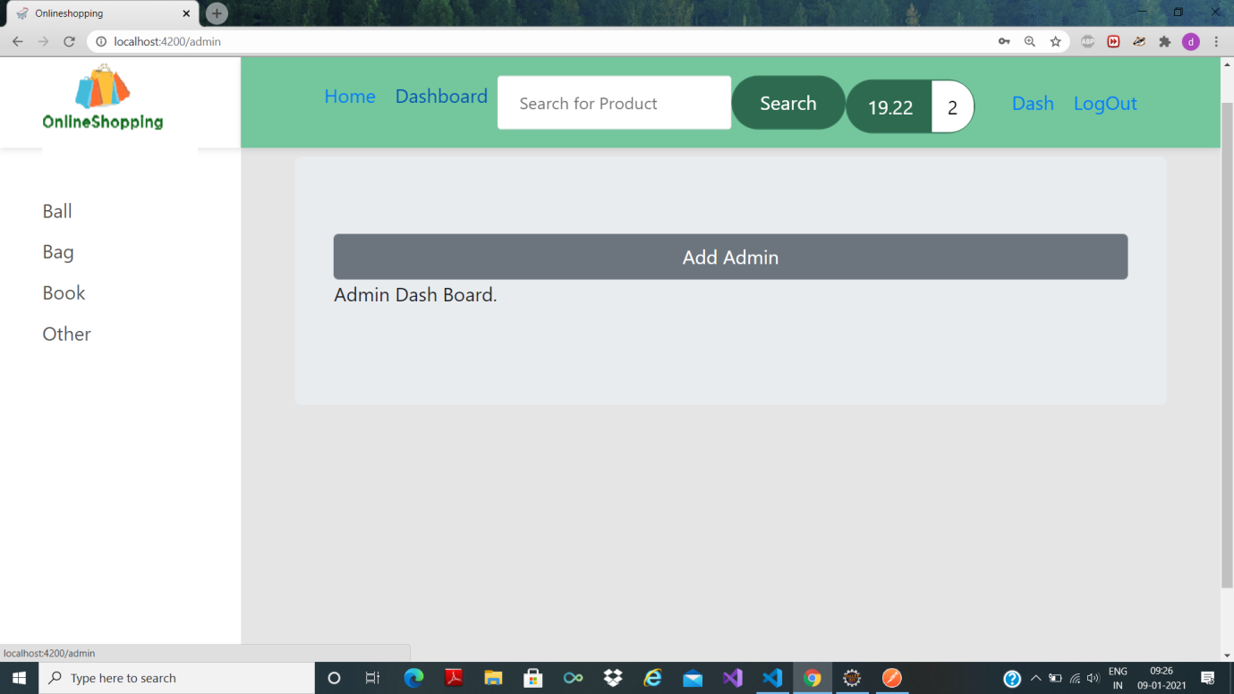

4. Dashboard seen only by admin(dummy page)

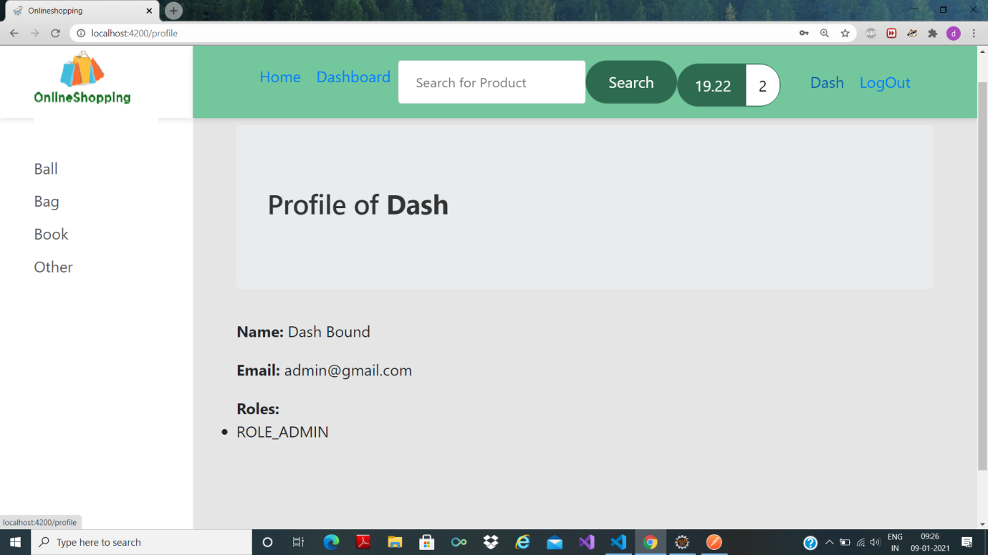

5. Profile of admin

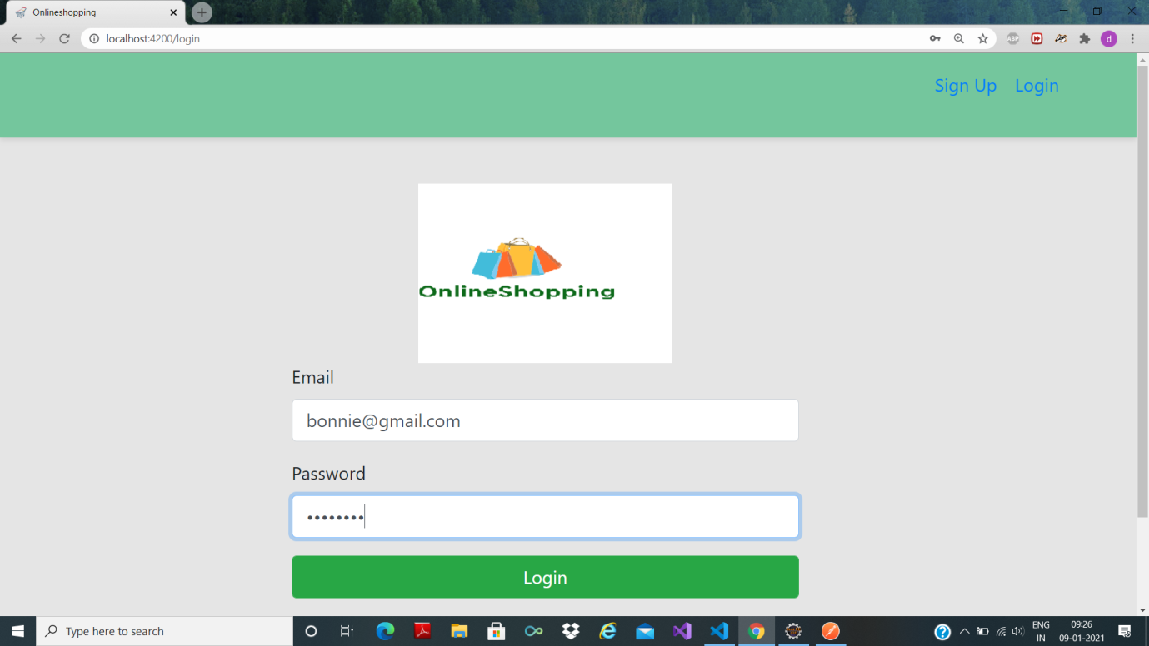

5. Log in as user

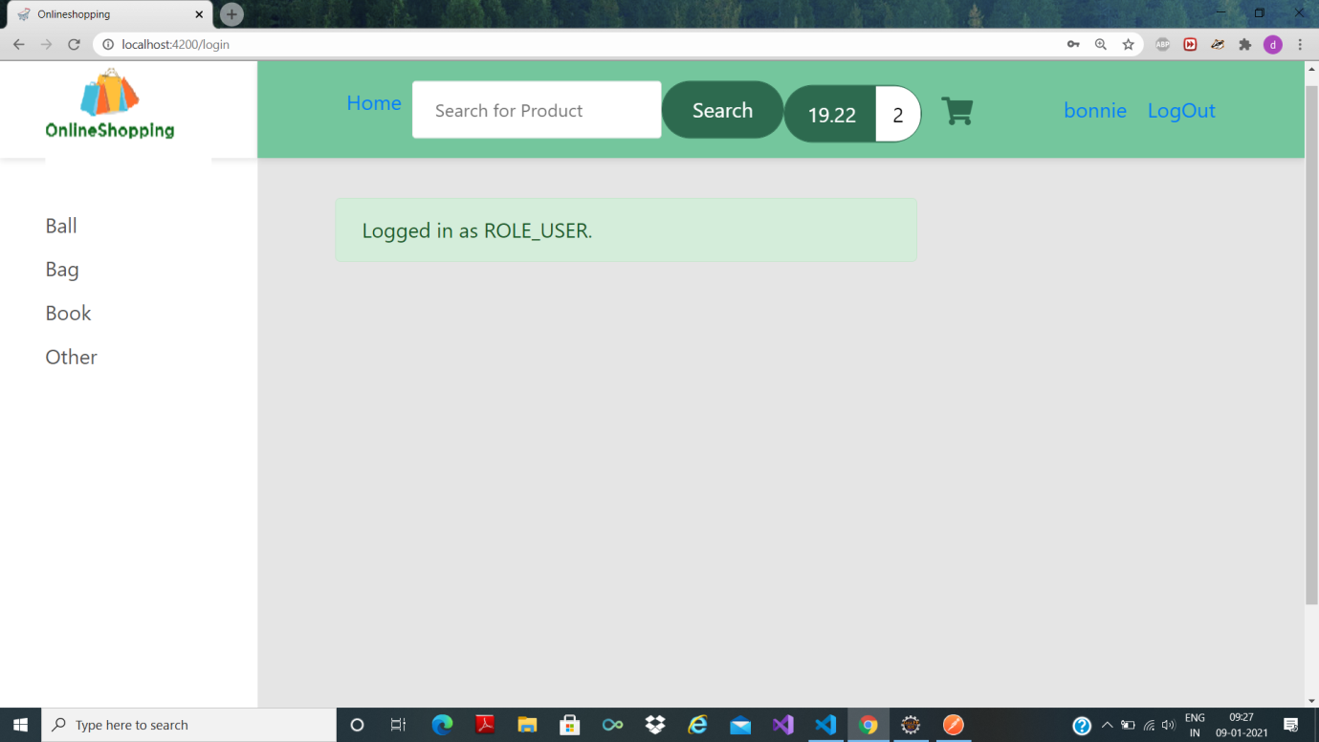

6. After logging in as user

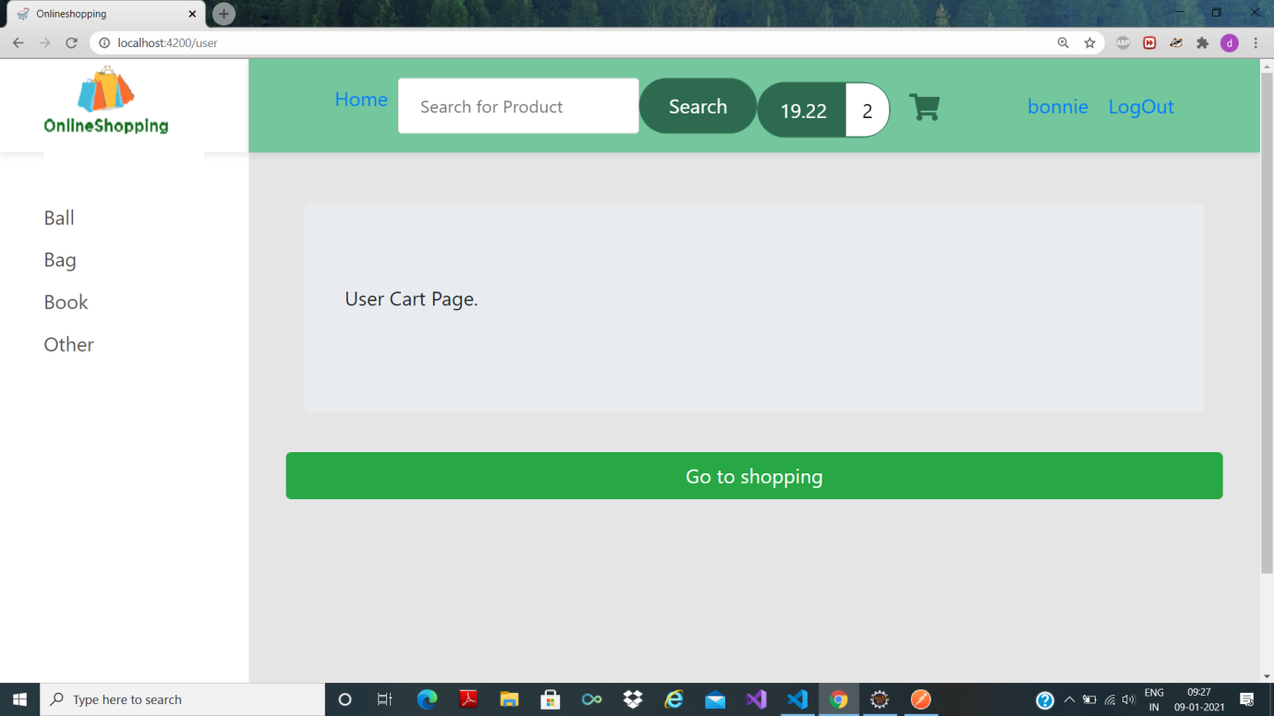

7. This page is visible on clicking cart icon (left of bonnie)---dummy cart page

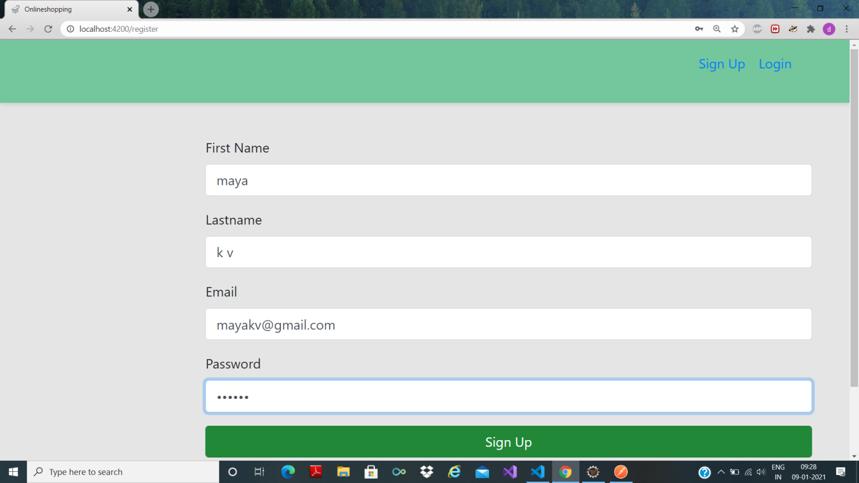

8. Register a new user “maya” (Signup page)

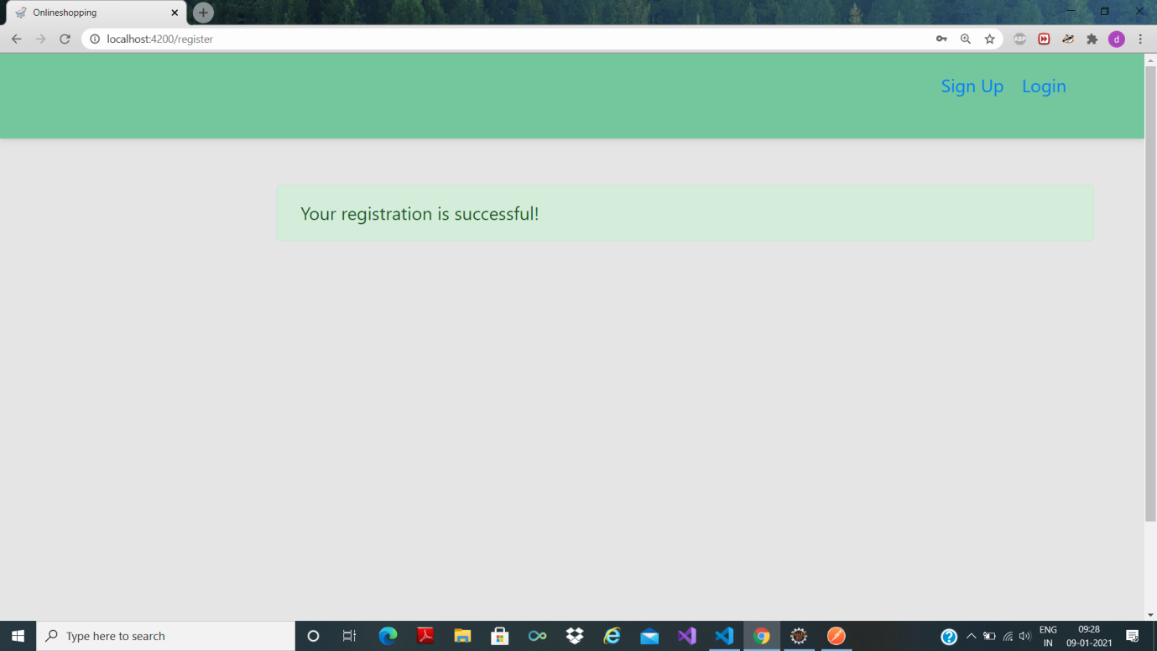

9. Registration of “maya” successful

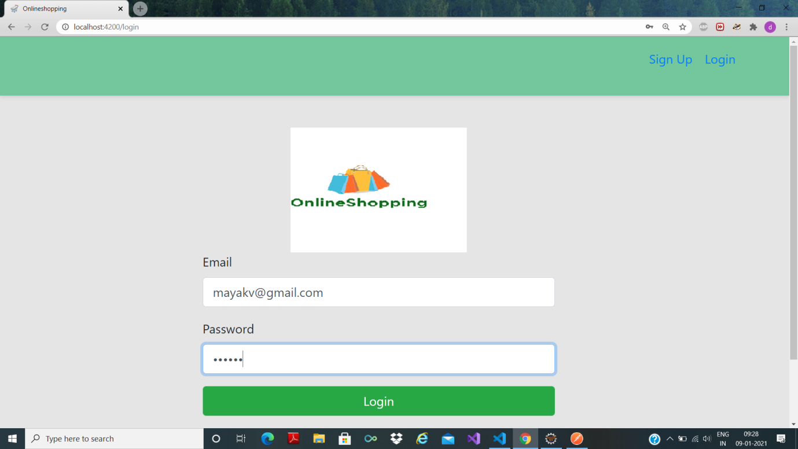

10. Login as maya

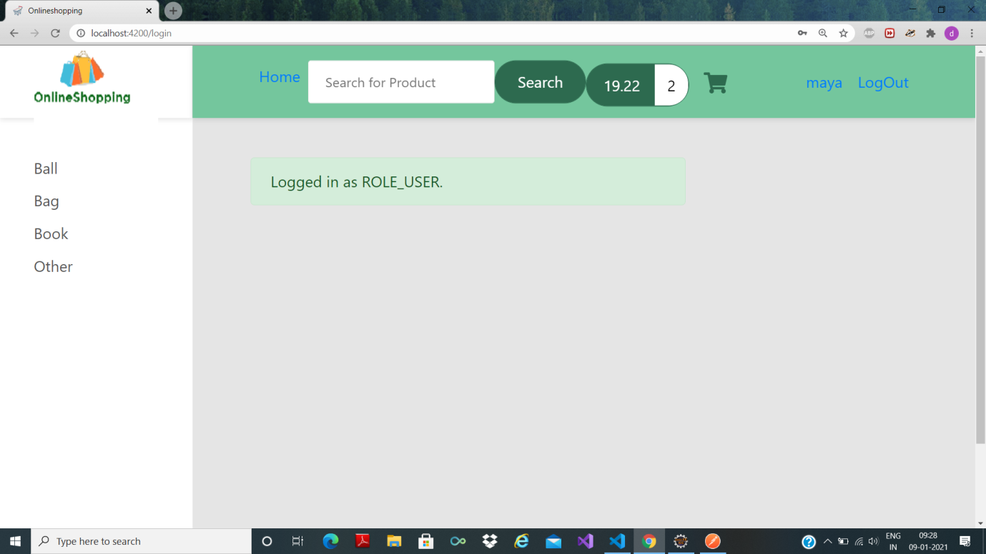

11. Login success

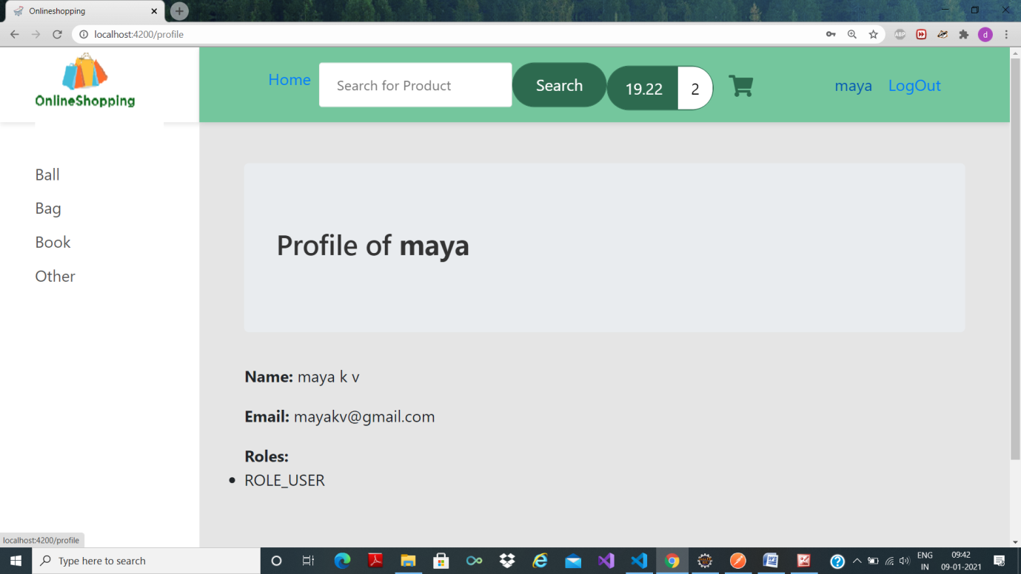

12. Profile of maya( same as picture 3.)

NOTE:

All dummy pages are for testing purpose only.

Dummy pages should be replaced by original pages.

Credentials of admin(email and password) are given in O03SQL/sqlrolesproject.txt along with necessary sql commands

First run spring and then write sql commands to mysql before sending any request.