1. **Global Credntial in Jenkins**

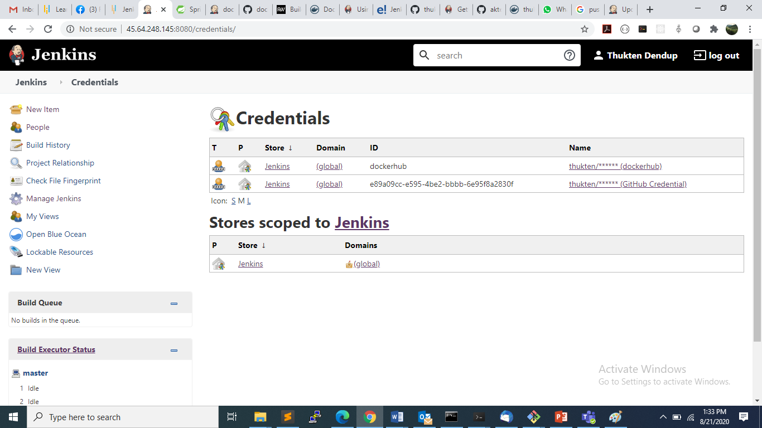

1. **Jenkin CI pipeline for building and pushing the image to docker hub.**

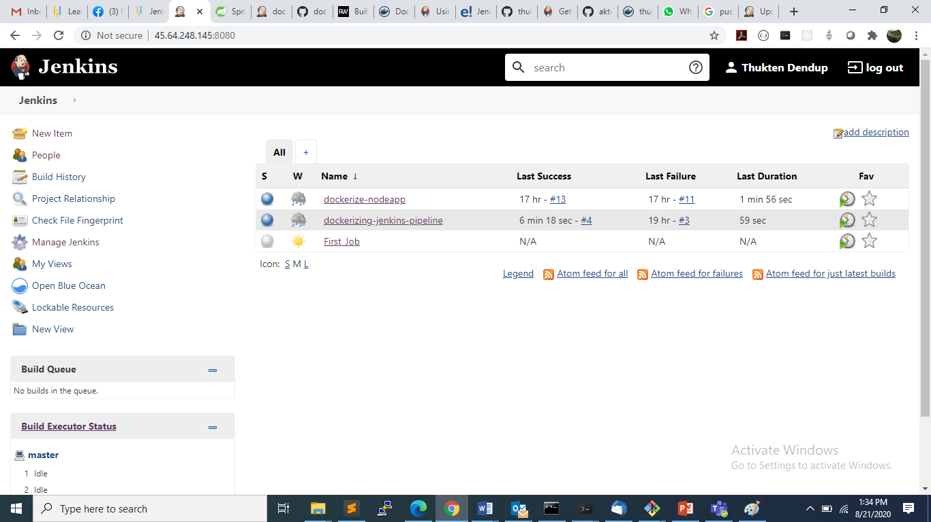

1. **CI pipeline at the time of execution.**

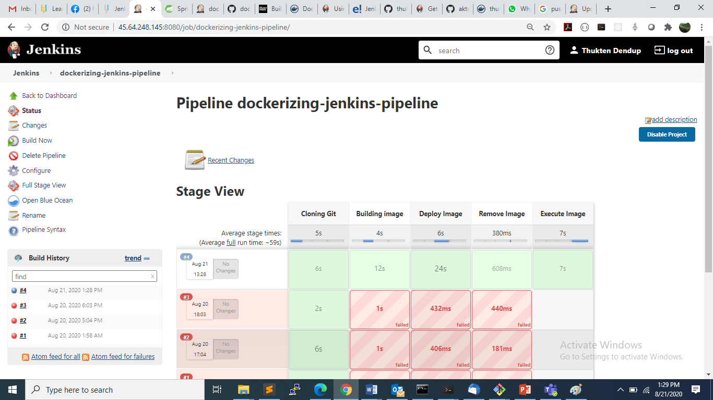

1. **CI pipeline executing the command “echo This is the code executing inside the container.” Inside the container.**

