Electric Bill System Database

Database Name :- project

1. *customer*

* *customer_id (Primary Key)*
* *first_name*
* *last_name*
* *address*
* *phone_number*
* *email*

1. *electric_meter*

* *meter_id (Primary Key)*
* *meter_number*
* *location*
* *cust_id(foreign key refernces customer(customer_id)*
* *merer_units*

1. *bills*

* *f_name*
* *l_name*
* *customer_id (primaru key)*
* *meter_id*
* *meter_units*
* *bill_date*
* *amount*
* *foreign key(customer_id) refernces customers(customer_id)*
* *foreign key(meter_id) refernces electric_meter(meter_id)*

***Display table:***

*Select * from customers;*

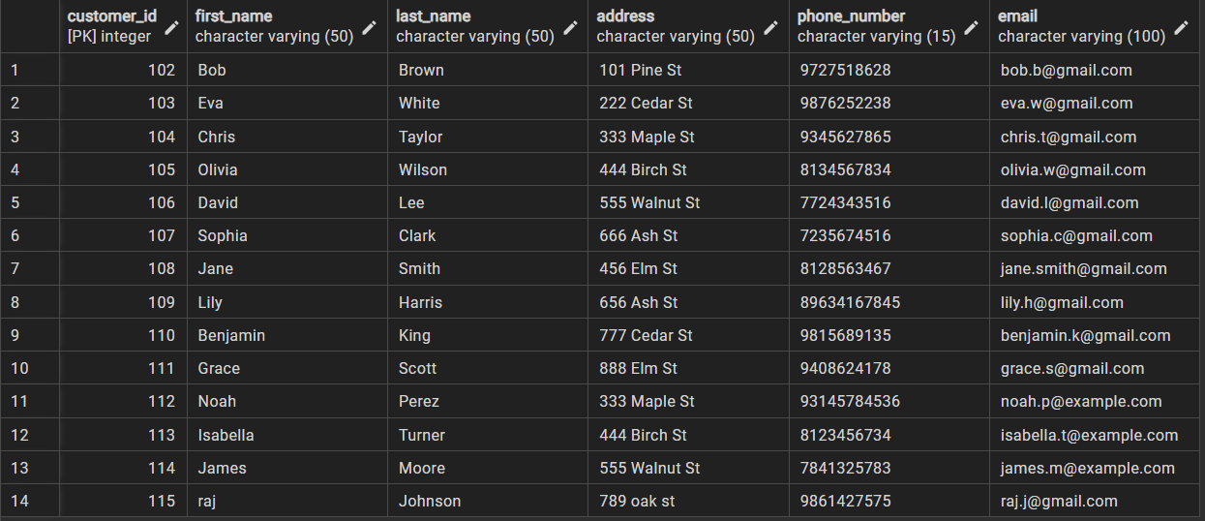

*Select * from electric_meter;*

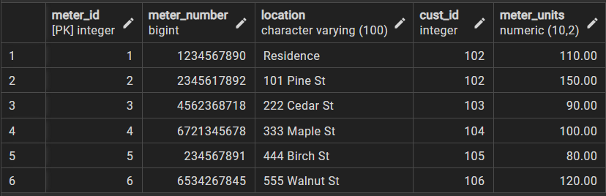

*Select * from bills;*

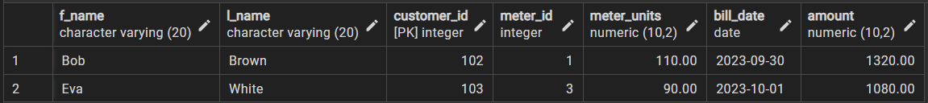

**Plsql Block :-**

1.create a function to calculate the total amount of customer.

CREATE OR REPLACE FUNCTION calculate_total_amount(customer_id IN INT)

RETURNS DECIMAL(10,2) as

$$

declare

total_amount DECIMAL(10, 2);

BEGIN

SELECT SUM(amount) INTO total_amount FROM bills

WHERE bills.customer_id = calculate_total_amount.customer_id;

RETURN total_amount;

END;

$$

language plpgsql;

select calculate_total_amount(103);

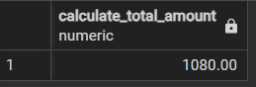

2. Create a function to insert bill detail into bills table.

create or replace function calculateBill(customer_id int)

returns decimal(10,2)

as

$$

declare

total_bill decimal(10,2);

b1 bills%rowtype;

c date:=current_date;

d cursor for select customers.first_name,customers.last_name,customers.customer_id,electric_meters.meter_id,electric_meters.meter_units from customers inner join electric_meters on customers.customer_id=electric_meters.cust_id where customers.customer_id=calculateBill.customer_id;

begin

open d;

loop

fetch d into b1;

exit when not found;

select (electric_meters.meter_units)*(12) into total_bill from electric_meters where electric_meters.cust_id=calculateBill.customer_id;

insert into bills values(b1.f_name,b1.l_name,b1.customer_id,b1.meter_id,b1.meter_units,c,total_bill);

end loop;

close d;

return total_bill;

end;

$$

language plpgsql;

select calculateBill(105);

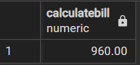

3. Query to retrieve customer details along with their electric meter location.

SELECT customers.first_name, customers.last_name, electric_meters.location

FROM customers INNER JOIN electric_meters ON customers.customer_id =

electric_meters.cust_id;

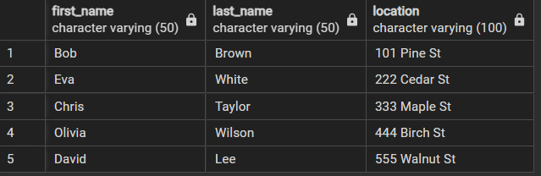

4. Query to retrieve the customer with the highest total bill amount:

SELECT customer_id, first_name, last_name FROM customers WHERE

customer_id = ( SELECT customer_id FROM bills GROUP BY customer_id

ORDER BY SUM(amount) DESC LIMIT 1);



5. Query to find customers who have electric meters but no bills:

SELECT first_name, last_name FROM customers WHERE customer_id IN

(SELECT cust_id FROM electric_meters) AND customer_id NOT IN

(SELECT customer_id FROM bills);



6. Query to find the total amount spent by each customer and display only customers who have spent less than 500 Rs. :

SELECT c.customer_id, c.first_name, c.last_name, SUM(b.amount) AS

total_amount FROM customers c

INNER JOIN bills b ON c.customer_id = b.customer_id

GROUP BY c.customer_id, c.first_name, c.last_name

HAVING SUM(b.amount) > 500;

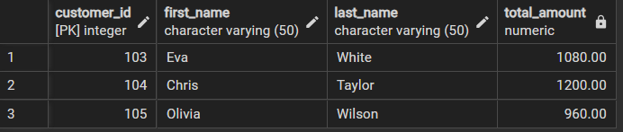

7. Query to find the total amount spent by customers with the last name 'Wilson' and having an address on '444 Birch St':

SELECT c.customer_id, c.first_name, c.last_name, SUM(b.amount) AS

total_amount FROM customers c

INNER JOIN bills b ON c.customer_id = b.customer_id

WHERE c.last_name = 'Wilson' AND c.address = '444 Birch St'

GROUP BY c.customer_id, c.first_name, c.last_name;

