AI Usage DISCLOSURE FORM

1. Team Details
Team Name: AgentXecution
Project / Product Name: AgentXecution
Organization / Institution (if any): Ramaiah Institute of Technology
Submission Date: 8th May 2026

2. AI Usage Declaration
Did your team use any Artificial Intelligence (AI) in developing this project? Yes / No
Yes

3. Purpose of AI Usage (Brief Details)
Idea generation / brainstorming - Used AI tools for brainstorming workflow automation ideas and refining feature concepts.
Code generation or assistance- Used AI-assisted support for frontend integration, backend APIs, debugging, and workflow orchestration.
UI / UX design- Used AI assistance for dashboard layouts, workflow visualization, and UI refinement.
Content creation- Used AI assistance for documentation, architecture explanations, and presentation wording.
Data analysis- Used AI-generated logic for workload analysis, risk prediction, and delay estimation.
Testing / debugging- Used AI tools for debugging frontend-backend integration and workflow execution issues.
Other- Voice-to-text experimentation and OpenClaw-inspired multi-agent workflow structuring.

4. Feature Origin Classification (Please add/delete based on the number of the feature)
1. Feature Name 1- Multi-Agent Workflow Orchestration
2. Self-Generated/AI-Generated/Both- Both
3. Description ( include AI tools/platform Used, prompt used , Output Summary, Modification)-
AI Tools Used: ChatGPT, OpenClaw references
Prompt Used: “Build a multi-agent workflow execution system from meeting transcripts.”
Output Summary: Generated agent orchestration and backend workflow ideas.
Modification Done: Team customized task execution, memory, monitoring, and frontend integration.

1. Feature Name 2- Voice-to-Task Execution
2. Self-Generated/AI-Generated/Both- Both
3. Description (include AI tools/platform Used, prompt used , Output Summary, Modification)-
AI Tools Used: ChatGPT, browser speech recognition references
Prompt Used: “Convert spoken meeting discussion into tasks using speech-to-text.”
Output Summary: Generated voice input and transcript conversion ideas.
Modification Done: Team connected voice capture with task generation and frontend workflow.

1. Feature Name 3- Risk Prediction & Workload Detection
2. Self-Generated/AI-Generated/Both- Both
3. Description (include AI tools/platform Used, prompt used , Output Summary, Modification)-
AI Tools Used: ChatGPT
Prompt Used: “Create a simple AI system to detect overloaded users and delayed tasks.”
Output Summary: Generated risk scoring and delay prediction ideas.
Modification Done: Team implemented workload counting, risk levels, and delay prediction logic.

1. Feature Name 4- Natural Language Command System
2. Self-Generated/AI-Generated/Both- Both
3. Description (include AI tools/platform Used, prompt used , Output Summary, Modification)-
AI Tools Used: ChatGPT
Prompt Used: “Build a command system for assigning and updating tasks using normal language.”
Output Summary: Generated command parsing and reassignment ideas.
Modification Done: Team implemented command execution, task reassignment, and undo functionality.

1. Feature Name 5- Dashboard & Workflow Visualization
2. Self-Generated/AI-Generated/Both- Both
3. Description (include AI tools/platform Used, prompt used , Output Summary, Modification)-
AI Tools Used: ChatGPT
Prompt Used: “Design a dashboard for AI workflow monitoring and task tracking.”
Output Summary: Generated dashboard layout and workflow visualization ideas.
Modification Done: Team created the React frontend, graphs, workflow cards, and monitoring UI.

5. Ethical & Compliance Confirmation
AI usage complies with guidelines and policies. Yes
No proprietary or copyrighted data misused. I Agree

6. Declaration & Sign-Off
Name of Team Representative: Pooja N
Role: Team Leader/Developer
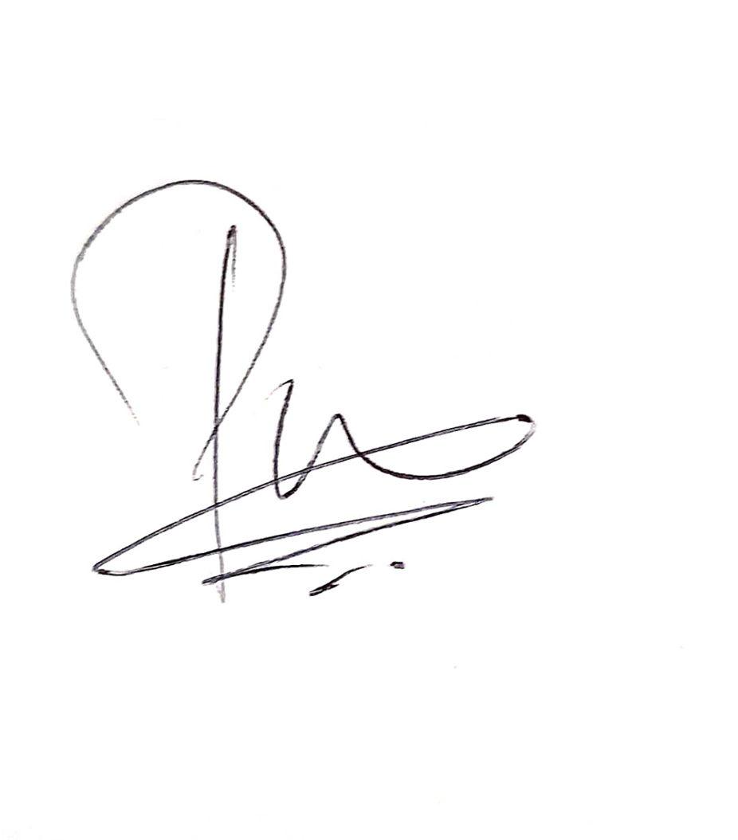
Signature:

Date: 8th May 2026

