**Project Part I**

The following steps demonstrate that we have loaded our data into the postgres system.

1. The data generation code is written in Go lang and we are able to execute the script and generate data which is loaded into the csv files.



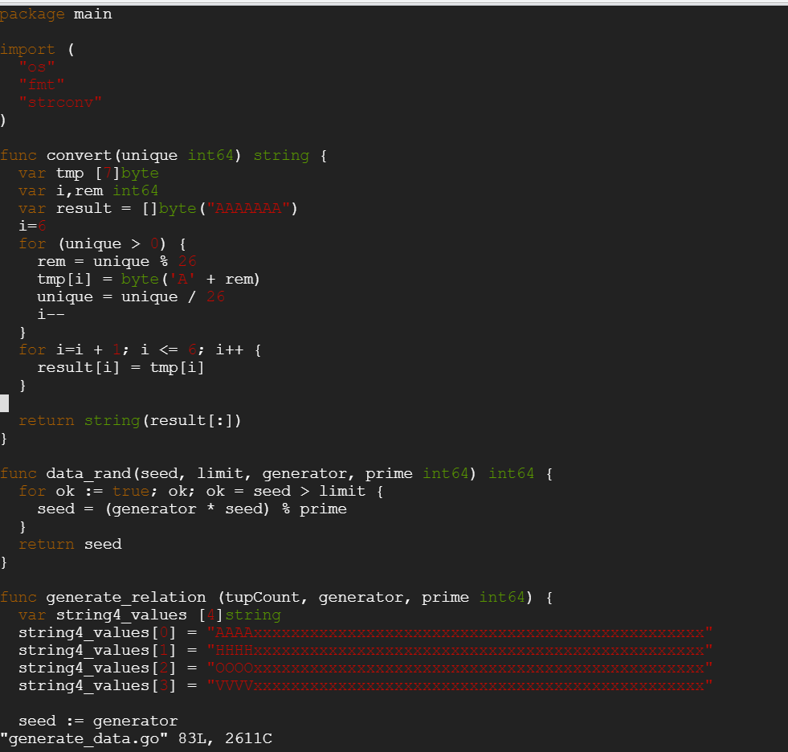









1. Creating a database and connecting to it

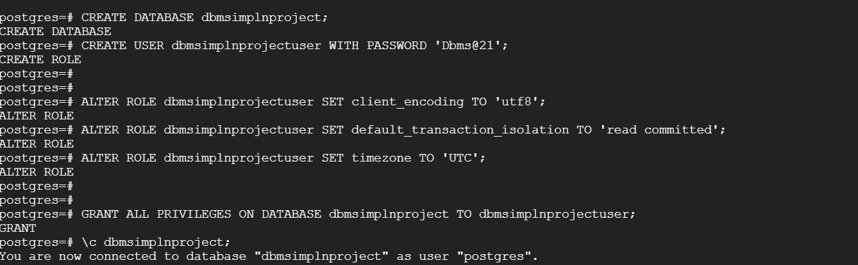

1. Creating tables in the database

* CREATE TABLE ONEKTUP(unique1 INTEGER UNIQUE NOT NULL, unique2 INTEGER PRIMARY KEY,two INTEGER NOT NULL,four INTEGER NOT NULL,ten INTEGER NOT NULL,twenty INTEGER NOT NULL,onePercent INTEGER NOT NULL,tenPercent INTEGER NOT NULL,twentyPercent INTEGER NOT NULL,fiftyPercent INTEGER NOT NULL,unique3 INTEGER NOT NULL,evenOnePercent INTEGER NOT NULL,oddOnePercent INTEGER NOT NULL,stringu1 CHAR(52) UNIQUE NOT NULL,stringu2 CHAR(52) UNIQUE NOT NULL,string4 CHAR(52) NOT NULL);



* CREATE TABLE TENKTUP1(unique1 INTEGER UNIQUE NOT NULL, unique2 INTEGER PRIMARY KEY,two INTEGER NOT NULL, four INTEGER NOT NULL, ten INTEGER NOT NULL, twenty INTEGER NOT NULL, onePercent INTEGER NOT NULL, tenPercent INTEGER NOT NULL, twentyPercent INTEGER NOT NULL, fiftyPercent INTEGER NOT NULL, unique3 INTEGER NOT NULL, evenOnePercent INTEGER NOT NULL, oddOnePercent INTEGER NOT NULL, stringu1 CHAR(52) UNIQUE NOT NULL, stringu2 CHAR(52) UNIQUE NOT NULL,string4 CHAR(52) NOT NULL);



* CREATE TABLE TENKTUP2(unique1 INTEGER UNIQUE NOT NULL, unique2 INTEGER PRIMARY KEY,two INTEGER NOT NULL, four INTEGER NOT NULL,ten INTEGER NOT NULL,twenty INTEGER NOT NULL,onePercent INTEGER NOT NULL,tenPercent INTEGER NOT NULL,twentyPercent INTEGER NOT NULL,fiftyPercent INTEGER NOT NULL,unique3 INTEGER NOT NULL,evenOnePercent INTEGER NOT NULL,oddOnePercent INTEGER NOT NULL,stringu1 CHAR(52) UNIQUE NOT NULL,stringu2 CHAR(52) UNIQUE NOT NULL,string4 CHAR(52) NOT NULL);



1. Copying the data generated from the script to the tables created in the database.

COPY ONEKTUP FROM '/home/pnalan/dbproject/onektup.csv' WITH (FORMAT csv);

COPY TENKTUP1 FROM '/home/pnalan/dbproject/tenktup.csv' WITH (FORMAT csv);

COPY TENKTUP2 FROM '/home/pnalan/dbproject/tenktup2.csv' WITH (FORMAT csv);





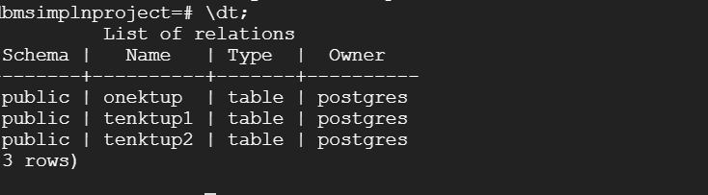

1. Viewing the data copied into the tables.

* SELECT * FROM onektup;

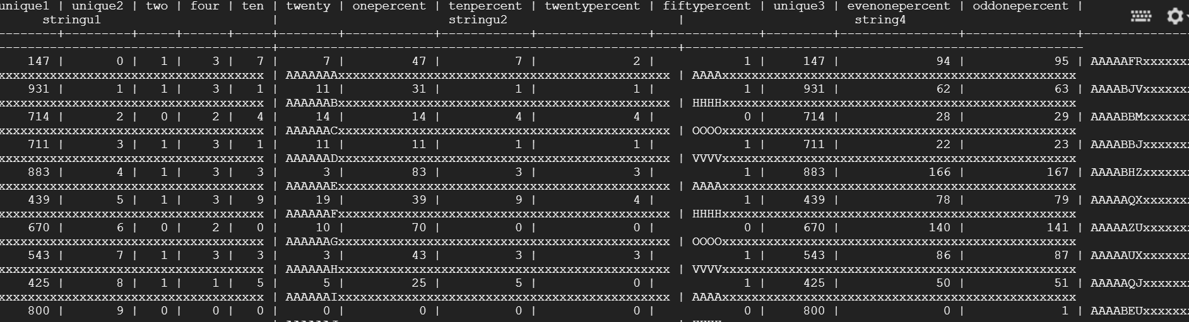

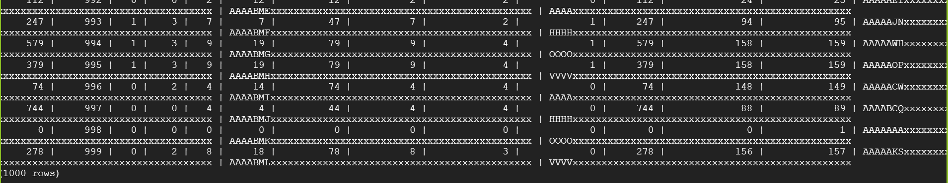

* SELECT * FROM tenktup1;

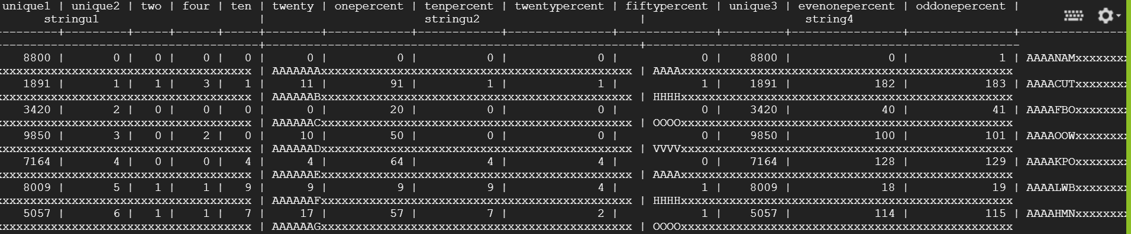

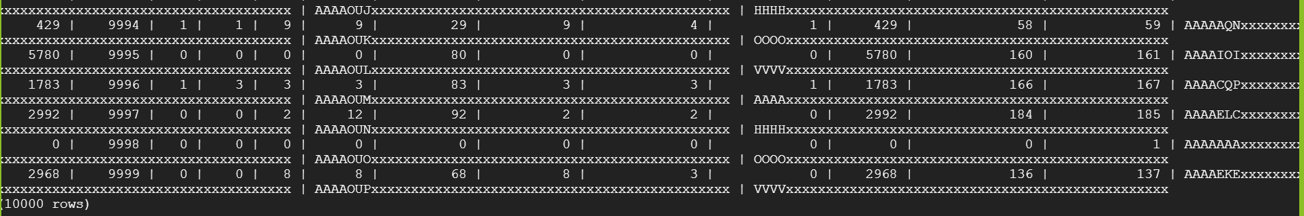

* SELECT * FROM tenktup2;

