Numpy Tutorial:-

Numpy is a Python package, it stands for Numerical Python, it is a library consisting of multidimensional array Objects and a collection of routines for the processing of array.

Pandas:

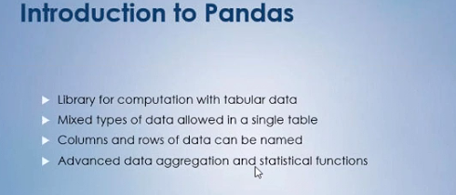

Two type of data structure are there in pandas.

1. Series

2. Dataframe