Week 6

Progress:

We’ve been successful in solving all eight questions of the problem statement. The first 4 are finding the path to a certain position using different algorithms namely DFS, BFS, Uniform Cost search, and A*. The next 2 questions were to find the shortest path to travel all four corners of the maze using BFS and A*. The next two were to find the shortest path to eat all dots and to implement a greedy algorithm that finds the path when A* fails to do the same. We’ve successfully accomplished solving both of them.

Learnings:

Our problem statement this week was modified from visiting 4 corners to visiting all the nodes provided in the form of a list which consists of the food dot positions. Our goal was to define a heuristic which gives the minimum length path to visit all food dots. We tried multiple alterations of different heuristics to finally arrive at a function that calculates the distance of our starting position with respect to all food dots and return the maximum of it. When we tried the minimum it didn’t work out well. For finding the suboptimal path we tried out all the previously implemented algorithms and BFS and UCS proved to be efficient. DFS failed to find the suboptimal path.

File Listing and Description:

search.py: It contains all the algorithms used by searchAgents to find paths through the maze. In this week we modified functions for the A* algorithm, initially it handled a goal state to reach all 4 corners and now we’re tackling a problem to visit multiple nodes with food. We’ve used the gamestate object in this case where we get a list of the positions for food dots.

searchAgents.py: This file contains all the agents to run pacman and the different problem states are defined here. We modified the AStarFoodSearchAgent for devising the new food heuristic. We’ve also edited the findPathToClosestDot to call the path finding functions in order to find a sub-optimal path in case A* fails to find an optimal one.

**Question 7:**

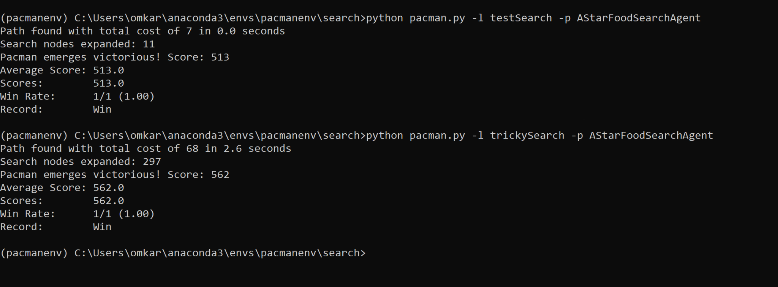

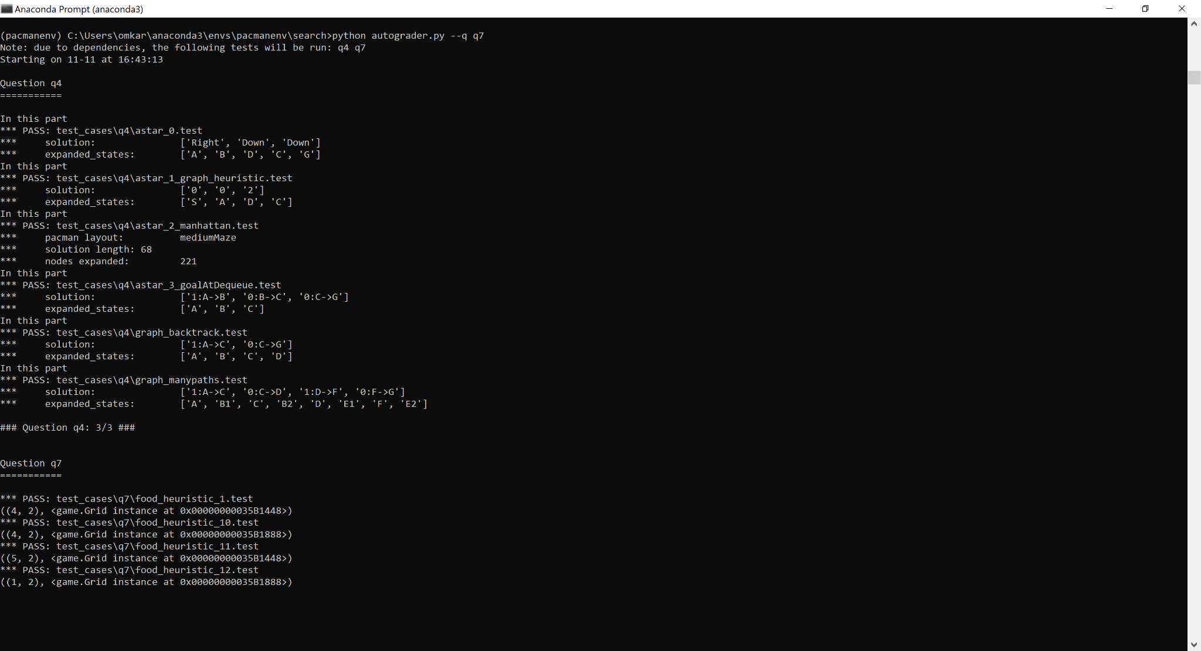



**Question 8:**

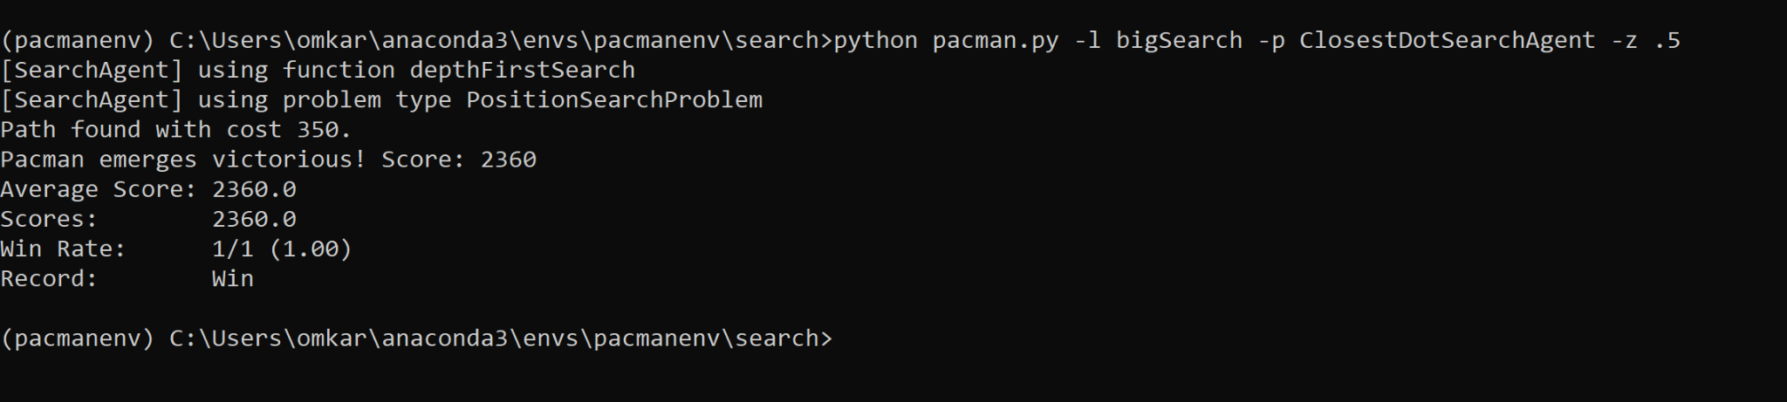

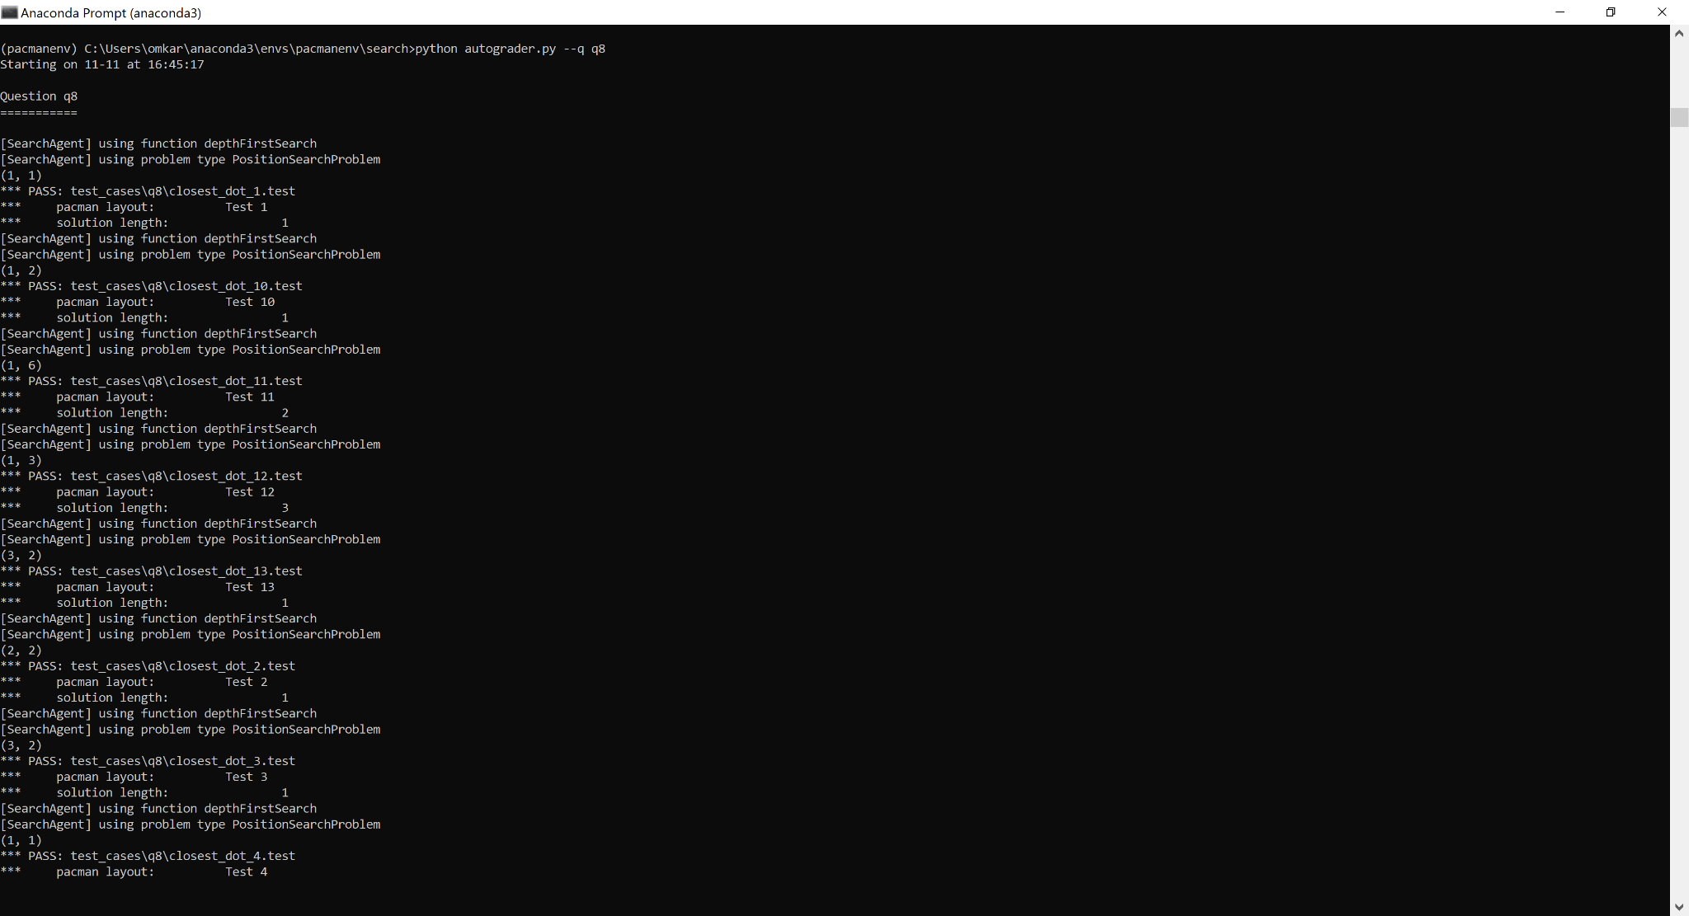

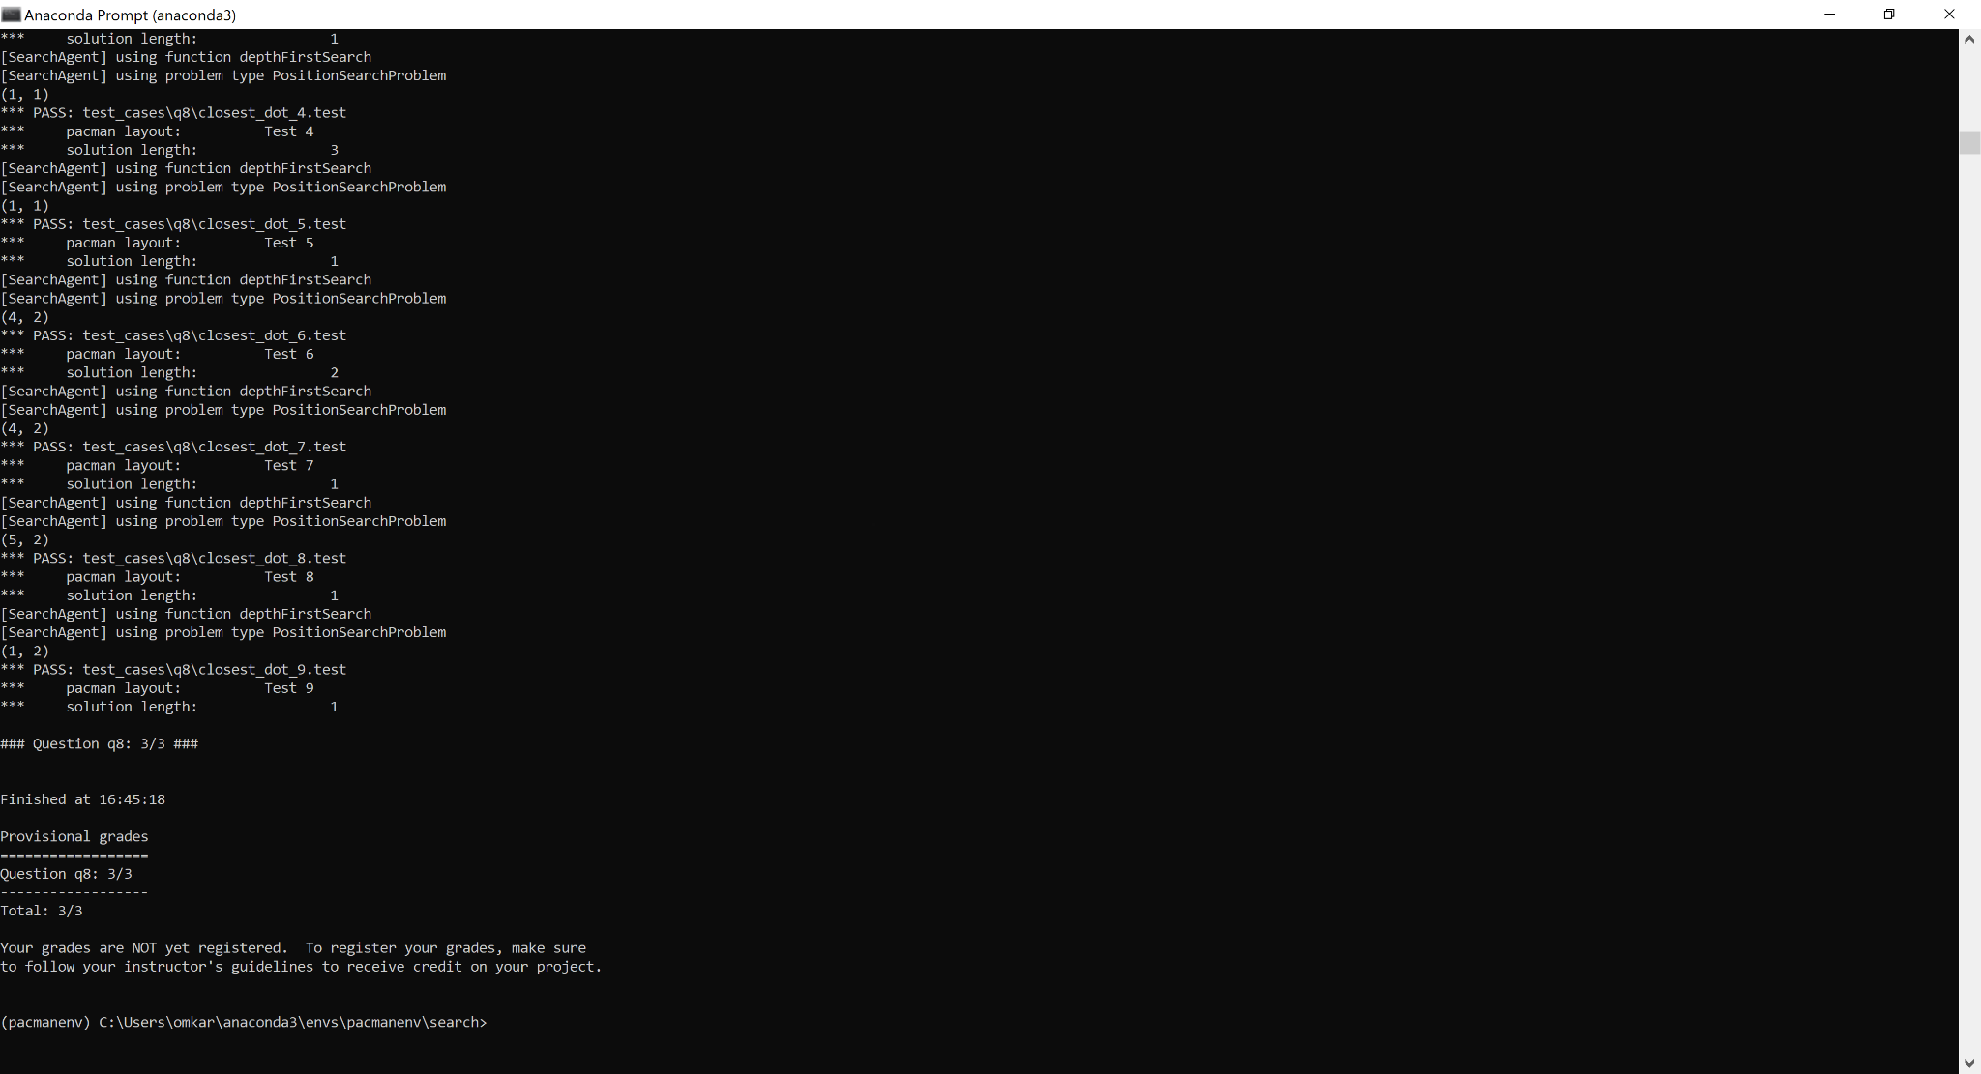

**Final Autograder:**

