MIT Art, Design & Technology University, Pune
School of Food Technology
Food Safety Training and Certifications (FoSTaC) Trainings Highlights
Food Safety Standard Authority India, New Delhi ((FSSAI)) has recommended all Central License/ State License food businesses to have at least one trained and FoSTaC certified food safety supervisor against every 25 food handlers. Food safety is shared responsibility where industry, government, institutions, producers and consumers can play their role. School of Food Technology is an approved “Training Partner” of “FoSTaC” under FSSAI to conduct these mandatory food safety trainings and recommend certification of candidate to FoSTaC. SoFT has organized 25 FoSTaC trainings for students, food industry delegate and caterers to ensure capacity building of food safety supervisors either for execution or entry in food business across the country. The successful organization of FoSTaC training to food industry stakeholders for ensuring safe food production is manifested as an incredible activity of the institution.

FoSTaC Trainings Details
Sr.No | Name of FoSTaC Training | Date | Participant details
1 | Advance Manufacturing  (Level-2) -Batch 1 | 3/10/2017 | Batch 1- 40  Batch 2- 35
2 | Advance Manufacturing  (Level-2) -Batch 2
3 | Advance Manufacturing  (Level-2) | 30/11/2017 | 8
4 | Advance Manufacturing  (Level-2) | 09/02/2018 | 21
5 | Advance Manufacturing  (Level-2) | 18/05/2018 | 10
6 | Advance(Level-2)  Catering | 14/09/2018 | 19
7 | Advance Manufacturing  (Level-2) | 20/12/2018 | 23
8 | Advance Manufacturing  (Level-2) | 10/04/2019 | 12
9 | Advance Manufacturing  (Level-2) | 30/04/2019 | 28
10 | Advance Manufacturing  (Level-2) | 14/12/2019 | 25
11 | Advance Manufacturing  (Level-2) | 08/02/2021 | 26
12 | Advance Manufacturing  (Level-2) | 03/02/2022 | 22
13 | Basic Catering & COVID | 29/09/2022 | 32
14 | Advance Manufacturing  (Level-2) | 5/04/2023 | 40
15 | Advance Manufacturing  (Level-2) | 8/05/2023 | 24
16 | Advance Manufacturing  (Level-2) | 7/03/2024 | 35
17 | Advance Manufacturing  (Level-2) | 24/04/2024 | 25
18 | Advance Manufacturing  (Level-2) | 16/07/2024 | 22
19 | Advance Manufacturing  (Level-2) | 28/11/2024 | 09
20 | Advance Manufacturing  (Level-2) | 13/12/2024 | 28
21 | Basic Catering & COVID | 18/07/2025 | 29
22 | Basic Retail and Distribution | 27th August 2025, | 100
23 | Basic Retail and Distribution | 27th August 2025, | 100
24 | Basic Retail and Distribution | 27th August 2025, | 100
25 | Basic catering | 04/01/2026 | 24

Glimpse of MITSoFT FoSTaC Trainings…..
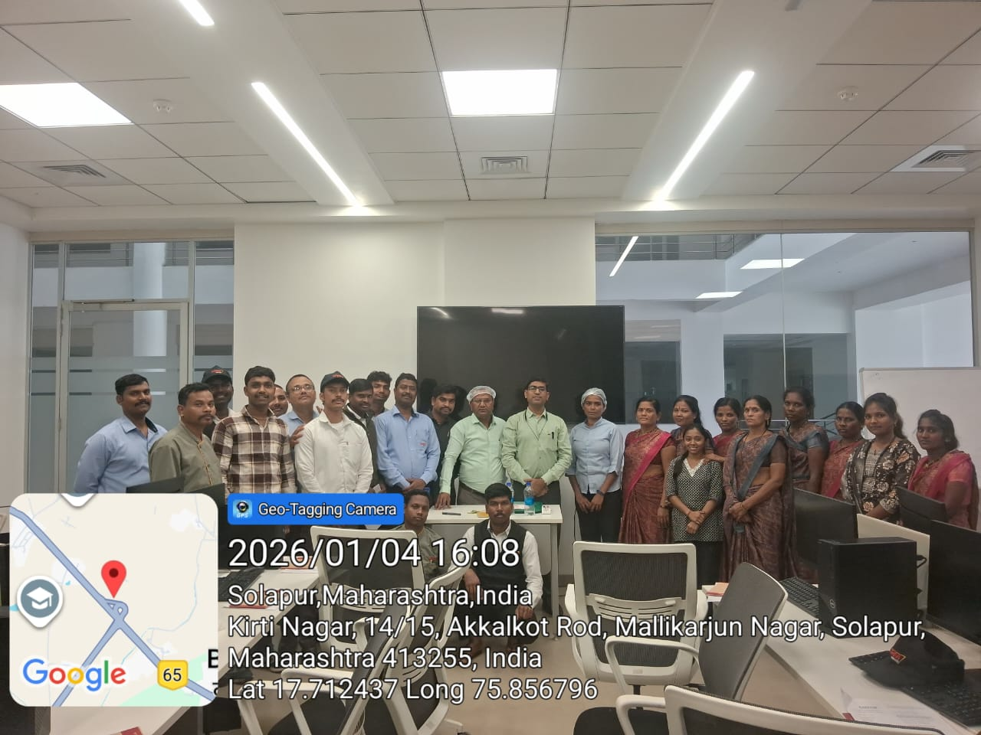
FoSTaC Training dated 04.01.2026

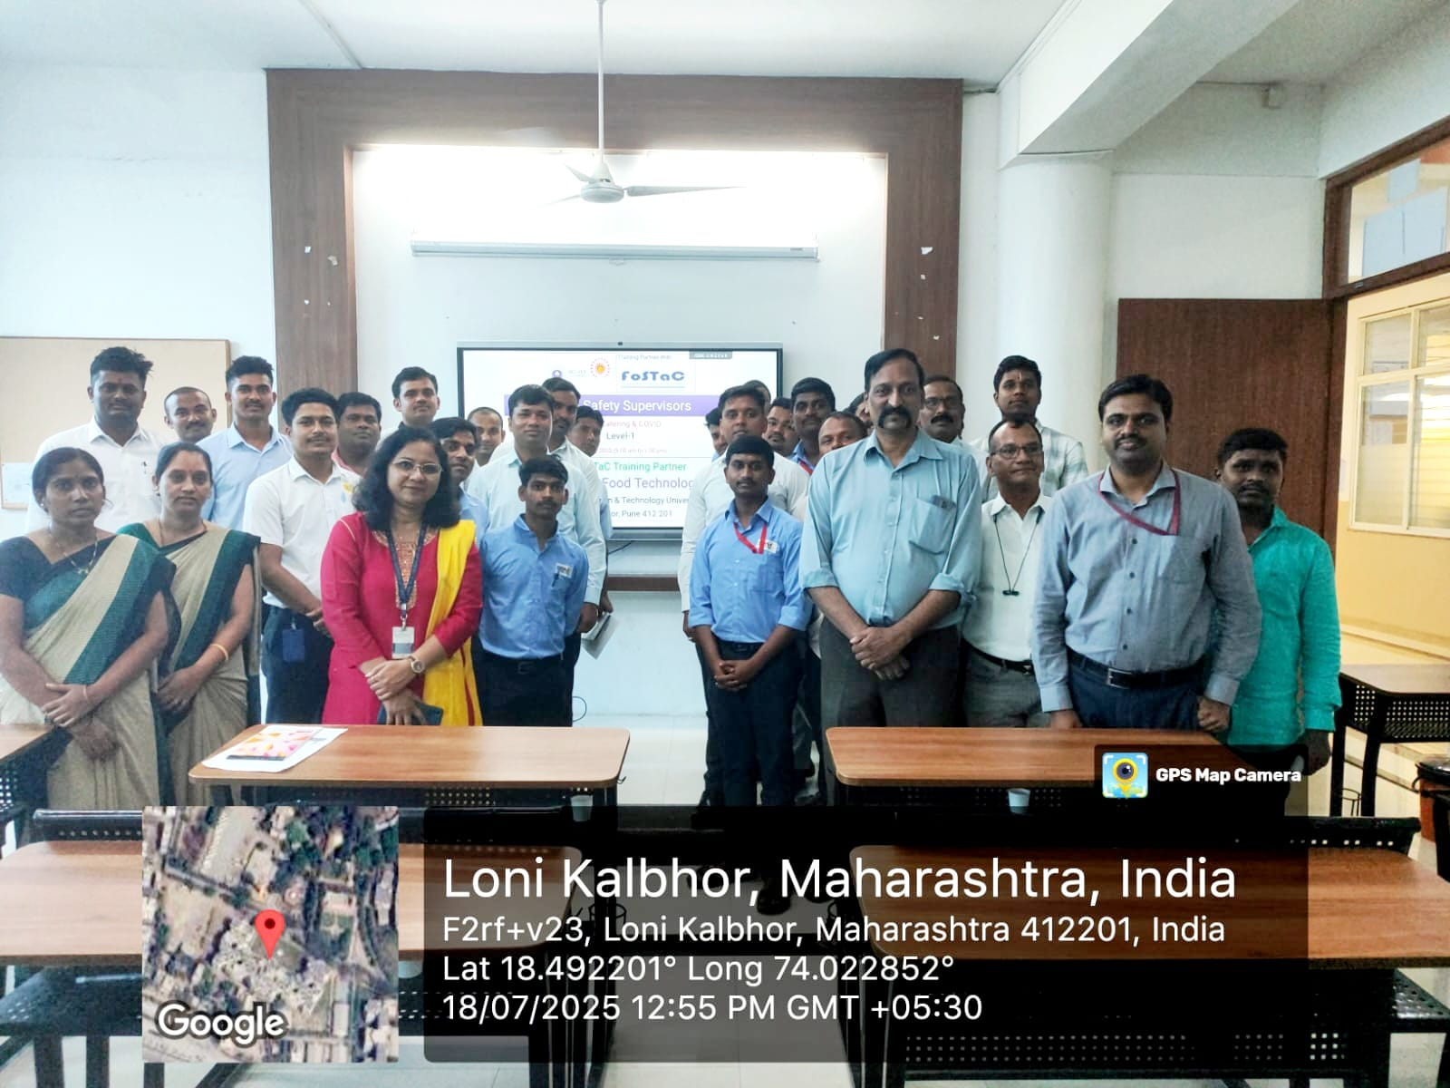
FoSTaC Training dated 18.07.2025
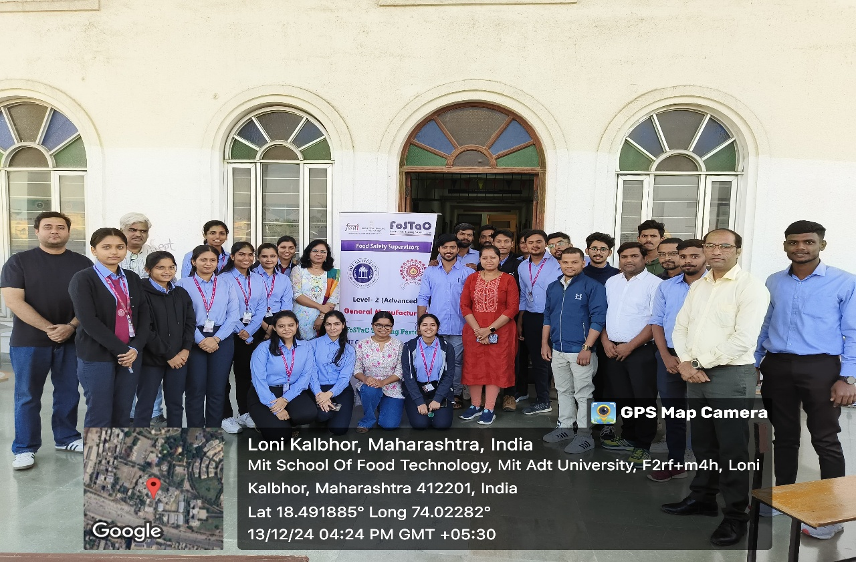
FoSTaC Training dated 13.12.2024
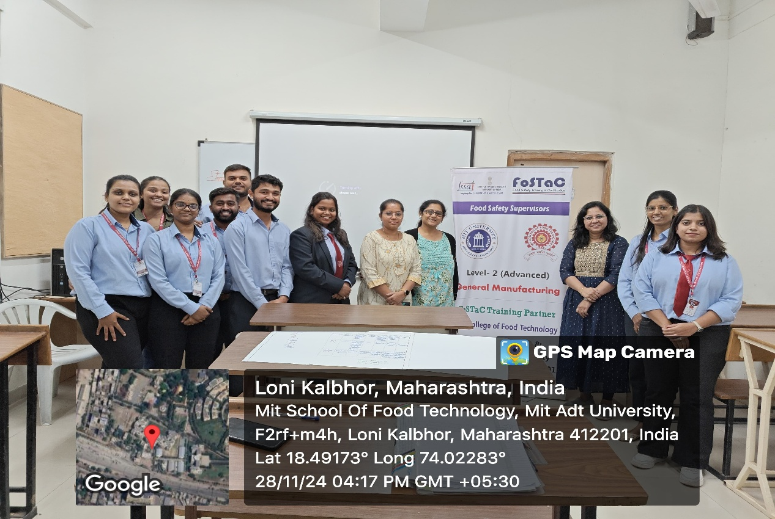
FoSTaC Training dated 28.11.2024
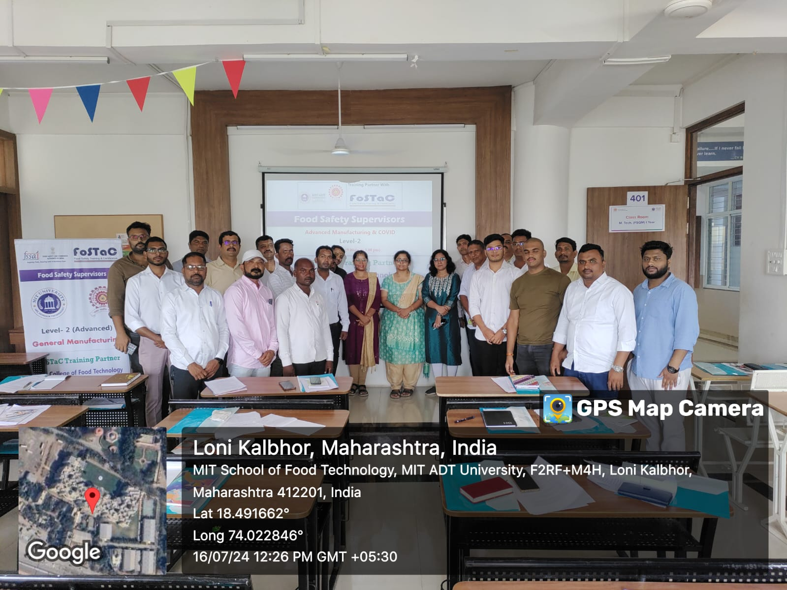
FoSTaC Training dated 16.07.2024
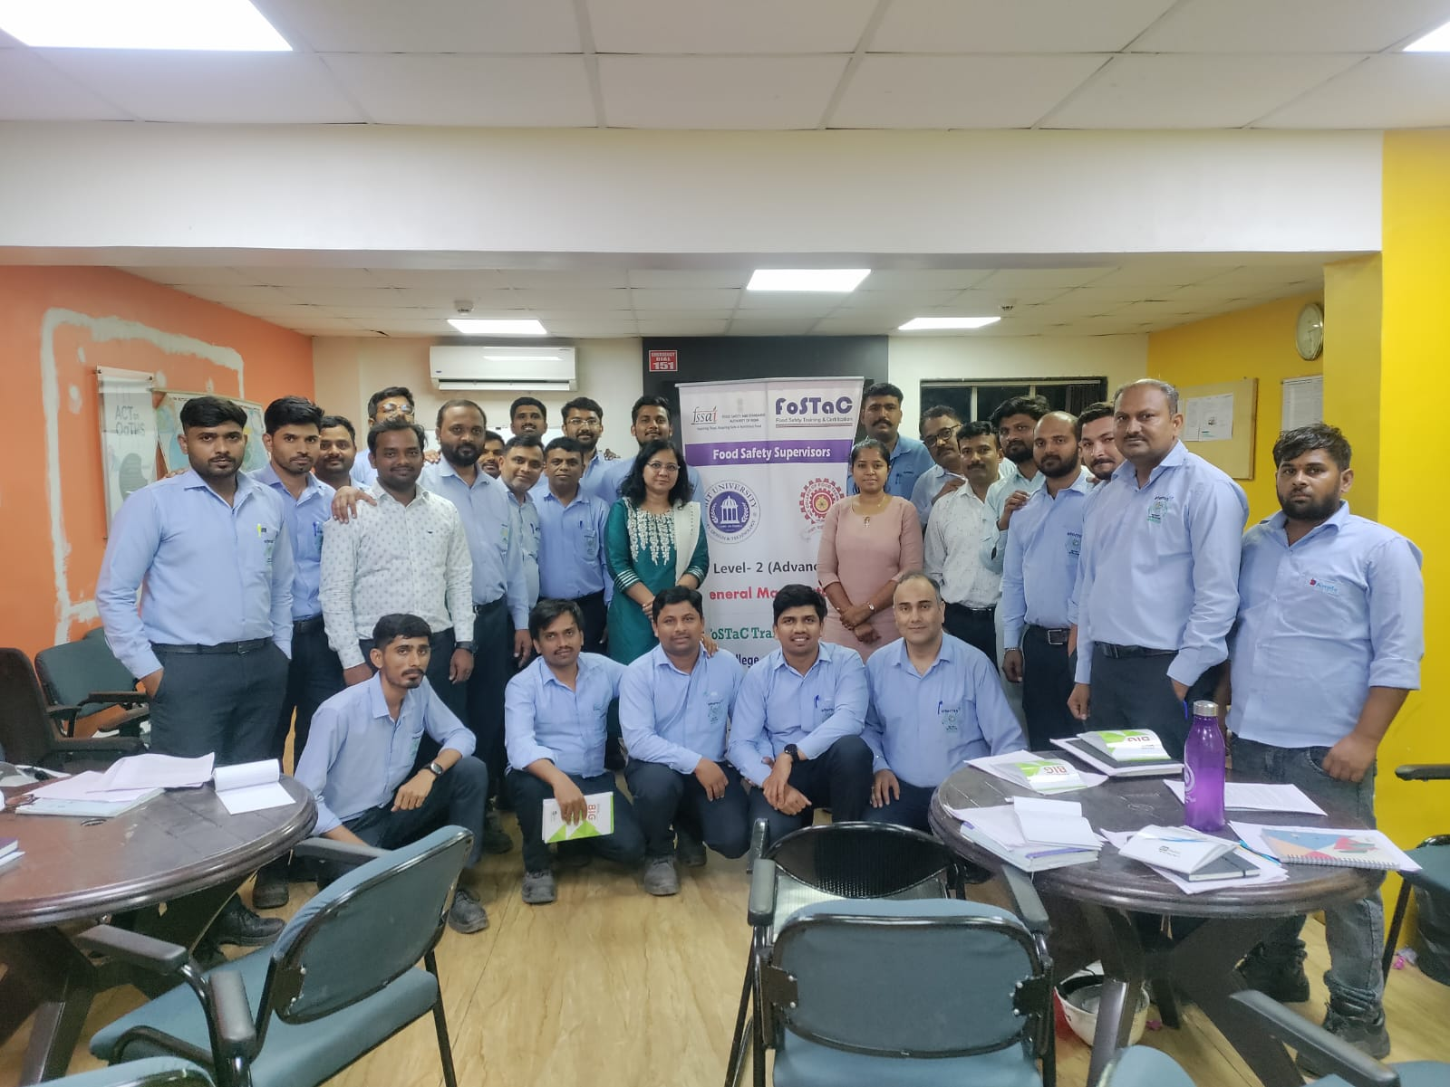
FoSTaC Training dated 24.04.2024
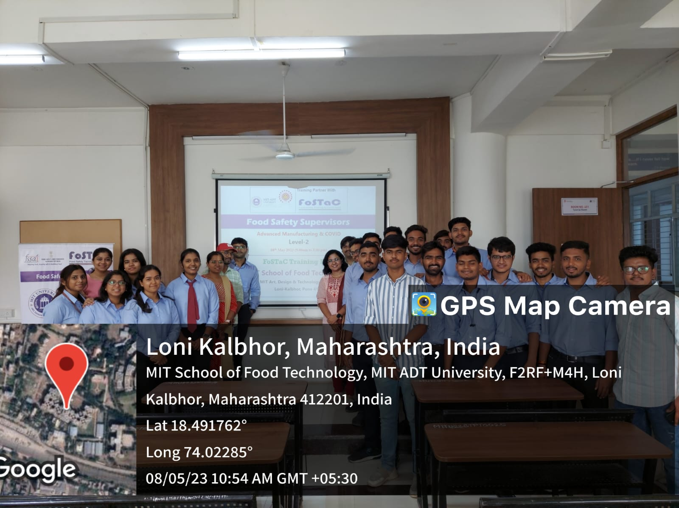
FoSTaC Training dated 08.05.2023
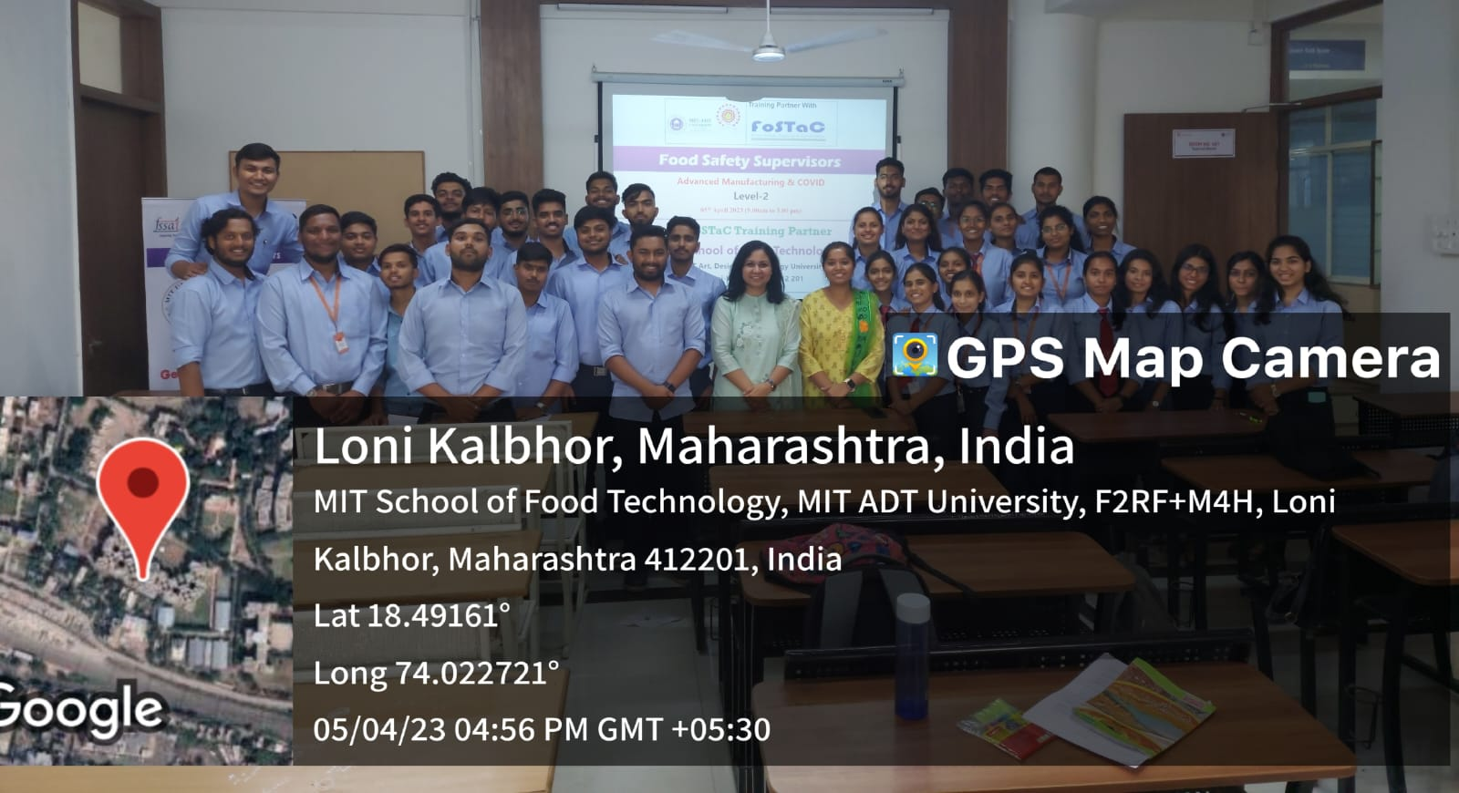
FoSTaC Training dated 05.04.2023
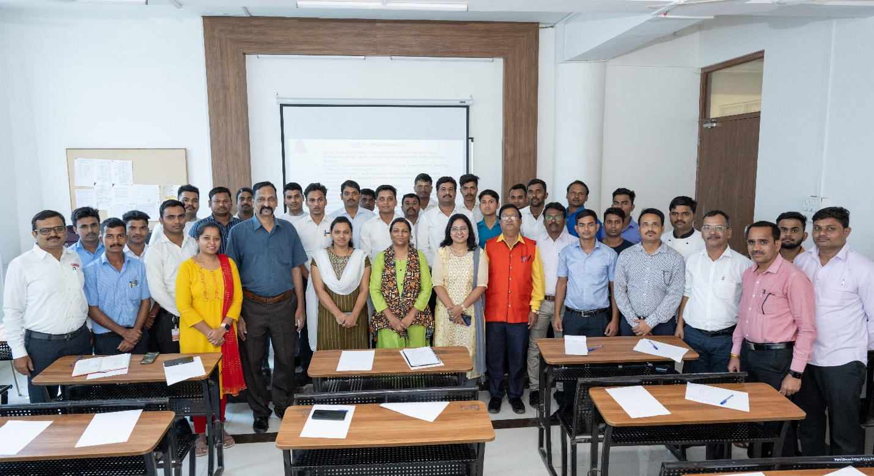
FoSTaC Training dated 29.09.2022
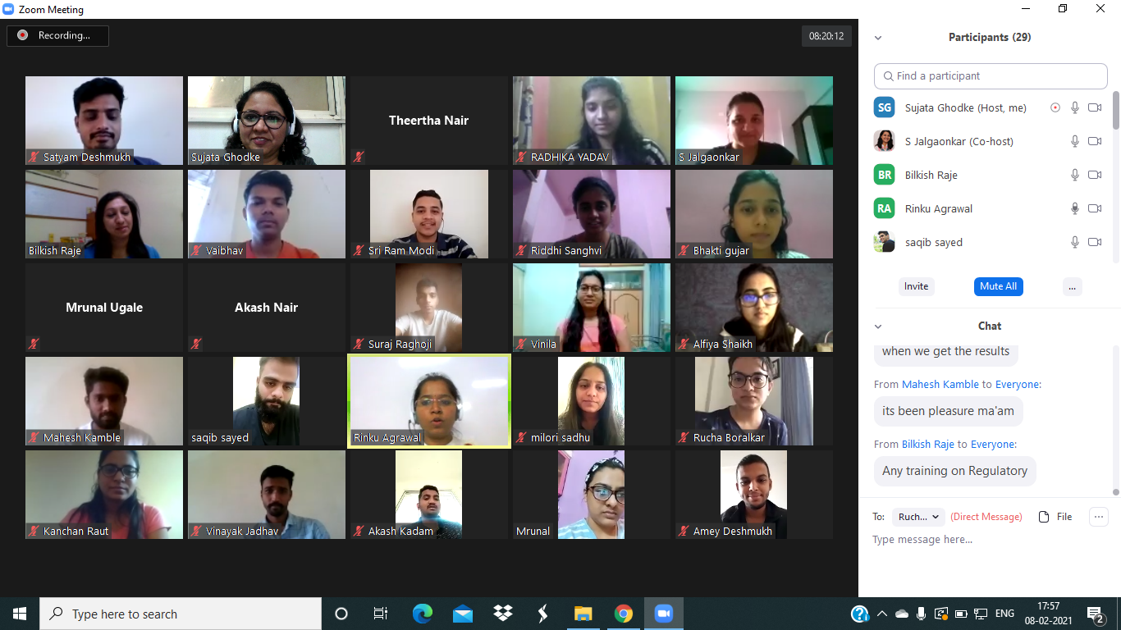
FoSTaC Training dated 08.02.2021

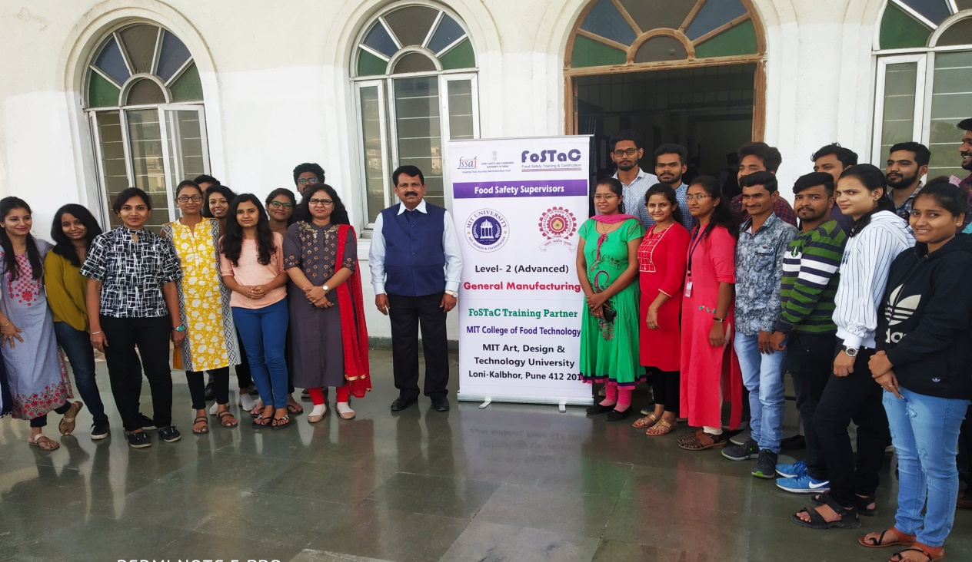FoSTaC Training dated 14.12.2019
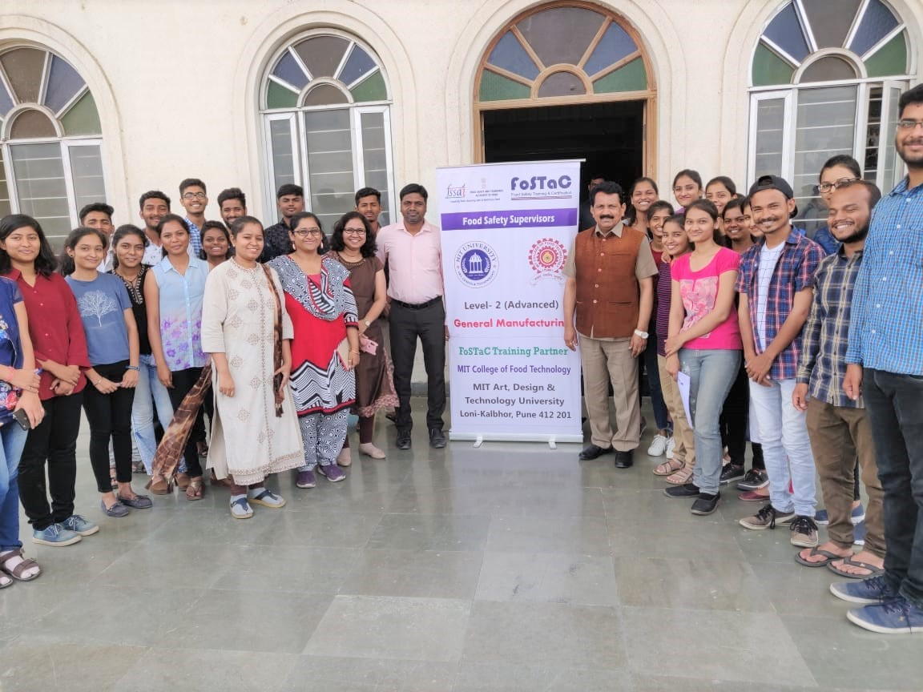FoSTaC Training dated 30.04.2019
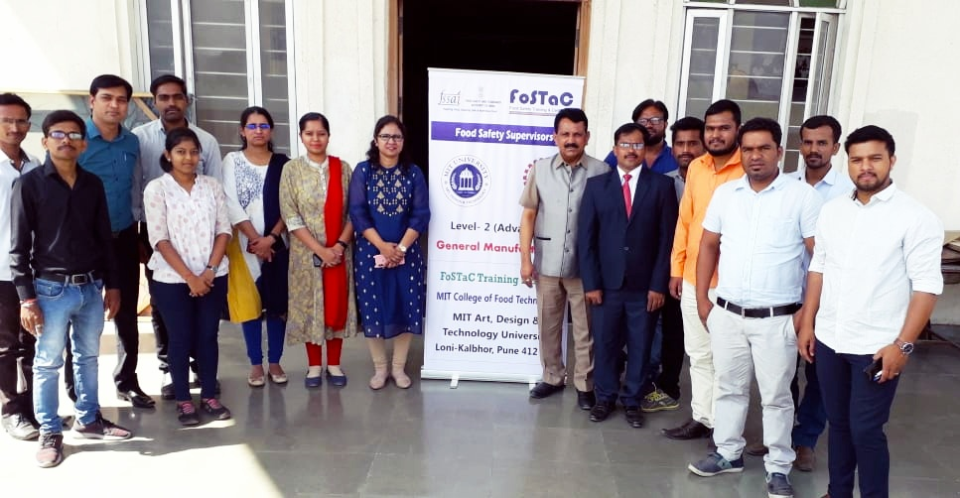FoSTaC Training dated 10.04.2019
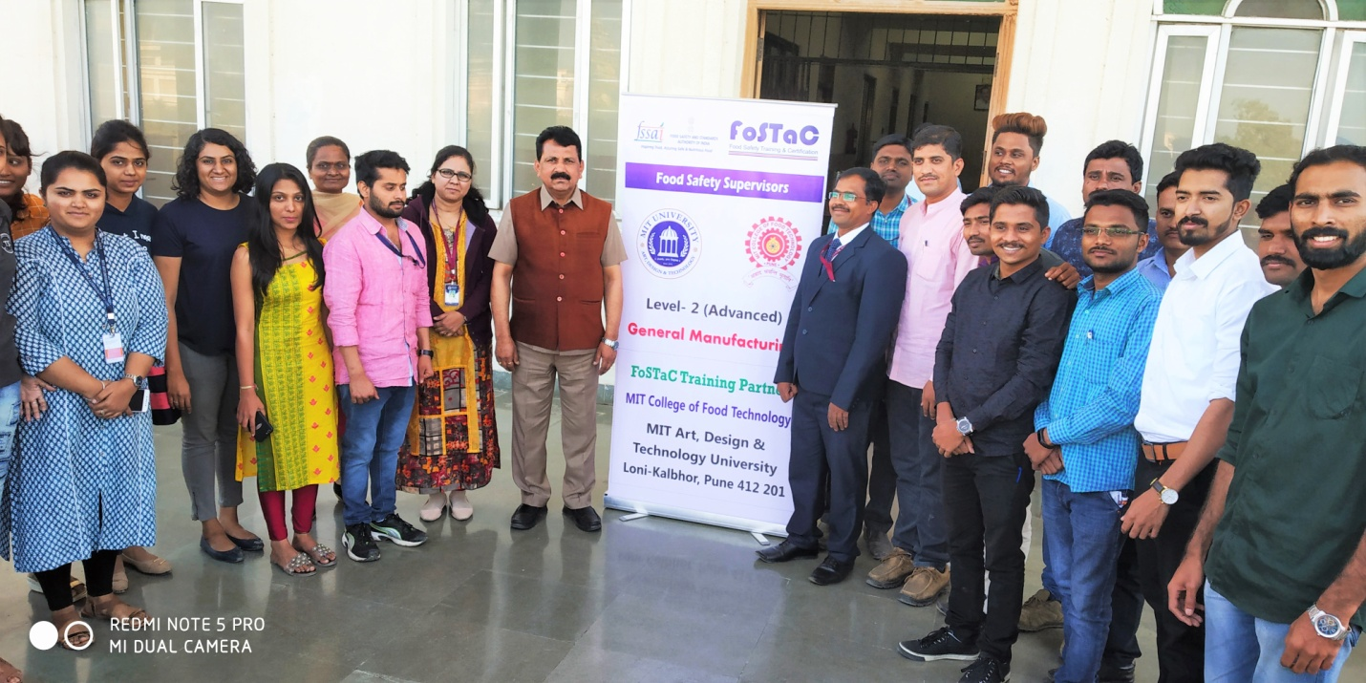FoSTaC Training dated 20.12.2018
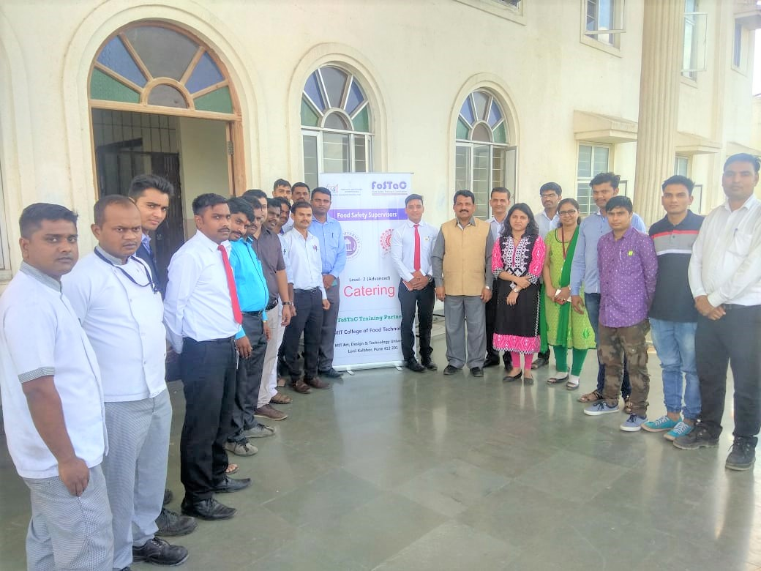
FoSTaC Training dated 14.09.2018
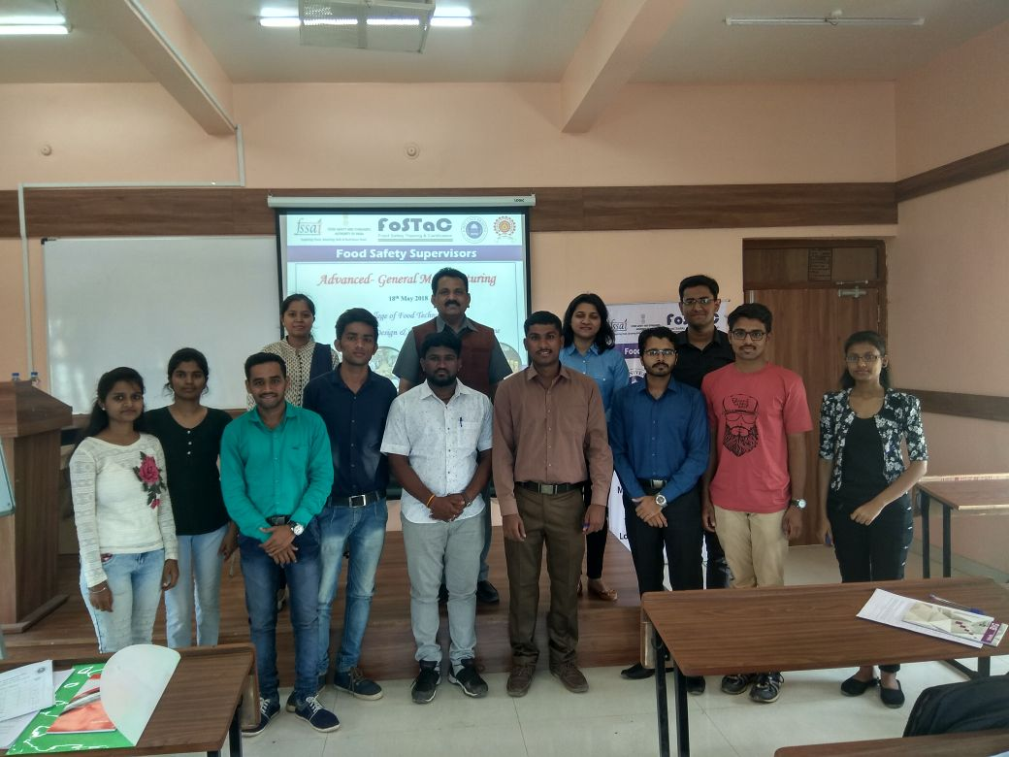
FoSTaC Training dated 18.05.2018
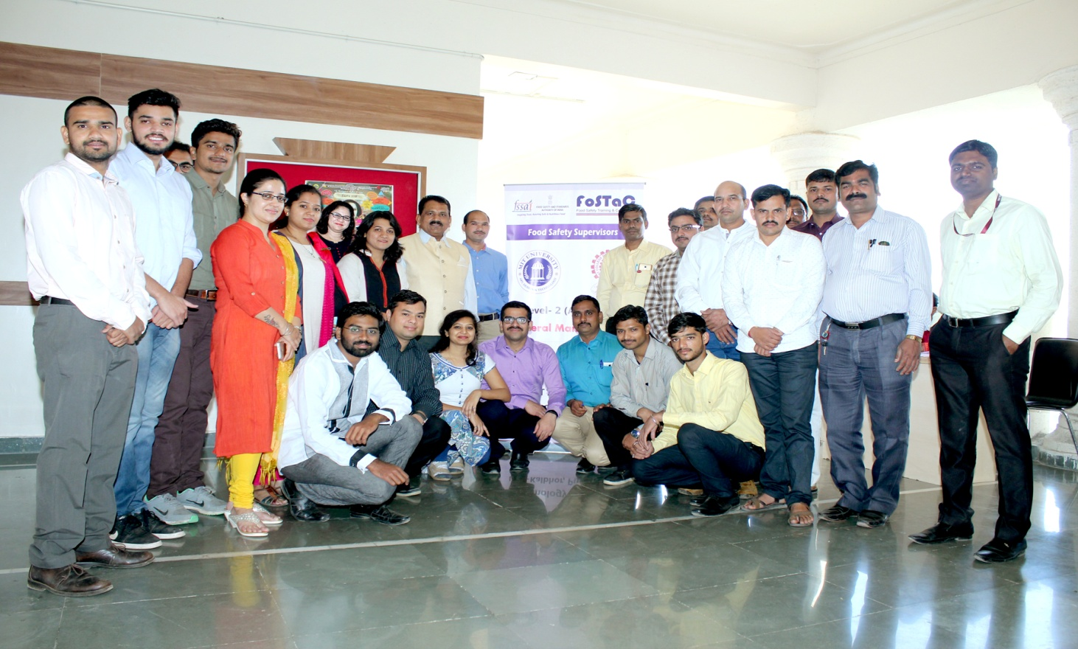
FoSTaC Training dated 09.02.2018
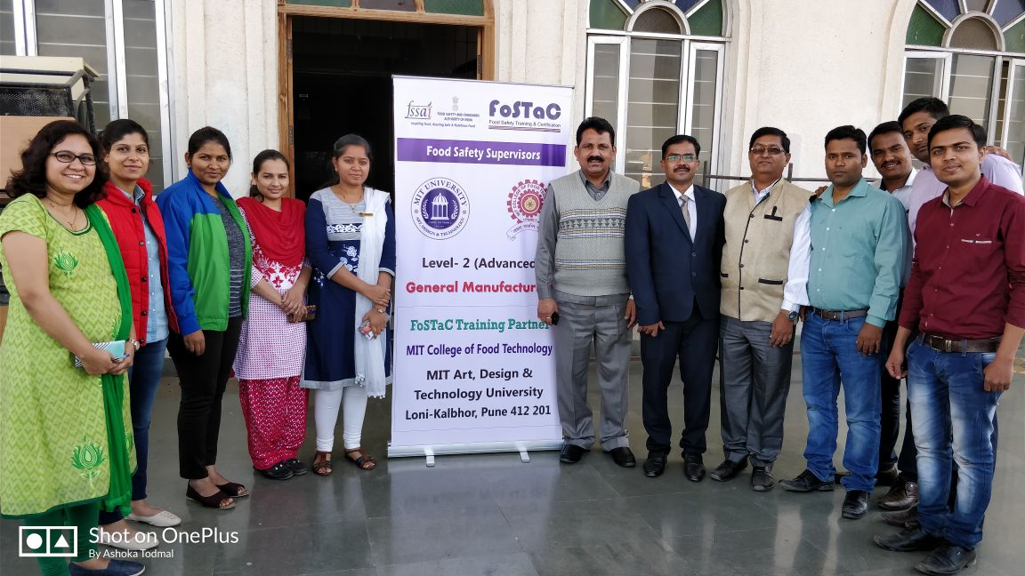
FoSTaC Training dated 30.11.2017
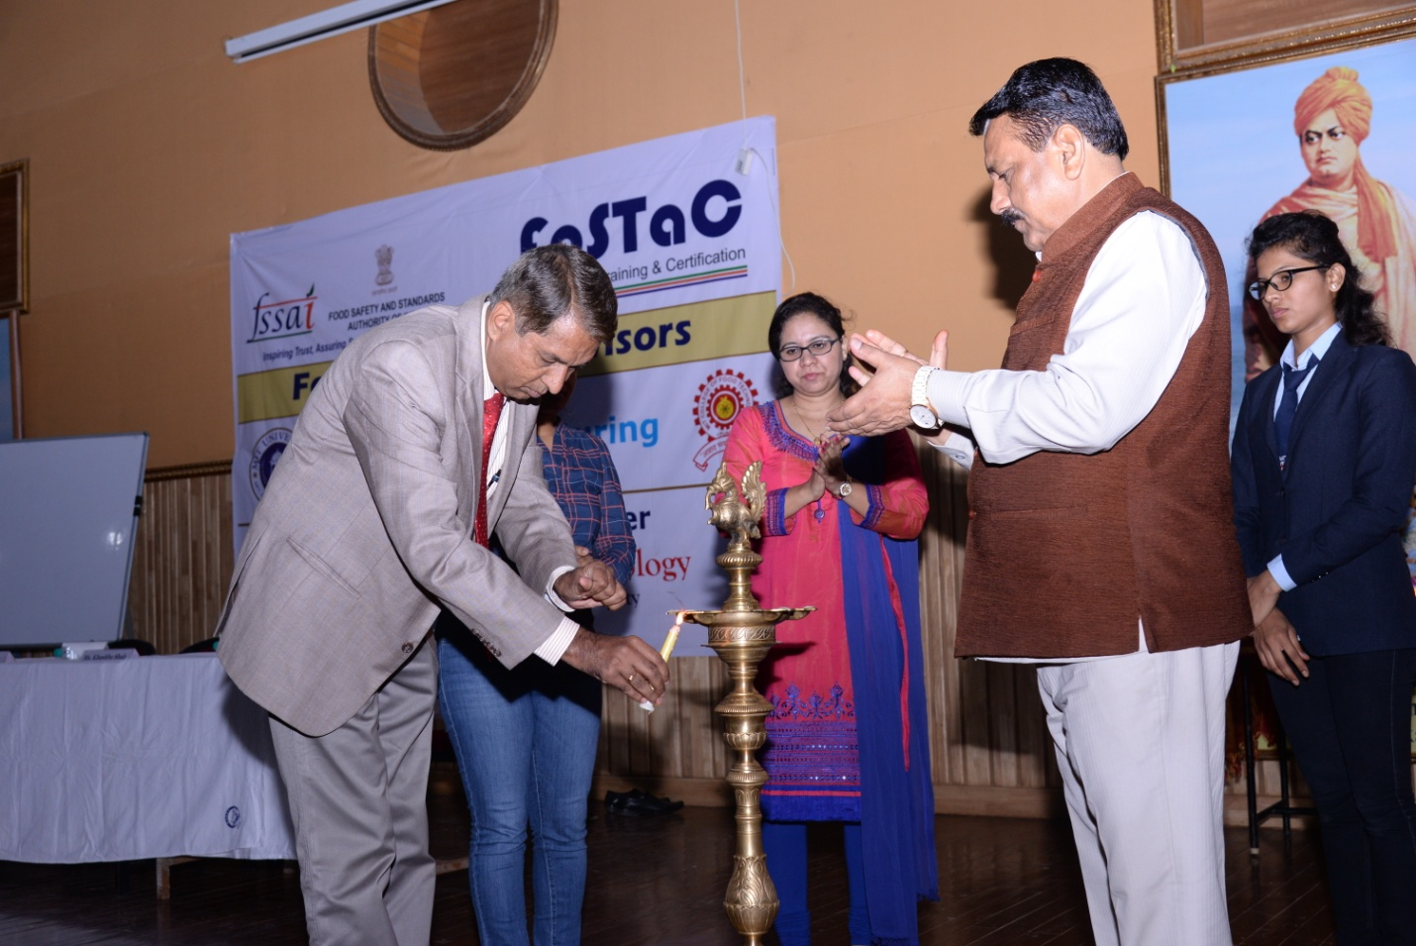
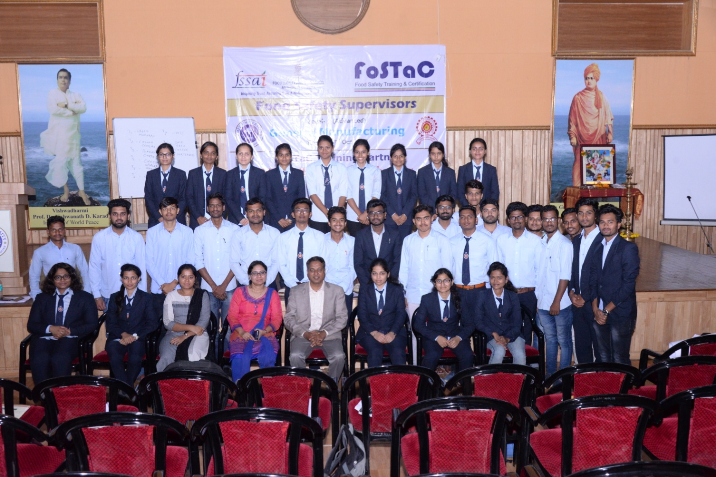
FoSTaC Training dated 30.10.2017

