create database amazon_selles;

-- Parent Tables

CREATE TABLE Category (

category_ID INT PRIMARY KEY,

category_name VARCHAR(50) NOT NULL

);

CREATE TABLE Customer (

customer_ID INT PRIMARY KEY,

first_name VARCHAR(50) NOT NULL,

last_name VARCHAR(50) NOT NULL,

state VARCHAR(50) NOT NULL,

address VARCHAR(255) NOT NULL

);

CREATE TABLE Seller (

seller_ID INT PRIMARY KEY,

seller_name VARCHAR(50) NOT NULL,

origin VARCHAR(50) NOT NULL

);

-- Child Tables

CREATE TABLE Product (

product_ID INT PRIMARY KEY,

product_name VARCHAR(50) NOT NULL,

price DECIMAL(10, 2) NOT NULL,

cogs DECIMAL(10, 2) NOT NULL,

category_ID INT,

FOREIGN KEY (category_ID) REFERENCES Category(category_ID)

);

CREATE TABLE Orders (

order_ID INT PRIMARY KEY,

order_date DATE NOT NULL,

customer_ID INT,

seller_ID INT,

order_status VARCHAR(20) NOT NULL,

FOREIGN KEY (customer_ID) REFERENCES Customer(customer_ID),

FOREIGN KEY (seller_ID) REFERENCES Seller(seller_ID)

);

CREATE TABLE Order_Item (

order_item_ID INT PRIMARY KEY,

order_ID INT,

product_ID INT,

quantity INT NOT NULL,

price_per_unit DECIMAL(10, 2) NOT NULL,

FOREIGN KEY (order_ID) REFERENCES Orders(order_ID),

FOREIGN KEY (product_ID) REFERENCES Product(product_ID)

);

CREATE TABLE Payment (

payment_ID INT PRIMARY KEY,

order_ID INT,

payment_date DATE NOT NULL,

payment_status VARCHAR(20) NOT NULL,

FOREIGN KEY (order_ID) REFERENCES Orders(order_ID)

);

CREATE TABLE shipping (

shipping_ID INT PRIMARY KEY,

order_ID INT,

shipping_date DATE NOT NULL,

FOREIGN KEY (order_ID) REFERENCES Orders(order_ID)

);

CREATE TABLE inventory (

inventory_ID INT PRIMARY KEY,

product_ID INT,

stock INT NOT NULL,

warehouse_ID INT NOT NULL,

last_stock_date DATE NOT NULL,

FOREIGN KEY (product_ID) REFERENCES Product(product_ID)

);

select * from seller;

select * from category;

select * from orders;

select * from order_item;

select * from product;

select * from seller;

select * from payment;

select * from customer;

select * from shipping;

select * from inventory;

SHOW WARNINGS;

SELECT COUNT(*) FROM payment;

SELECT COUNT(*) FROM seller;

desc inventory;

use amazon_selles;

alter table order_item add column total_sales float;

update order_item set total_sales=quantity*price_per_unit;

SET SQL_SAFE_UPDATES = 0;

UPDATE order_item

SET total_sales = quantity * price_per_unit;

SET SQL_SAFE_UPDATES = 1;

select * from order_item;

------ find Top 10 product by total sales>> include- product_name,total_quantity,total_sales value

SELECT

oi.product_ID,

p.product_name,

SUM(oi.total_sales) AS total_sales,

COUNT(o.order_ID) AS total_order

FROM

orders o

JOIN

order_item oi ON o.order_ID = oi.order_ID

JOIN

product p ON p.product_ID = oi.product_ID

GROUP BY oi.product_ID , p.product_name

ORDER BY total_sales DESC

LIMIT 10;

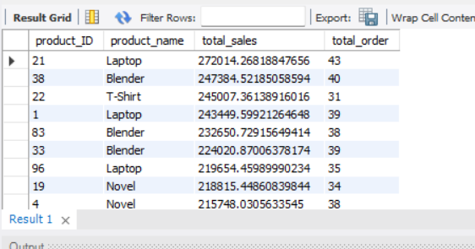

----- Revenue by category >> calculate total revenue genrated by each product category

------ Include percentage contribution of each category to tatal_revenue

SELECT

*

FROM

category;

SELECT

*

FROM

product;

SELECT

p.category_ID,

c.category_name,

SUM(oi.total_sales) AS total_sales,

ROUND(SUM(oi.total_sales) / (SELECT

SUM(total_sales)

FROM

order_item) * 100,

2) AS contribution

FROM

order_item oi

JOIN

product p ON oi.product_ID = p.product_ID

LEFT JOIN

category c ON c.category_ID = p.category_ID

GROUP BY p.category_ID , c.category_name

ORDER BY total_sales DESC;

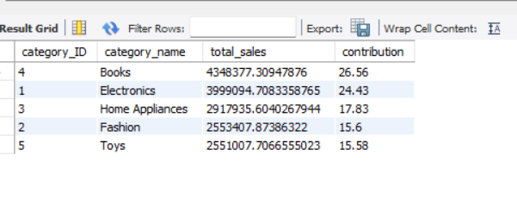

----- Average order value (AOV)>>coumpute average order value of each category>>> include only customer with more than 4 order

----- Aov=sum(total_sales)/count(o.order_ID)

SELECT

cu.customer_ID,

CONCAT(cu.first_name, '', cu.last_name) AS full_name,

COUNT(o.order_ID) AS total_order,

SUM(oi.total_sales) AS total_sales,

SUM(oi.total_sales) / COUNT(o.order_ID) AS AOV

FROM

orders o

JOIN

customer cu ON o.customer_ID = cu.customer_ID

JOIN

order_item oi ON oi.order_ID = o.order_ID

GROUP BY cu.customer_ID , full_name

HAVING COUNT(o.order_ID) >= 5;

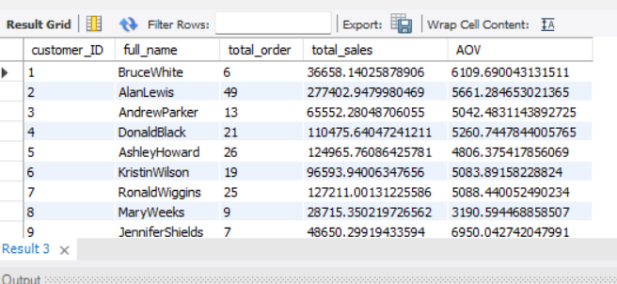

------ Monthly sales trend >> monthly total sales over the past year>>display the sales trend,grouping by month,return current month sales ,last month sales

SELECT

year, month, total_sales AS current_sales

FROM

(SELECT

MONTHNAME(o.order_date) AS month,

YEAR(o.order_date) AS year,

ROUND(SUM(oi.total_sales), 2) AS total_sales

FROM

orders o

JOIN order_item oi ON o.order_ID = oi.order_ID

WHERE

o.order_date >= CURRENT_DATE - INTERVAL 1 YEAR

GROUP BY MONTHNAME(o.order_date) , YEAR(o.order_date)

ORDER BY year , month) ti;

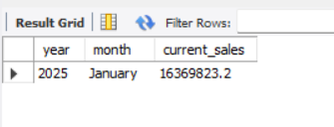

------ customer with no purches find customer who have registered but never place order

SELECT

*

FROM

customer

WHERE

customer_ID NOT IN (SELECT DISTINCT

customer_ID

FROM

orders);

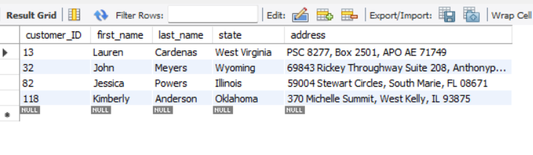

----- best selling categories by state >> identify the best selling product category for each state>> include the tatal sales for that category within each state

with ranking as( select c.state,cat.category_ID,sum(oi.total_sales) as total_sales,

rank() over(partition by state order by sum(oi.total_sales) desc) as rankno from orders o join customer c on o.customer_ID=c.customer_ID

join order_item oi on o.order_ID=oi.order_ID join product p on oi.product_ID=p.product_ID join category cat on cat.category_ID=p.category_ID

group by c.state,cat.category_ID)

select * from ranking where rankno=1;

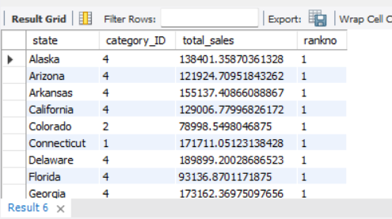

----- Customer lifetime value (cltv) >> calculate the total value of orders placed by each customer over their lifetime

select c.customer_ID ,concat(first_name,'',last_name) as full_name,sum(oi.total_sales) as cltv,DENSE_RANK() over(order by sum(oi.total_sales))

as customer_rank from orders o join customer c on o.customer_ID=c.customer_ID join order_item oi on oi.order_ID=o.order_ID group by

c.customer_ID ,full_name order by sum(oi.total_sales) desc;

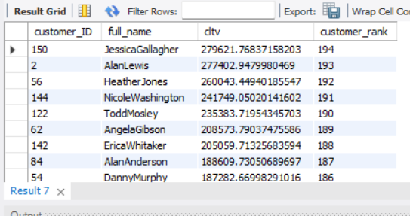

------ Invenntory stock alter >> query products with stock leavel below a certauin thresholds(ex. less tham 10 unit

-- Include last restock date and warehouse Information.

SELECT

i.inventory_ID,

p.product_name,

i.stock AS current_stock_left,

i.warehouse_ID

FROM

inventory i

JOIN

product p ON p.product_ID = i.product_ID

WHERE

stock < 10;

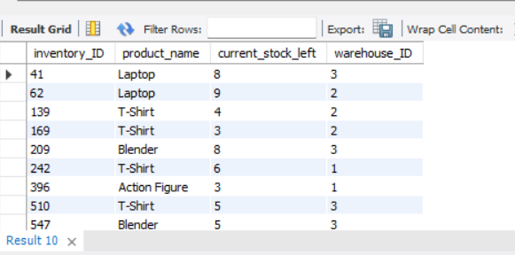

----- Shipping delays << identify orders where the shipping date is later(more) then 3 days after the order date >>

-------- Include customer, order details, and delivery provider .

SELECT

c.*, o.order_date, o.order_ID, s.shipping_date

FROM

orders o

JOIN

customer c ON o.customer_ID = c.customer_ID

JOIN

shipping s ON o.order_ID = s.order_ID

WHERE

s.shipping_date - o.order_date > 3;

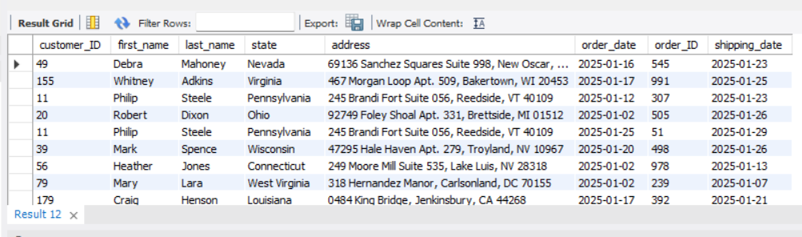

------- Payment success rate <<calculate The percentage of successful payment across all orders >>

------- include breakdown by payment status (eg.failer,pending)

SELECT

pay.payment_status,

COUNT(*) AS total_count,

(COUNT(*) / (SELECT

COUNT(*)

FROM

orders)) * 100 AS success_pay

FROM

orders o

JOIN

payment pay ON o.order_ID = pay.order_ID

GROUP BY pay.payment_status;

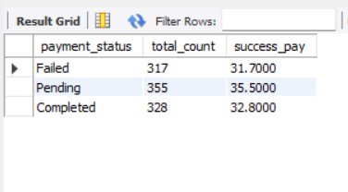

----- Top performing seller>> find top 5 saller based on total sales value>>

---------- include both successfull and falier orders and display their percentage of successful order

WITH top_seller AS (

SELECT s.seller_id, s.seller_name, SUM(oi.total_sales) AS total_sales

FROM orders o

JOIN seller s ON o.seller_ID = s.seller_ID

JOIN order_item oi ON o.order_ID = oi.order_ID

GROUP BY s.seller_id, s.seller_name

ORDER BY SUM(oi.total_sales) DESC

LIMIT 5

),

seller_report AS (

SELECT o.seller_ID, ts.seller_name, o.order_status, COUNT(*) AS total_orders

FROM orders o

JOIN top_seller ts ON ts.seller_id = o.seller_id

GROUP BY o.seller_ID, ts.seller_name, o.order_status

)

SELECT seller_id,

seller_name,

SUM(CASE WHEN order_status = 'completed' THEN total_orders ELSE 0 END) AS completed_orders,

SUM(CASE WHEN order_status = 'failed' THEN total_orders ELSE 0 END) AS failed_orders,

SUM(total_orders) AS total_orders,

SUM(CASE WHEN order_status = 'completed' THEN total_orders ELSE 0 END) / SUM(total_orders) * 100 AS success_order_per

FROM seller_report

GROUP BY seller_id, seller_name;

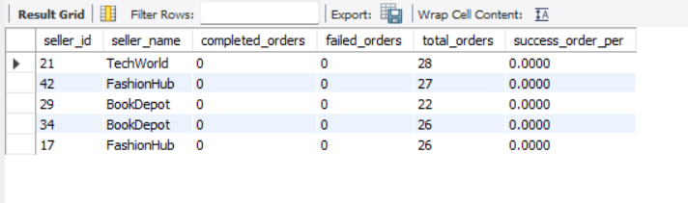

----- Product profit margin >>> calculate the profit margin for each product (difference between price and cost of goods sold)>>>

------ challenge: rank product by their profit margin showing highest of lowest

select product_id,product_name,profit_margin,dense_rank() over(order by profit_margin desc) as prod_ranking from

(select p.product_id,p.product_name,sum(oi.total_sales-(p.cogs*oi.quantity)) as profit,

sum(oi.total_sales-(p.cogs*oi.quantity))/sum(oi.total_sales)*100 as profit_margin from order_item oi

join product p on oi.product_id=p.product_id group by p.product_id,p.product_name) as t1;

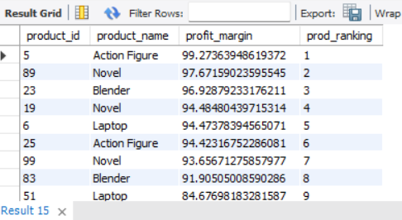

------- Most returned products >>>> the top 10 products by the number of failed

-- challenge: display the returned rate as a percentage of total units solved for each product

SELECT

p.product_id,

p.product_name,

COUNT(*) AS total_unit_sold,

SUM(CASE

WHEN o.order_status = 'Cancelled' THEN 1

ELSE 0

END) AS total_failed,

SUM(CASE

WHEN o.order_status = 'Cancelled' THEN 1

ELSE 0

END) / COUNT(*) * 100 AS return_persentage

FROM

order_item oi

JOIN

product p ON oi.product_ID = p.product_ID

JOIN

orders o ON oi.order_ID = o.order_ID

GROUP BY p.product_id , p.product_name

ORDER BY SUM(CASE

WHEN o.order_status = 'Cancelled' THEN 1

ELSE 0

END) / COUNT(*) * 100 DESC;

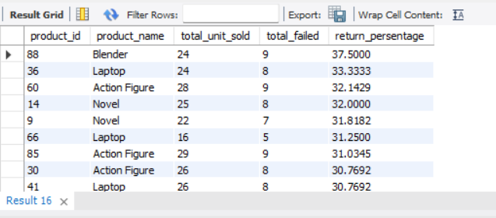

------- Inactive seller >>> identify seller who have not made any sale in last six month

------ >>challenge :show last sale date and total sale from those sellers

select * from seller;

SELECT

t1.customer_id,

t1.full_name AS customer,

t1.total_orders,

CASE

WHEN t1.total_return > 5 THEN 'returning_customer'

ELSE 'new'

END AS re_cus

FROM

(SELECT

c.customer_ID,

CONCAT(c.first_name, ' ', c.last_name) AS full_name,

COUNT(o.order_id) AS total_orders,

SUM(CASE

WHEN o.order_status = 'Cancelled' THEN 1

ELSE 0

END) AS total_return

FROM orders o

JOIN customer c ON o.customer_ID = c.customer_ID

JOIN order_item AS oi ON o.order_ID = oi.order_ID

GROUP BY c.customer_id, c.first_name, c.last_name) AS t1;

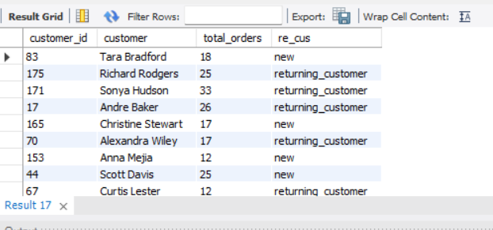

------ top 5 customers by orders in each state identify the top 5 customer with the highest number of orders for each state

--- >>>challenge include the number of orders in total sales for each customer

select * from (select c.state,sum(oi.total_sales) as total_sales,

CONCAT(c.first_name, ' ', c.last_name) AS full_name,

COUNT(o.order_id) AS total_orders ,dense_rank() over(partition by state order by COUNT(o.order_id) desc) as rankno from

orders o join order_item oi on o.order_ID=oi.order_ID join customer c on c.customer_ID= o.customer_ID group by c.state,

CONCAT(c.first_name, ' ', c.last_name)) t1 where rankno<=5;

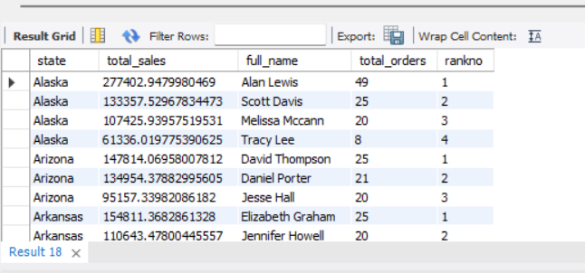

------- Revenue by shipping_id calculate the total revenue handled by shipping_id>>

----- challenge: include the total number of orders handled and the average delivery time for each provider

SELECT

s.shipping_id,

COUNT(o.order_id) AS total_orders,

SUM(oi.total_sales) AS total_revenue,

COALESCE(AVG((o.order_date) - (s.shipping_date)),

0) AS avg_time

FROM

orders o

JOIN

order_item oi ON o.order_ID = oi.order_ID

JOIN

shipping s ON o.order_ID = s.order_ID

GROUP BY s.shipping_id;

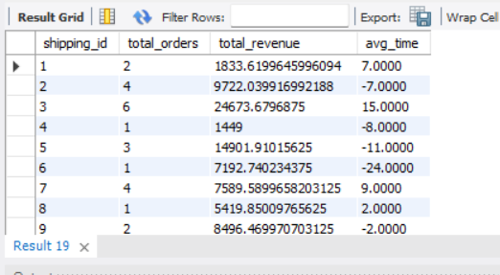

------ Top 10 product with highest decreasing revenue ratio compared to last 2022 and current year 2023 challenging>>>

-- return product ID, product name, 2022 revenue, and 2023 revenue, decrese ratio at end round the result

with last_year_sale as (select p.product_id,p.product_name,sum(oi.total_sales) as revenue

from orders o join order_item oi on o.order_ID=oi.order_ID join product p on oi.product_ID=p.product_ID where year(o.order_date)=2022 group by p.product_id,p.product_name),

curr_year_sale as(select p.product_id,p.product_name,sum(oi.total_sales) as revenue

from orders o join order_item oi on o.order_ID=oi.order_ID join product p on oi.product_ID=p.product_ID where year(o.order_date)=2023 group by p.product_id,p.product_name)

select ls.product_id,ls.revenue as last_year_reve,cs.revenue as curr_year_reve,(ls.revenue-cs.revenue) as revenue_diff,

round((cs.revenue-ls.revenue)/ls.revenue*100,2) as decrese_ratio_reve from last_year_sale ls join curr_year_sale cs on

ls.product_id=cs.product_id where ls.revenue >cs.revenue;

