PREREQUISITES:

Python 3.x+

Django 2.0

Package Manager (Anaconda, Virtual Env)

IDE (PyCharm, Visual Studio Code)

**ASSIGNMENTS**

**TASK ONE: ENVIRONMENT SETUP AND FIRST PROJECT**

1. Setup the Anaconda or any other Package Manager and create the Virtual Environment provide name as per your choice and install Django into that.

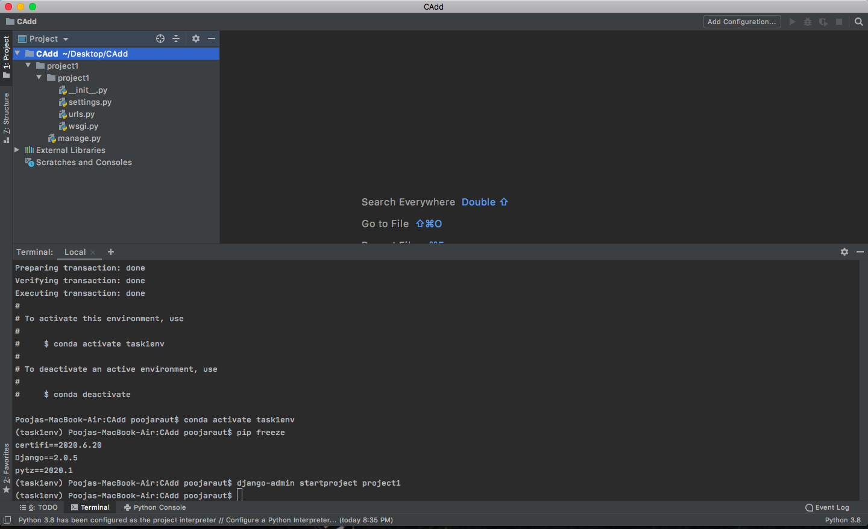

1. Make sure to keep your code Modular and always write your dependencies in requirements.txt

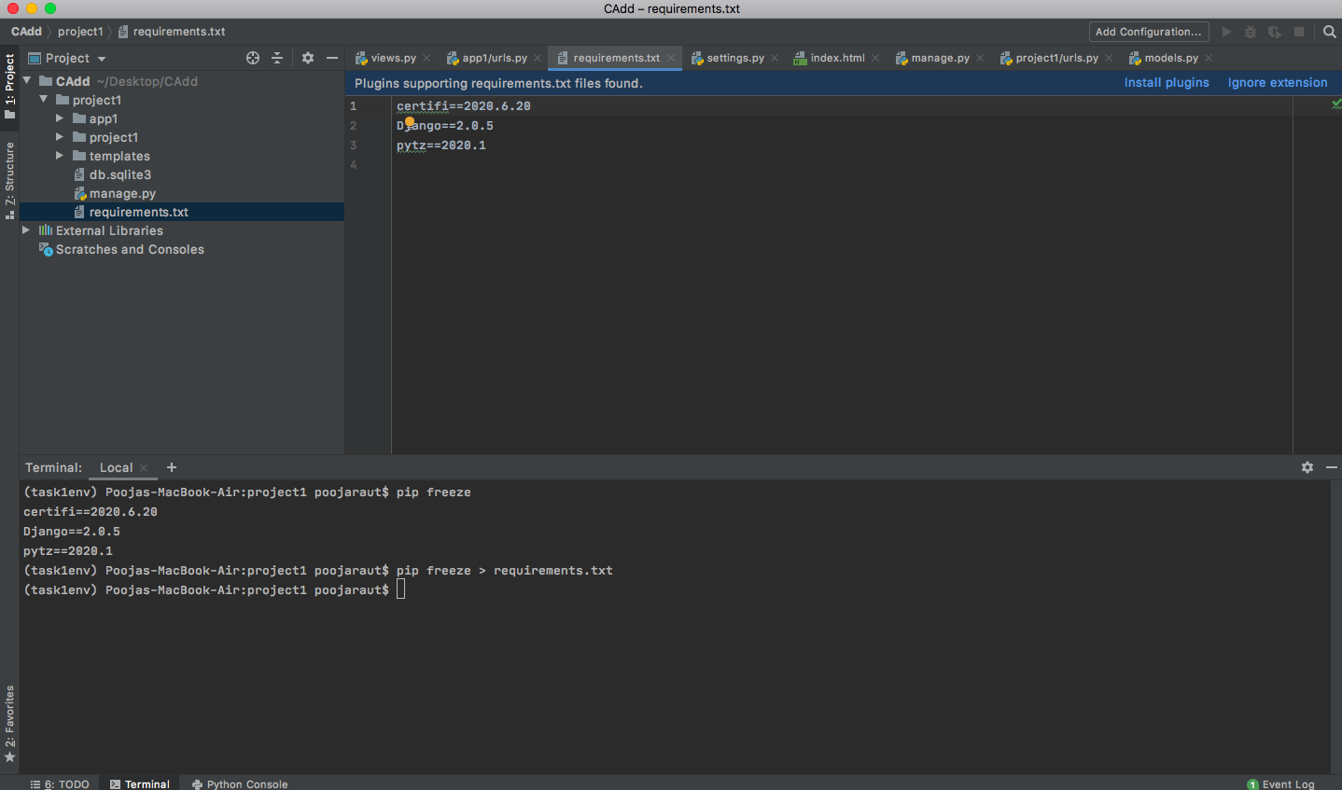

**TASK TWO: LOG-IN PAGE IN PROCESS**

Create a Log-in page where you need to work on these three files as of now-

Templates

Views.py

Urls.py

Follow these three steps given below:

* Create a 'login.html' template for a log-in page which have four entities (username, email-address, password and a submit button) and use Template Tagging for the same.
* Create a view in views.py which connects to the template tag of login.html
* Finally, Give the url mapping to the urls.py file of the login page.

**Note:** On hitting the submit button, it should be redirected to a page which shows "Congratulations! You're signed in."

Solution:

Views.py code-

from django.shortcuts import render  
from django.http import HttpResponse  
  
# Create your views here.  
def first_page(request):  
 return render(request, 'app1/login.html')  
  
def complete(request):  
 return HttpResponse('Congratulations! You are signed in.')

application urls.py code –

from django.urls import path  
from . import views  
  
urlpatterns = [  
 path('', views.first_page, name='first_page'),  
 path('complete', views.complete),  
]

project urls.py code-

*"""project1 URL Configuration  
  
The `urlpatterns` list routes URLs to views. For more information please see:  
 https://docs.djangoproject.com/en/2.0/topics/http/urls/  
Examples:  
Function views  
 1. Add an import: from my_app import views  
 2. Add a URL to urlpatterns: path('', views.home, name='home')  
Class-based views  
 1. Add an import: from other_app.views import Home  
 2. Add a URL to urlpatterns: path('', Home.as_view(), name='home')  
Including another URLconf  
 1. Import the include() function: from django.urls import include, path  
 2. Add a URL to urlpatterns: path('blog/', include('blog.urls'))  
"""*from django.contrib import admin  
from django.urls import include, path  
  
  
urlpatterns = [  
 path('admin/', admin.site.urls),  
 path('', include('app1.urls'))  
]

login.html code-

<!DOCTYPE html>  
<html>  
 <head>  
 <title>LOGIN PAGE</title>  
 </head>  
 <body>  
 <center>  
 <h3>Login Here</h3>  
 <table>  
 <tr>  
 <td>Username:</td>  
 <td>  
 <input type="text" name="user">  
 </td>  
 </tr>  
  
 <tr>  
 <td>Email Address:</td>  
 <td>  
 <input type="text" name="user_email">  
 </td>  
 </tr>  
  
 <tr>  
 <td>Password:</td>  
 <td>  
 <input type="password" name="user_password">  
 </td>  
 </tr>  
  
 <tr>  
 <td>  
 <a href="/complete">  
 <button>Submit</button>  
 </a>  
 </td>  
 </tr>  
 </table>  
  
 </center>  
 </body>  
</html>

The login page –

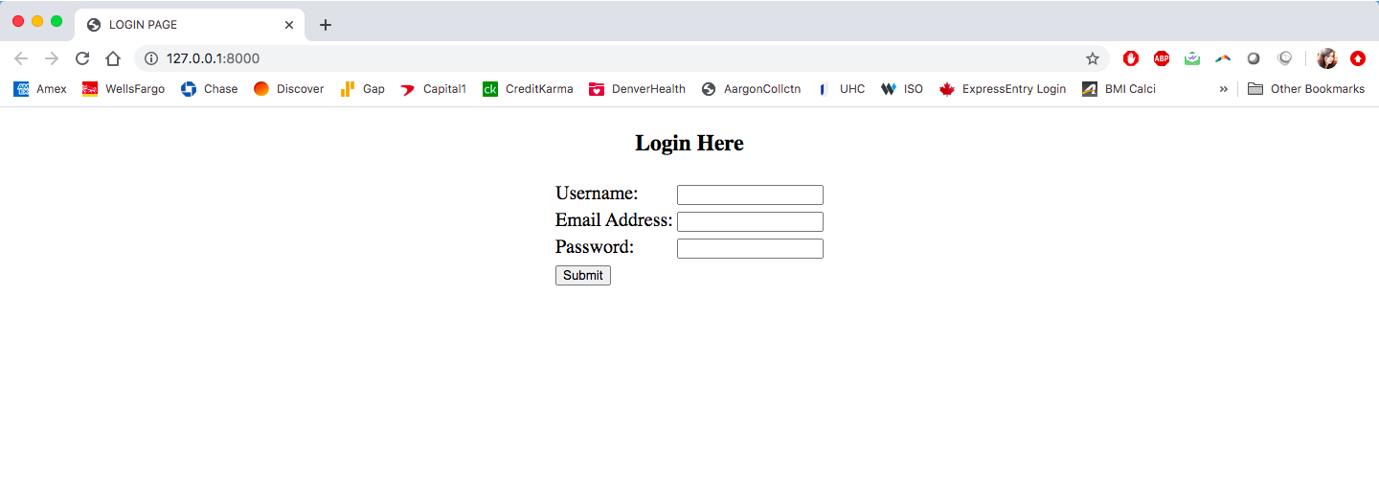

Login page with credentials –

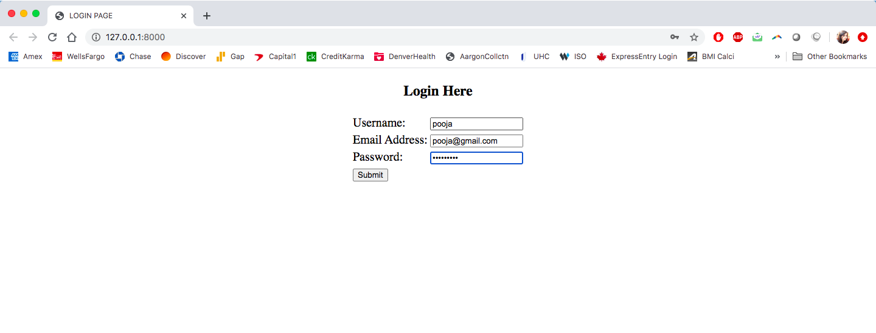

After hitting submit button –

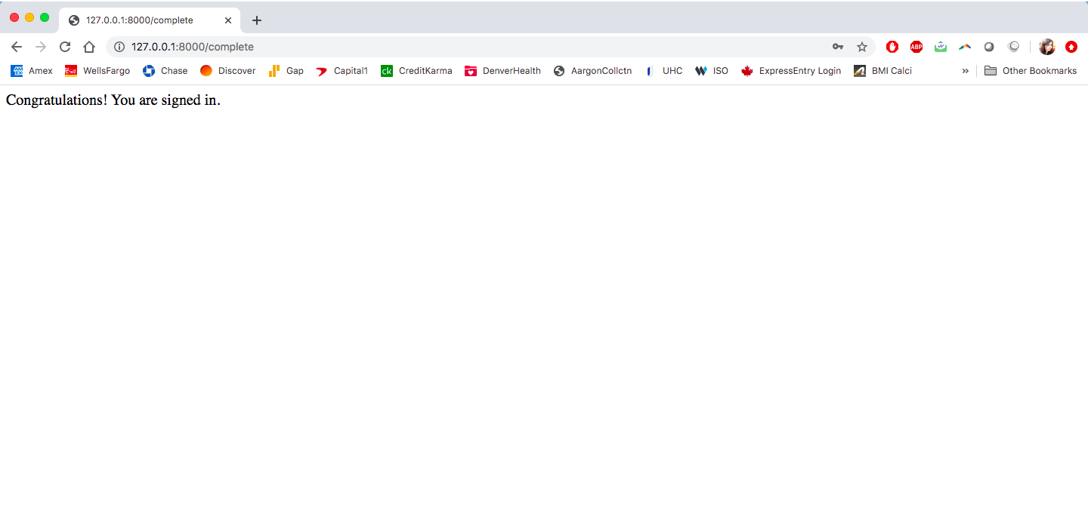

**TASK THREE: Working on a Skeleton Web App**

* Create a sign up page which have four fields- first name, last name, password and Enter- Password-Again. The sign up page should be redirected to the log-in page after the user is registered.
* The details are registered in the database once the user enters its details.
* At the log-in page, when the user enters the details, it should fetch the details from the database and check if the user is registered.
* After login, the page should be redirected to the second page which shows "Hello <username>" and a home page of Blogging Application.

In this blog home page, there should be the following options:

-Create Blog

-Update Blog (For particular blog)

-Delete Blog (For particular blog)

-Logout

-About us

**Note:** Perform the CRUD Operations