Assignment – 1

Submitted by Pooja Raut

30th May 2020

TASK ONE: NUMBERS AND VARIABLES

1. Create three variables in a single a=[‘line and assign different values to them and make sure their data types are different. Like one is int, another one is float and the last one is a string.

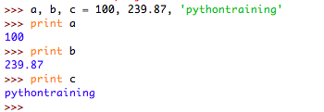

1. Create a variable of value type complex and swap it with another variable whose value is an integer.

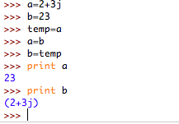

1. Swap two numbers using the third variable as the result name and do the same task without using any third variable.

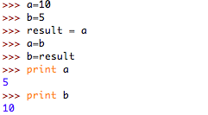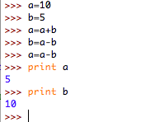

1. Write a program to print the value given by the user by using both Python 2.x and Python 3.x Version.

(Sorry, my system was giving some errors when downloaded Python 3.x, I will try doing it again and will submit the solution to this question soon)

1. Write a program to complete the task given below:

●Ask the user to enter any 2 numbers in between 1-10 and add both of them to another variable call z.

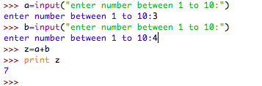

●Use z for adding 30 into it and print the final result by using variable results.

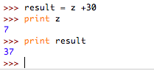

1. Write a program to check the data type of the entered values. HINT: Printed output should say - The input value data type is: int/float/string/etc

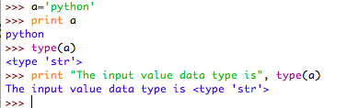

1. Create Variable using CamelCase, LadderCase and UPPERCASE. (Refer: https://capitalizemytitle.com/camel-case/) - Variable Conventions to write

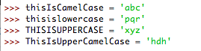

1. If one data type value is assigned to ‘a’ variable and then a different data type value is assigned to ‘a’ again. Will it change the value. If Yes then Why?

Solution: Yes, the data type of the variable will change when reassigned to another data. This is because python uses 2 types of type conversion, implicit and explicit. In implicit conversion, python interpreter automatically converts one data type of another data type without user involvement. Due to this python avoids any loss of data.