**TASK THREE: DATA STRUCTURES**

**Submitted by Pooja Raut (11th June)**

1. Create a list of the 10 elements of four different types of Data Types like int, string, complex, and float.

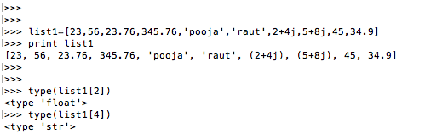

1. Create a list of size 5 and execute the slicing structure

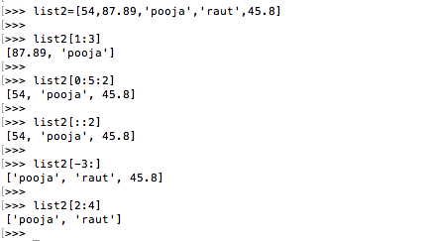

1. Write a program to get the sum and multiply of all the items in a given list.

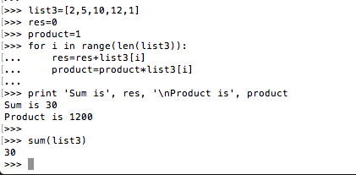

1. Find the largest and smallest number from a given list.

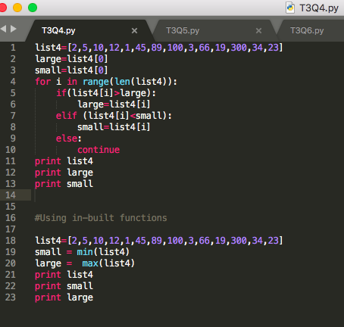

1. Create a new list that contains the specified numbers after removing the even numbers from a predefined list.

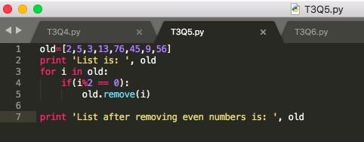

1. Create a list of first and last 5 elements where the values are square of numbers between 1 and 30 (both included).

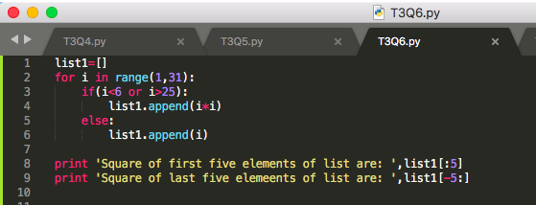

7. Write a program to replace the last element in a list with another list.

Sample data: [[1,3,5,7,9,10],[2,4,6,8]]

Expected output: [1,3,5,7,9,2,4,6,8]

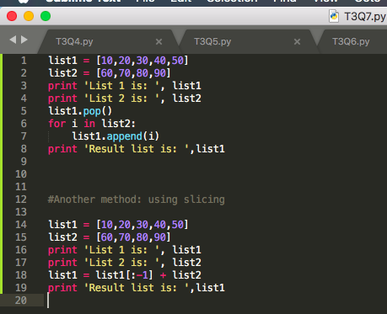

8. Create a new dictionary by concatenating the following two dictionaries:

a={1:10,2:20}

b={3:30,4:40}

Expected Result: {1:10,2:20,3:30,4:40}

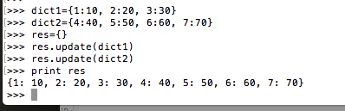

9. Create a dictionary that contains a number (between 1 and n) in the form(x,x*x).

Sample data (n=5)

Expected Output: {1:1,2:4,3:9,4:16,5:25}

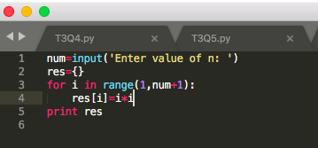

10. Write a program which accepts a sequence of comma-separated numbers from the console and generate a list and a tuple which contains every number. Suppose the following input is supplied to the program:

34,67,55,33,12,98

The output should be:

[‘34’,’67’,’55’,’33’,’12’,’98’]

(‘34’,’67’,’55’,’33’,’12’,’98’)

