**TASK FOUR: FUNCTION**

**Submitted by Pooja Raut (13th June)**

1. Write a program to reverse a string.

Sample data: “1234abcd”

Expected Output: “dcba4321”

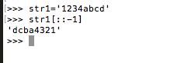

2. Write a function that accepts a string and calculate the number of uppercase letters and lowercase letters.

Expected Output:

No. of Upper case characters : 3

No. of Lower case Characters : 12

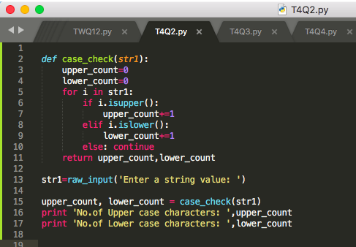

1. Create a function that takes a list and returns a new list with unique elements of the first list.

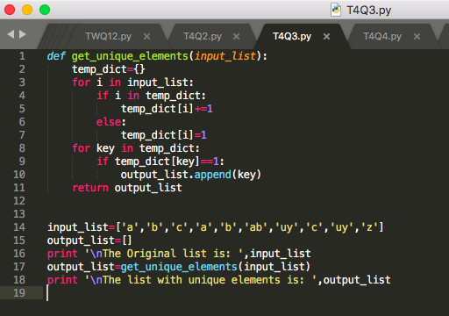

4. Write a program that accepts a hyphen-separated sequence of words as input and prints the words in a hyphen-separated sequence after sorting them alphabetically.

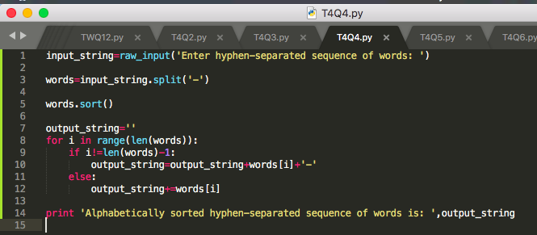

5. Write a program that accepts a sequence of lines as input and prints the lines after making all characters in the sentence capitalized.

Sample input:

Hello world

Practice makes perfect

Expected Output:

HELLO WORLD

PRACTICE MAKES PERFECT

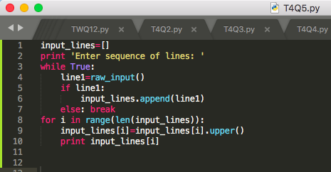

6. Define a function that can receive two integral numbers in string form and compute their sum and print it in console.

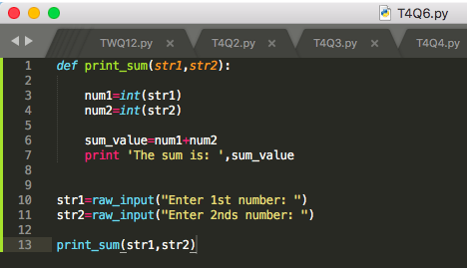

7. Define a function that can accept two strings as input and print the string with maximum length in console. If two strings have the same length, then the function should print all strings line by line.

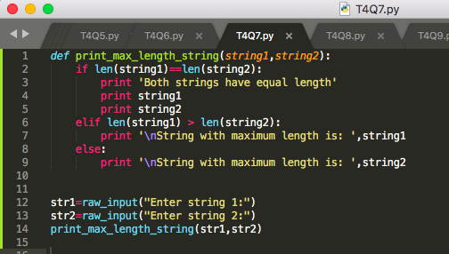

8. Define a function which can generate and print a tuple where the value are square of numbers between 1 and 20.

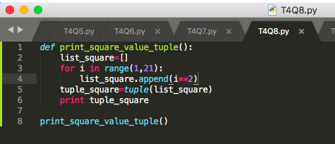

9. Write a function called showNumbers that takes a parameter called limit. It should print all the numbers between 0 and limit with a label to identify the even and odd numbers.

Example: If the limit is 3 , it should print:

0 EVEN

1 ODD

2 EVEN

3 ODD

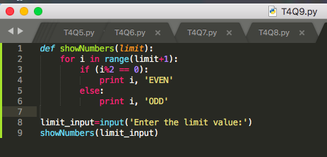

10. Write a program which can filter() to make a list whose elements are even number between 1 and 20 ( both included)

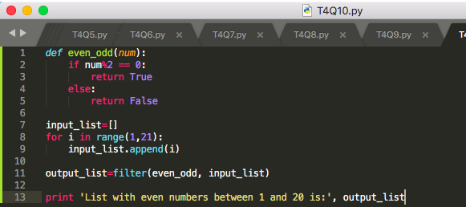

11. Write a program which can map() and filter() to make a list whose elements are square of even number in [1,2,3,4,5,6,7,8,9,10]

Hints: Use map() to generate a list.

Use filter() to filter elements of a list

Use lambda to define anonymous functions

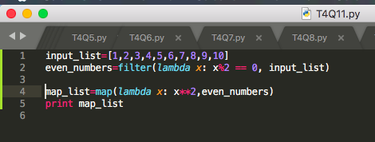

12. Write a function to compute 5/0 and use try/except to catch the exceptions

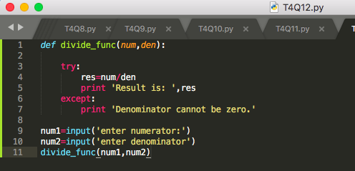

13. Flatten the list [[1,2,3].,[4,5],[6,7,8]] into [1,2,3,4,5,6,7,8] using reduce

Goal : Turn [1,2,3,4,5,6,7] to 1234567

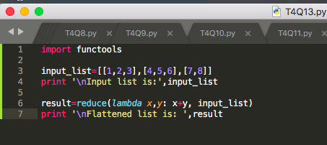

14.

(i) def foo():

try:

return 1

finally:

return 2

k = foo()

print(k)

**Solution: 2**

(ii) def a():

try:

f(x, 4)

finally:

print('after f')

print('after f?')

a()

**Solution: after f (then errors)**

