**TASK FIVE: HIGHER ORDER FUNCTIONS, GENERATORS, LIST COMPREHENSION AND DECORATOR**

**Submitted by Pooja Raut (13th June)**

1. Write a program to Python find the values which is not divisible 3 but is should be a multiple of 7. Make sure to use only higher order function.

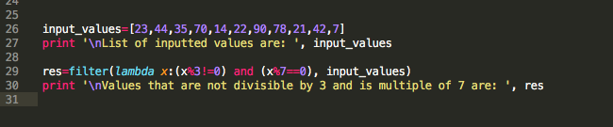

1. Write a program in Python to multiple the element of list by itself using a traditional function and pass the function to map to complete the operation.

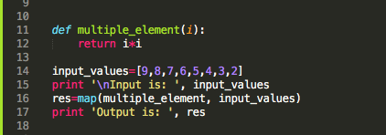

1. Write a program to Python find out the character in a string which is uppercase using list comprehension.

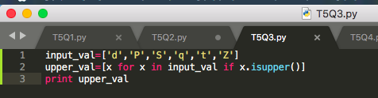

1. Write a program to construct a dictionary from the two lists containing the names of students and their corresponding subjects. The dictionary should maps the students with their respective subjects. Let’s see how to do this using for loops and dictionary comprehension. HINT-Use Zip function also

* Student = ['Smit', 'Jaya', 'Rayyan']
* capital = ['CSE', 'Networking', 'Operating System']

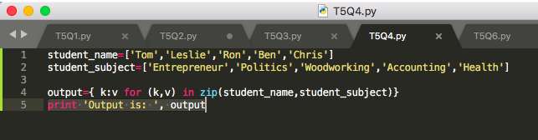

1. Learn More about Yield, next and Generators

Sol: Yield is a keyword in Python that is used to return from a function without destroying the states of its local variable and when the function is called, the execution starts from the last yield statement. Any function that contains a yield keyword is termed as generator. Hence, yield is what makes a generator. The next() function returns the next item from iterator, which is the next yield value. Python generators are a simple way of creating iterators. A generator is a function that returns an object (iterator) which we can iterate over (one value at a time).

1. Write a program in Python using generators to reverse the string. Input String = “Consultadd Training”

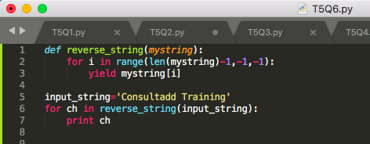

1. Write any example on decorators.

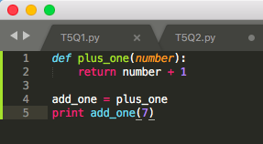

1. **Learn about What is FRONT END and its Technologies and Tools**

* Make sure to mention at least 5 top notch technologies of Frontend.
* Also mentioned the name of companies using those 5 technologies individually

Sol: Front end technologies are used in developing the user interface of web applications and webpages. With the help of front end technologies, the developers create the design, structure, animation, behavior, and everything that you see on the screen while you open a web application, website or mobile app.

List of front end technologies and the companies that uses it –

1. Vue.js - is a JavaScript library for developing distinct web interfaces.

Companies – Grammarly, 9GAG.

1. Ionic 4 - Ionic is an open-source Software Development Kit used for building Hybrid Mobile Applications. It consists of three main components; a Sass-based UI framework, an Angular framework, and a compiler.

Companies – McLaren Automotive, JustWatch, Honeyfi

1. Bootstrap - Bootstrap is the highly used front end technologies to develop responsive and mobile-first websites.

Companies – Spotify, Udemy, Twitter

1. Chrome DevTools - It is a set of developers tools built directly into the Google Chrome web browser.

Companies – FLUX, MediaSolutions

1. Grunt - Grunt is primarily, a task runner written on top of NodeJS.

Companies – Adobe, Twitter