**TASK SIX: FILE HANDLING AND EXCEPTION HANDLING**

**Submitted by Pooja Raut (16th June)**

1. Write a program in Python to allow the error of syntax to go in exception. HINT: use SyntaxError

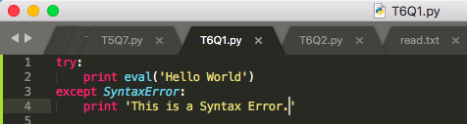

1. Write a program in Python to allow user to open a file by using argv module. If the entered name is incorrect throw an exception and ask them to enter the name again. Make sure to use read only mode.

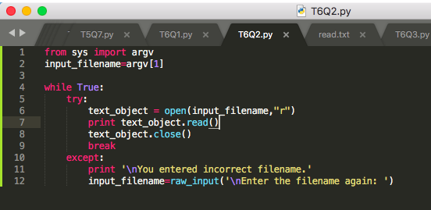

1. Write a program to handle an error if the user entered the number more than four digits it should return “Please length is too short/long !!! Please provide only four digits”

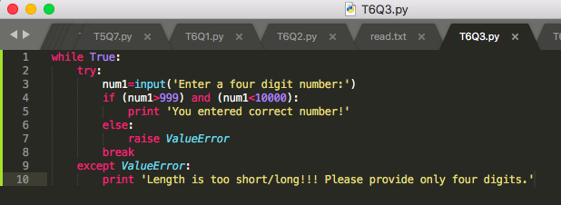

1. Create a login page backend to ask user to enter the UserEmail and password. Make sure to ask Re-Type Password and if the password is incorrect give chance to enter it again but it should not be more than 3 times.

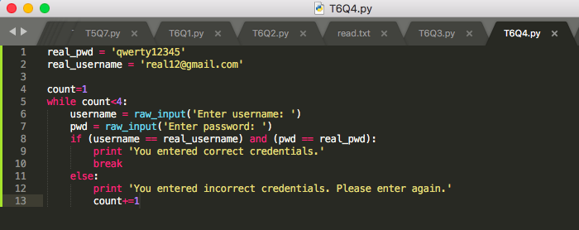

5. <https://www.programiz.com/python-programming/exception-handling> Go through this link to understand Finally and Raise concept. - **done**

6. Read any file using Python File handling concept and return only the even length string from the doc.txt file.  
Consider the content as:

Hello I am a file

Where you need to return the data string

Which is of even length

Make sure you return the content in

The same link as it is present.

