**WEEKEND ACTIVITY ON DATA STRUCTURES**

**Submitted by Pooja Raut (12th June)**

1. Create a list of the 10 elements of four different types of Data Types like int, string, complex, and float.

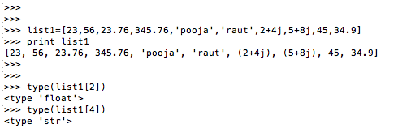

1. Create a list of size 5 and execute the slicing structure

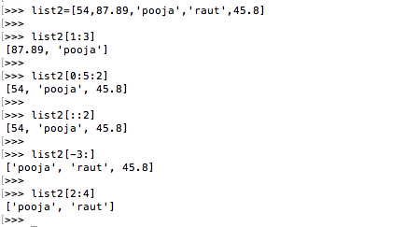

3. Create a list of given structure and run

**x=[100,200,300,400,500,[1,2,3,4,5,[10,20,30,40,50],6,7,8,9],600,700,800]**

* Access list [1, 2, 3, 4] – **print x[5][:4]**
* Access list [600, 700] – **print x[6:8]**
* Access list [100, 300, 500, 600, 800] – **print x[:9:2]**
* Access list [[800, 700, 600, [1, 2, 3, 4, 5, [10, 20, 30, 40, 50], 6, 7, 8, 9], 500, 400, 300, 200, 100]] – **print x[::-1]**
* Access list [10] – **print x[5][5][0]**
* Access list [ ] **– print x[0:0] (can use any same index number, and it will return empty)**

1. Create a list of thousand numbers using range and xrange and see the difference between each other.

Sol: **When used range the return type is in list, when used xrange the return type is in xrange. Also range function utilizes more memory as compared to xrange function.**

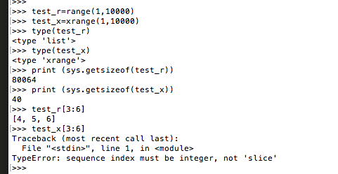

5. How Tuple is beneficial as compared to the list? – **tuples are immutable that is it is of fixed size and the data cannot be changed once created, whereas list is mutable that is it is dynamic in size and can modify the data after initialization i.e. user can add, update, or delete the items in list, this makes tuples faster than a list. If the user is using data that remains unchanged, implementing tuple will make sure that the data is write-protected. Tuples can also be used as key in dictionaries, as only immutable values can be hashed, whereas lists cannot be used like this.**

6. Write a program in Python to iterate through the list of numbers in the range of 1,100 and print the number which is divisible by 3 and a multiple of 2.

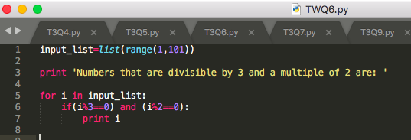

7. Write a program in Python to reverse a string and print only the vowel alphabet if it exists in the string with their index.

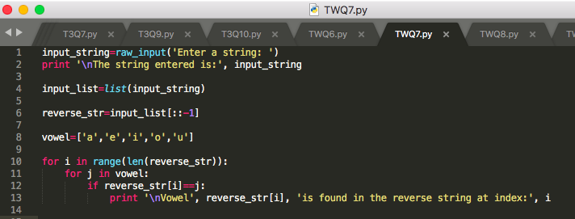

8. Write a program in Python to iterate through the string “hello my name is Abcde” and print the string which has even length of the word.

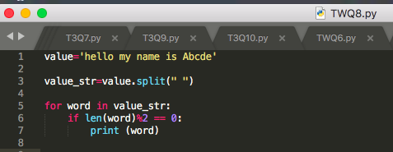

9. Write a program in python to print the pair of numbers whose sum is equal to the result number that is let's say 8.

**x=[1,2,3,4,5,6,7,8,9,-1]**

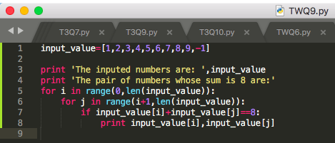

10. Write a program in Python to complete the following task:

* Create two different lists as in even_list and odd_list
* Ask the user to enter the number in the range of 1,50 and make sure if the entered number is even appended it to the even_list and if the entered number is odd append it to the odd list.
* Keep that in mind you can only add 5 items in each list
* Make sure once you entered the total 5 elements calculate the sum of the list and return the maximum out of the list.

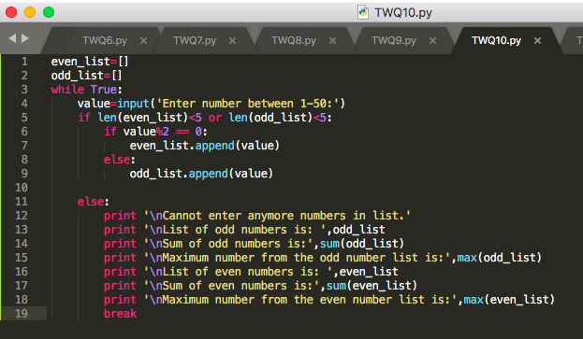

11. Write a program to find out the occurrence of a specific word from an alphanumeric statement. **Example:** 12abcbacbaba344ab

**Output:** a=5 b=5 c=2 make sure you should avoid the numbers in you logic

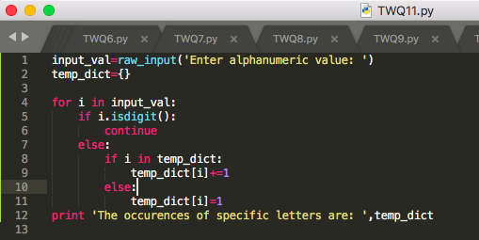

12. Generate and print another tuple whose values are even numbers in the given tuple (1,2,3,4,5,6,7,8,9,10).

