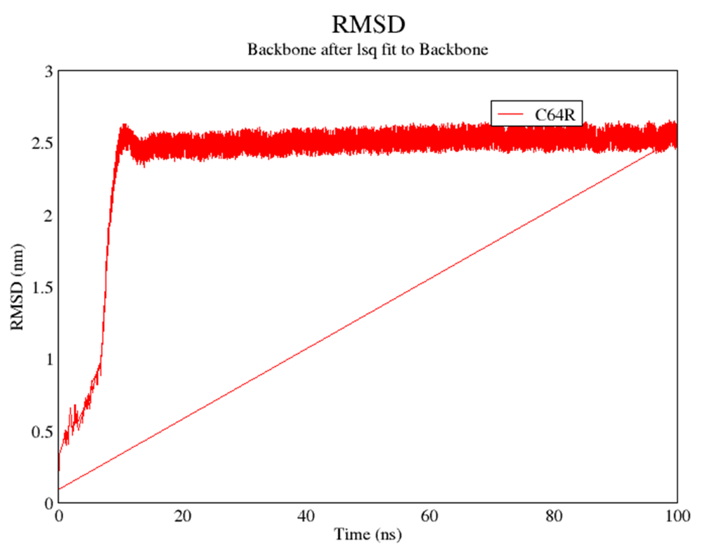

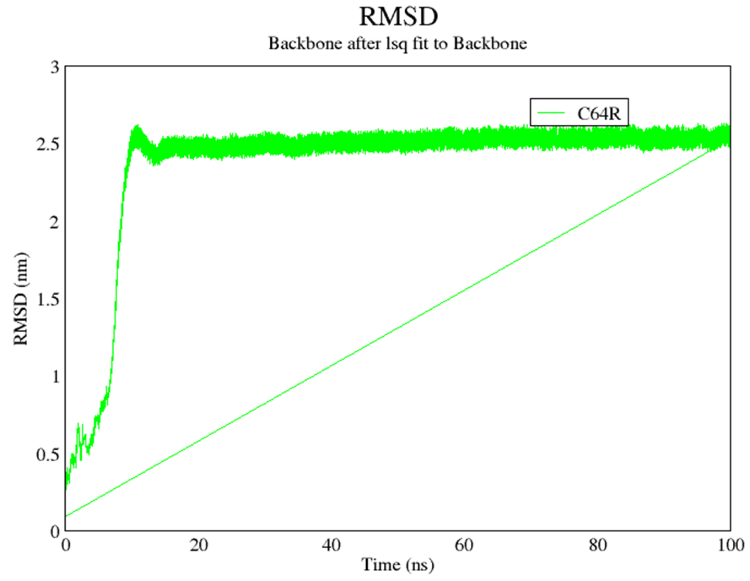
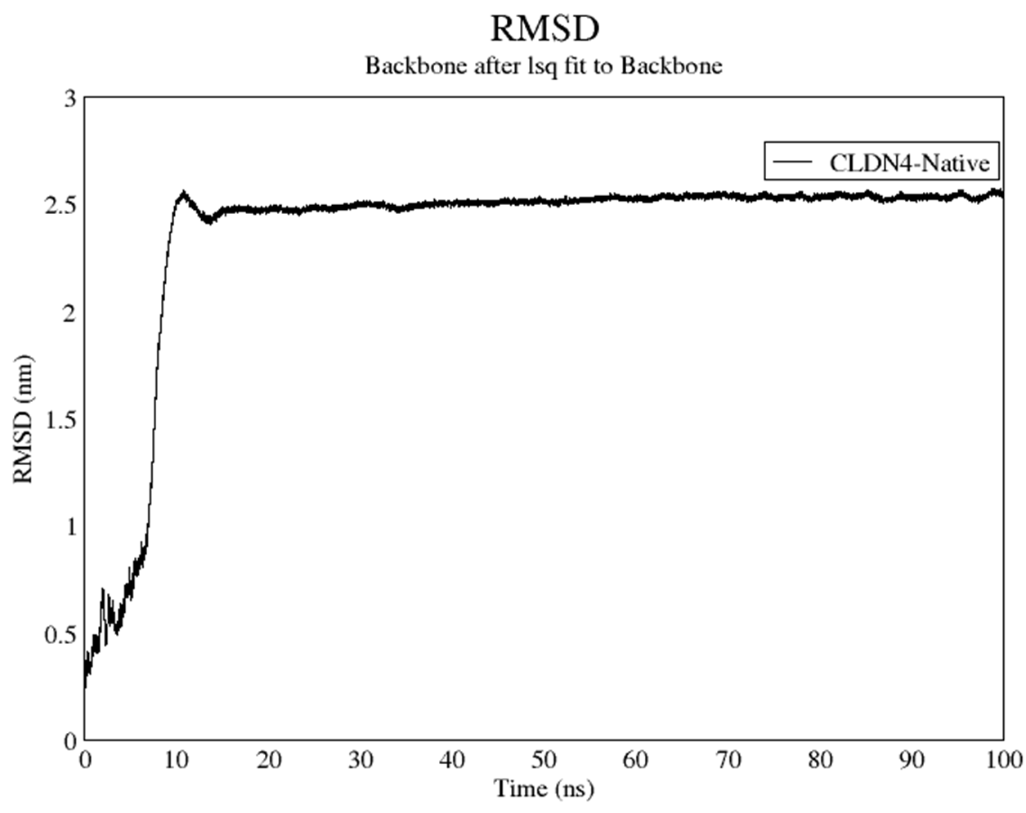
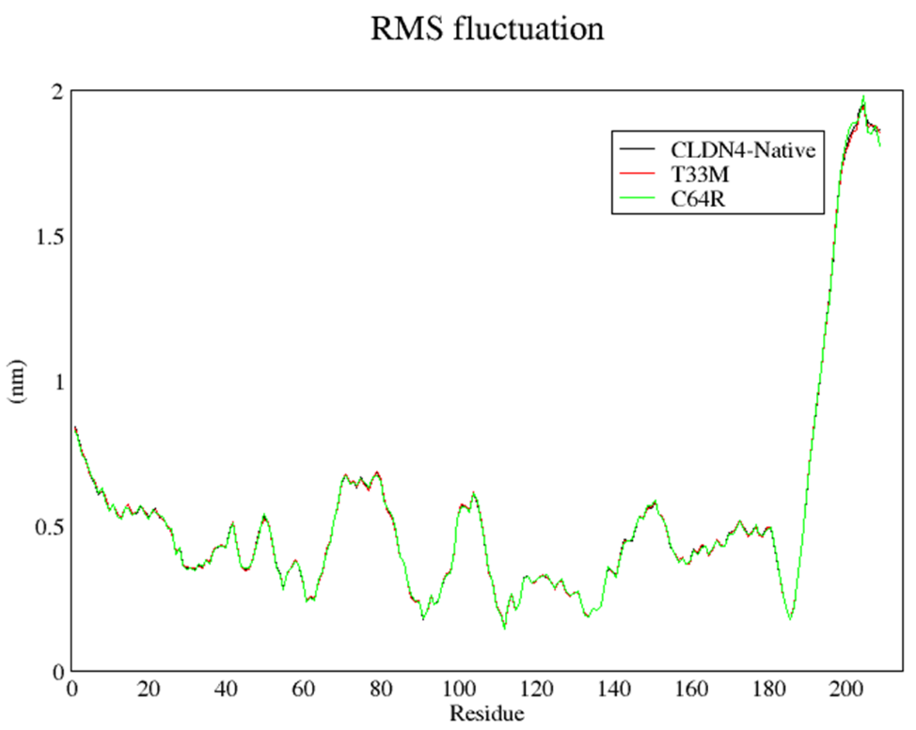
**This MD simulation of CLDN4 in a DPPC lipid environment is presented only for demonstration purposes. If the reviewer recommends including it in the manuscript, the authors will incorporate it in a more refined and detailed manner.

