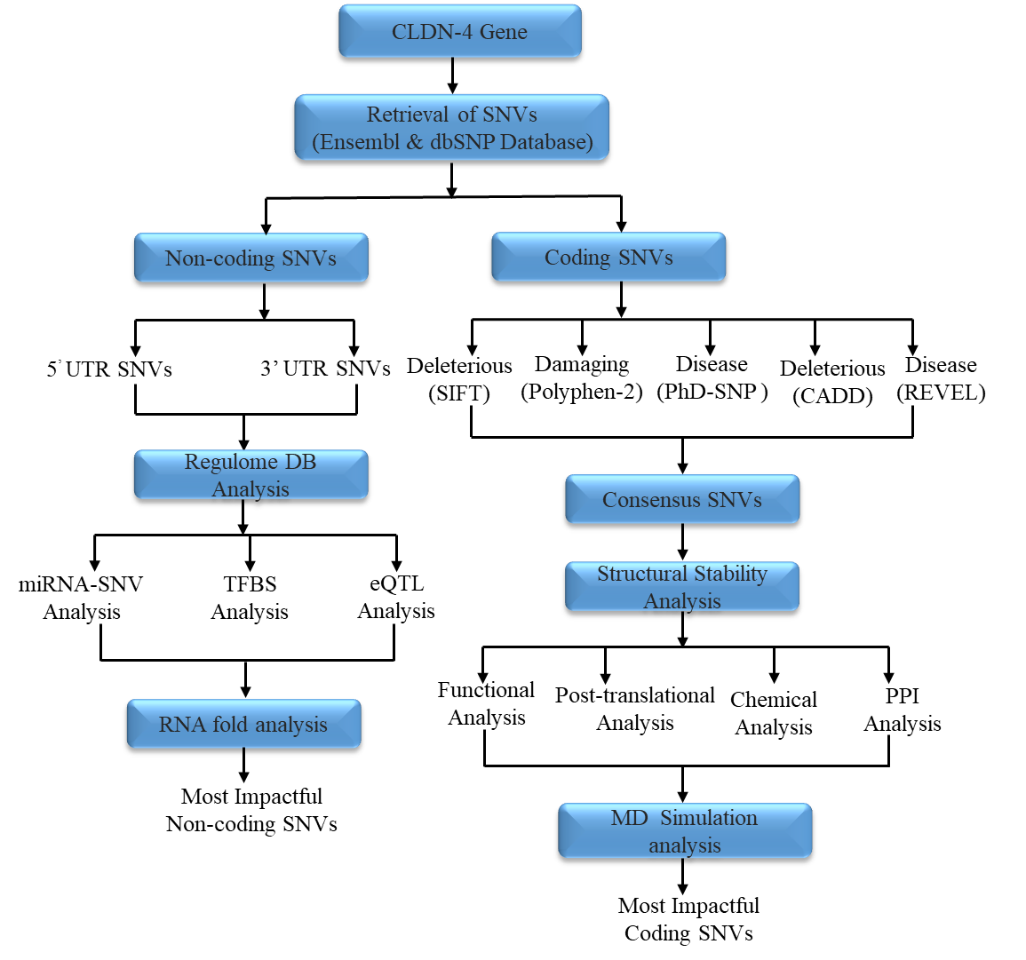
Figure 1: Employed outline for current study
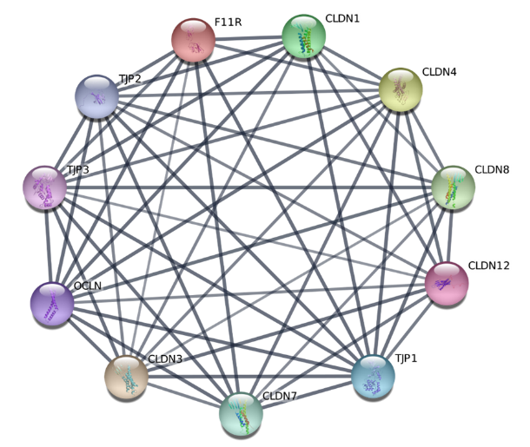
Figure 2: Protein-protein interaction analysis for CLDN4.

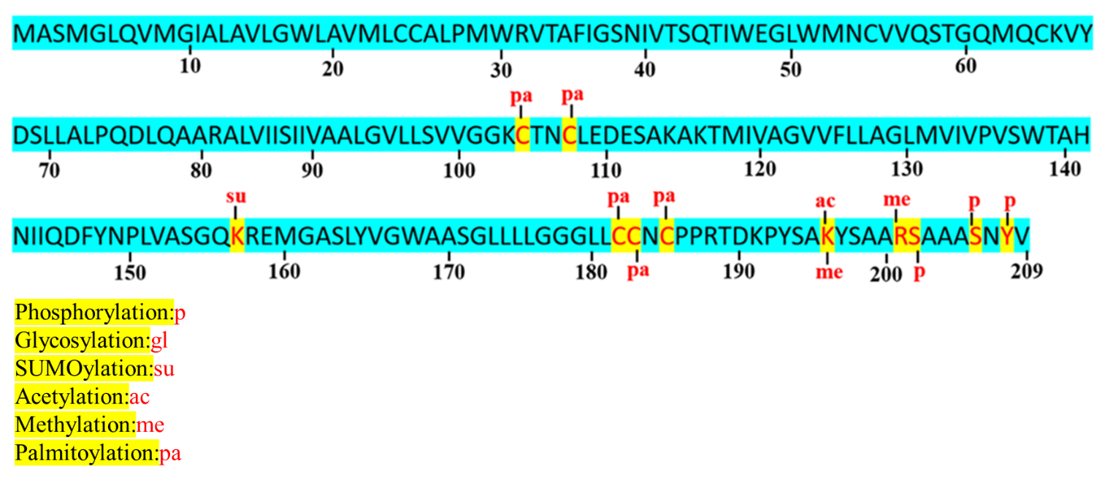
Figure 3: Post-translational modification analysis of CLDN4.
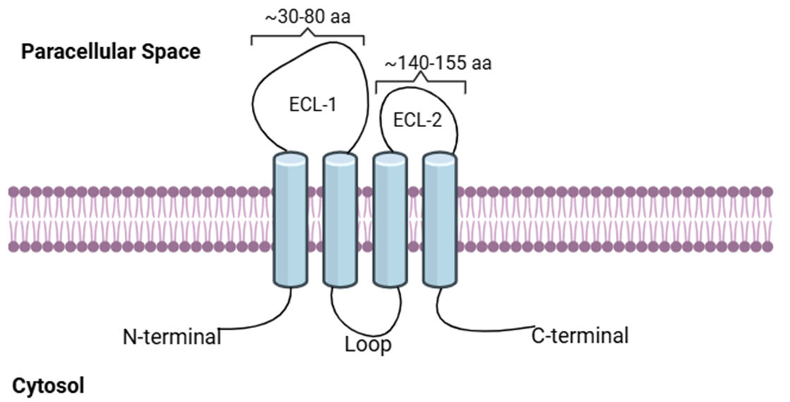
Figure 4: Fundamental modelled structure of CLDN4 accepted and modified form Hashimoto et al, 2019.

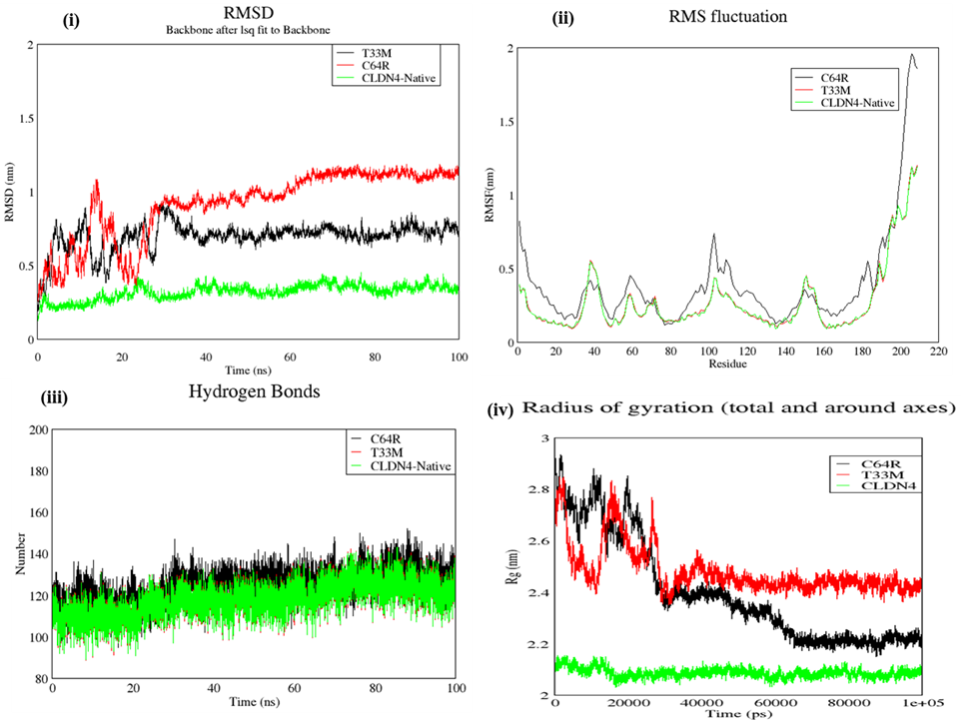
Figure 5: Molecular dynamic simulation analysis of CLDN4 along with its two mutants.

(A)
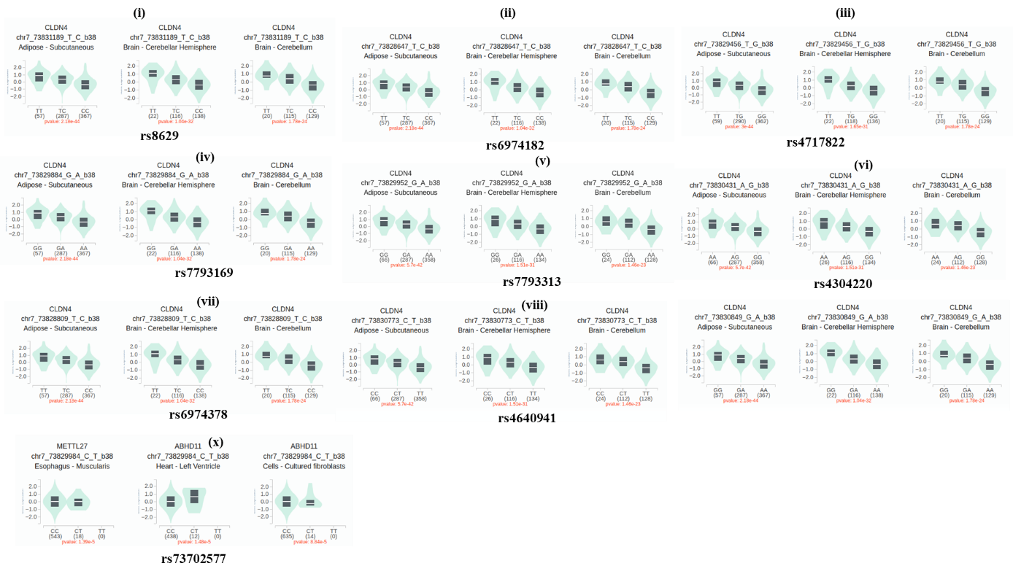
(B)
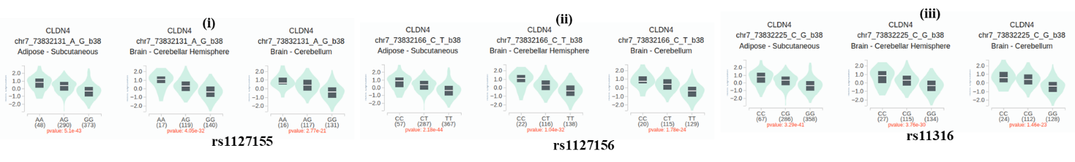
Figure 6: Single-Tissue eQTL Analysis of UTR using GTEx portal.

