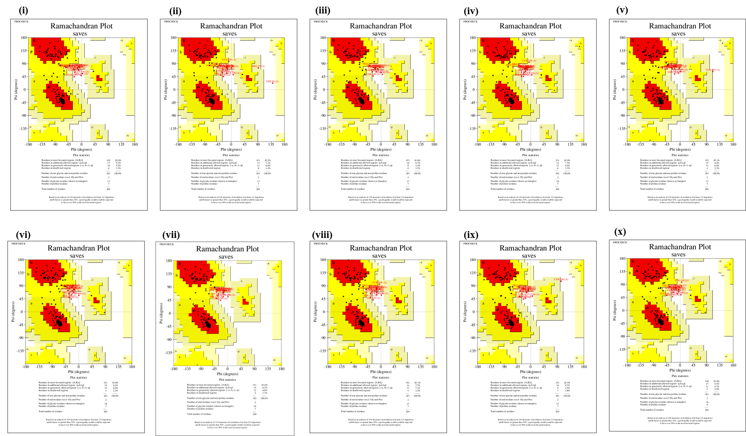
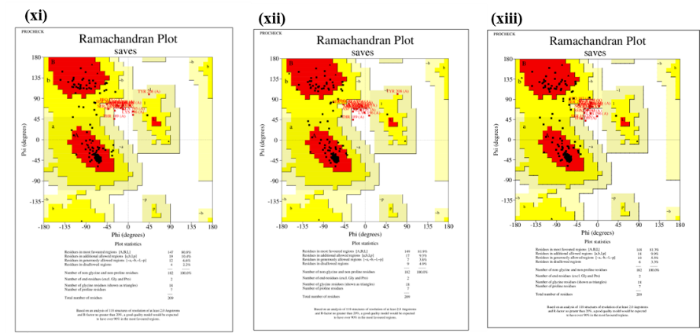
Supple. Figure 1: Ramachandran plot for CLDN4 along with its 13 sorted consensus nsSNVs.
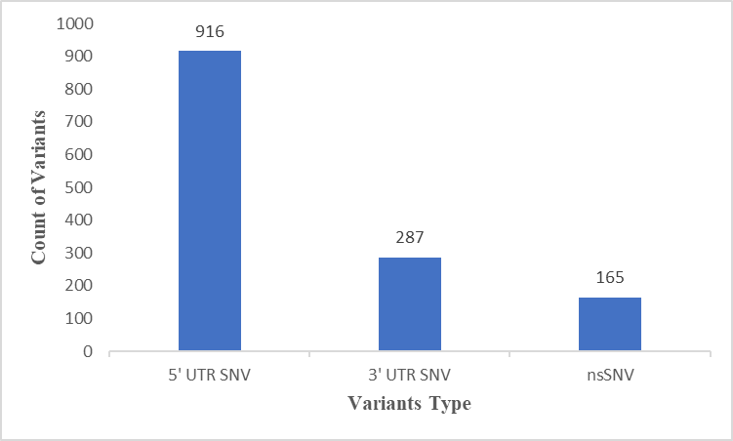
Supple. Figure 2: Distribution of coding and non-coding variants in CLDN4.
UTR; Untranslated region, nsSNVs; non-synonymous single nucleotide variant

