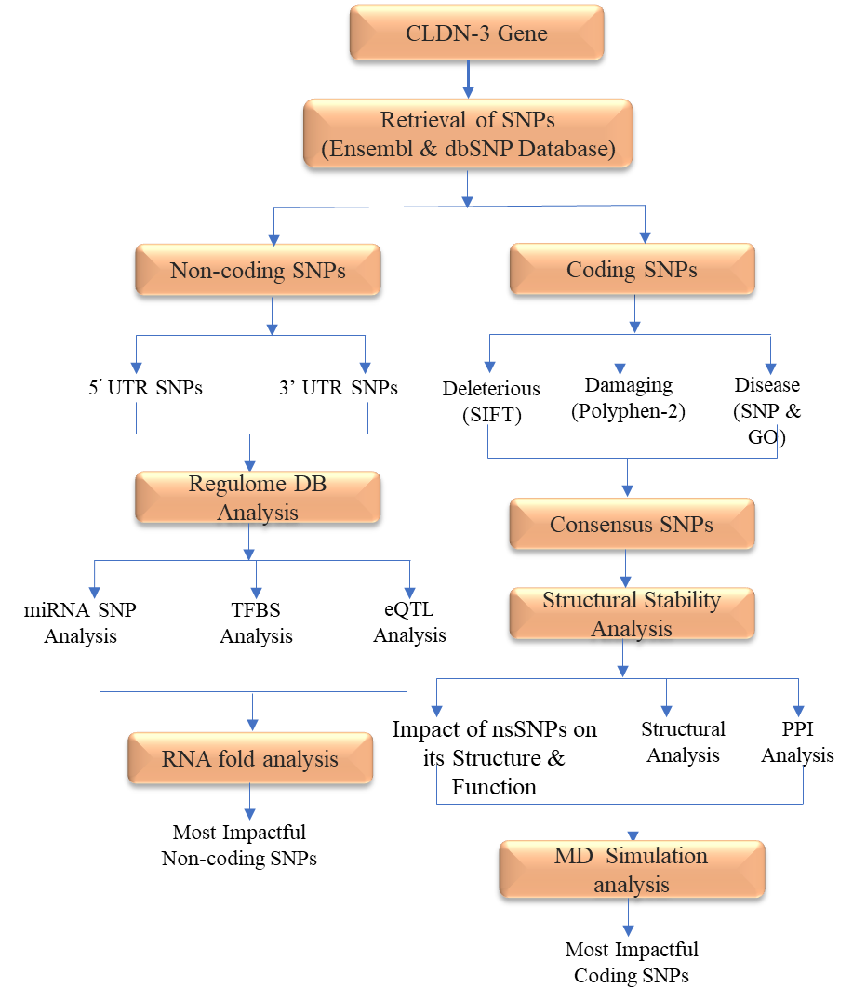

Figure 1. Outlined methodology utilized in the present study.

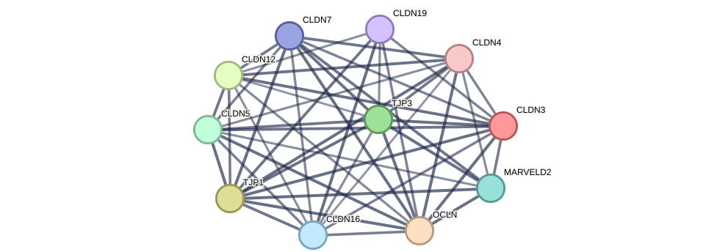

Figure 2. CLDN-3 protein interaction network analysis.

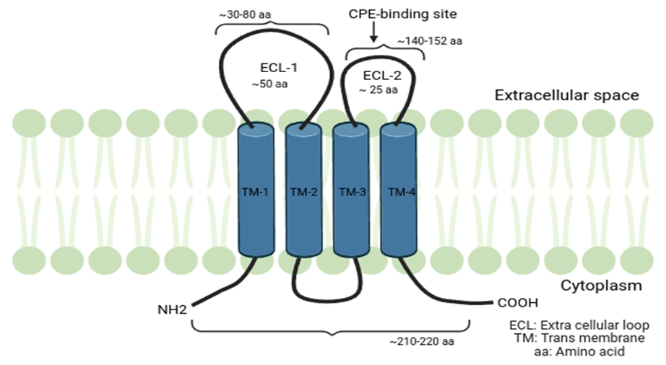

Figure 3. Structural models of CLDN-3 protein (adapted and modified from Yosuke et al., 2018) serve as a foundational model for understanding the structural impact of nsSNPs on these proteins.

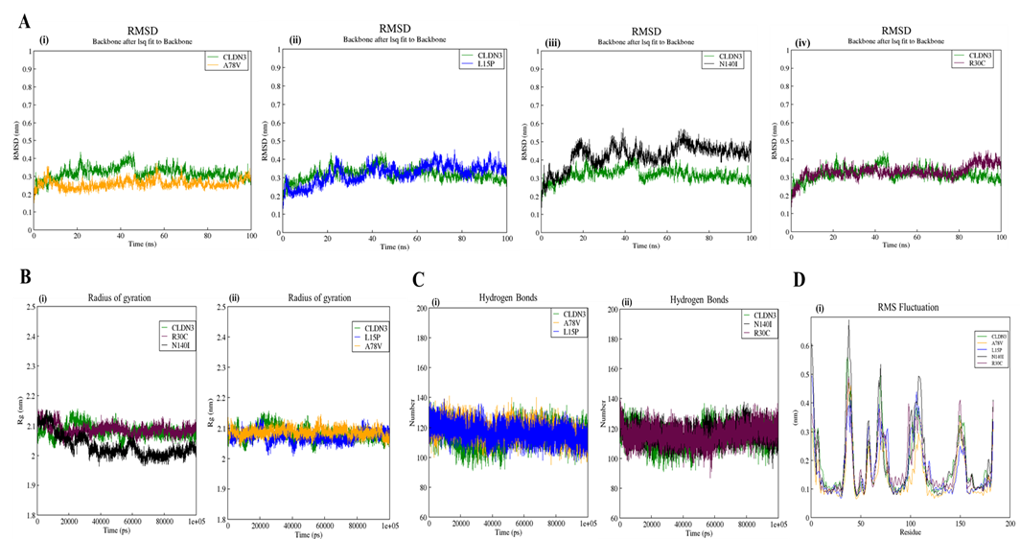

Figure 4. Molecular dynamic simulation analysis for CLDN-3 nsSNP A78V, L15P, N140I and R30C. (A) RMSD analysis, which is represented as time dependent fluctuation during the simulation (i-iv), (B) Rg analysis, which is represented as time dependent flexibility during the analysis (i-ii), (C) H-bond analysis, which shows time dependent H-bond formation during the simulation (i-ii) and (D) RMSF analysis, which is represented as residue dependent fluctuation during the simulation (i).

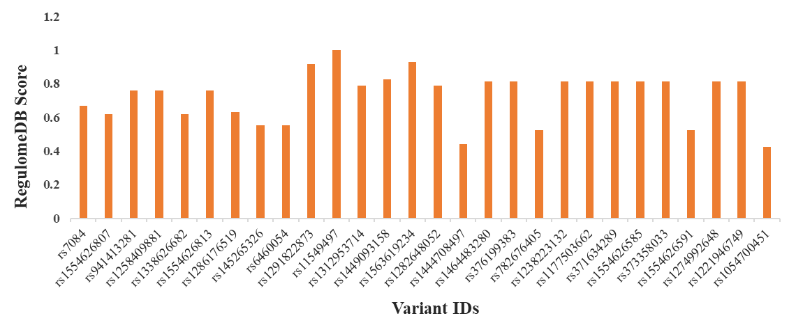Figure 5. Annotation and scoring of 28 UTR SNPs obtained through RegulomeDB database.

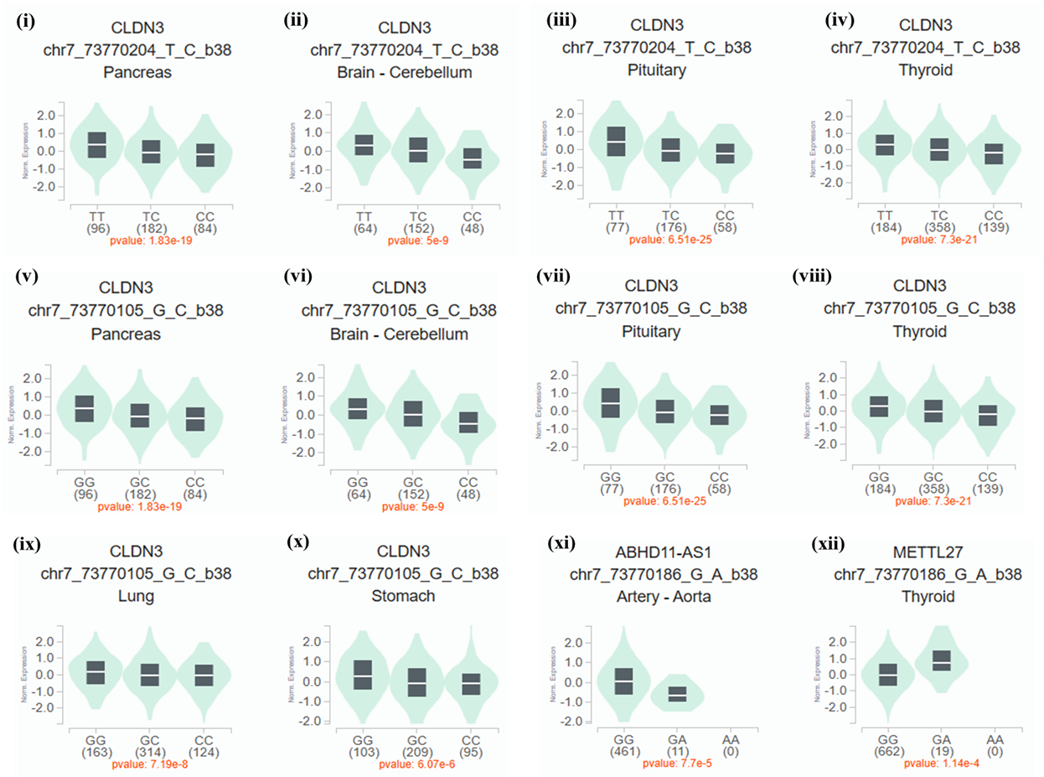

Figure 6. Single-Tissue eQTL Analysis of UTR using GTEx portal. Violin plots show the impact of SNP **rs6460054** (i-iv), **rs7084** (v-x) and **rs145265326** (xi-xii) on CLDN-3 gene expression.

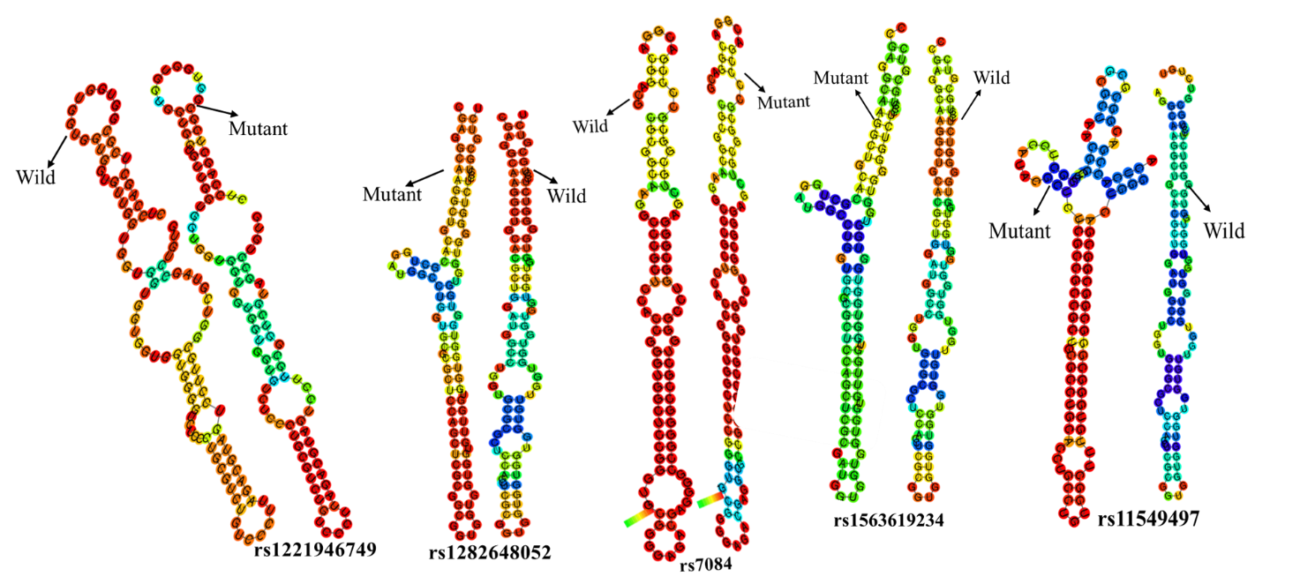

Figure 7. mRNA secondary structure comparison of more stabilized UTR SNPs with its wild-type using RNAfold tool.