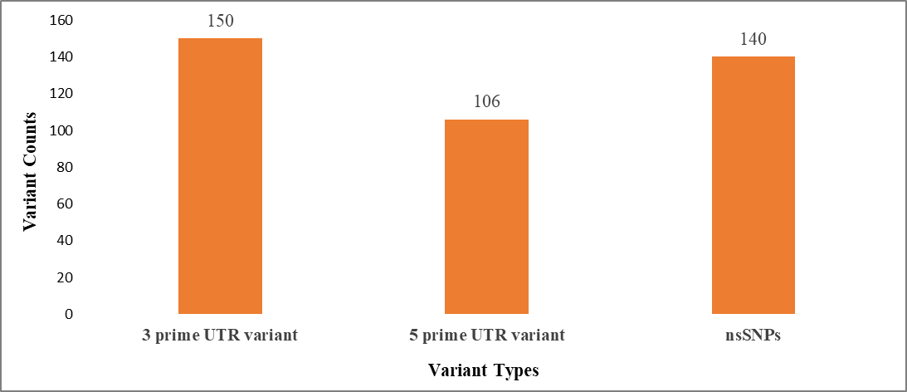

Supple. Figure 1. Coding and non-coding variants distribution.

UTR; Untranslated region, nsSNPs; Non-synonymous polymorphism

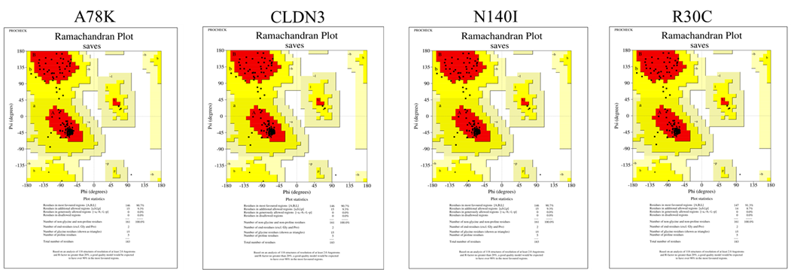

Suppl. Figure 2: Ramachandran plot for CLDN-3 along with its four modelled nsSNPs

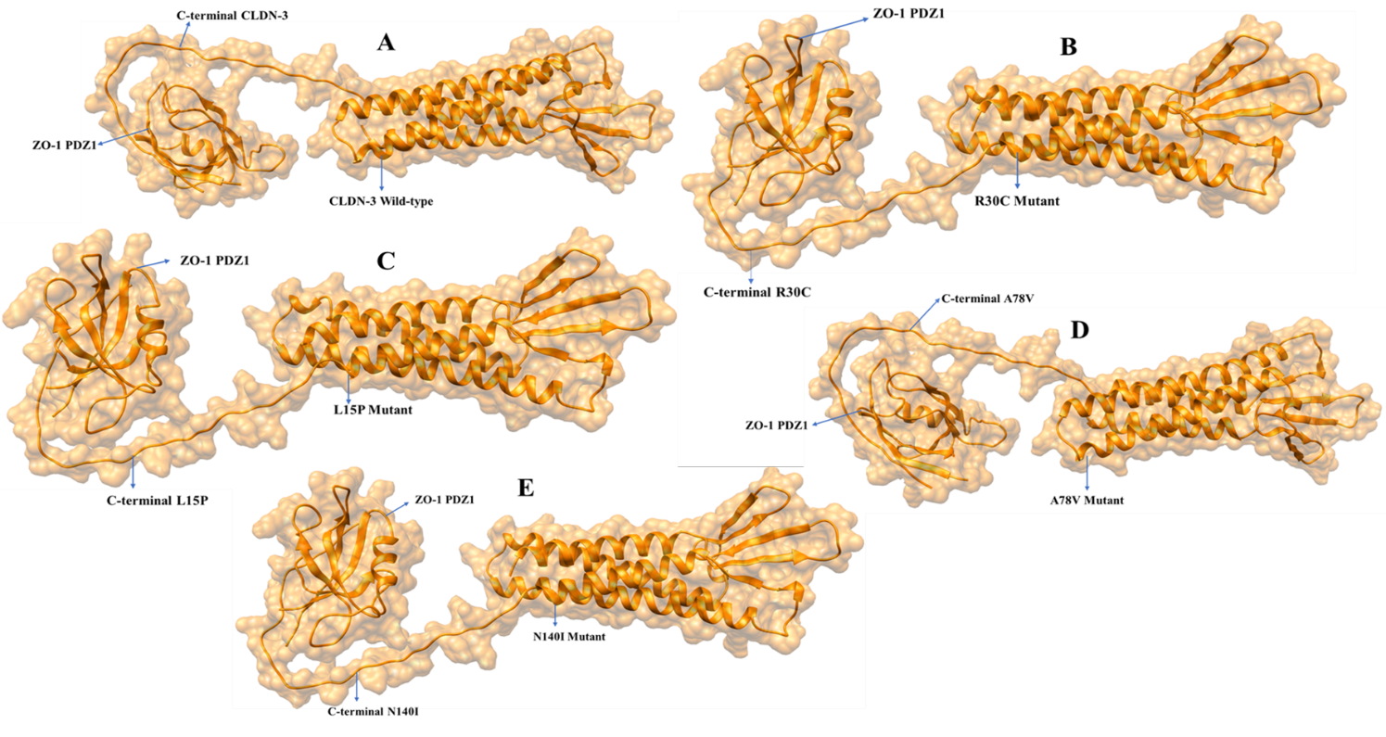

Suppl. Figure 3: Molecular docking analysis of CLDN-3 along with its four nsSNPs to ZO-1.

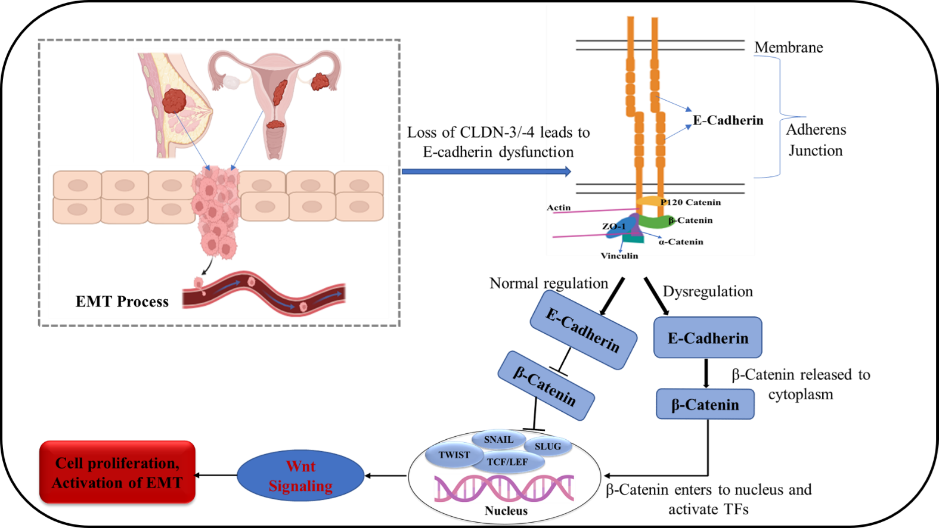

Suppl. Figure 4: Proposed model of CLDN-3 dysfunction in β-catenin mediated pathway.