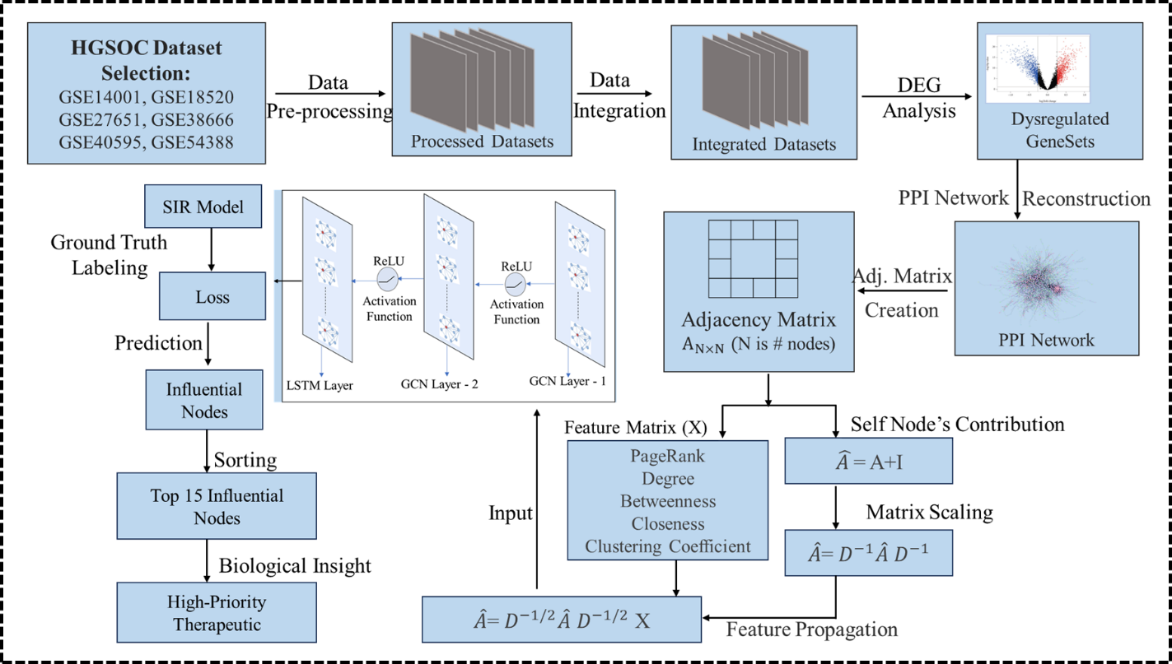
Figure 1: Utilised pipeline in present study.
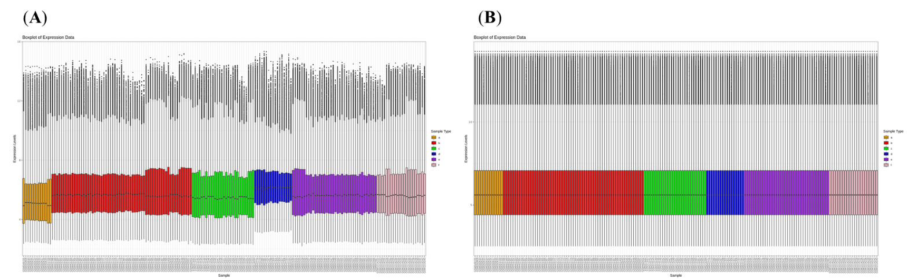
Figure 2: Expression values comparison among high-grade serous ovarian cancer. (A) After the integration and without joint normalization. (B) After the integration and joint normalization.
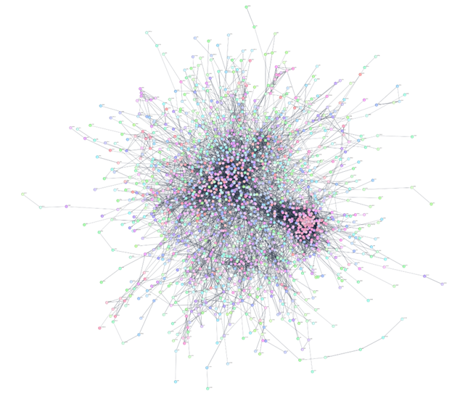
Figure 3: Reconstruction of PPI network for dysregulated genes. A graph representation of PPI network for dysregulated genes using STRING database with confidence score > 0.70 involving 1804 nodes as proteins and 8821 edges as interaction between them.
(A)
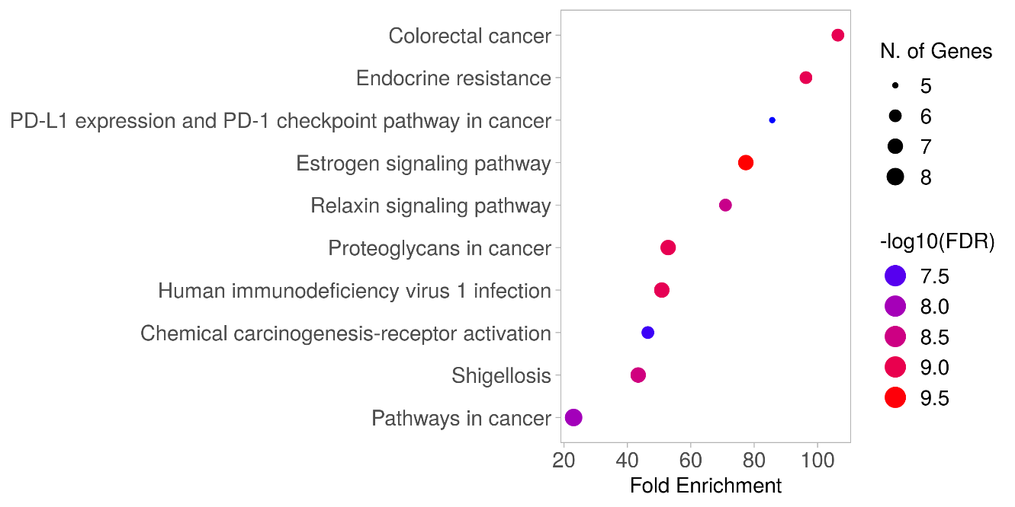

(B)
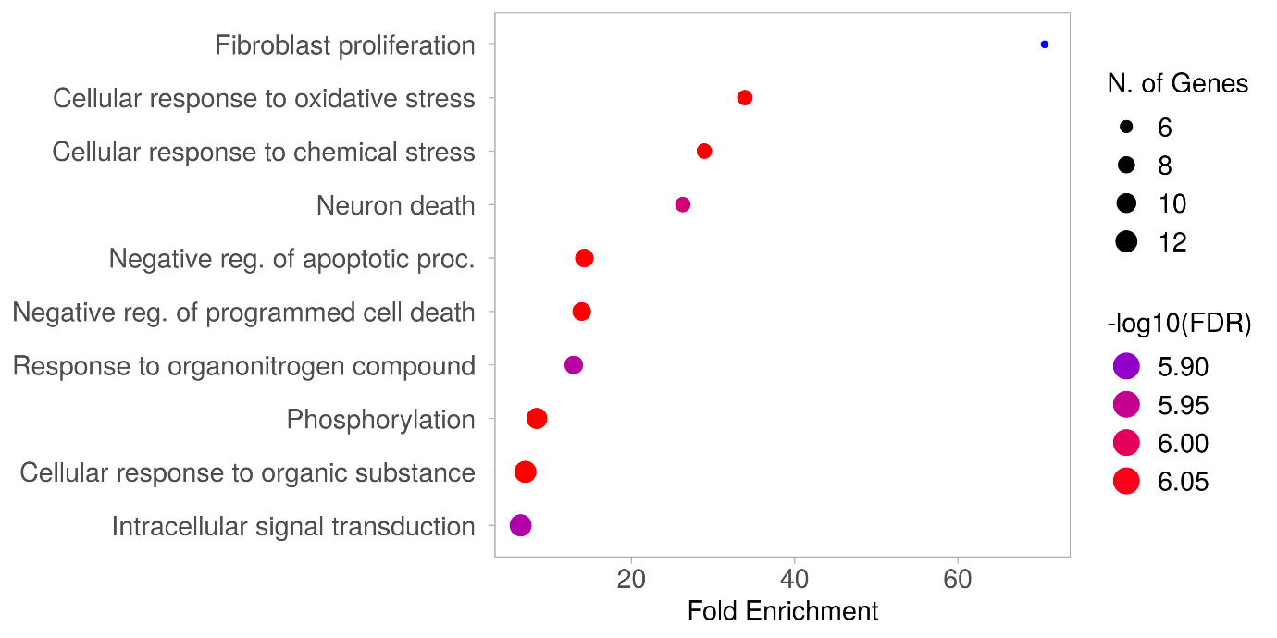
(C) 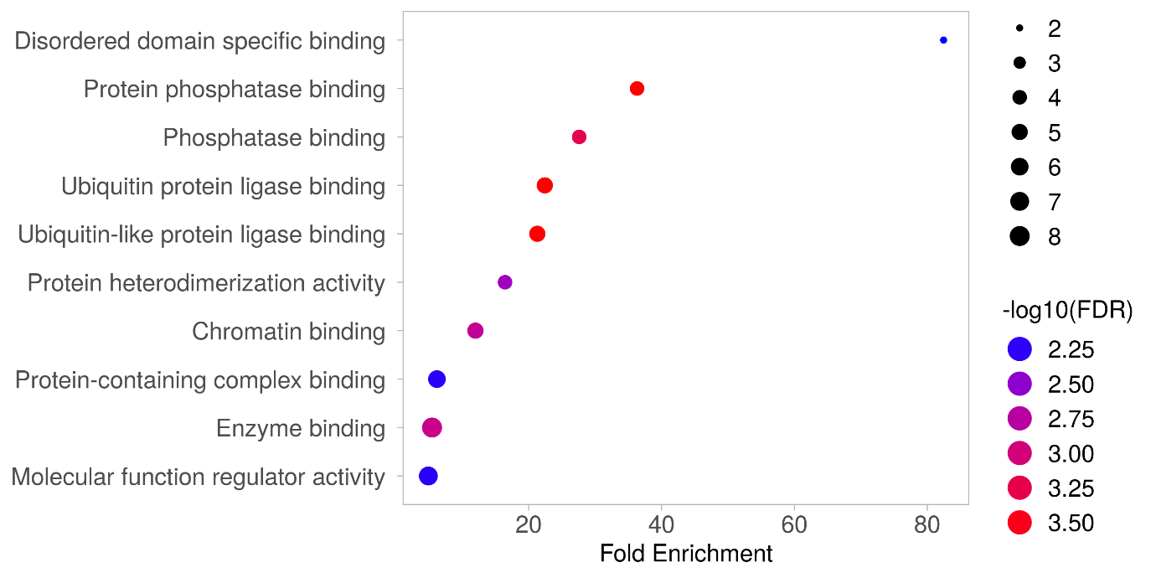(D) 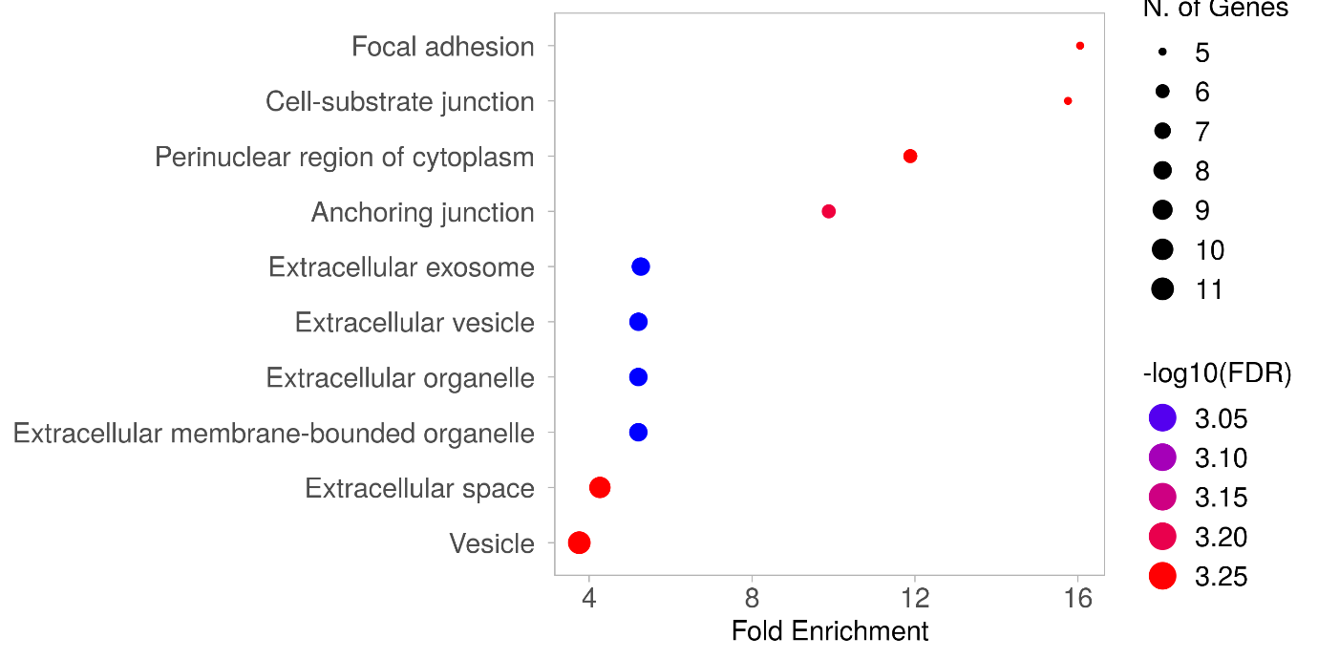
Figure 4: Enrichment analysis of the identified candidate genes. Bubble plots show the top 10 enriched terms for KEGG pathways (A), Gene ontology biological processes (B), molecular functions (C), cellular components (D), based on the top 15 candidate genes. Analysis was performed using the ShinyGO tool, with p-values ≤ 0.05 considered statistically significant.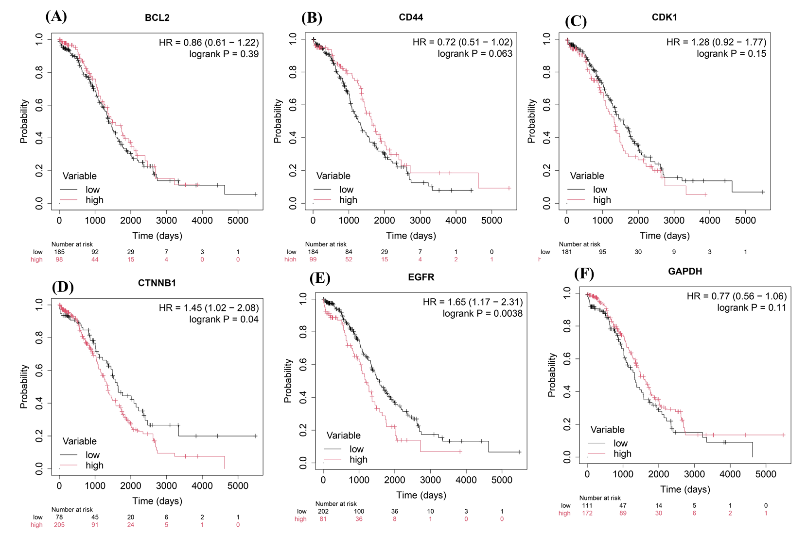
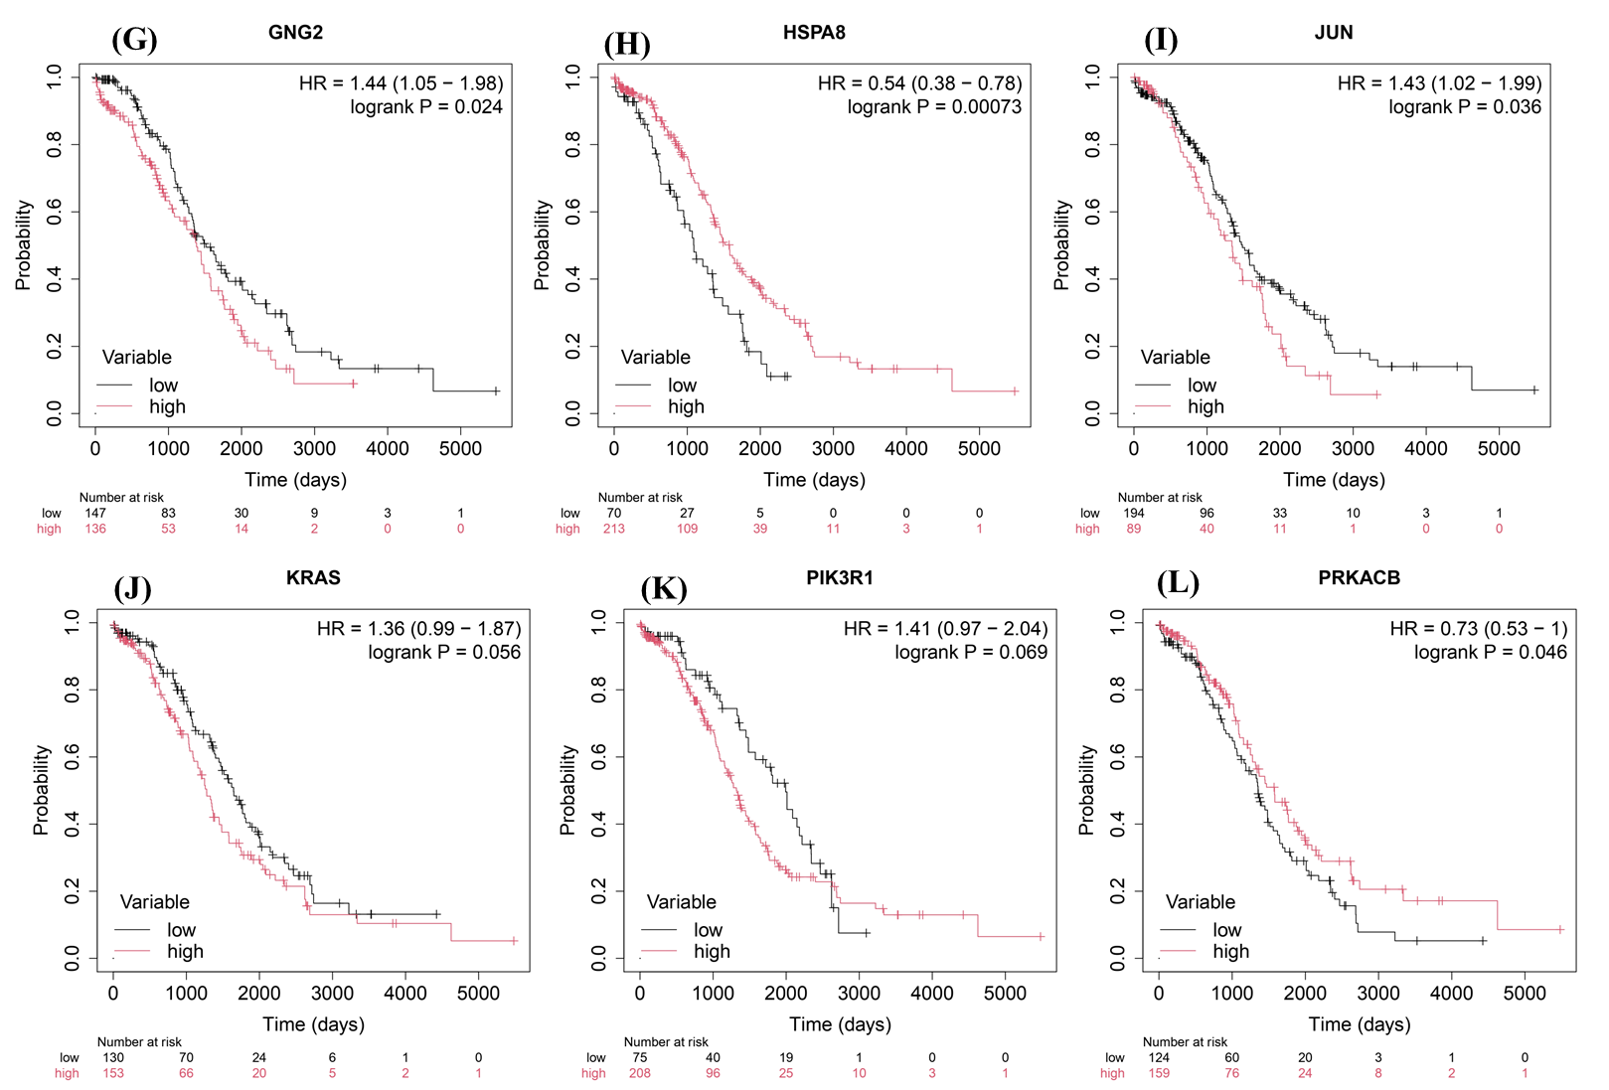
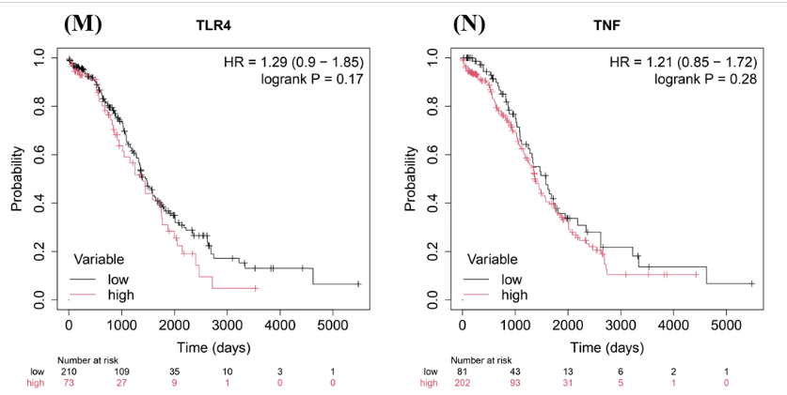
Figure 5: Disease-specific survival analysis of candidate genes. (A-N) Kaplan-Meier survival curves were plotted to compare low and high gene expression groups using an independent TCGA ovarian cancer dataset, and Log-rank p-values ≤ 0.05 were considered statistically significant.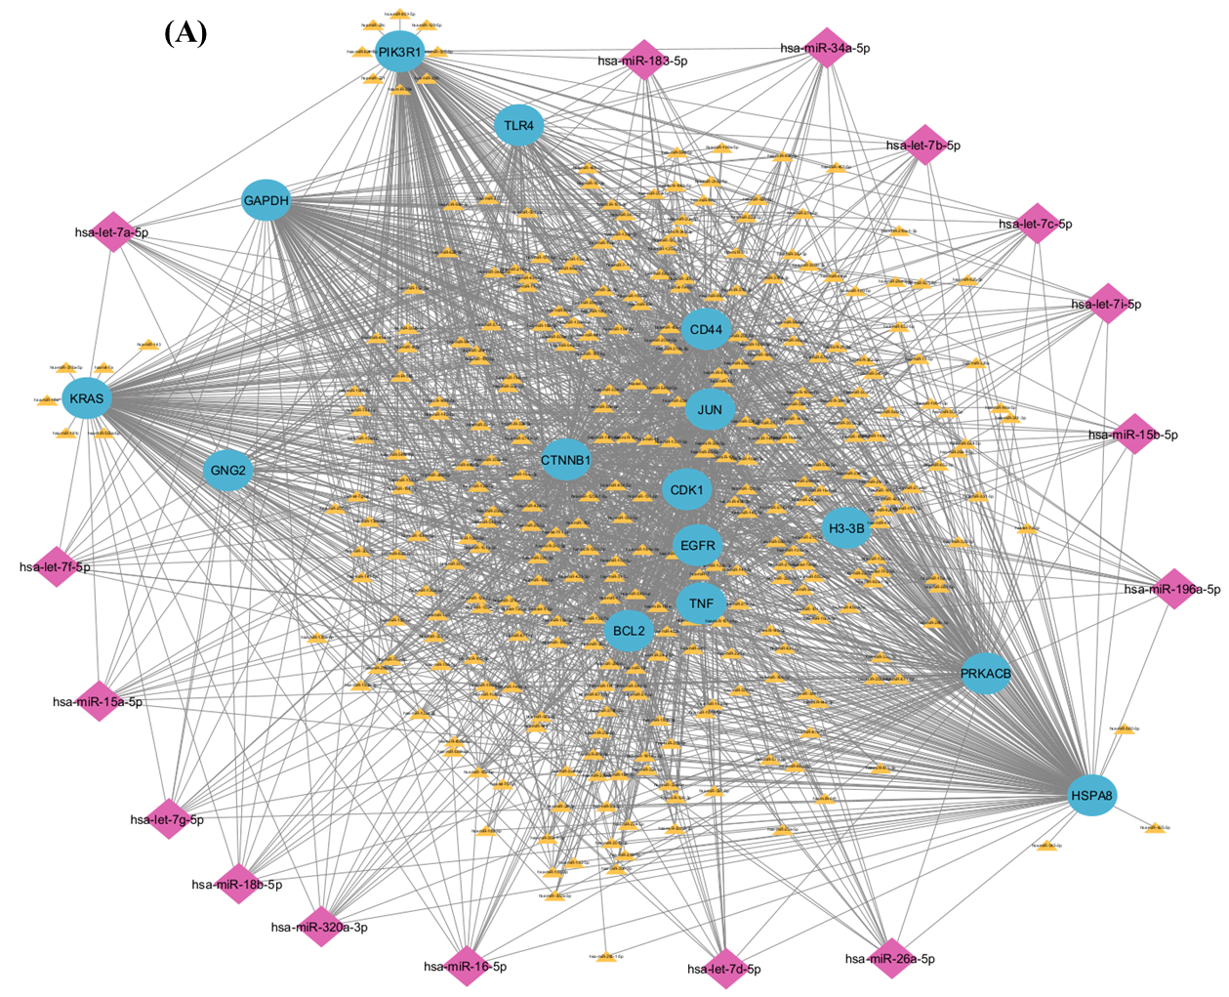
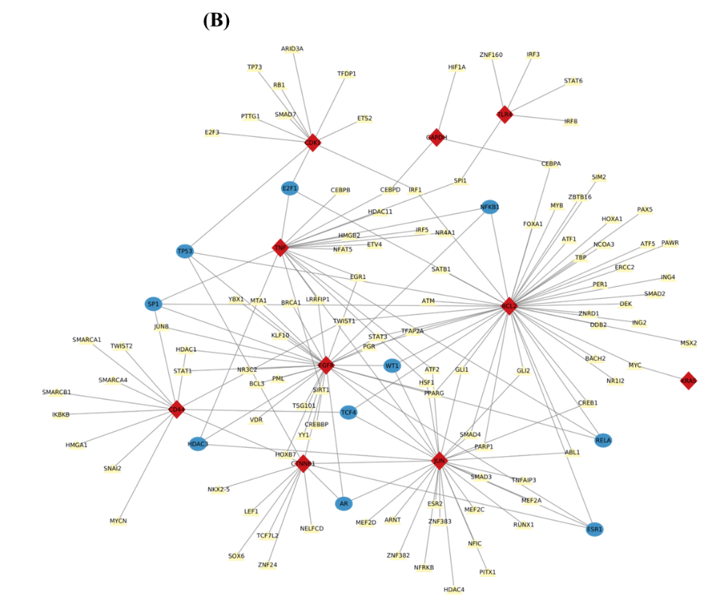
Figure 6: Analysis of interactions between associated regulatory molecules. In the miRNAs-candidate genes network (A) candidate genes are shown in blue ovals, 16 consensus miRNAs in purple diamonds, and other associated miRNAs in yellow diamonds shape. In the TFs-candidate genes network (B), candidate genes are shown in blue ovals, TFs interacting with more than three candidate genes are shown in red, and other associated TFs are shown in yellow diamond shape.
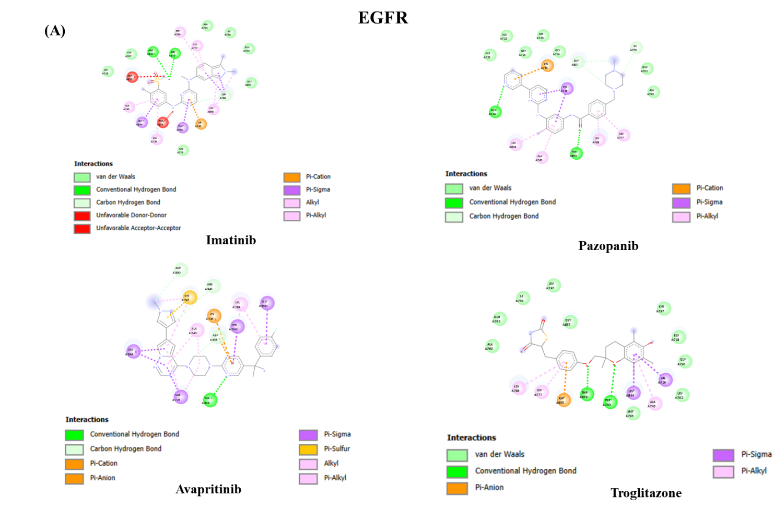
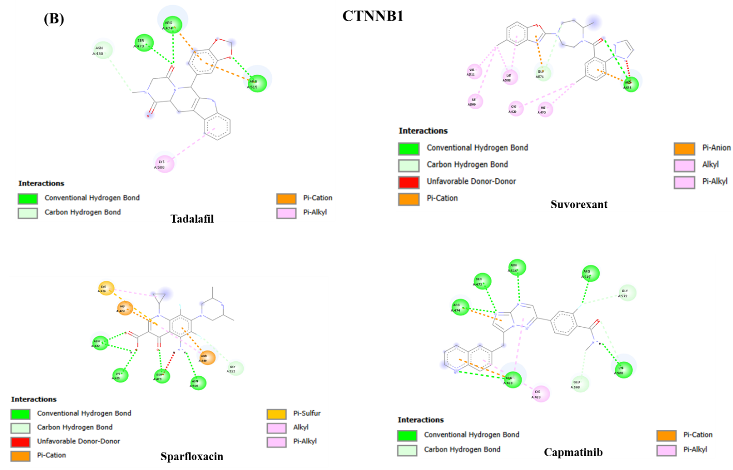
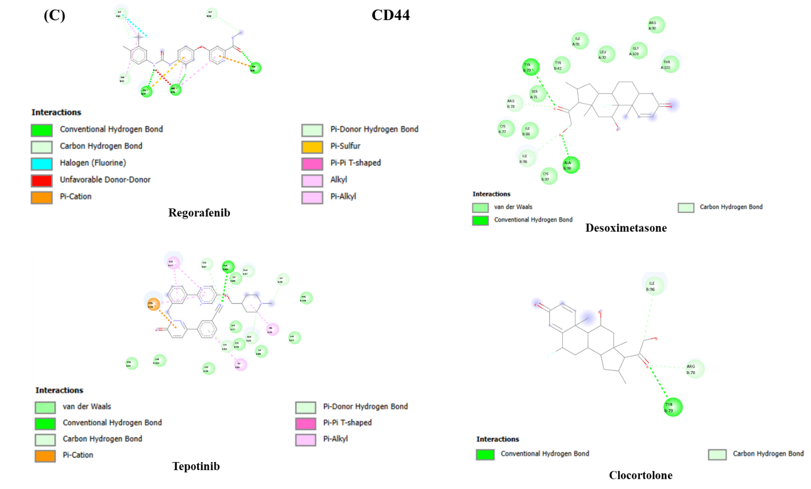
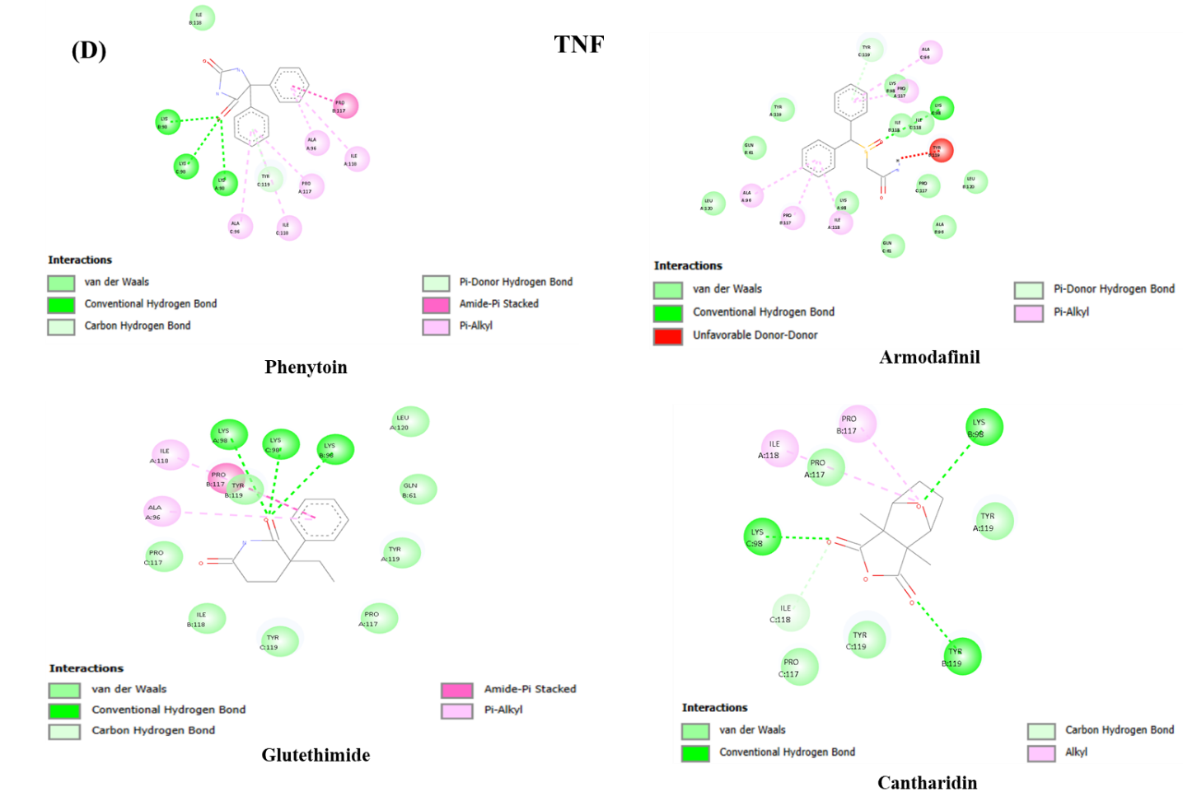
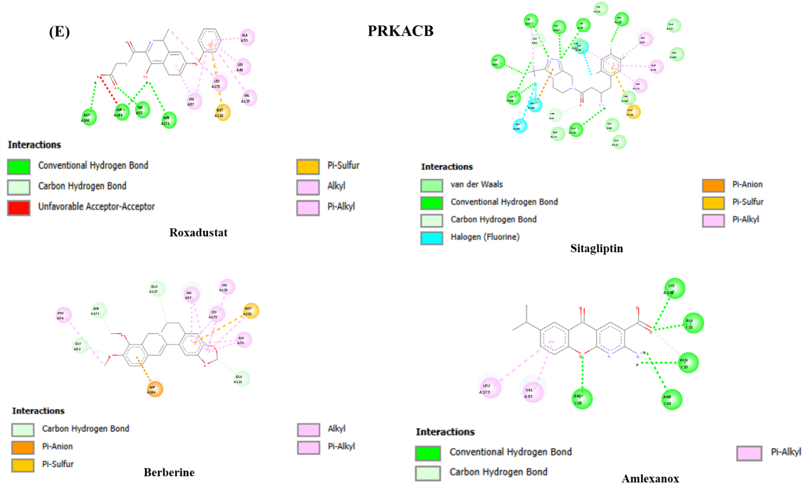
Figure 7: 2D molecular interaction of the top five selected candidate genes with docked FDA-approved drugs. (A-E) Non-covalent interactions between the top five genes and the four FDA-approved drugs with the highest binding affinities are shown. Diagrams were generated using BIOVIA Discovery Studio.
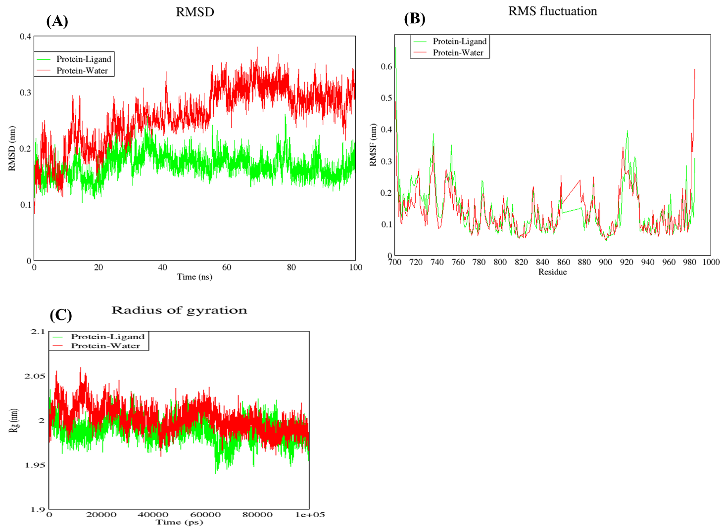
Figure 8: MD simulation analysis of the EGFR target gene. Trajectory analysis of EGFR target gene was performed for ligand-bound (EGFR-Imatinib) and unbound (EGFR-Water) forms to evaluate structural stability (A), flexibility (B), and compactness (C).
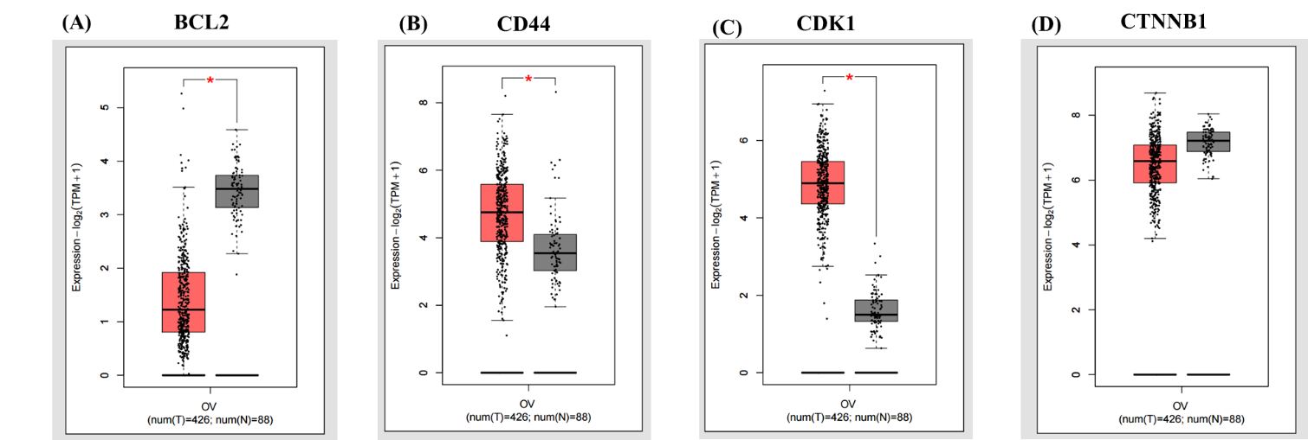
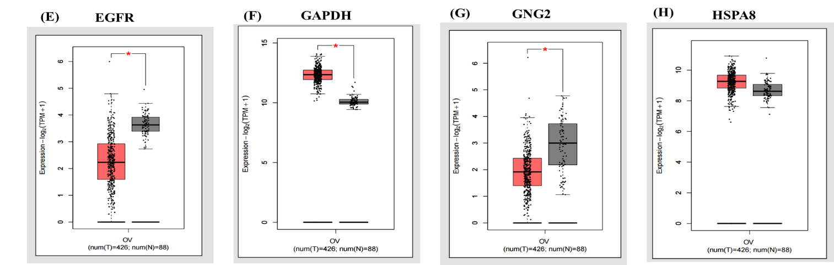
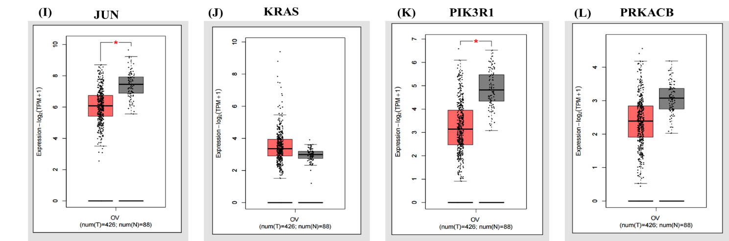
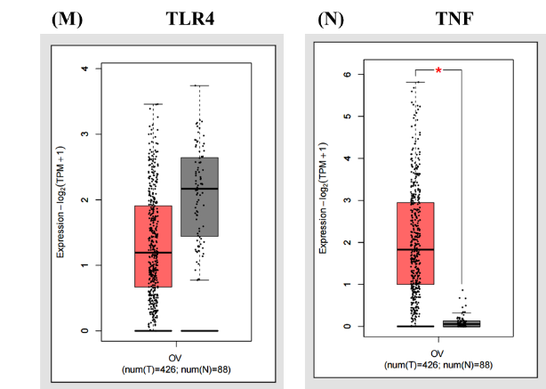
Figure 9: Box plot analysis of identified genes between normal and tumour samples. (A - N) to verify the expression level of identified genes between the tumour and normal sample of HGSOC box plot were generated using the tool GEPIA2.

