PROJECT REPORT ON

IoT Based Smart Irrigation System
Carried Out at


CENTER FOR DEVELOPMENT OF ADVANCED COMPUTING ELECTRONIC CITY, BANGALORE

UNDER THE SUPERVISION OF
Dr. Vishal J. Rathod Submitted By
Patil Pavan Shivaji (220950126006)

Patil Vijay Anil(220950126007)

Pooja (220950126008) Varsha(220950126012)

PG DIPLOMA IN INTERNET OF THINGS C-DAC, BANGALORE

Candidate’s Declaration

We hereby certify that the work being presented in the report entitled IoT Based Smart Irrigition System, in partial fulfillment of the requirements for the award of PG Diploma Certificate and submitted in the department of PG-DIOT of the C-DAC Bangalore, is an authentic record of our work carried out during the period, Feb 2023 to Mar 2023 under the supervision of Mr. Shrikrishna S Chippalkatti, C-DAC Bangalore. The matter presented in the report has not been submitted by us for the award of any degree of this or any other Institute/University.

(Name and Signature of Candidate)
- Patil Pavan Shivaji(220950126006)
- Patil Vijay Anil(220950126007)
- Pooja(220950126008)
- Varsha(220950126012)

Counter Signed by

ACKNOWLEDGMENT

We avail this opportunity to express our sincere thanks to our esteemed guide Dr. Vishal J. Rathod, for splendid guidance, authentic supervisor, cooperation and moral support throughout this project.

We would like to express our profound gratitude to Mr. Shrikrishna S Chippalkatti Training coordinator for creating required facilities to complete this project.

We would like to express our sincere thanks to our staff and management of C-DAC for giving all support and suggestions to complete our project.

We acknowledge here out debt to those who contributed significantly to one or more steps. We take full responsibility for any remaining sins of omission and commission.

Student’s Name
- Patil Pavan Shivaji (220950126006)
- Patil Vijay Anil(220950126007)
- Pooja (220950126008)
- Varsha(220950126012)

CERTIFICATE

This is to certify that this is a bonafide record of project work on the entitled IoT Based Smart Irrigition System done by Patil Pavan Shivaji (06) Patil Vijay Anil (07) Pooja (08) Varsha (12) and under the guidance of Dr. Vishal J. Rathod Sir in partial fulfillment of the requirement of a Diploma in Internet of Things at C-DAC Bangalore for the academic session of September 2022.

Mr. Shrikrishna S Chippalkatti CDAC #68, Electronic City, Bangalore-560100, India

ABSTRACT

India is mainly an agricultural country. Agriculture is the most important occupation for the most of the Indian families. It plays vital role in the development of agricultural country. In India, agriculture contributes about 16% of total GDP and 10% of total exports. Water is main resource for Agriculture.
As water supply is becoming scarce in today’s world there is an urgency of adopting smart ways of irrigation. Irrigation is one method to supply water but in some cases there will be lot of water wastage. So, in this regard to save water and time we have proposed project titled IoT based smart irrigation system.

The project describes how irrigation can be handled smartly using IOT. This project aims at saving time and avoiding problems like constant vigilance. It also helps in conserving water by automatically providing water to the plants/field depending on the water requirements. This system can also prove to be helpful in agriculture, parks and lawns. In this proposed system we are using various sensors like temperature, humidity, soil moisture sensors which senses the various parameters of the soil and based on soil moisture value land gets automatically irrigated by ON/OFF of the motor. These sensed parameters and motor status will be displayed on user android application.

TABLE OF CONTENT

1. | Introduction………………………………………………………………..... |  |  | 1
 | 1.1 | About Project…………………………………………………...……... |  | 1
 | 1.2 | Scope of Project…………………………………………………..…... |  | 1
 | 1.3 | Requirements System……………………………………………..….. |  | 2
 |  | 1.3.1 | Hardware Requirements……………………………….……… | 2
 |  | 1.3.2 | Software Requirements………………………………….…….. | 6
2. | Background and Related Work..…………………………………………….. |  |  | 7
 | 2.1 | Related Work……………………………………………………….…. |  | 6
 |  | 2.1.1 | Internet of Things……………………………………………... | 6
 |  | 2.1.2
 |  | 2.1.3
 | 2.2 | Background……………………………………………………………. |  | 8
3. | Proposed Method…………………………………………………………… |  |  | 12
 | 3.1 | Working Flow………………………………………………………… |  | 12
 | 3.2 | Implementation……………………………………………………….. |  | 13
 |  | 3.2.1 | code…………………...…………….. | 13
 |  | 3.2.2 | Code…………………………………………... | 14
 |  | 3.2.3 | Prototype………………………….…….. | 15
4. | Limitation and Enhancements………………………………………………. |  |  | 16
 | 4.1 | Limitation……………………………………………………………… |  | 16
 | 4.2 | Enhancement………………………………………………………….. |  | 16
5. | Conclusion…………………………….…………………………………….. |  |  | 17
6. | References…………………………………………………………………… |  |  | 18

List of Figures

Fig. No. | Figure | Page No.
Fig 1.1 | NODE MCU Board | 2
Fig 1.2 | Relay module | 3
Fig 1.3 | DC Mini water pump | 3
Fig 1.4 | DHT11 Sensor | 4
Fig 1.5 | Soil Moisture Sensor | 5
Fig 3.1 | Flow chart | 13
Fig 3.2 | Code | 11
Fig 3.3 | Code | 12
Fig 3.4 | Prototype | 13

CHAPTER 1 INTRODUCTION

Agriculture is the backbone of Indian Economy. In today’s world, as we see rapid growth in global population, agriculture becomes more important to meet the needs of the human race. However, agriculture requires irrigation and with every year we have more water consumption than rainfall, it becomes critical for growers to find ways to conserve water while still achieving the highest yield. But in the present era, the farmers have been using irrigation technique through the manual control in which they irrigate the land at the regular interval. There is an urgent need to create strategies based on science and technology for sustainable use of water, including technical, agronomic, managerial and institutional improvements. Agricultural irrigation based on Internet technology is based on crop water requirement rules. By using Internet technology and sensor network technology we can control water wastage and to maximize the scientific technologies in irrigation methods. Hence it can greatly improve the utilization of water and can increase water productivity.
.

1.1 About Project
In this project we are using various sensors like temperature, humidity, soil moisture sensors which senses the various parameters of the soil and based on soil moisture value land gets automatically irrigated by ON/OFF of the motor. These sensed parameters and motor status will be displayed on user android application.

1.2 Scope of Project
This project helps reducing farmers efforts towards cost effectiveness and controlling on field-the most precious resource on earth that is water.

1.3 Requirement System
    - Hardware and its specification

- NODEMCU Board
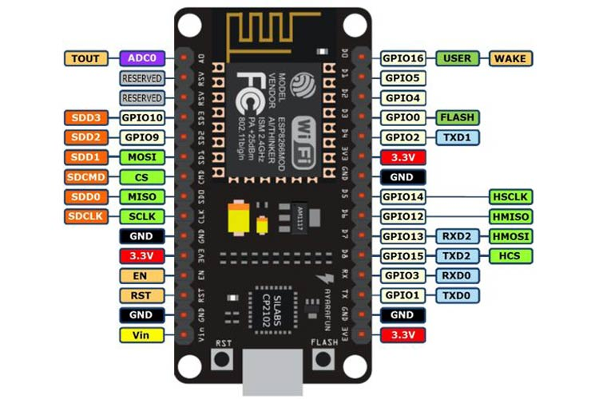

Fig 1.1 NODEMCU Board

Specification:
- Microcontroller: ESP-8266 32-bit
- Clock Speed:80MHz
- Operating Voltage: 3.3V
- Input Voltage: 4.5V-10V
- Flash Memory/SRAM: 4 MB / 64 KB
- Analog In Pins: 1
- Development Board: Node MCU
- WiFi Built-In: 802.11 b/g/n
- Temperature Range: -40C - 125C
- UART/SPI/I2C: 1 / 1 / 1
- GPIO Pins: GPIO1 to GPIO16

Relay Board
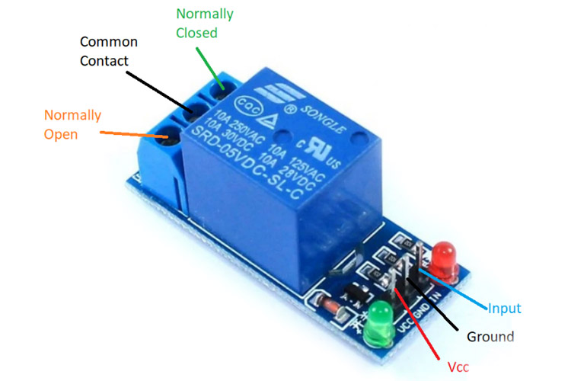

Fig 1.2 Relay module

Specification:
- Quiescent current is 2mA
- Once the relay is active then the current is ~70mA
- The highest contact voltage of a relay is 250VAC/30VDC
- The maximum current is 10A
- Voltage supply ranges from 3.75V – 6V
- DC Mini Water Pump
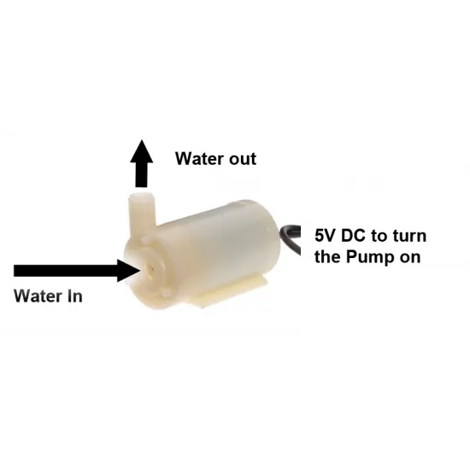

Fig 1.3 DC Mini water pump

Specification:
- Operating Voltage : 2.5 ~ 6V
- Operating Current : 130 ~ 220mA
- Flow Rate : 80 ~ 120 L/H
- Outlet Outside Diameter: 7.5 mm
- Outlet Inside Diameter: 5 mm

(iv) DHT11 Sensor

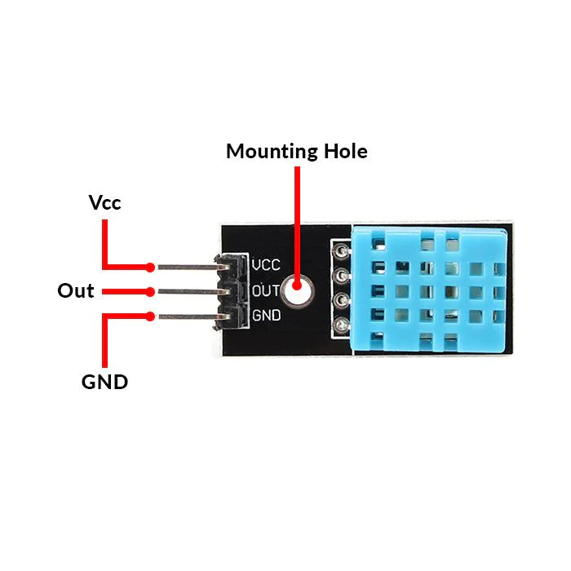

Fig 1.4 DHT11 Sensor

Specification:
- Vcc: Power supply 3.5V to 5.5V
- Data: Outputs both Temperature and Humidity through serial Data
- NC: No Connection and hence not used
- Ground: Connected to the ground of the circuit

Soil Moisture Sensor:

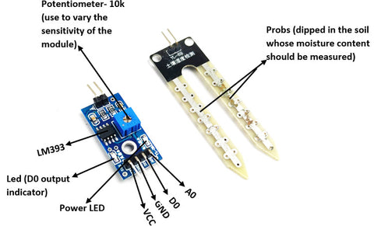

Fig 1.5 Soil Moisture Sensor

Specification:
- Operating voltage:3.3v to 5v DC
- Operating current: 15mA
- Output Digital - 0V to 5V, Adjustable trigger level from preset
- Output Analog - 0V to 5V based on infrared radiation from fire flame falling on the sensor
- PCB Size: 3.2cm x 1.4cm

1.3.2 Software and its Specification

(i) Arduino Cloud | Version: 1.8.19  Contains a text editor for writing code, a message area, a text console, a toolbar with buttons for common functions and a series of menus.
(ii) Microsoft Office | Version 2013
(iii) Draw.io | for Diagrams

CHAPTER 2
BACKGROUND AND RELATED WORK

Related Work

Here we are building a IoT based Irrigation System using ESP8266 Node MCU Module ,DHT11 Sensor and soil moisture sensor . It will not only automatically irrigate the field based on the moisture level in the soil but also can display the Data from Arduino cloud Server.

Internet of things

During the late 90s, Kevin Ashton, a director at AUTO-ID centre at the Massachusetts Institute of Technology (MIT), coined the term Internet of Things (IoT) [5]. Ashton explained that he wanted a system that “empowers computers with their own means of gathering information, so that they can see, hear and smell the planet for themselves, altogether its random glory”.

In other words, IoT will be accustomed link the physical world to the digital world through the internet [5]. As of today, IoT remains developing as more objects are adopting this method [6]. The word “things” within the internet of things will be applied to all or any styles of devices that may be utilized in lifestyle while the words “internet'' refers to the wireless connection made through the web [7]. The main objective of IoT is to attach several devices to every other and this may be finished the assistance of various technologies, like frequency Identification (RFID), Wireless Sensor Networks (WSN) and Cloud Computing [6].

Through IoT, individuals should be ready to access and control their devices whenever and wherever they need as long as they're connected to the internet [3]. As an example, in an exceedingly smart home, IoT devices will be able to control the temperature and therefore the light. As mentioned, IoT as a system relies heavily on the internet for it to function and it's therefore highly at risk of security breaches [3] for instance, a tool will be hacked by individuals that ought to not have access to that the particular authorised user can, because of these attacks
suffer from severe privacy violations. Therefore, implementation of security measures is crucial to make sure that the privacy of the users is violated. IoT is attacked in several ways supported where the attack occurs. as an example, attacks can either be physical or dematerialized. With physical attacks, the attacker has access to the device itself and might therefore destroy it or temper with it physically [7].

However, security breaches through physical attacks don't seem to be relevant for this thesis and can therefore not be examined or considered throughout the remainder of this paper. Dematerialized attacks, on the opposite hand, don't require physical access. Instead, an attacker can target the software round the device to attack [7], meaning either the network layer, the applying layer, or the transport layer. Attacks on the network layer mean that the attacker aims to disturb the web communication between two devices, as an example by targeting the traditional routing information or the traffic analysis. These forms of attacks can as an example be executed with the assistance of spoofing where the attacker is in a position to swap the transmission of legitimate data to instead transmit malicious data. Attacks on the appliance layer are executed to focus on the end-user software of the IoT devices [7] the often attacked with the assistance of Denial of Service (DoS) attacks which are applying layer are commonly wont to exhaust the available resources of the server, like the memory or the bandwidth of [8]

By exhausting the resources, the client’s legitimate access to the server is going to be denied. Attacks within the transport layer implies that the delivering of information between devices may well be in danger. so as to deliver data between devices of IoT [7], transmission control protocols (TCP) are used. Similarly, to the applying layer, within the previous paragraph, the transport layer may also be attacked with the assistance of DoS attacks which during this case aim to exhaust and monopolize the information delivering function of the protocols. In this project, the most focus are going to be on attacks that occur within the Application layer of IoT, particularly the Message Queuing Telemetry Transport (MQTT) protocol which could be a quite common standard that's implemented on top of the TCP [9].

Github

GitHub, Inc. is an Internet hosting service for software development and version control, with software feature requests, task management, continuous integration, and wikis for every project. It is commonly used to host open source software development projects. As of June 2022, Hub reported having over 83 million developers and more than 200 million repositories, including at least 28 million public repositories. It is the largest source code host as of November 2021. It provides the distributed version control of Git plus access control, bug tracking,

Background
According to the research, the user and the system engage with one other sporadically. Although other parking systems have distinct protocols, awareness of a parking system like the one at Sunway Pyramid, the method is often as follows. As soon as the consumer clicks the machine's button, a ticket will emerge, which he should take before the gate opens. The client will now move to the accessible space. The green light bulb on top of each available lot designates the spots that are still available. The red light over the parking lot signifies either a reserved place or a vehicle parked there. There is a sensor available that will read the card if the user is using a "touch and go" (Malaysian prepaid card), and if there is enough money, the system will deduct the charges. However, there are cash payment devices that the consumer can slip his ticket into, and the machine will read it, estimate the number of hours spent, and calculate the amount the user must pay. The customer must put the amount of money specified by the system
into the machine. The ticket will be verified by the system and given 15 minutes, which is ample time for a person to drive their car to the closest exit gate.
A number of technologies have been deployed in the endeavor to solve the parking problem. While some parking solutions are deployed as stand-alone technologies in some situations, in other situations multiple technologies are combined to achieve a given goal.

These technologies include-
- Camera-based sensor technology
- Infrared sensor technology and
- Ultrasonic sensor technology.

- Camera-based sensor technology Access control systems have been developed and installed in various parking lots. At the airport in Cape Town, an access control point was put in place. It works in such a way that a driver requests for a ticket at the entrance of the parking by pressing a button. When a ticket is issued, the driver is granted access to enter the parking bay [5]. The ticket issued is marked with a code that records the time of entrance to the bay. At the time of exit, the driver has to pay for the time the car spent in the bay. Payment is done by inserting the ticket in another machine which reads the code on the ticket and calculates the amount of time spent. Then a parking fee is charged according to the time spent. Sensors are used at entrance and exit points to keep track of the cars in and out. A display board (variable message sign) is used at the entrance to show whether the bay is full or still has unused slots. This technology helps with the management of payment of use of the parking bays. It also gives users a general idea of the number of available parking slots by displaying a message like “level 1 full”. However, 5 it doesn’t give much help to the driver in finding an exact parking space in the shortest time possible nor allows localization of his car in a given parking spot using for example Radio Frequency Identification (RFID) technology.

- Infrared sensor technology In Cavendish shopping mall in Claremont, Cape Town, and the access control system is used as well as another system that checks the status of each parking point. The system uses an infrared sensor to detect if a car is parked in a place. A light is fitted above each parking point to show the status. The light operates in the same way as the traffic lights on the road. However the meaning attached to the light colors is slightly different. A red light means that there is a car parked while a green light is used to express a free parking. There
is a section designated for parents with kids. This section has an orange light to show that parking is meant for parents with children. This section also uses the red and green lights to show whether the parking spot is free or used. Another section is reserved for the disabled. It is marked with a blue light. This section also uses the red and green light to show the status of the parking. This system is helpful to the drivers once they go through the entrance. It is relatively easy for the driver to look ahead and figure out where there are green lights in the bay. However, this is only possible for the corridor in which the driver is moving through. The driver has to keep looking until they can land on a green light. However, there is still a likely flaw that a driver may see a green light yet find it red and in-use by the time he reaches the spot.

- Ultrasonic sensor technology: Siemens AG developed a similar system (SIPARK) that uses ultrasound sensors. These are installed above every single parking to determine whether the parking space is occupied or not [12]. This has been used in more than 70,000 parking spaces. The system is being used with better pay points that accept a wide range of payment options ranging from cash to noncash options such as credit cards. In a report by M. Crowder and C. Michael Walton, the need for intelligent transportation systems (ITS) is examined across a wide range of places [8]. These include business districts, airports, and transit stations. The report emphasizes that university premises are yet a new pressure zone with an increasing need for a parking solution. This report further details the need for real time provision of information to motorists as a remedy to reduction in traffic congestion. Among the systems examined in this report are: Saint Paul Advanced Parking Information system (St Paul APIS) in Minnesota, Phoenix Arizona intelligent parking system, Seattle center APIS, and a few others. In the St Paul APIS [8], static signs are placed in town to direct motorists to where the parking bays are located and the general condition of the road. These signs variable message signs(VMS) have the ability to display different messages as Set by the traffic control staff. Parking could be an expensive process in terms of the money or the time and effort spent. Current studies have revealed that a car is parked for 95 percent of its lifetime and only on the road for the other 5 percent [9].

If we take England in 2014 as an example, on average a car was driven for 361 hours a year according to the British National Travel Survey [10] yielding about 8404 hours in which a car would be parked. Now where would you park your car for these very long hours? Cruising for parking is naturally the first problem caused by the increase of car owners globally. On average,
30 percent of traffic is caused by drivers wandering around for parking spaces [1]. In 2006, a study in France revealed an estimation that 70 million hours were spent every year in France only in searching for parking which resulted in the loss of 700 million Euros annually [11]. In 2011, a global parking survey by IBM [2] stated that 20 minutes are spent on average in searching for a coveted spot. With these statistics, we can predict that a great portion of global pollution and fuel waste is related to cruising for parking [12]. Parking spaces are found to be more than plenty in some places and very rare to find in others. Pricing policies had played an important role in the overall parking 10 Literature Review availability for decades [13].

Here comes the important question: do we need to have more parking spaces or do we need better parking management? Numerous countries are working to manage their current transportation systems and road infrastructure to enhance traffic flows, mobility and safety [5]. Emerging from these motivations is the concept of Intelligent Transportation Systems (ITS). ITS are advanced applications applied to transport and infrastructure to exchange information between frameworks for enhanced productivity, safety and environmental performance. ITS vary in technologies applied, from basic management systems; navigation systems, traffic control systems, speed cameras, variable message signs; and to more advanced applications that fuse live information and feedback from other sources, such as Parking Guidance and Information (PGI) systems and Parking Reservation Systems (PRS).

CHAPTER 3

PROPOSED METHOD

Working Flow

First we sense the land condition using soil moisture sensor and DHT11 sensor. This data is send to dashboard if tha threshold value is less than 30% then tha motor will get on automatically.if the threshold value greater than 30% then motor will get off.at last using Nodemcu wifi model sending data to Arduino cloud.
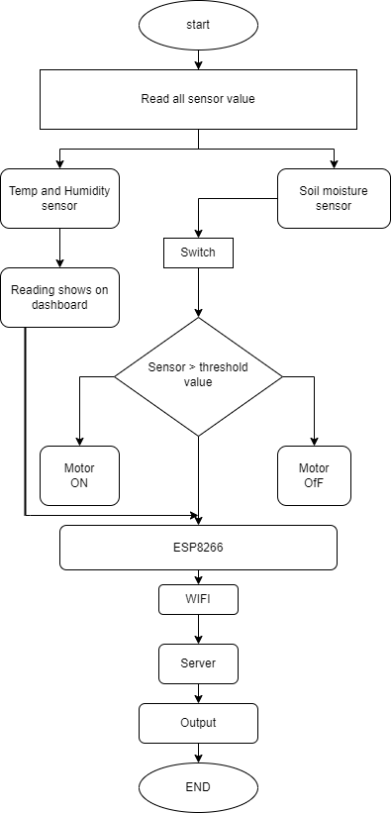

Fig. 3.1 Flow Chart of iot based smart irrigation system

IMPLEMENTATION
For implementation, Arduino Cloud is used. The code written consists of 122 lines. The code can be found on Github.
For Reference get a look at the github.io link: [4]

IoT Based Smart Irrigation Code
Dht11 Sensor check the temperature and humidity of present in the air . The Soil Moisture Sensor check the water content in the soil. The water pump on/off based on soil moisture threshold value.

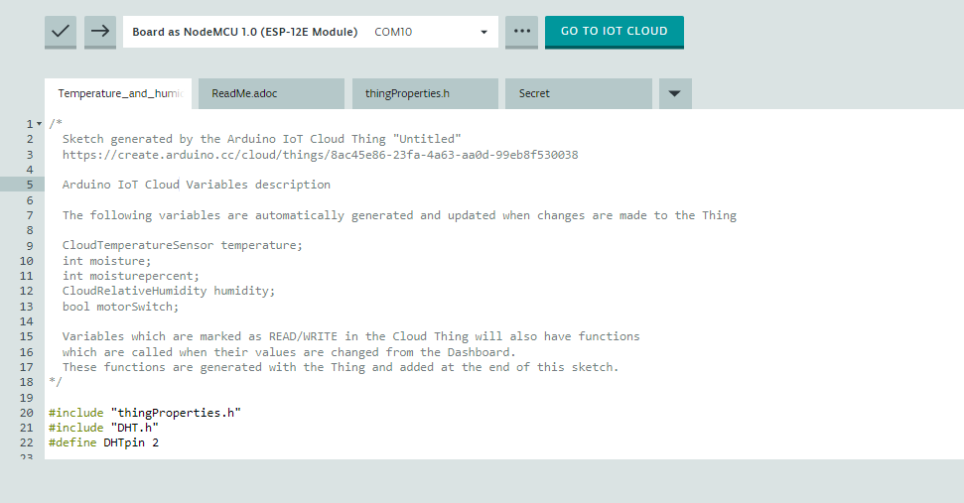

Fig 3.1 Code Slide 2

Fig 3.1 Code Slide 1
We are taking here bourdrate (9600) and also give the delay (2000). Also select relay pin as output mode.
We connect the server via Ardino iot preference connection.
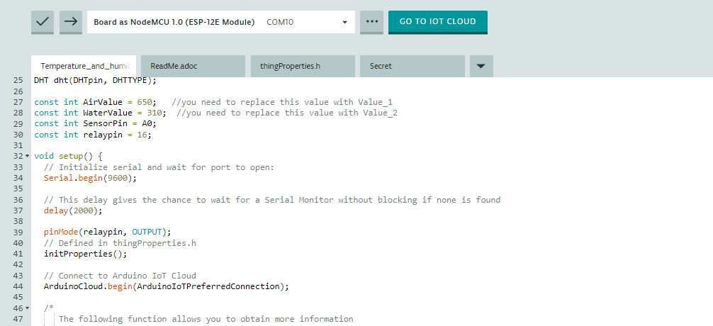
Fig 3.1 Code Slide 2 | .

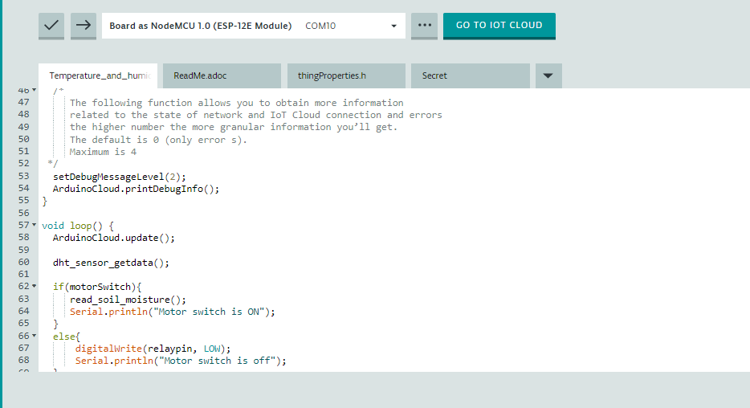

Fig 3.1 Code Slide 3

In fig 3.1 code slide 3 we read soil moisture and as per calculation pump will get ON & OFF and also print of the status of the pump

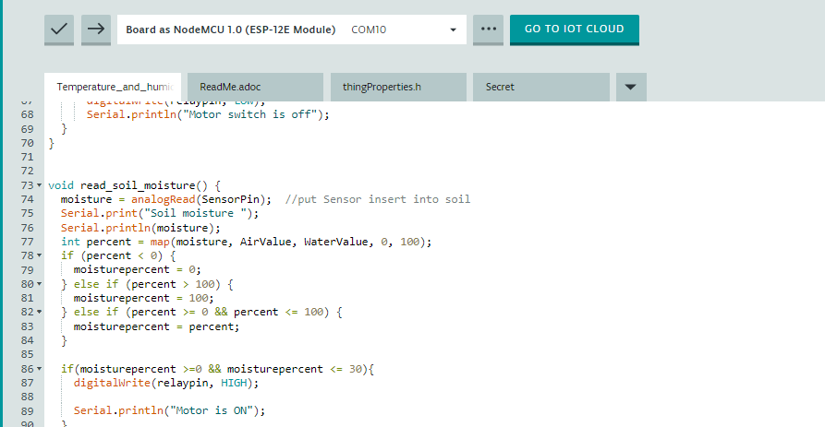

Fig 3.1 Code Slide 4

In fig 3.1 code slide 4 To read the soil moisture via moisture sensor in percentage as per their calculations.If soil moisture percentage is 0 to 30 range then pump gets ON .

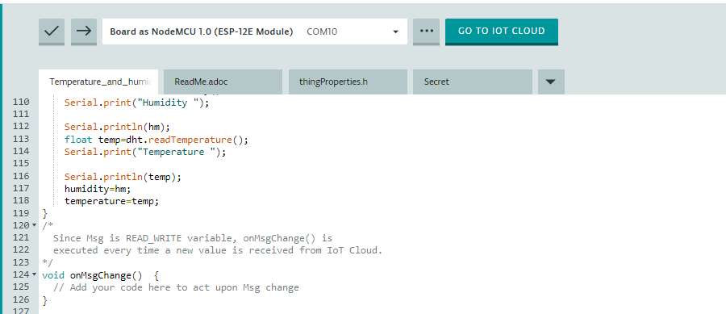

Fig 3.1 Code Slide 5

In fig 3.1 code slide 4 To read the soil moisture via moisture sensor in percentage as per their calculations. if soil moisture percentage is 30-100 motor gets off.

IoT Based Smart Irrigition System

The prototype of the self-parking system was made in consideration of the related work done in the field beforehand. The prototype works as per the functionalities discussed above, with some minor mechanical errors, which can be fixed by using adamant resources and tweaks in calculation for motor drivers.

Fig. 3.4 Prototype

CHAPTER-4

LIMITATION AND ENHANCEMENT

Limitations

    - The disadvantages of automatic irrigation are: costs for purchasing, installing and maintaining the equipment.
    - Reliability of irrigation system (due to human error when setting up) increased maintenance of channels and equipment to ensure it is working properly..

Enhancement

  - A proper sensor and code can be implemented using industrial-grade building software.

  - The owner of the agriculture can get a precise location of where the sensor is located and the duration of data we get on cloud.

  - Irrigation data can be made available to owners and relevant authorities by granting them real- time cloud access

  - The pump ON/OFF can be totally automated using esp8266 technology.

CHAPTER 5 CONCLUSION

We have successfully designed and implemented a smart irrigation system using the concept of Internet of Things. This automated irrigation system is easily controlled using a computer. It behave as an intelligent switching system that detects the soil moisture level and irrigates the plant if necessary.

I conclude that this system is easy to implement and time ,money and man power saving for irrigating fields.
A farmer should visualize his agriculture lands moisture content from time to time and water level of source is sufficient or not. IoT based smart irrigation system displays the values of sensors continuously in smart phone or on computers web page and farmer can operation them anytime from and anywhere.

REFERENCES

