

**CMPE-277: Smartphone App dev**

**Assignment: Android Datastorage**

|  |  |
| --- | --- |
| **Submitted To** |  |
| Prof. Chandrasekar Vuppalapati |  |
| **Date of Submission** |  |
| 4th April 2017 |  |
| **Submitted By** |  |
| Pooja Shah  010828311 |  |

**Objective:** Using Android SQLite, develop a simple product item performing insert and search operations.

**Project Code:** <https://github.com/poojashah89/CMPE-277-Android-App-Development/tree/master/Ass5-Datastorage>

Figure 1 shows the mobile application with two options.

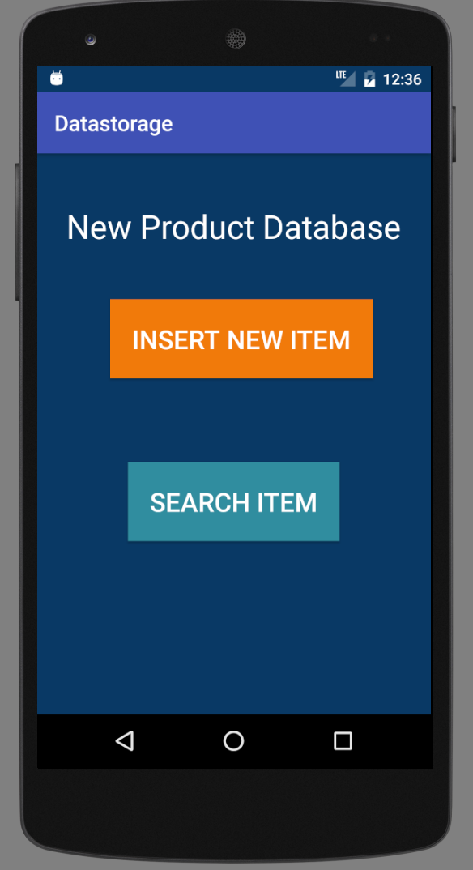

Fig 1 Mobile application with Insert and Search options

Fig 2 shows the screen to enter item details. Enter item name, item description, price and review of the item. Click on Add and It will create a database and save entry in a table. Cancel operation will go back to the previous screen.

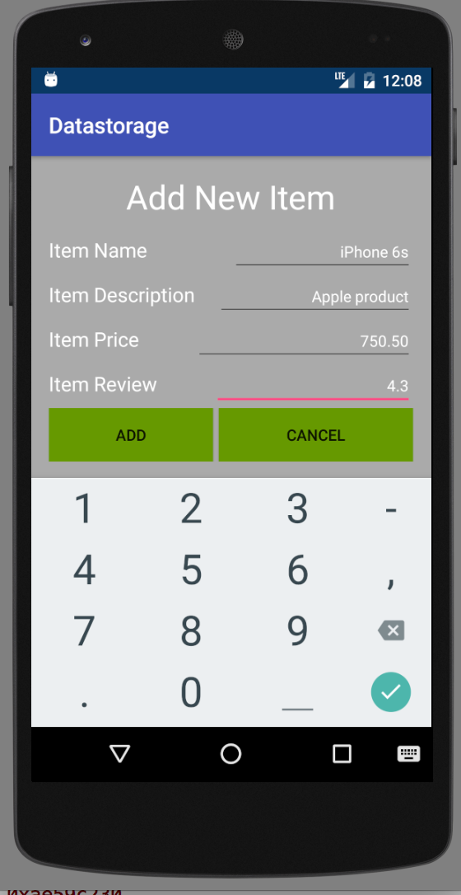

Fig 2. Add Item

Fig 3 shows the search screen. Enter item name and hit search and you will get the result.

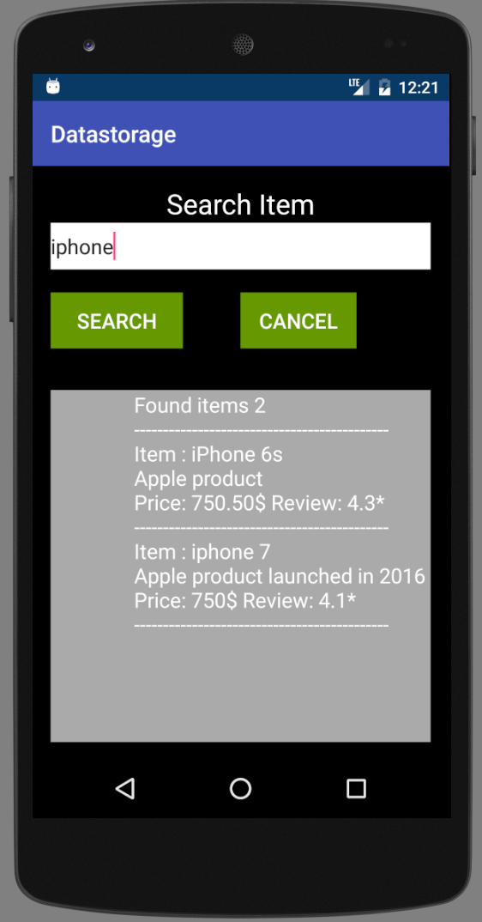

Fig 3. Search screen

Figure 4 shows the search scenario if no item found.

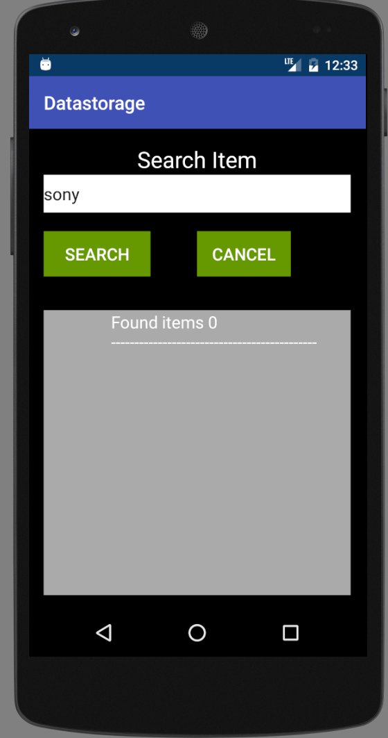

Fig 4. Search screen