**ASSIGNMENT 2**

Farm IoT – Broadcast Receiver

POOJA SHAH: 010828311

**Objective**: The goal of the assignment is to apply broadcast receiver to send and receive data between activities.

**Code**: <https://github.com/poojashah89/CMPE277_FarmIoT>

**Scenario 1**

* Fig 1 shows the main IoT application in which temperature and humidity values will be loaded. Values will be broadcasted to other application.

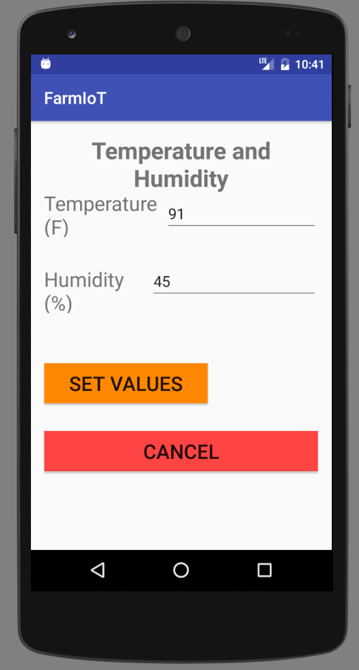

Fig 1. Screenshot of an FarmIoT application

* Fig2 shows the IoTAutomate application which automatically detects that the values of temperature and humidity are above level and fan and sprinkler is turned on.
* Fig 3 shows the FarmManager application which is an application which controls the fan and sprinkler sensor and can be turned on or off manually.

|  |  |
| --- | --- |
| Fig 2. IoTAutomate application: after setting temperature (91F) and humidity (45%) values | Fig 3. Farm Manager application: Manual application with temperature (91F) and humidity (45%) values |

* When you click on FAN AND SPRINKLER ON, the button turns the fan and sprinkler off. Fig 4 shows the status of fan and sprinkler in off mode.

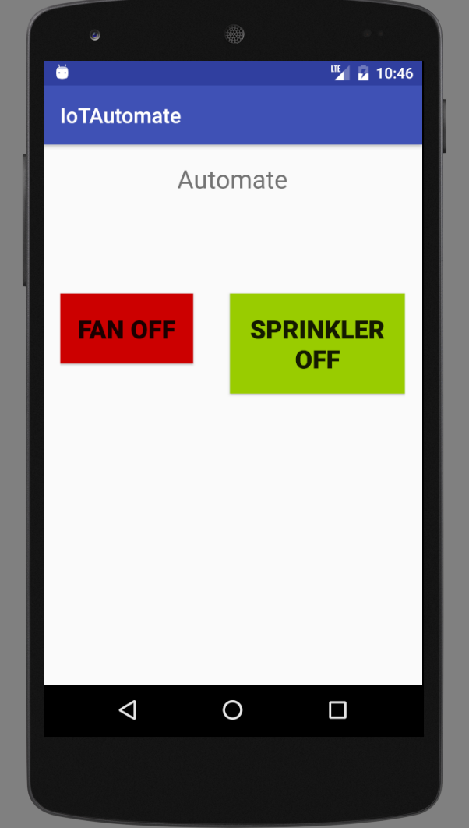

Fig 4. Fan and Sprinkler OFF mode on IoT Automate application

**Scenario 2**

* When temperature and Humidity values are below level, values will be broadcasted to fan and sprinkler sensors and Fig 5 shows the simulation.
* Fig 6 shows the IoTautomate application to show the Fan and Sprinkler status which is set to off because of temperature and humidity values 69F and 23% respectively.

|  |  |
| --- | --- |
| Fig 5. FarmIoT application with below level values | Fig 6 IoT Automate application with Fan and Sprinkler OFF |

* Fig 7 shows the Farm Manager application which is now in off state and once you press any of the buttons, fan or sprinkler or both will set to OFF.
* Fig 8 will show the automatic reply when just FAN OFF is clicked in fig 7.

|  |  |
| --- | --- |
| Fig 7 Farm Manager Application | Fig 8 FAN ON and Sprinkler OFF after clicking on FAN OFF which turns on the fan |

DESCRIPTION

In this assignment, I have created 3 applications with 2 Receiver classes.

1. FarmIoT application :

broadcastValues.setAction(**"com.assignments.sjsu.poojashah.temphumidity"**)

*//Broadcasting temperature Value*broadcastValues.putExtra(**"Temperature"**, **tempVal**);

*//Broadcasting Humidity Value*

broadcastValues.putExtra(**"Humidity"**, **humidityVal);**

This line of code will send temperature and humidity values to FarmManager Application

1. FarmManager application with receiver class ‘MyReceiver’

Manifest file contains the information of receiver class.

<receiver android:name=".MyReceiver"></receiver>

MyReceiver which is a Receiver class will take the values that are broadcasted and checks for the limit values. Accordingly, values will be boardcasted.

1. IoTAutomate application with receiver class ‘AutomateReceiver’

Manifest file of IoTAutomate application contains :

<**receiver android:name=”.AutomateReceiver”**>  
  
 <**intent-filter**>  
 <**action android:name=”com.assignments.sjsu.poojashah.fanon”**></**action**>  
 <**action android:name=”com.assignments.sjsu.poojashah.fanoff”**></**action**>  
 <**action android:name=”com.assignments.sjsu.poojashah.fansprinkleron”**></**action**>  
 <**action android:name=”com.assignments.sjsu.poojashah.fansprinkleroff”**></**action**>  
  
 </**intent-filter**>  
</**receiver**>

These are the broadcasted values from FarmManager application and according to the satisfied condition valued will be received.