

**CMPE-277: CLOUD SERVICES**

TH Sensor driver using Async Task

|  |  |
| --- | --- |
| **Submitted To** |  |
| Prof. Chandrasekar Vuppalapati |  |
| **Date of Submission** |  |
| 20th March 2017 |  |
| **Submitted By** |  |
| Pooja Shah  010828311 |  |

**Objective:**

Using Async task, generating random values and updating UI. Used random generate function to generate values for Temperature, Humidity and Activity Inputs. Number of Sensor Readings value controls the iteration count to generate the random values.

**Project Code:**

<https://github.com/poojashah89/CMPE-277-Android-App-Development/tree/master/Ass4-THSensorDriver>

**Temperature Humidity Sensor Driver**

Fig 1 shows the layout of the application. You need to enter all values for Temperature, Humidity, Activity and number of sensor reading values. Number of sensor reading will decide the number of output.

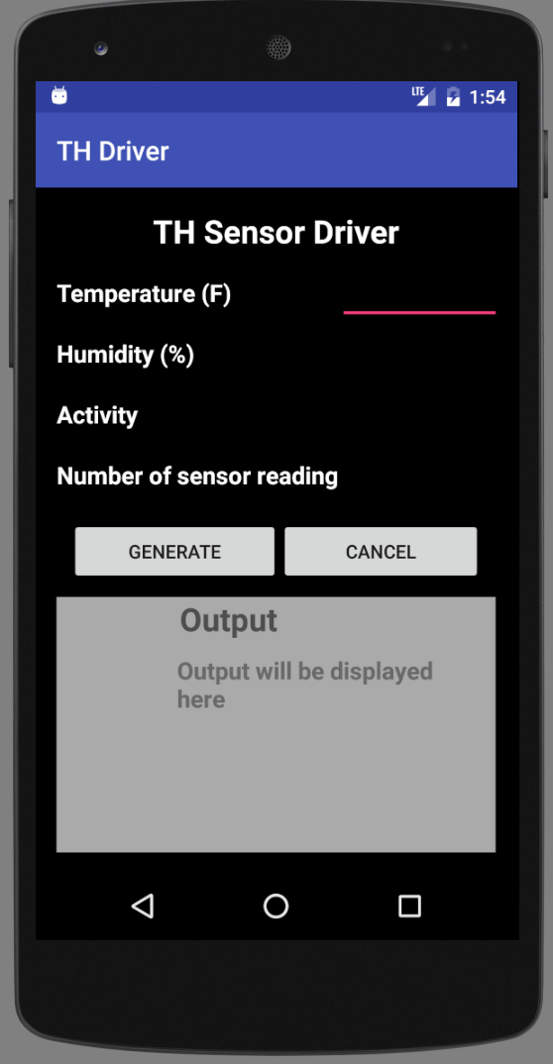

Fig 1. Application

**2. Generate Values**

After clicking on Generate, values will be generated in doInBackground method and UI will be updated accordingly. As per the requirement, java thread is not used but async task will put all values in worker thread and postExecute will display the result on UI.

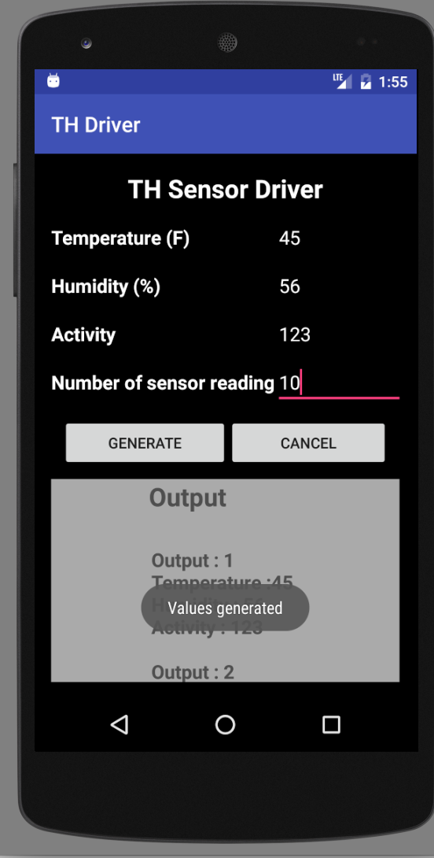’

Fig 2. Toast message after values generated

**3. Result**

Fig 3 shows the values generated based on Number of sensor reading

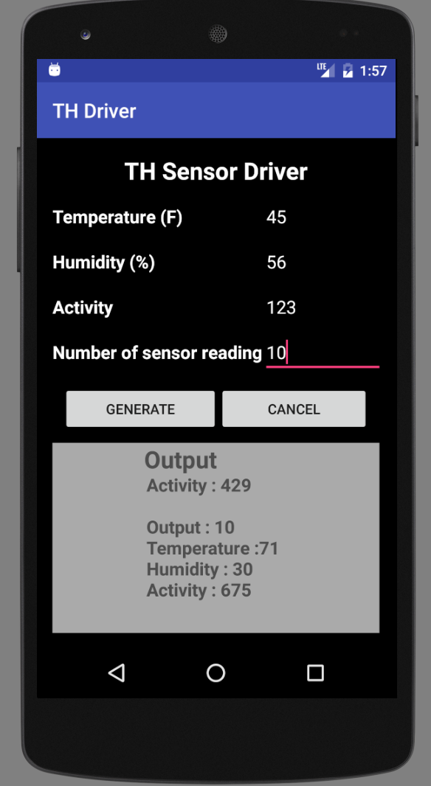

Fig 3. Generated output values

**4. Cancel Task**

Task is stopped once you click on cancel and the doInBackground will be interrupted.

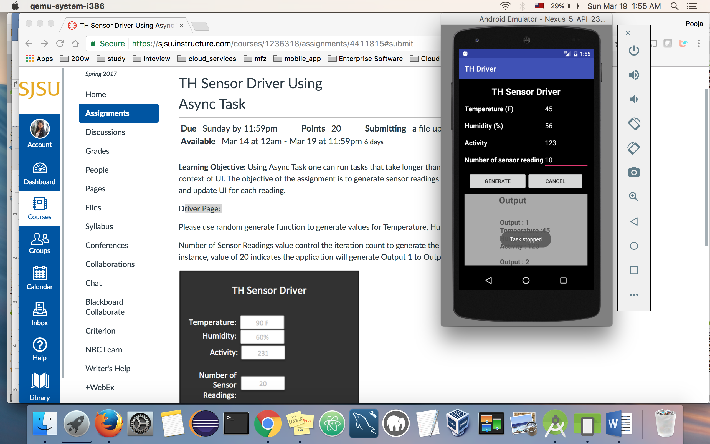

Fig 4. After cancel button is clicked