Section1:Delivery Delay Analysis

Query 1: Average Delivery Time by Restaurant
Business Question:
Which restaurants have the longest average delivery times?
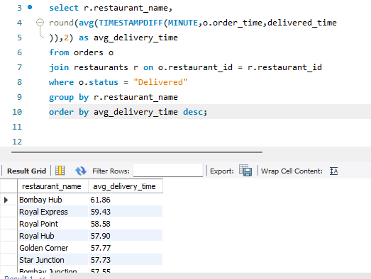
Business Insight
- Identifies restaurants with consistently slow deliveries.
- Management can investigate kitchen delays or operational issues.
Query 2: Top 10 Slowest Restaurants
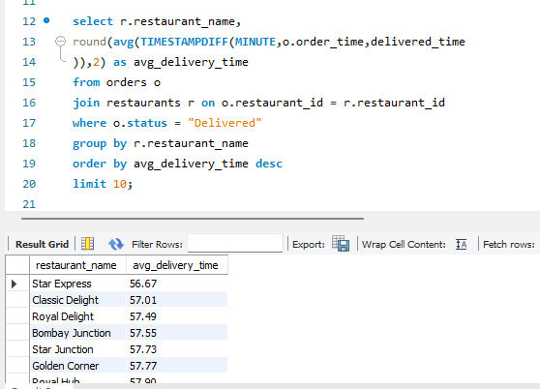
Business Insight
These restaurants should be prioritized for operational improvement.
Query 3: Fastest Restaurants
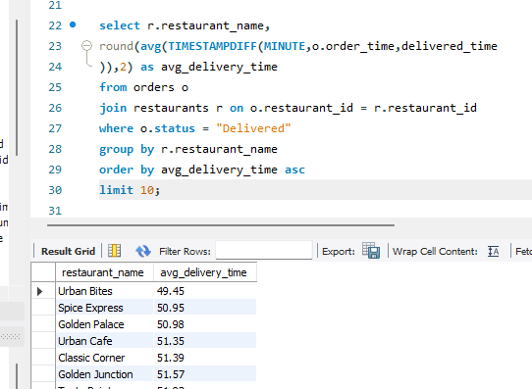
Business Insight
These restaurants represent best practices that can be replicated.
Query 4: Average Delivery Time by Delivery Partner
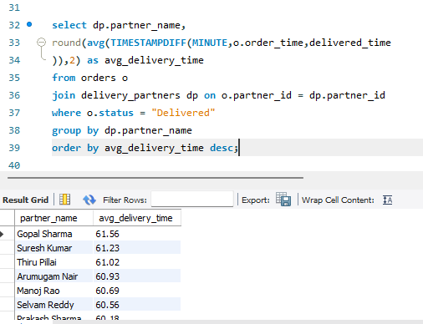

Query 5: Top 10 Slowest Delivery Partners
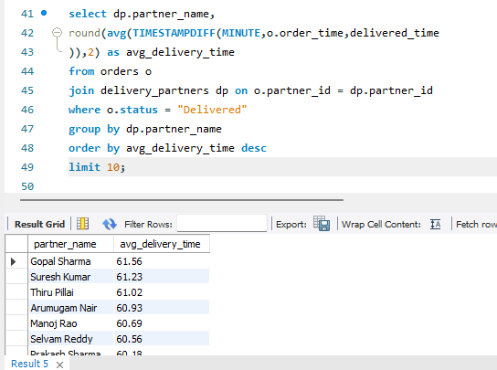

Query 6: Top 10 Fastest Delivery Partners

Query 7: Average Delivery Time by City
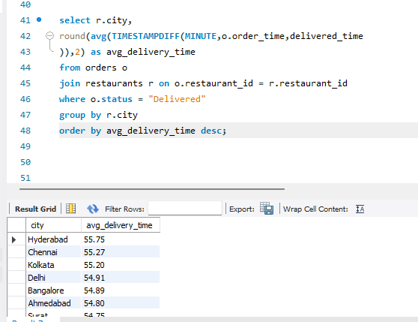

Query 8: Delivery Time by Cuisine
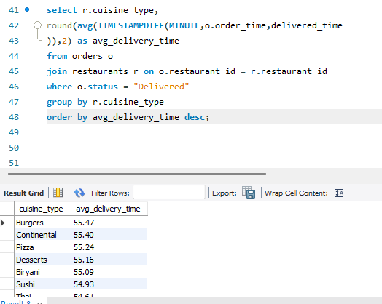

Query 9: Overall Average Delivery Time
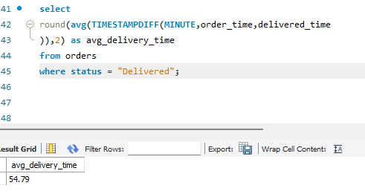

Query 10: Longest Delivery Ever
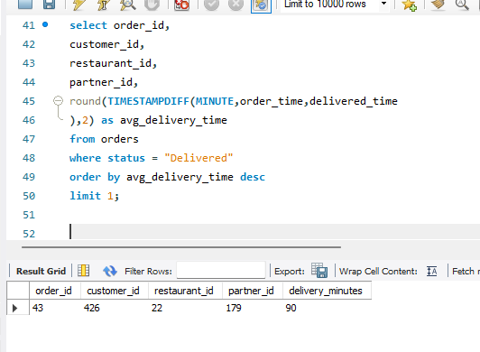

Order Cancellation Analysis
Query 11: Total Cancelled Orders
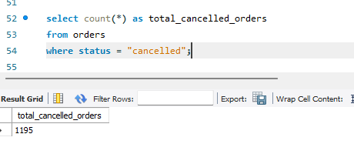
Business Insight: Gives the overall number of cancelled orders, which is a key operational KPI.
Query 12: Cancellation Rate
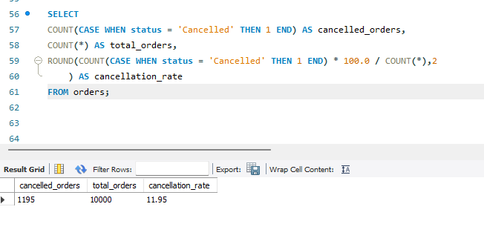
Business Insight: Shows what percentage of all orders are cancelled.

Query 13: Restaurants with the Highest Cancellations
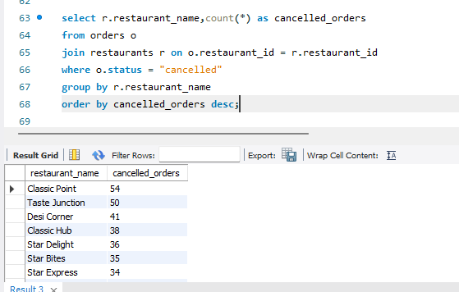
Business Insight: Highlights restaurants that may have operational or inventory issues.

Query 14: Top 10 Restaurants by Cancellation Count
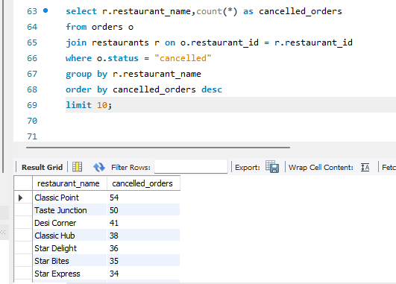

Query 15: Cancellation Rate by City
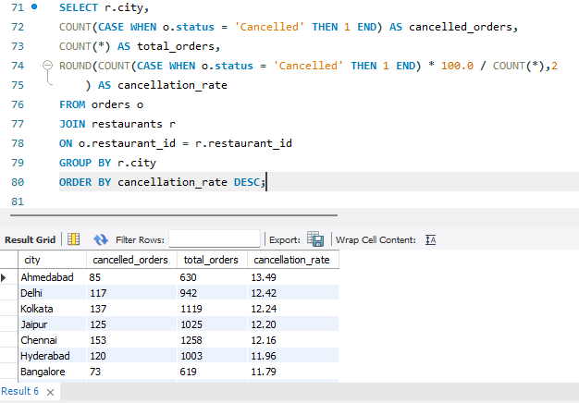

Query 16: Cancellations by Cuisine Type

Query 17: Cancellations by Payment Mode
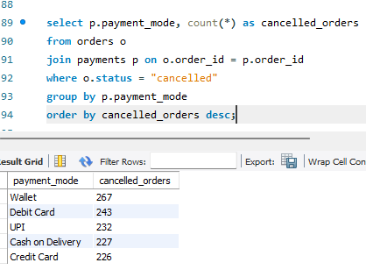
Business Insight: Helps determine whether a particular payment method is associated with more cancellations.
Query 18: Monthly Cancellation Trend
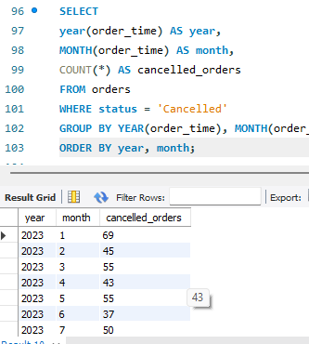

Revenue Optimization Analysis

Query 21: Total Company Revenue
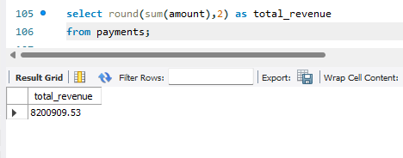
Business Insight
Shows the total revenue generated by the company.

Query 22: Top Revenue-Generating Restaurants
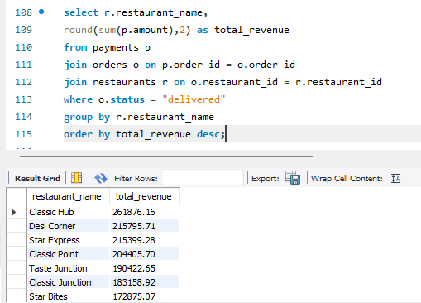
Business Insight
Identifies restaurants contributing the highest revenue.

Query 23: Top 10 Revenue-Generating Restaurants
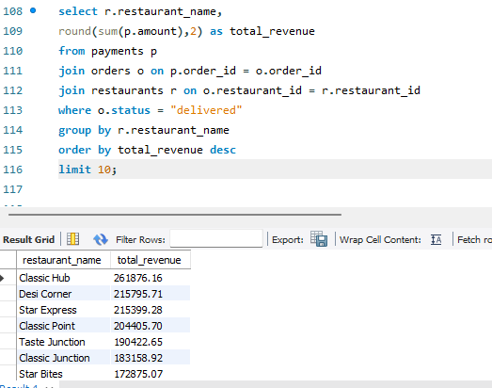

Query 24: Revenue by City
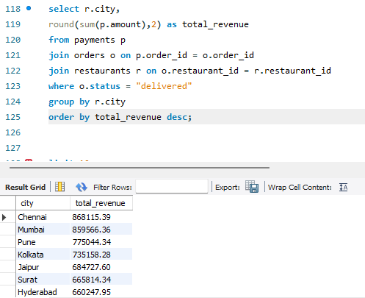
Business Insight
Shows which cities generate the most revenue.

Query 25: Revenue by Cuisine
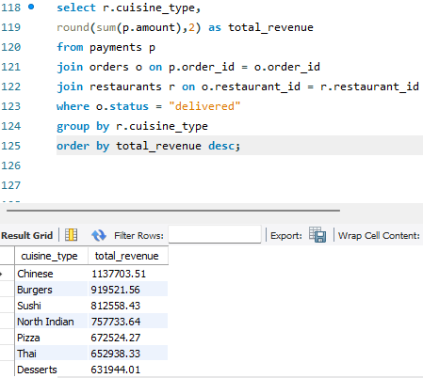

Query 26: Revenue by Payment Method
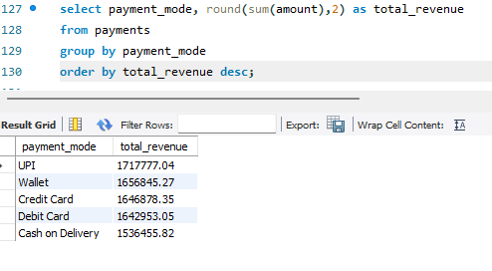

Business Insight
Identifies which payment methods contribute the highest revenue.

Query 27: Monthly Revenue Trend
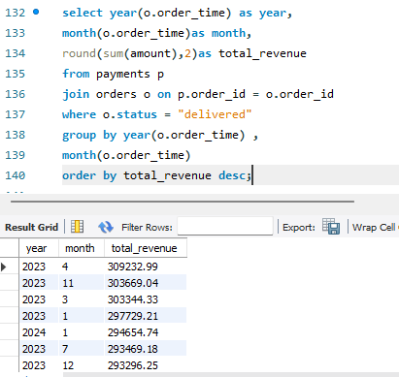
Business Insight
Shows revenue growth or decline month by month.

Query 28: Average Revenue per Order
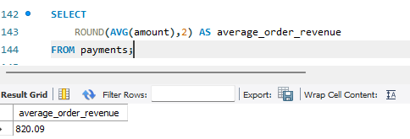

Query 29: Highest Value Order
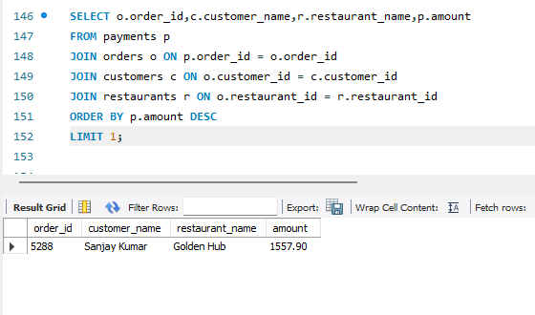

Customer Retention Analysis
Query 31: Top 10 Customers by Lifetime Spending
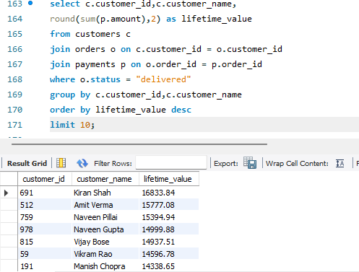
Business Insight:
These customers are your VIP customers and should be targeted with loyalty programs.

Query 32: Customers Who Ordered Most Frequently
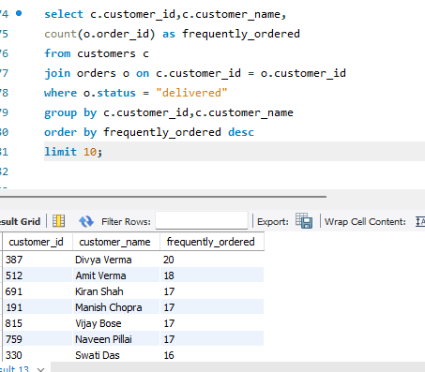

Query 33: Average Order Value per Customer
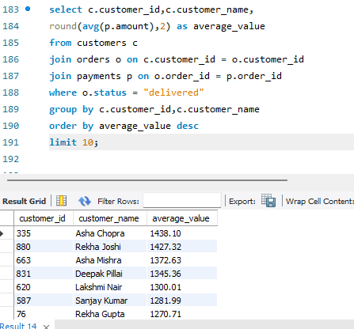

Query 34: Inactive Customers (Using customer_behavior)
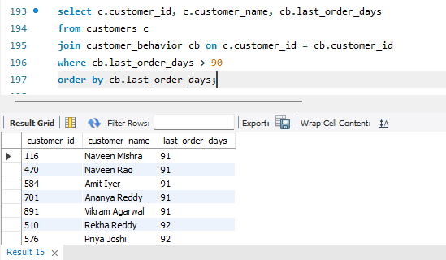

Business Insight:
These customers are candidates for re-engagement campaigns.

Query 35: Churned Customers
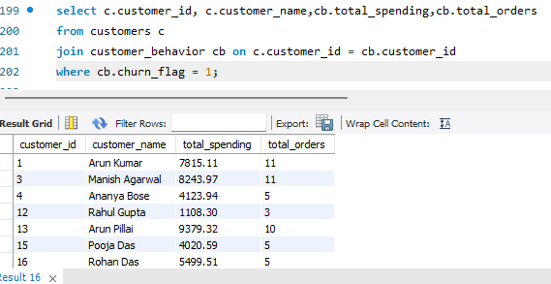

Query 36: Customer Spending Tier (CASE Statement)
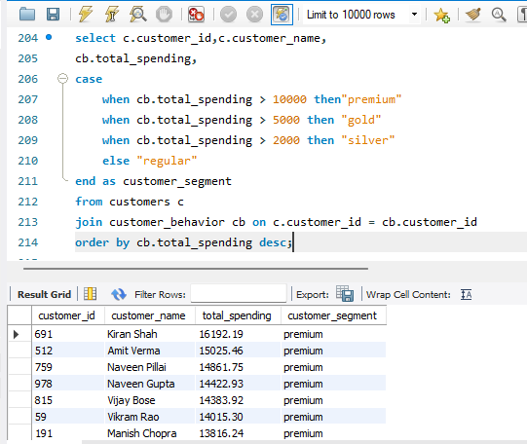

Query 37: Rank Customers by Spending
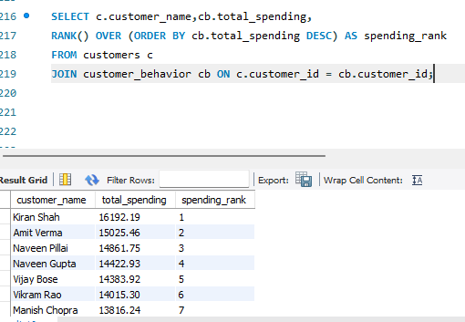

Query 39: Customers Spending Above Average (Subquery)
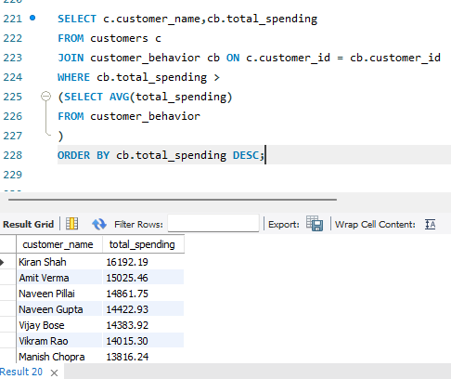

Top 10 Customers Using a CTE
WITH customer_revenue AS
(SELECT c.customer_id,c.customer_name, SUM(p.amount) AS total_spent
FROM customers c
JOIN orders o ON c.customer_id = o.customer_id
JOIN payments p ON o.order_id = p.order_id
WHERE o.status = 'Delivered'
GROUP BY c.customer_id, c.customer_name
)
SELECT * FROM customer_revenue
ORDER BY total_spent DESC
LIMIT 10;
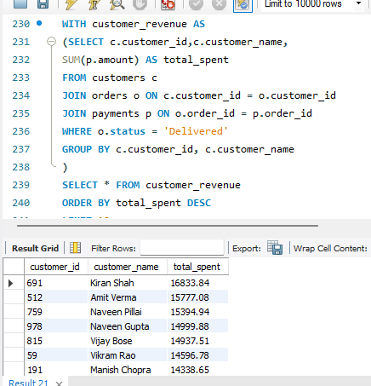

Delivery Partner Performance Analysis
Query 41: Total Deliveries by Each Partner
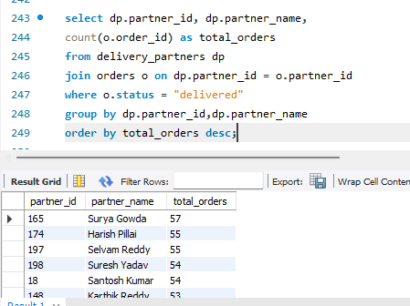
Business Insight
Identifies the busiest delivery partners.

Query 42: Top 10 Delivery Partners
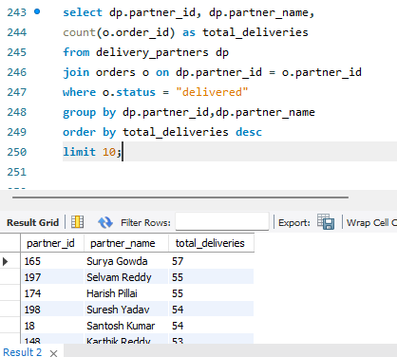

Query 43: Average Delivery Time per Partner
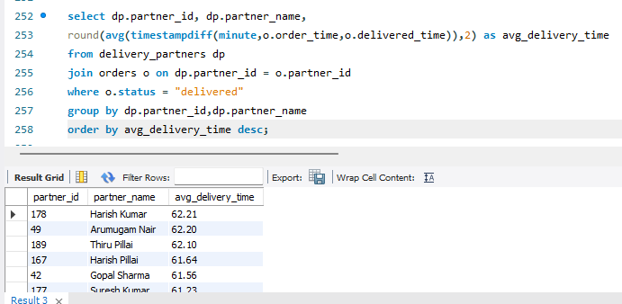

Business Insight
Measures delivery efficiency for each partner.

Query 44: Fastest Delivery Partners
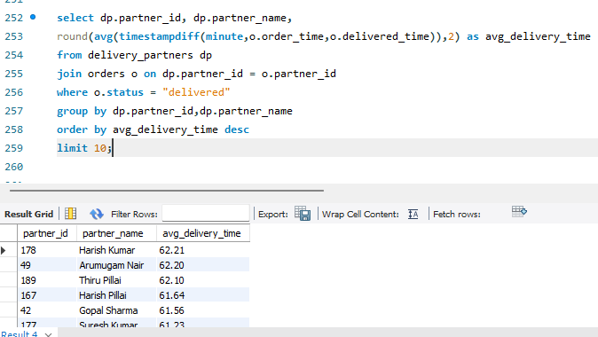

Query 45: Delivery Partners with Highest Revenue
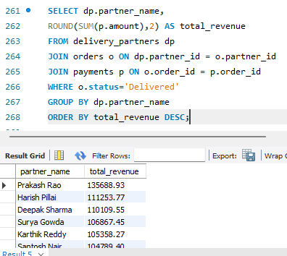

Business Insight
Shows which partners contribute most to company revenue.

Query 46: Performance Ranking (Window Function)
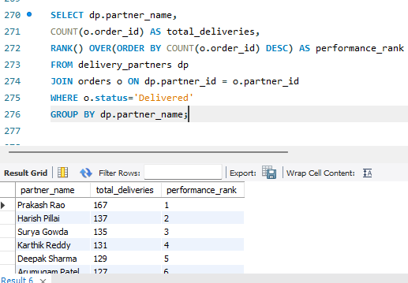

Query 47: Revenue per Delivery Partner
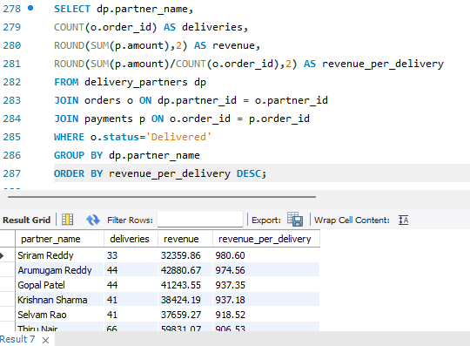

Query 48: Vehicle Type Performance
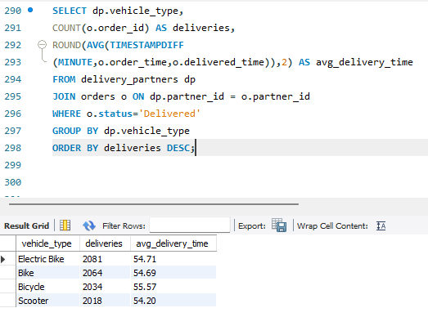

Business Insight
Compares efficiency across different vehicle types.

Query 49: Top Partner in Each Vehicle Type
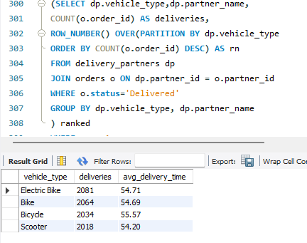

Query 50: Delivery Partner Performance Score
SELECT dp.partner_name,
COUNT(o.order_id) AS deliveries ROUND(
AVG(TIMESTAMPDIFF(o.order_time, o.delivered_time)) 2) AS avg_delivery_time,
ROUND(SUM(p.amount),2) AS revenue,
DENSE_RANK() OVER(
ORDER BY COUNT(o.order_id) DESC,SUM(p.amount) DESC
) AS overall_rank
FROM delivery_partners dp
JOIN orders o ON dp.partner_id = o.partner_id
JOIN payments p ON o.order_id = p.order_id
WHERE o.status='Delivered'
GROUP BY dp.partner_name;

