**Military Weapons and Technology Evolution**

Name: Pooja Sharma

RollNo: 19CH10030

Email: [poojasharma201902@gmail.com](mailto:poojasharma201902@gmail.com)

Phone: 7742689039

IKS TERM PAPER

KS60001

**INTRODUCTION**

Human history is filled with warfare between tribes, nations and empires. The equipment used in war has progressed from *sharpened sticks* and *rocks* to automatic *guns* and *predator missiles*. Each new piece of military technology changes the way people fight and the tactics employed. If you want to know how wars change over time, you have to understand the changes to military equipment.

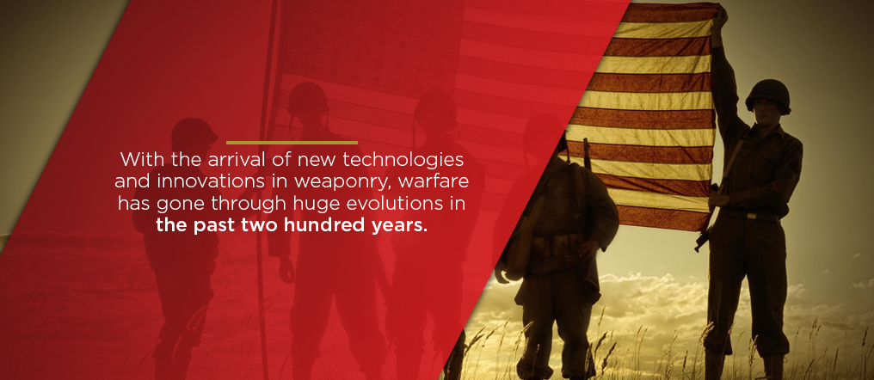

The artillery of the British-Indian Army between 1858 and end of World War 1 (and beyond till 1935) consisted only of the Indian Mountain Artillery and latter’s history during this war can be taken to constitute the history of the Indian Artillery during that titanic struggle. Between 1880s and 1970s, the *mountain guns* in service evolved in design from ‘*2.5 inch rifled muzzle-loading (RML) gun*’ (Kipling’s ‘Screw Gun’) to ‘3.7 inch ***howitze*r**’, but with the gun barrel always in “two bits’, so as to form a load, viable for a large and sturdy Mountain Artillery mule to carry in rough terrain. On coming into action, the two portions of the gun-barrel were screwed together by a threaded collar and a ‘junction nut’, and hence the mountain gun was known as the “Screw Gun”, be it a ‘2.5 inch RML’ (1879-1916), a ‘10 pounder’ (1901-18), a ‘2.75 inch breach loading gun’ (1914-19) or finally a ‘3.7 inch howitzer’ (1915-1970s).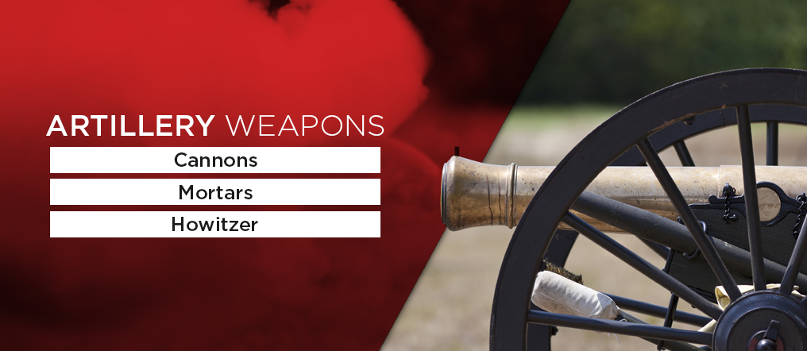

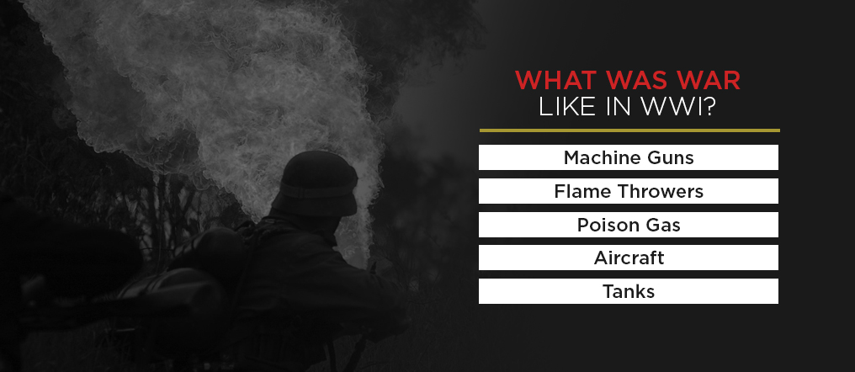

**LITERATURE REVIEW**

**Medieval Weapons**

Knights and Foot Soldiers were the major two types of soldiers back then. There were different styles of fighting like hand to hand combat, sieges and bows and arrows. Siege weapons include ballistas, mangonels, trebuchets and battering rams.

Weapons used were battle axes, maces billhook, caltrop, flail, halbred, hammer etc.

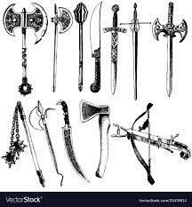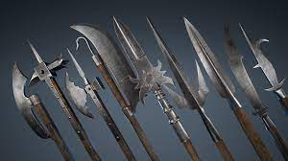

**Today’s Weapons**

Machine Guns

In the Civil War, the Gatling gun was the main weapon troops used to lay down rapid-fire. It was incredibly heavy and resembled a cannon. With major improvements to military technology, heavy-calibre machine guns became a critical part of the war. Hiram Maxim developed the first machine gun in 1884, but the gun was not widely used until WWI when forces on both sides started using several similar designs.

Flame Throwers

WWI gave the weapon a chance to shine at the detriment of those on the receiving end. The close conditions of trench warfare made flamethrowers especially dangerous, as they could catch enemy soldiers on fire without causing structural damage to the trench.

Aircraft

Though aircraft was more significant in World War II (WWII), it still played a roll in WWI and steadily grew in importance as the war continued. Initially, airplanes were used primarily for reconnaissance, providing information about enemy positions. As airplane technology advanced, both sides developed designs for mono and biplane fighters and began mounting machine guns and bombs on the planes.

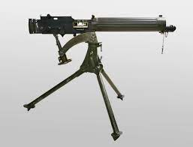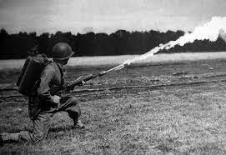

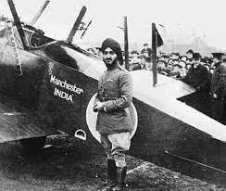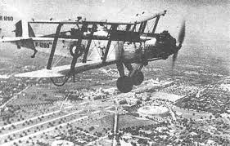

**World War II Equipments:**

Though many modern weapons made their appearance in WWI, WWII brought forward huge changes to the way war was waged. Instead of fighting in trenches, troops began to take cover in shell craters and foxholes, rather than hunker down in set lines. There were also more ways for troops to get to the battlefield, with motorized vehicles, railways and airplanes adding extra speed and leading to an evolution of warfare tactics.

Garand Rifle

Airplanes

The Atom Bomb

**Modernisation from 2011 to 2021**

The Indian military’s quest for modernisation has been long and frustratingly slow, indicating the presence of complex challenges as well as inefficiencies in the system. As of October 2020, the Army required approximately 9.5 lakh assault rifles, 4.6 lakh CQB carbines, over 57,000 light machine guns (LMGs), and around 5,000 sniper rifles, for its over 12-lakh-strong force with more than 380 Infantry and 63 Rashtriya Rifles battalions

Despite these massive gaps, the Indian Army’s Infantry has not seen any substantial modernisation in the last decade. Its standard issue assault rifles are the INSAS (Indian Small Arms Systems), adopted in the 1990s and known for their lack of reliability; and the indigenously produced Trichy Assault Rifle and Ghatak, variants of the famous AK-47. Of these, even the more favourable AK-47 variants have long become outdated, and the Infantry urgently needs a new generation of assault rifles to transform it into a lean and more efficient fighting force.

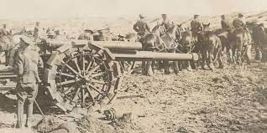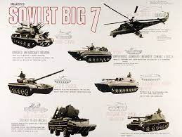

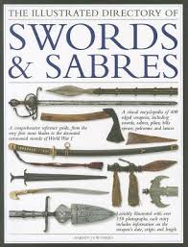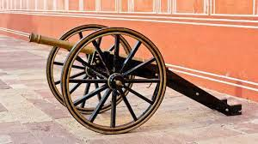

**CONCORDANCES AND DISCORDANCES**

Medieval weapons were far more primitive than modern weapons but they have some similarities. We have evolved from bows and arrows to guns, seige engines to tanks, cannons to missiles and horses to planes. They do the same thing but occur in far different time periods. Our fighting style greatly changed in terms of the technology used but not so much the type of weapons.

In modernising the Indian artillery, key aspects have included the mediumisation of artillery; balancing between *indigenisation* and *foreign procurement*; proper ammunition development (towed, precision, bunker building, and fuel in explosives and air bursts); and ensuring artillery reach. This is evident from the profile of the weapons and weapon systems that have been added to the Indian artillery since 2011

In 2015, it was refitted with Barak 8 long-range surface-to-air missiles (LRSAMs) and a Russian-built AK-630 close-in weapon system for operational purposes. The AK-630 close-in weapon system was taken from the decommissioned Godavari-class ship. The upgrades were deemed necessary as the warship lacked self-protection systems. Barak 8 SAMs were a collaborative effort between the DRDO and several Israeli entities.

India began its platform modernisation some decades ago, with the turret (i.e. the one near the bows) of the old Talwar-class frigates, for example being removed and replaced with anti-ship missiles removed from missile boats. Eponymous “Mid life updates”(MLU) have technical, operational and financial angles to balance. They need budget outlays for replacement hardware; matching refit loading of yards; and finally, maintenance of a minimum operational force level.

Sensors (sonars and radars), self-defence systems (torpedo countermeasures, anti-missile), main guns, torpedoes, and fire-control systems were upgraded with far better indigenous or a few imported upgrades. Among other benefits, logistics and maintenance costs should come down.

Indian Army aims for modernisation, it must adopt a new generation of systems that will not only be dependable in challenging environments and situations, but also give its troops an edge over their adversaries.

**CONCLUSION**

At its core, warfare still requires soldiers to risk their lives to serve their country. It takes courage and discipline to put on a uniform and go into a battle. The level of heroism that the battlefield often requires is part of the reason why so many people remain fascinated by and reverent to the troops, taking trips to pay their respects at national cemeteries, museums and monuments.

Rapid technological advancement and an increasing shift towards information warfare capabilities require the modern Indian artillery to be technology-intensive. The artillery for the 21st century will be dominated by non-linearity, speed, homogenisation, continuity, connectivity, synchronisation, perception management, and deception.[37] The future will involve directing firepower using precision-guided systems that include loitering munitions, radars, and unmanned combat aerial vehicles (UAVs) as well as drones, missiles and rockets. Thus, in the modernisation of the IA’s artillery, the pivotal capabilities are ammunition and precision. While developments in the range of ammunition have already increased the artillery’s reach, surveillance remains restricted, which limits precision

**REFERENCES**

1.Weapons-BharatRakshak-Indian Army& Land Forces

<https://www.bharat-rakshak.com/ARMY/weapons.html>

2.Indian Artillery in World War I-USI <https://usiofindia.org/publication/usi-journal/indian-artillery-in-world-war-i/>

3.Military Equipment <https://www.military.com/equipment>

4.Technology Perspective <https://www.mod.gov.in/sites/default/files/TPCR13.pdf>

5.Futuristic Weapons <https://www.pocket-lint.com/gadgets/news/142272-28-incredible-futuristic-weapons-showing-modern-military-might>

6.Indian Military Platform Modernisation <https://www.orfonline.org/research/indian-military-platform-modernisation/>