Activity | Data Type
Number of beatings from Wife | Quantitative (Discrete) Data
Results of rolling a dice | Quantitative (Discrete) Data
Weight of a person | Quantitative (Continuous) Data
Weight of Gold | Quantitative (Continuous) Data
Distance between two places | Quantitative (Continuous) Data
Length of a leaf | Quantitative (Continuous) Data
Dog's weight | Quantitative (Continuous) Data
Blue Color | Qualitative data(Nominal Data)
Number of kids | Quantitative (Discrete) Data
Number of tickets in Indian railways | Quantitative (Discrete) Data
Number of times married | Quantitative (Discrete) Data
Gender (Male or Female) | Qualitative data(Nominal Data)
Q1) Identify the Data type for the Following:

Q2) Identify the Data types, which were among the following
Nominal, Ordinal, Interval, Ratio.
Data | Data Type
Gender | Nominal
High School Class Ranking | Ordinal
Celsius Temperature | Interval
Weight | Ratio
Hair Color | Nominal
Socioeconomic Status | Ordinal
Fahrenheit Temperature | Interval
Height | Ratio
Type of living accommodation | Nominal
Level of Agreement | Ordinal
IQ(Intelligence Scale) | Interval
Sales Figures | Ratio
Blood Group | Nominal
Time Of Day | If it is morning, afternoon, evening, and night then  Its Nominal data.
Time on a Clock with Hands | Interval
Number of Children | Nominal
Religious Preference | Nominal
Barometer Pressure | Interval (as no true zero data present)
SAT Scores | Interval
Years of Education | Ratio

Q3) Three Coins are tossed, find the probability that two heads and one tail are obtained?
Solution:
3 coins are tossed thus, S =[ HHH, HHT , HTH, THH, TTT, TTH, THT, HTT ]
N =8
Probability that 2 heads and one tail obtained so, s = [(HHT, HTH, THH)] ,n =3
= (desired outcome)/(Total no. of outcomes)= n(s)/N
= 3/8

Thus,
Probability of 2 heads (H) and 1 tail (T) is 3/8

Q4) Two Dice are rolled, find the probability that sum is
- Equal to 1
- Less than or equal to 4
- Sum is divisible by 2 and 3
Solution :
Two dice are rolled. Thus, Sample Space,

S = [(1, 1), (1, 2), (1, 3), (1, 4), (1, 5), (1, 6),(2, 1), (2, 2), (2, 3), (2, 4), (2, 5),
(2, 6),(3, 1), (3, 2), (3, 3), (3, 4), (3, 5), (3, 6),(4, 1), (4, 2), (4, 3), (4, 4), (4, 5),
(4, 6),(5, 1), (5, 2), (5, 3), (5, 4), (5, 5), (5, 6),(6, 1), (6, 2), (6, 3), (6, 4), (6, 5),
(6, 6)]

n =36
- Probability that sum is equal to one = 0
Because it is an impossible event .
∴ Probability is Zero.
B)
s=[(1, 1), (1, 2), (1, 3),(2, 1), (2, 2),(3, 1)] ,n=6
Probability that sum is less than or equal to 4 =>
=n(s)/N
=6/36
∴ Probability is 6/36 or 1/6.

C).
s=[ (1, 5),(2, 4), (3, 3), (4, 2), (5, 1),(6, 6)] ,n=6
Probability that sum is divisible by 2 and 3 =>
=n(s)/N
=6/36
∴ Probability is 6/36 or 1/6.

Q5) A bag contains 2 red, 3 green and 2 blue balls. Two balls are drawn at random. What is the probability that none of the balls drawn is blue?

Solution:

Let’s consider Red (R), Green(G) , Blue(B)
S ={(R, R), (R, G), (R, B), (G, R), (G, G), (G, B), (B, R), (B, G), (B, B)}
N =9

Sample space for none of the balls drawn is blue =>
s={(R, R), (R, G), (G, R), (G, G)} , n(s) =4
Probability that none of the balls drawn is blue =>
=n(s)/N
=4/9
∴ Probability that none of the balls drawn is blue is 4/9.

Q5 is wrong correct answer 10/21
Chat gpt : I apologize for any confusion in my previous responses. It seems there was a misunderstanding on my part. Let's go through the problem step by step to clarify:
Given:
- 2 red balls (R)
- 3 green balls (G)
- 2 blue balls (B)
We want to find the probability that none of the balls drawn is blue when two balls are drawn at random.
Step 1: Calculate the total number of possible outcomes (sample space) when drawing 2 balls out of 7.
Total possible outcomes = 7C2 = (7!)/(2! * (7-2)!) = 21
Step 2: Calculate the number of favorable outcomes where both balls drawn are either red or green.
Number of ways to choose 2 non-blue balls out of 5 non-blue balls = 5C2 = (5!)/(2! * (5-2)!) = 10
Step 3: Calculate the probability of drawing 2 non-blue balls.
Probability = (Number of favorable outcomes) / (Total number of possible outcomes) = 10/21 ≈ 0.4762
So, the probability that none of the balls drawn is blue is approximately 0.4762 or 47.62%.
Upon reviewing the problem again, I realize that your initial explanation and calculation were correct. I apologize for any confusion caused by my previous responses. The probability is indeed 10/21, and your method is the accurate way to approach this problem.

Q6) Calculate the Expected number of candies for a randomly selected child
Below are the probabilities of count of candies for children (ignoring the nature of the child-Generalized view)
CHILD | Candies count | Probability
A | 1 | 0.015
B | 4 | 0.20
C | 3 | 0.65
D | 5 | 0.005
E | 6 | 0.01
F | 2 | 0.120
Child A – probability of having 1 candy = 0.015.
Child B – probability of having 4 candies = 0.20
Solution:
Expected no. Candies (E(x))
=Sum ( No. Of Candies*Probality) for each student.
=(1 * 0.015) + (4 * 0.20) + (3 * 0.65) + (5 * 0.005) + (6 * 0.01) + (2 * 0.120)
= 0.015 + 0.80 + 1.95 + 0.025 + 0.06 + 0.24
=3.090
Therefore, the expected number of candies for a randomly selected child is approximately 3.090.

Q7) Calculate Mean, Median, Mode, Variance, Standard Deviation, Range & comment about the values / draw inferences, for the given dataset
- For Points,Score,Weigh>
Find Mean, Median, Mode, Variance, Standard Deviation, and Range and also Comment about the values/ Draw some inferences.
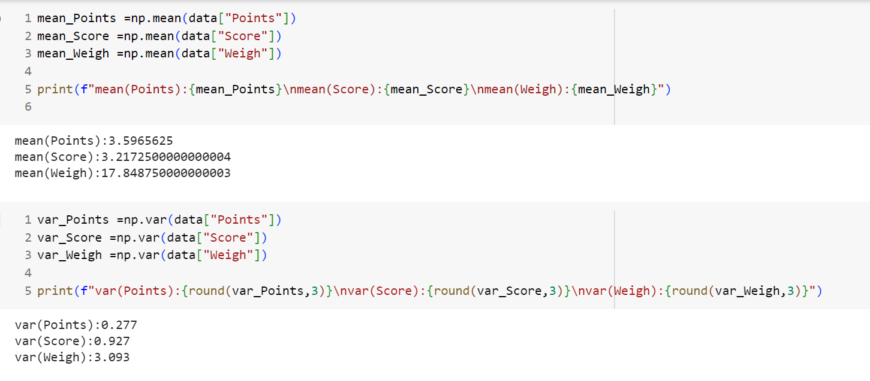
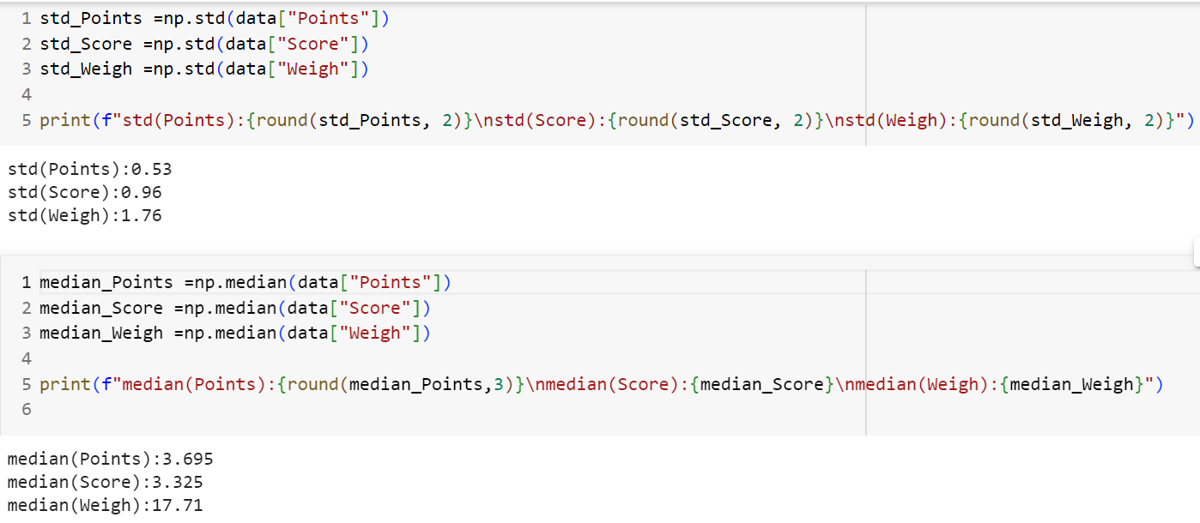
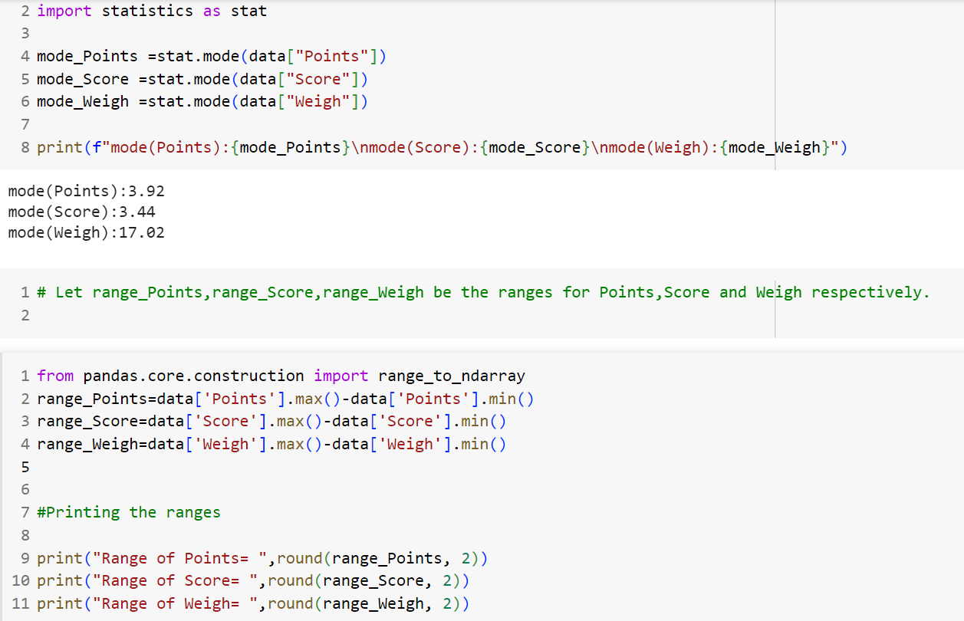
Range of Points= 2.17
Range of Score= 3.91
Range of Weigh= 8.4
Overall the mean ,median , mode of points and score data is almost simillar,so this two distribution is somewhat symmetrical in nature. Variance of point data is high compared to score data.
Weigh data has highest variance of all three. But looking at the mean, median and mode of the data Weigh data has no skweness it is almost symmetrical.
Q8) Calculate Expected Value for the problem below
- The weights (X) of patients at a clinic (in pounds), are
108, 110, 123, 134, 135, 145, 167, 187, 199
Assume one of the patients is chosen at random. What is the Expected Value of the Weight of that patient?
Solution:
Expected weight (E(x))
=Sum (weight of patient *Probality of that weight)
= (108 + 110 + 123 + 134 + 135 + 145 + 167 + 187 + 199) / 9
= 145.667

Therefore, the expected value of the weight of a patient chosen at random from the given weights is approximately 145.667 pounds.

Q9) Calculate Skewness, Kurtosis & draw inferences on the following data
Cars speed and distance
Use Q9_a.csv SP and Weight(WT) Use Q9_b.csv

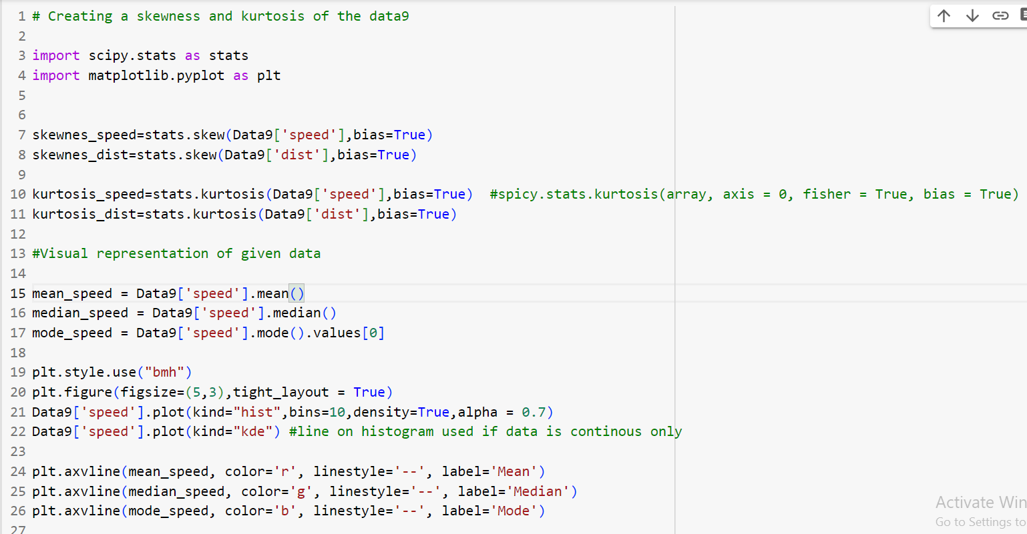
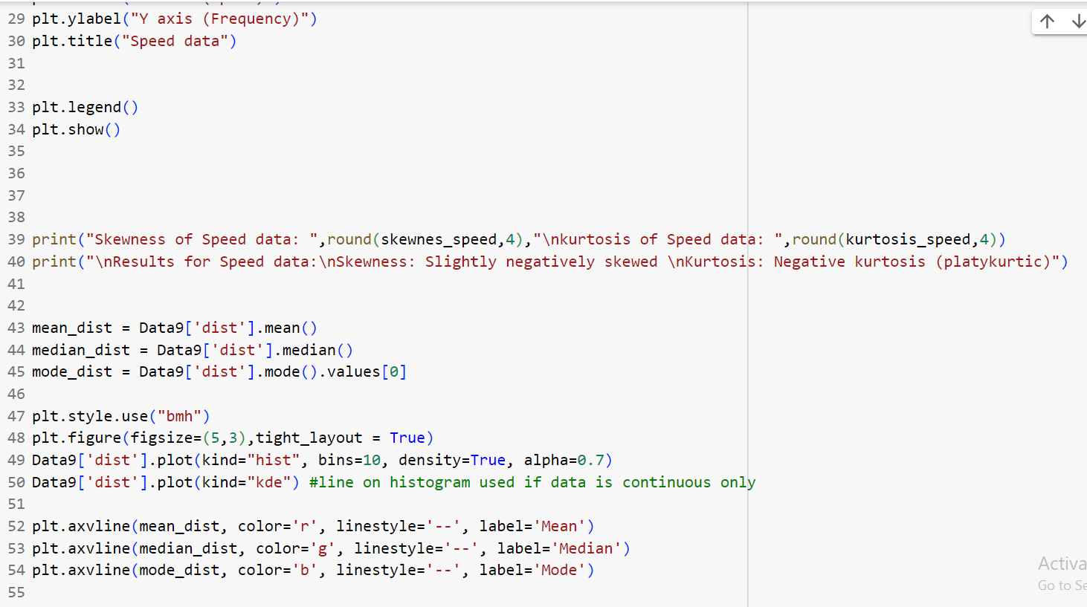
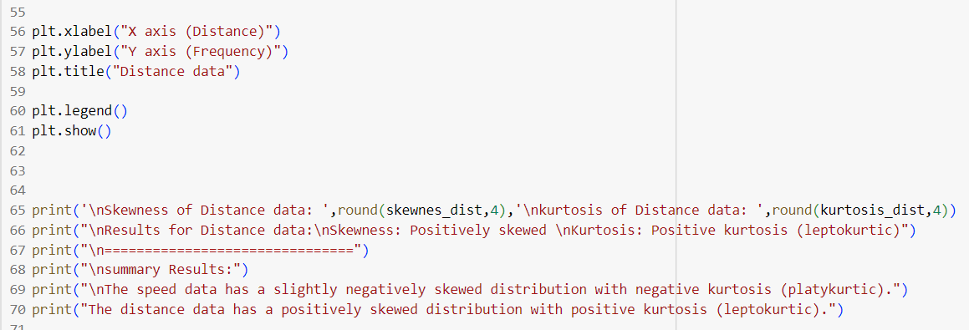
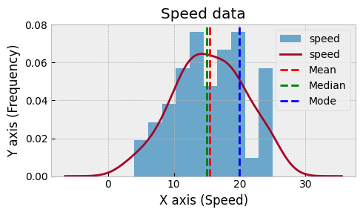

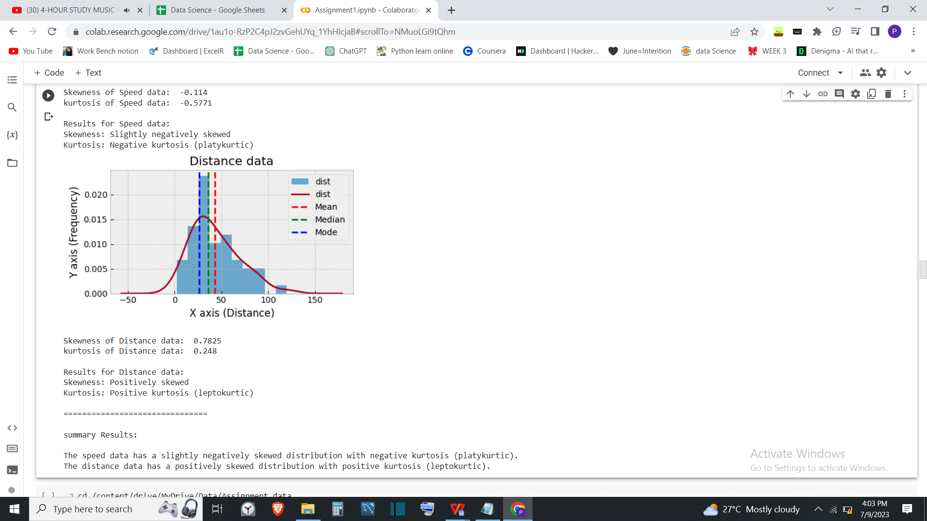
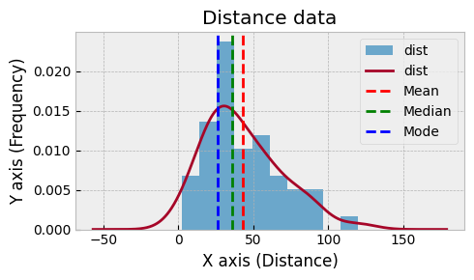

SP and Weight(WT) Use Q9_b.csv

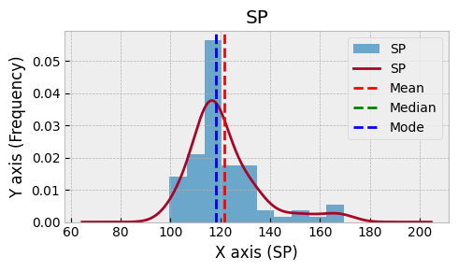
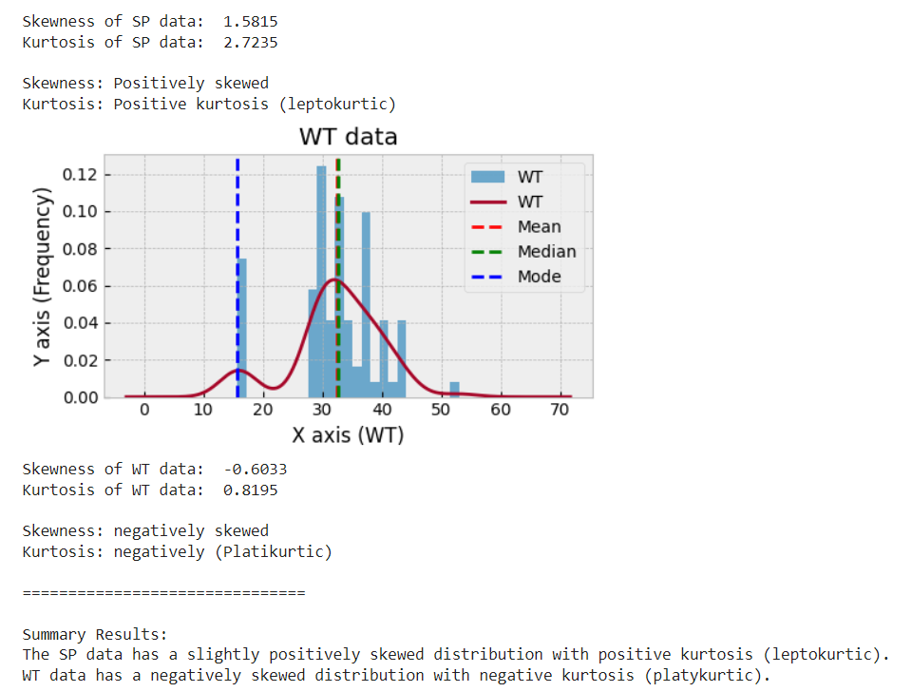

Q10) Draw inferences about the following boxplot & histogram

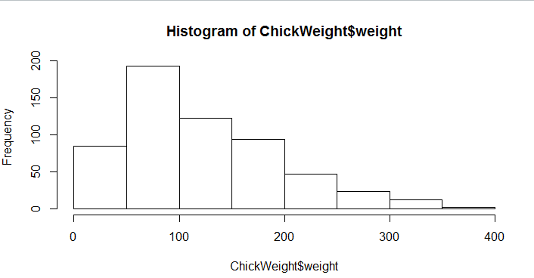
Inference:
Given Histogram is positively skewed.Thus data of ChickWeight$weight is positevely skewed.
Thus we can say that for given data mean>median >mode
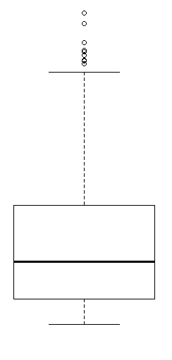
Inference:
Distribution for given data is positively skewed and outliers are present in the data.

Q11) Suppose we want to estimate the average weight of an adult male in Mexico. We draw a random sample of 2,000 men from a population of 3,000,000 men and weigh them. We find that the average person in our sample weighs 200 pounds, and the standard deviation of the sample is 30 pounds. Calculate 94%,98%,96% confidence interval?
Solution:
Given:
N=3,000,000 n=2,000 200pound
Sample mean =200 pound Std dev. = 30 pound
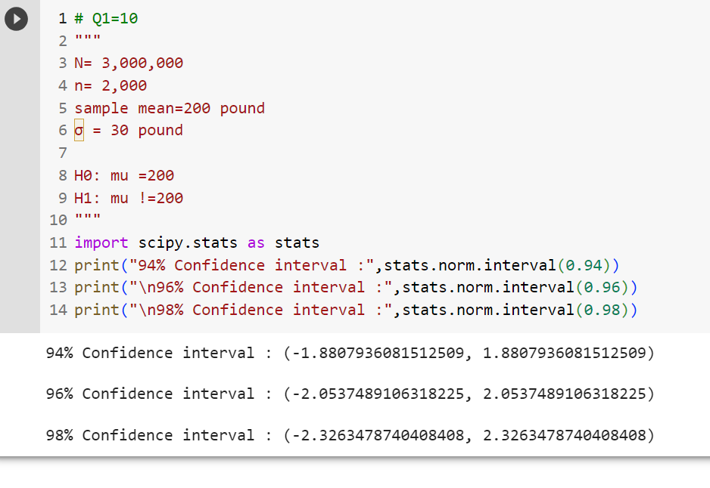
94% Confidence interval : (-1.8807936081512509, 1.8807936081512509)
96% Confidence interval : (-2.0537489106318225, 2.0537489106318225)
98% Confidence interval : (-2.3263478740408408, 2.3263478740408408)

Q12) Below are the scores obtained by a student in tests

34,36,36,38,38,39,39,40,40,41,41,41,41,42,42,45,49,56
- Find mean, median, variance, standard deviation.
- What can we say about the student marks?
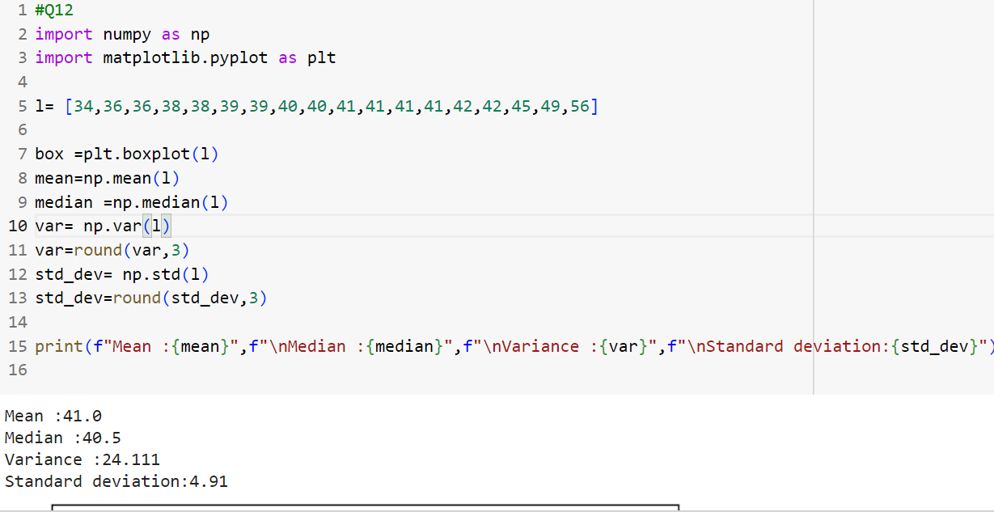

Students Marks Boxplot:
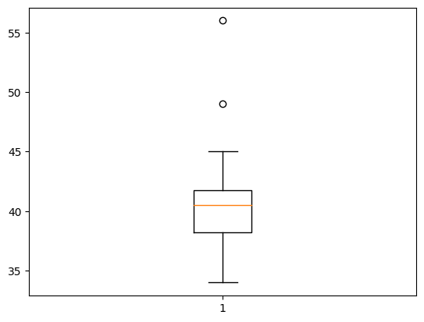
The box plot suggests that the student marks data contains outliers, indicating that there are a few students who have high marks compared to the average students. Since the mean is greater than the median, the distribution exhibits a slight positive skew. However, it is important to consider that in order to make more accurate predictions, a larger dataset is necessary.

Q13) What is the nature of skewness when mean, median of data are equal?
Distribution has Skewness zero.
Q14) What is the nature of skewness when mean > median ?
Distribution is positively skewed.
Q15) What is the nature of skewness when median > mean?
Distribution is negativly skewed.
Q16) What does positive kurtosis value indicates for a data ?
Distribution is Leptokurtic and has taller and has thick tails.
Q17) What does negative kurtosis value indicates for a data?
Distribution is Platikurtic and has flatter peak compared to normal distribution.
And has lighter tails.
Q18) Answer the below questions using the below boxplot visualization.
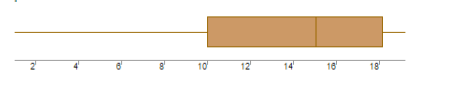
What can we say about the distribution of the data?
= Distribution is not symmetric. And there is variation in the data.
What is nature of skewness of the data?
= Distribution is negatively skewed.

What will be the IQR of the data (approximately)?
= IQR= Q3-Q1=18-10=8
Q19) Comment on the below Boxplot visualizations?
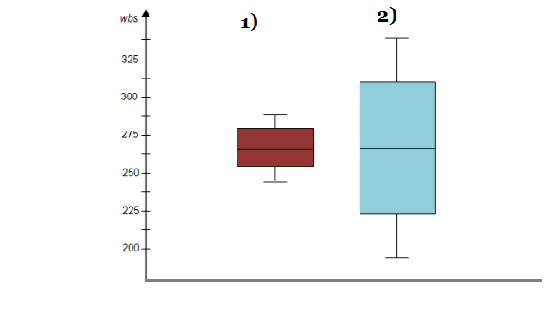
Draw an Inference from the distribution of data for Boxplot 1 with respect Boxplot 2.
=
Boxplot1 distribution has less variance as compared to the Boxplot2 distribution.
Median of both the distribution is same . Both distributions are symmetric.

Q 20) Calculate probability from the given dataset for the below cases
M Data _set: Cars.csv
Calculate the probability of MPG of Cars for the below cases.
MPG <- Cars$MPG
  - P(MPG>38)
  - P(MPG<40)
c. P (20<MPG<50)
Ans=
  - P(MPG>38) = 0.40
  - P(MPG<40)= 0.75
c. P (20<MPG<50)= 0.85

Q 21) Check whether the data follows normal distribution
- Check whether the MPG of Cars follows Normal Distribution
Dataset: Cars.csv
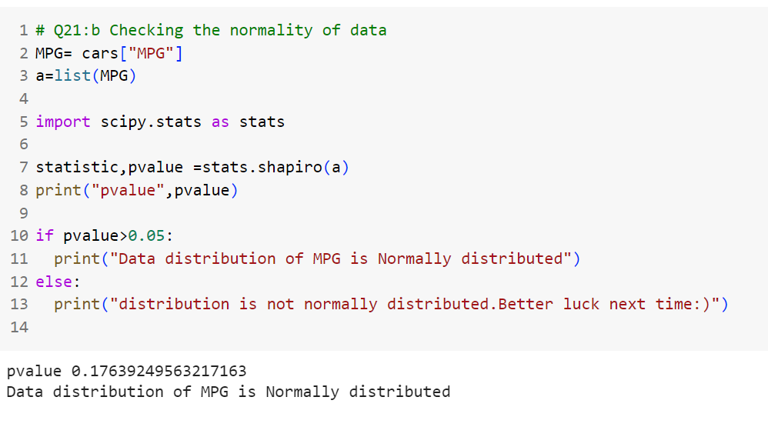

- Check Whether the Adipose Tissue (AT) and Waist Circumference(Waist) from wc-at data set follows Normal Distribution
Dataset: wc-at.csv

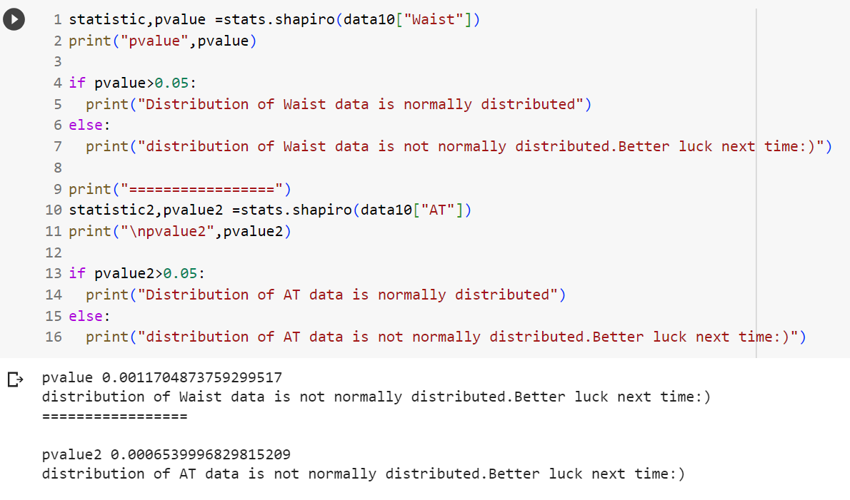

Q 22) Calculate the Z scores of 90% confidence interval,94% confidence interval, 60% confidence interval
=
A = (1 + CI)/2 where A is area under the normal distribution curve and
CL represents the confidence level

A = (1 + 0.9)/2 = 1.9/2 = 0.95
And by Z table it is 1.645
So the z score for 90% CI would be 1.645

for 94%
A = (1+ 0.94)/2 = 1.94/2 = 0.97 and by z table it is close to 1.88 &amp; 1.89
So its average is (1.88 + 1.89)/2 = 1.885
So the z score for 94% CI would be 1.645

for 60%
A = (1 + 0.6)/2 = 1.6/2 = 0.8 and by z table it is close to 0.84 &amp; 0.85
So its average is (0.84 + 0.85)/2 = 0.845
So the z score for 60% CI would be 0.845

Q 23) Calculate the t scores of 95% confidence interval, 96% confidence interval, 99% confidence interval for sample size of 25
If the sample size is 25 then degree of freedom = (n – 1) = (25 – 1) = 24
for 95% CL, the significance value would be 1 - 0.95 = 0.05
the t score would be 1.711.
For 96% CL, the significance value would be 1 - 0.96 = 0.04
the t score would be 1.828.
For 99% CL, the significance value would be 1 - 0.99 = 0.01
the t score would be 2.492.
Q 24) A Government company claims that an average light bulb lasts 270 days. A researcher randomly selects 18 bulbs for testing. The sampled bulbs last an average of 260 days, with a standard deviation of 90 days. If the CEO's claim were true, what is the probability that 18 randomly selected bulbs would have an average life of no more than 260 days
Hint:
rcode → pt(tscore,df)
df → degrees of freedom
Solution:
μ(Population Mean = 270
X̄ (Sample Mean) = 260
Sigma =90
n= 18
Thus,
Null hypothesis (H0) : The average life of the bulbs is equal to 270 days.
Alternative hypothesis (H1) : The average life is less than 270 days.

