|  |  |  |
| --- | --- | --- |
| **Sr No** | **Topics** | **Sign** |
| **1** | Implement Linear Regression (Diabetes Dataset) |  |
| **2** | Implement Logistic Regression (Iris Dataset) |  |
| **3** | Implements Multinomial Logistic Regression (Iris Dataset) |  |
| **4** | Implement SVM classifier (Iris Dataset) |  |
| **5** | Train and fine-tune a Decision Tree for the Moons Datase |  |
| **6** | Implement Batch Gradient Descent with early stopping for Softmax Regression |  |
| **7** | Implement MLP for classification of handwritten digits (MNIST Dataset) |  |
| **8** | Classification of images of clothing using Tensorflow (Fashion MNIST dataset) |  |
| **9** | Implement Regression to predict fuel efficiency using Tensorflow (Auto MPG dataset) |  |

**INDEX**

**Practical No.: 1 Date: / /** **Aim: Linear Regression.**

**Source code:**

# Import necessary libraries

import pandas as pd  # for data manipulation

import numpy as np   # for scientific computing

import seaborn as sns # for visualization

import matplotlib.pyplot as plt # for plotting & visualization

from sklearn import datasets

from sklearn.model_selection import train_test_split

from sklearn.linear_model import LinearRegression

from sklearn import metrics as mt

# Load the diabetes dataset

diabetes = datasets.load_diabetes()

# Print dataset description

print(diabetes.DESCR)

# Display feature names and dataset shapes

print(diabetes.feature_names)

print(diabetes.data.shape)

print(diabetes.target.shape)

# Create a DataFrame from the dataset

db_df = pd.DataFrame(diabetes.data, columns=diabetes.feature_names)

print(db_df.sample(5))

# Add target column 'Progression' to the DataFrame

db_df['Progression'] = diabetes.target

# Check for missing values

print(db_df.isna().sum())

# Display summary statistics

print(db_df.describe())

# Display information about the DataFrame

print(db_df.info())

# Calculate correlation matrix

corr = db_df.corr()

# Plot the heatmap of the correlation matrix

plt.subplots(figsize=(8, 8))

sns.heatmap(corr, cmap='RdYlGn', annot=True)

plt.show()

# Define independent (features) and dependent (target) variables

x = db_df.drop(labels='Progression', axis=1)  # Features

y = db_df['Progression']  # Target variable

# Split the dataset into train and test sets (75% train, 25% test)

train_x, test_x, train_y, test_y = train_test_split(x, y, test_size=0.25, random_state=999)

# Display shapes of train and test sets

print(train_x.shape)

print(test_x.shape)

print(train_y.shape)

print(test_y.shape)

# Create an instance of the Linear Regression model

lm = LinearRegression()

print(lm)

print(type(lm))

# Fit the model on the training data

lm.fit(train_x, train_y)

# Predict on the test set

predicted_y = lm.predict(test_x)

# Evaluate the model

print("1) The model explains", np.round(mt.explained_variance_score(test_y, predicted_y) * 100, 2), "% variance of the target w.r.t features")

print("2) The Mean Absolute Error of the model is:", np.round(mt.mean_absolute_error(test_y, predicted_y), 2))

print("3) The R-Square score of the model is", np.round(mt.r2_score(test_y, predicted_y), 2))

# Display coefficients and intercept of the model

coeff = pd.Series(lm.coef_, index=train_x.columns)

intercept = lm.intercept_

print("Coefficients:\n", coeff)

print("\nIntercept:\n", intercept)

**Output:**

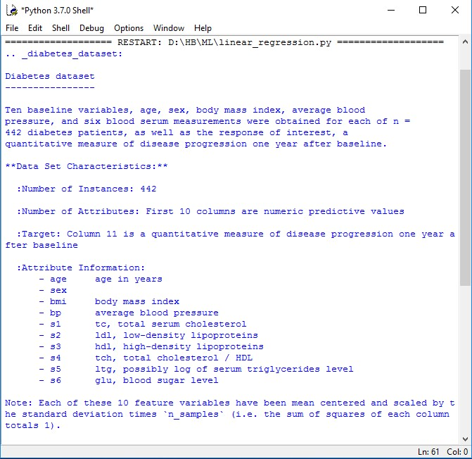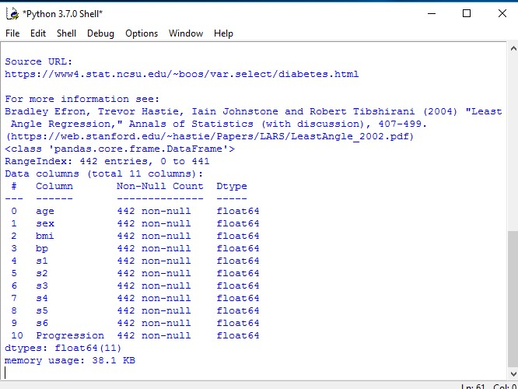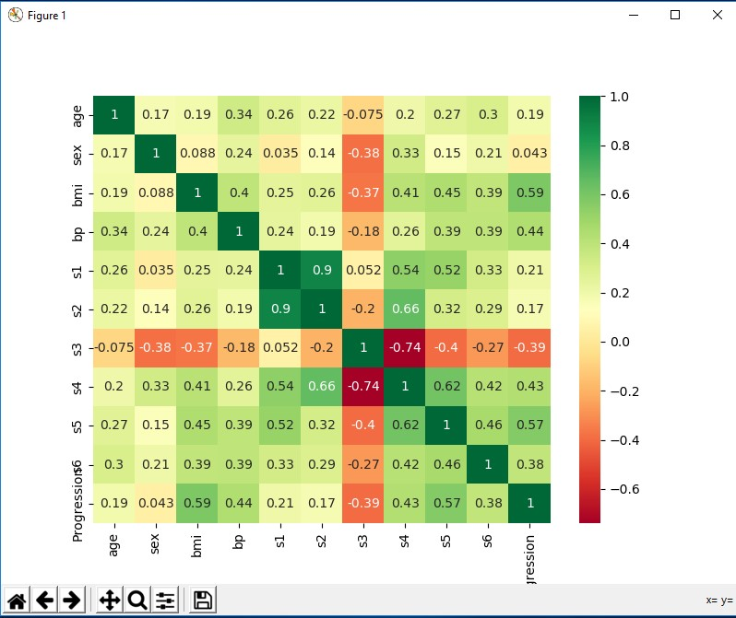

**Practical No.: 2 Date: / /**

**Aim: Logistic Regression.**

**Source Code:**

# Import necessary libraries

import matplotlib.pyplot as plt

import numpy as np

import torch

import torch.nn.functional as F

from sklearn import datasets

from sklearn import preprocessing

from sklearn.model_selection import train_test_split

from collections import Counter

# Load the iris dataset

iris = datasets.load_iris()

# Select only 2 classes and 2 features (sepal length/width)

X = iris.data[:-50, :2]

y = iris.target[:-50]

# Scale the features

X = preprocessing.scale(X)

# Print data details

print("Class distribution:", Counter(y)) # 50 of each iris flower

print("Flower types:", list(iris.target_names[:-1])) # Type of flower

print("Feature shape:", X.shape)

# Scatter plot of the two classes

plt.scatter(X[:, 0], X[:, 1], c=y)

plt.xlabel('Sepal Length')

plt.ylabel('Sepal Width')

plt.title('Scatter Plot of Iris Classes')

plt.show()

# Train/Test split

X_train, X_test, y_train, y_test = train_test_split(X, y, test_size=0.2)

# Print sizes of training and test sets

print(f'X train size: {X_train.shape}')

print(f'X test size: {X_test.shape}')

print(f'y train size: {y_train.shape}')

print(f'y test size: {y_test.shape}')

# Distribution of both classes are roughly equal

print("Training set class distribution:", Counter(y_train))

# print(f'Validation Accuracy: {acc.item() :.4f}')

**Output:**

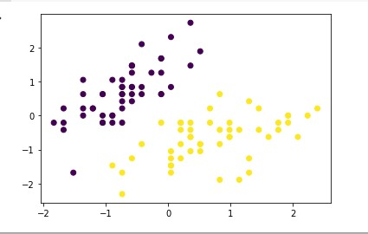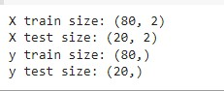

**Practical No.: 3 Date: / /**

**Aim: Implement Multinomial Logistic Regression(Iris Dataset).**

**Source Code:**

# Import necessary libraries

from sklearn.linear_model import LogisticRegression

from sklearn import datasets

from sklearn.preprocessing import StandardScaler

# Load the iris dataset

iris = datasets.load_iris()

X = iris.data

y = iris.target

# Standardize the features

scaler = StandardScaler()

X_std = scaler.fit_transform(X)

# Instantiate and fit the Logistic Regression model

clf = LogisticRegression(random_state=0, multi_class='multinomial', solver='newton-cg')

model = clf.fit(X_std, y)

# Define a new observation and predict its class

new_observation = [[0.5, 0.5, 0.5, 0.5]]

predicted_class = model.predict(new_observation)

predicted_probabilities = model.predict_proba(new_observation)

# Output the predictions

print("Predicted class:", predicted_class)

print("Predicted probabilities:", predicted_probabilities)

**Output:** array([[0.01982536, 0.74491994, 0.2352547 ]])

**Practical No.: 4 Date:**

**Aim: Implement Support Vector Classifier(Iris Dataset).**

**Source code:**

from sklearn import datasets # To Get iris dataset from sklearn import svm # To fit the svm classifier import numpy as np import matplotlib.pyplot as plt # To visuvalizing the data

# import iris data to model Svm classifier iris_dataset = datasets.load_iris() def visuvalize_sepal_data(): iris = datasets.load_iris()

X = iris.data[:, :2] # we only take the first two features.

y = iris.target print(X[:,0])

#cmap- color map,it is a colour representation of 3D values plt.scatter(X[:, 0], X[:, 1], c=y, cmap=plt.cm.coolwarm) plt.xlabel('Sepal length') plt.ylabel('Sepal width') plt.title('Sepal Width & Length') plt.show() visuvalize_sepal_data()

output

-

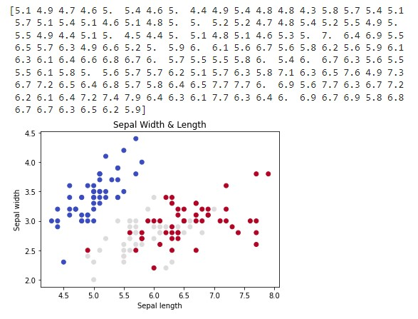

def visuvalize_petal_data(): iris = datasets.load_iris()

X = iris.data[:, 2:] # we only take the last two features. y = iris.target plt.scatter(X[:, 0], X[:, 1], c=y, cmap=plt.cm.coolwarm) plt.xlabel('Petal length')

plt.ylabel('Petal width') plt.title('Petal Width & Length') plt.show() visuvalize_petal_data()

output

-

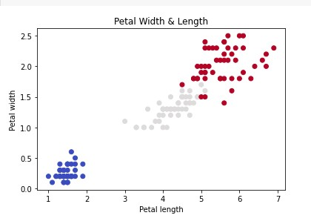

# Import necessary libraries

from sklearn import datasets, svm

import numpy as np

import matplotlib.pyplot as plt

# Load the iris dataset

iris = datasets.load_iris()

X = iris.data[:, :2]  # Use only the first two features (Sepal length and width)

y = iris.target

C = 1.0  # SVM regularization parameter

# Create SVM classifiers with different kernels

# SVC with linear kernel

svc = svm.SVC(kernel='linear', C=C).fit(X, y)

# LinearSVC (linear kernel)

lin_svc = svm.LinearSVC(C=C, max_iter=10000).fit(X, y)

# SVC with RBF kernel

rbf_svc = svm.SVC(kernel='rbf', gamma=0.7, C=C).fit(X, y)

# SVC with polynomial (degree 3) kernel

poly_svc = svm.SVC(kernel='poly', degree=3, C=C).fit(X, y)

# Define a step size in the mesh

h = .02

# Create a mesh to plot in

x_min, x_max = X[:, 0].min() - 1, X[:, 0].max() + 1

y_min, y_max = X[:, 1].min() - 1, X[:, 1].max() + 1

xx, yy = np.meshgrid(np.arange(x_min, x_max, h),

                     np.arange(y_min, y_max, h))

# Titles for the plots

titles = [

    'SVC with linear kernel',

    'LinearSVC (linear kernel)',

    'SVC with RBF kernel',

    'SVC with polynomial (degree 3) kernel'

]

# Plot decision boundaries for each classifier

for i, clf in enumerate((svc, lin_svc, rbf_svc, poly_svc)):

    plt.subplot(2, 2, i + 1)

    plt.subplots_adjust(wspace=0.4, hspace=0.4)

    # Predict for each point in the mesh

    Z = clf.predict(np.c_[xx.ravel(), yy.ravel()])

    Z = Z.reshape(xx.shape)

    # Put the result into a color plot

    plt.contourf(xx, yy, Z, cmap=plt.cm.coolwarm, alpha=0.8)

    # Plot also the training points

    plt.scatter(X[:, 0], X[:, 1], c=y, cmap=plt.cm.coolwarm, edgecolors='k')

    plt.xlabel('Sepal length')

    plt.ylabel('Sepal width')

    plt.xlim(xx.min(), xx.max())

    plt.ylim(yy.min(), yy.max())

    plt.xticks(())

    plt.yticks(())

    plt.title(titles[i])

# Show the plots

plt.show()

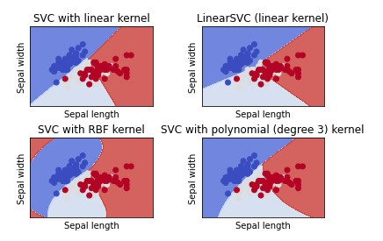output-

**Practical No.:5 Date: / /**

**Aim: Train and Find Tune Decision Tree for the moon dataset.**

**Source code:**

from sklearn.datasets import make_moons

from sklearn.model_selection import train_test_split, GridSearchCV

from sklearn.tree import DecisionTreeClassifier

from sklearn.metrics import accuracy_score

# Generate the Moons dataset

X, y = make_moons(n_samples=1000, noise=0.2, random_state=42)

# Split the dataset into training and test sets

X_train, X_test, y_train, y_test = train_test_split(X, y, test_size=0.3, random_state=42)

# Define the model

model = DecisionTreeClassifier(random_state=42)

# Define the parameter grid

params = {

    'max_depth': [None, 5, 10, 20],

    'min_samples_split': [2, 5, 10],

    'min_samples_leaf': [1, 2, 4]

}

# Setup GridSearchCV

grid_search = GridSearchCV(model, params, cv=5, n_jobs=-1)

# Fit GridSearchCV to the training data

grid_search.fit(X_train, y_train)

# Get the best parameters and the best model

best_params = grid_search.best_params_

best_model = grid_search.best_estimator_

# Print the best parameters

print(f"Best parameters: {best_params}")

# Predict and evaluate the best model

y_pred = best_model.predict(X_test)

print(f"Accuracy of the best model: {accuracy_score(y_test, y_pred):.4f}")

**Output:**



**Practical No.:6 Date: / /**

**Aim: Implement Batch Gradient Descent with early stopping for Softmax Regression.**

**Source code:**

import numpy as np import scipy as sp import matplotlib.pyplot as plt

from sklearn.datasets import load_iris

iris=load_iris() X=iris['data']

y=iris['target']

X_with_bias = np.c_[np.ones([len(X), 1]), X] np.random.seed(1234)

test_ratio = 0.2 validation_ratio = 0.2

total_size = len(X_with_bias)

test_size = int(total_size * test_ratio) validation_size = int(total_size * validation_ratio) train_size = total_size - test_size - validation_size

rnd_indices = np.random.permutation(total_size)

X_train = X_with_bias[rnd_indices[:train_size]] y_train = y[rnd_indices[:train_size]]

X_valid = X_with_bias[rnd_indices[train_size:-test_size]] y_valid = y[rnd_indices[train_size:-test_size]] X_test = X_with_bias[rnd_indices[-test_size:]] y_test = y[rnd_indices[-test_size:]]

def one_hot(Y): nclasses=Y.max()+1 m = len(Y)

Y_one_hot=np.zeros((m,nclasses)) Y_one_hot[np.arange(m),Y]=1 return Y_one_hot

y_valid[:10]

one_hot(y_valid[:10]) y_train_prob = one_hot(y_train) y_valid_prob = one_hot(y_valid) y_test_prob = one_hot(y_test)

def softmax(sk_X): top = np.exp(sk_X) bottom = np.sum(top,axis=1,keepdim=True) return top/bottom

n_inputs = X_train.shape[1] n_outputs = len(np.unique(y_train))

print (n_inputs, n_outputs)

**Output:**

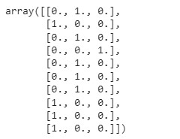



# Practical No.:7 Date: / / Aim: Implement MLP for classification of handwritten digits (MNIST Dataset)

## Code:-

import numpy as np import matplotlib.pyplot as plt import random

from keras.datasets import mnist from keras.models import Sequential from keras.layers.core import Dense, Dropout, Activation from keras.utils import np_utils

(X_train, y_train), (X_test, y_test) = mnist.load_data()

**Output:-**

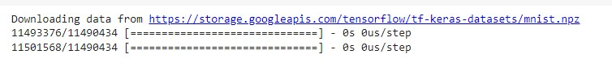

print("X_train shape", X_train.shape) print("y_train shape", y_train.shape) print("X_test shape", X_test.shape) print("y_test shape", y_test.shape)

## Output:-

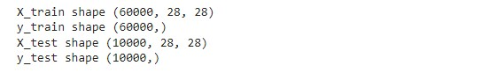

plt.rcParams['figure.figsize'] = (9,9) # Make the figures a bit bigger for i in range(9):

plt.subplot(3,3,i+1) num = random.randint(0, len(X_train)) plt.imshow(X_train[num], cmap='gray', interpolation='none') plt.title("Class {}".format(y_train[num]))

## Output:-

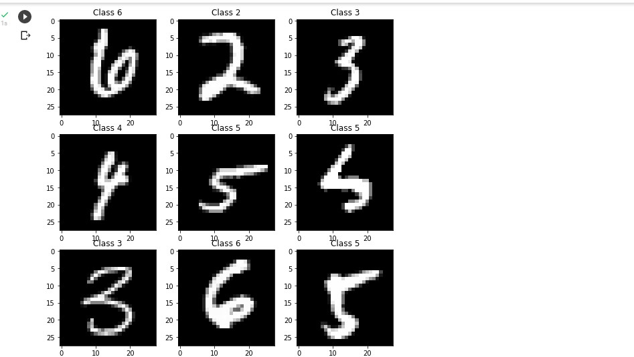

plt.tight_layout()

## Output:-



def matprint(mat, fmt="g"):

col_maxes = [max([len(("{:"+fmt+"}").format(x)) for x in col]) for col in mat.T] for x in mat: for i, y in enumerate(x):

print(("{:"+str(col_maxes[i])+fmt+"}").format(y), end=" ")

print("")

matprint(X_train[num])

## Output:-

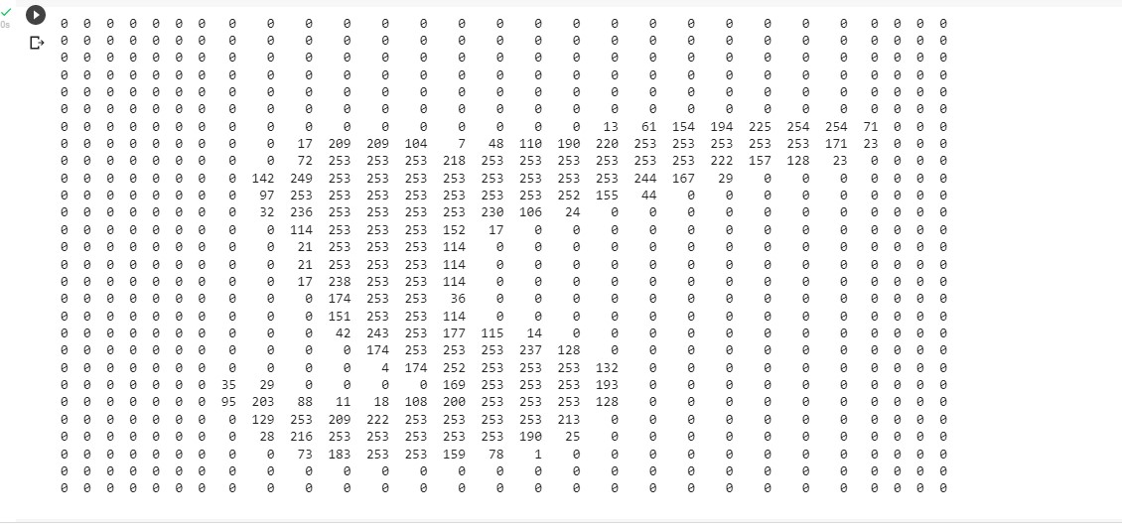

X_train = X_train.reshape(60000, 784)

X_test = X_test.reshape(10000, 784)

X_train = X_train.astype('float32')

X_test = X_test.astype('float32')

X_train /= 255

X_test /= 255 print("Training matrix shape", X_train.shape) print("Testing matrix shape", X_test.shape)

## Output:-



nb_classes = 10

Y_train = np_utils.to_categorical(y_train, nb_classes) Y_test = np_utils.to_categorical(y_test, nb_classes) model = Sequential() model.add(Dense(512, input_shape=(784,))) model.add(Activation('relu')) model.add(Dropout(0.2)) model.add(Dense(512)) model.add(Activation('relu')) model.add(Dropout(0.2)) model.add(Dense(10)) model.add(Activation('softmax')) model.summary()

## Output:-

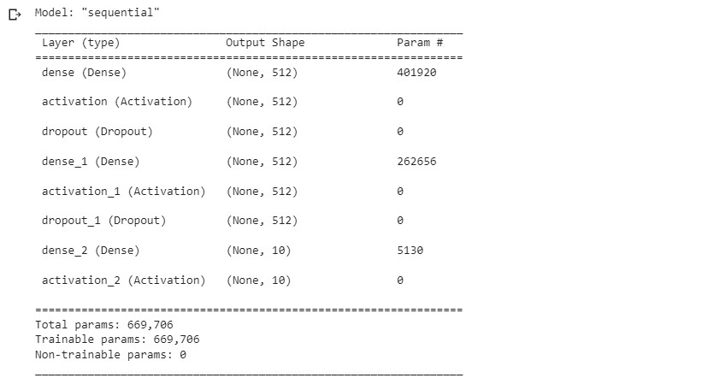

model.compile(loss='categorical_crossentropy', optimizer='adam', metrics=['accuracy']) model.fit(X_train, Y_train, batch_size=128, epochs=5, verbose=1)

## Output:-

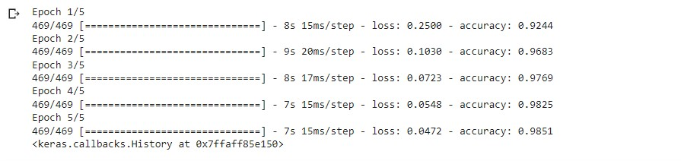

score = model.evaluate(X_test, Y_test) print('Test score:', score[0]) print('Test accuracy:', score[1])

## Output:-



# Practical No.:8 Date: / / Aim: Classification Of images Of Clothing Tensorflow (Fashion MNIST Dataset

**Code:-** import tensorflow as tf import tensorflow_datasets as tfds tfds.disable_progress_bar() import math import numpy as np import matplotlib.pyplot as plt import logging logger = tf.get_logger() logger.setLevel(logging.ERROR) dataset, metadata = tfds.load('fashion_mnist', as_supervised=True, with_info=True) train_dataset, test_dataset = dataset['train'], dataset['test'] **Output:-**

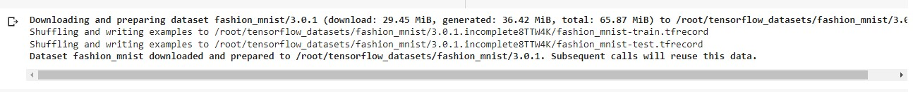

class_names = ['T-shirt/top', 'Trouser', 'Pullover', 'Dress', 'Coat',

'Sandal', 'Shirt', 'Sneaker', 'Bag', 'Ankle boot']

num_train_examples = metadata.splits['train'].num_examples num_test_examples = metadata.splits['test'].num_examples print("Number of training examples: {}".format(num_train_examples)) print("Number of test examples: {}".format(num_test_examples)) **Output:-**



def normalize(images, labels):

images = tf.cast(images, tf.float32)

images /= 255 return images, labels train_dataset = train_dataset.map(normalize) test_dataset = test_dataset.map(normalize) train_dataset = train_dataset.cache() test_dataset = test_dataset.cache() for image, label in test_dataset.take(1): break

image = image.numpy().reshape((28,28))

plt.figure()

plt.imshow(image, cmap=plt.cm.binary) plt.colorbar() plt.grid(False) plt.show()

## Output:-

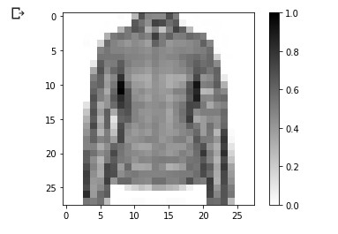

plt.figure(figsize=(10,10)) i = 0

## Output:-



for (image, label) in test_dataset.take(25):

image = image.numpy().reshape((28,28))

plt.subplot(5,5,i+1) plt.xticks([]) plt.yticks([]) plt.grid(False)

plt.imshow(image, cmap=plt.cm.binary) plt.xlabel(class_names[label])

i += 1

plt.show()

## Output:-

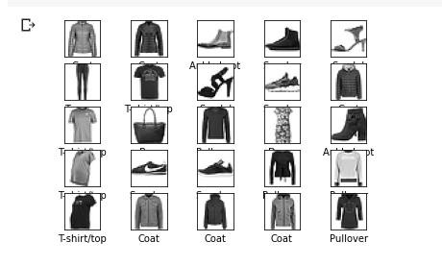

model = tf.keras.Sequential([ tf.keras.layers.Flatten(input_shape=(28, 28, 1)), ]) model.compile(optimizer='adam',

loss=tf.keras.losses.SparseCategoricalCrossentropy(), metrics=['accuracy'])

BATCH_SIZE = 32 train_dataset = train_dataset.cache().shuffle(num_train_examples).batch(BATCH_SIZE) test_dataset = test_dataset.cache().batch(BATCH_SIZE) test_loss, test_accuracy = model.evaluate(test_dataset, steps=math.ceil(num_test_examples/32)) print('Accuracy on test dataset:', test_accuracy)

## Output:-



for test_images, test_labels in test_dataset.take(1):

test_images = test_images.numpy() test_labels = test_labels.numpy() predictions = model.predict(test_images) predictions.shape

## Output:-



predictions[0]

## Output:-

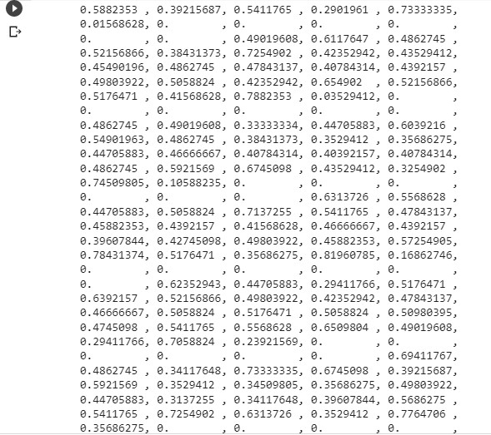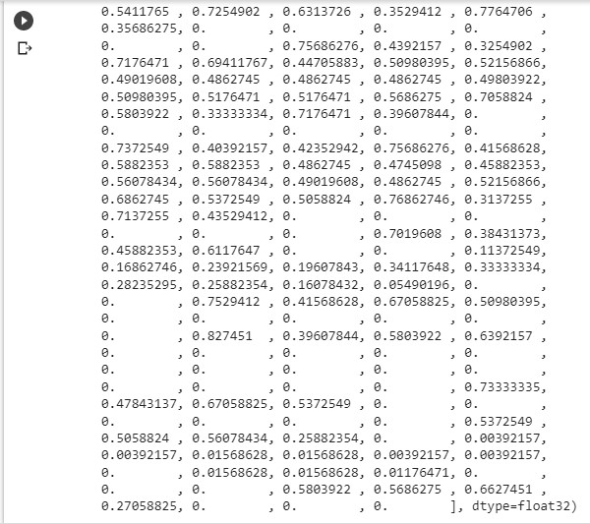

## Practical No.: 9 Date: / /

**Aim: Implement Regression to predict fuel efficiency using Tensorflow (Auto MPG dataset).**

**Source code:**

import matplotlib.pyplot as plt import numpy as np import pandas as pd import seaborn as sns

# Make NumPy printouts easier to read.

np.set_printoptions(precision=3, suppress=True)

import tensorflow as tf from tensorflow import keras from tensorflow.keras import layers

url = 'http://archive.ics.uci.edu/ml/machine-learning-databases/autompg/auto-mpg.data' column_names = ['MPG', 'Cylinders', 'Displacement', 'Horsepower', 'Weight' ,

'Acceleration', 'Model Year', 'Origin'] raw_dataset = pd.read_csv(url, names=column_names, na_values='?', comment='\t', sep=' ', skipinitialspace=True)

dataset = raw_dataset.copy() dataset.tail() dataset.isna().sum() dataset = dataset.dropna() dataset['Origin'] = dataset['Origin'].map({1: 'USA', 2: 'Europe', 3: 'Japa n'}) dataset = pd.get_dummies(dataset, columns=['Origin'], prefix='', prefix_se p='') dataset.tail()

## Output-

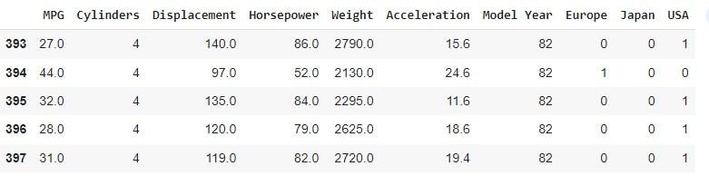

url = 'http://archive.ics.uci.edu/ml/machine-learning-databases/autompg/auto-mpg.data'

column_names = ['MPG', 'Cylinders', 'Displacement', 'Horsepower', 'Weight' ,

'Acceleration', 'Model Year', 'Origin'] raw_dataset = pd.read_csv(url, names=column_names, na_values='?', comment='\t', sep=' ', skipinitialspace=True) dataset = raw_dataset.copy() dataset.tail() dataset.isna().sum() dataset = dataset.dropna() dataset['Origin'] = dataset['Origin'].map({1: 'USA', 2: 'Europe', 3: 'Japa n'}) dataset = pd.get_dummies(dataset, columns=['Origin'], prefix='', prefix_se p='') dataset.tail()

## Output-

[[ 5.478 195.318 104.869 2990.252 15.559 75.898 0.178 0.197 0.624]]

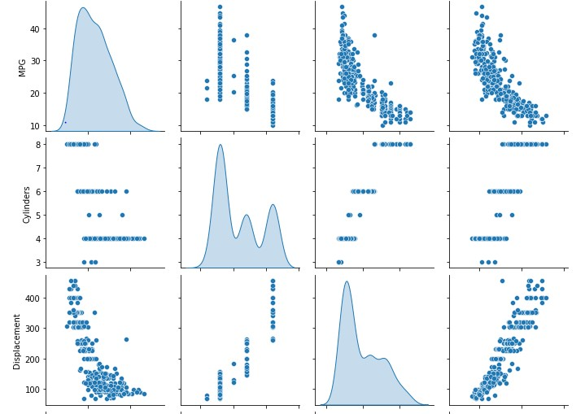

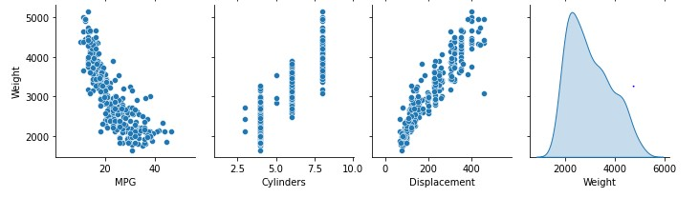

first = np.array(train_features[:1]) with np.printoptions(precision=2, suppress=True): print('First example:', first) print() print('Normalized:', normalizer(first).numpy())

horsepower = np.array(train_features['Horsepower']) horsepower_normalizer = layers.Normalization(input_shape=[1,], axis=None) horsepower_normalizer.adapt(horsepower) horsepower_model = tf.keras.Sequential([ horsepower_normalizer, layers.Dense(units=1)

]) horsepower_model.summary() horsepower_model.predict(horsepower[:10]) horsepower_model.compile( optimizer=tf.optimizers.Adam(learning_rate=0.1), loss='mean_absolute_error') history = horsepower_model.fit(train_features['Horsepower'],train_labels,e pochs=100, verbose=0, validation_split = 0.2) hist = pd.DataFrame(history.history) hist['epoch'] = history.epoch

hist.tail()

## Output-

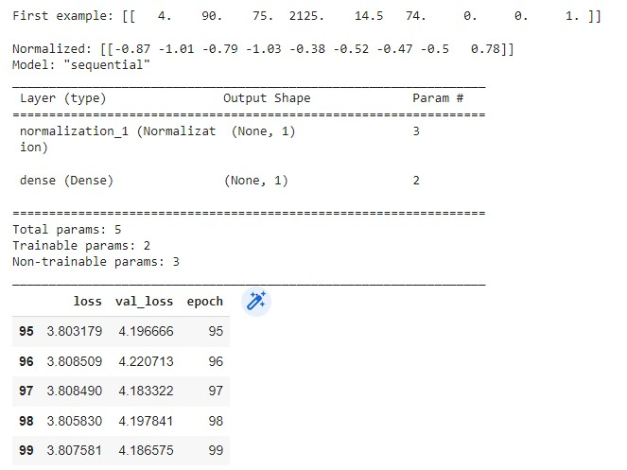

def plot_loss(history):

plt.plot(history.history['loss'], label='loss') plt.plot(history.history['val_loss'], label='val_loss') plt.ylim([0, 10]) plt.xlabel('Epoch') plt.ylabel('Error [MPG]')

plt.legend() plt.grid(True) plot_loss(history) test_results = {} test_results['horsepower_model'] = horsepower_model.evaluate( test_features['Horsepower'], test_labels, verbose=0) x = tf.linspace(0.0, 250, 251) y = horsepower_model.predict(x)

## Output-

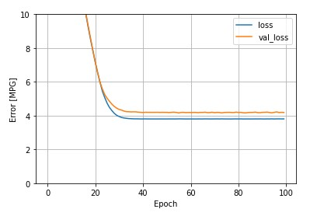

def plot_horsepower(x, y):

plt.scatter(train_features['Horsepower'], train_labels, label='Data') plt.plot(x, y, color='k', label='Predictions') plt.xlabel('Horsepower') plt.ylabel('MPG') plt.legend()

plot_horsepower(x, y)

## Output-

