**What will the following commands do?**

* echo "Hello, World!"

o/p=>it print same output Hello, World!

* name="Productive"

o/p=>it shows the variable name stored the value productive

* touch file.txt  
    
  o/p=>touch it use to create file.it create the file name as file.txt
* ls -a  
    
  o/p=>this commands shows all the directories and file hidden files also
* rm file.txt  
    
  o/p=>this command remove and delete the file or directory permently
* cp file1.txt file2.txt  
    
  o/p=>this command copy the content from file 1 to file 2
* mv file.txt /path/to/directory/  
    
  o/p=>this command move the file to the specific directory we added
* chmod 755 script.sh  
    
  o/p=>this command use for give read write and execute permission to the file
* grep "pattern" file.txt  
    
  o/p=>this command use for search specific word from file
* kill PID  
    
  o/p=>this command kill the process
* mkdir mydir && cd mydir && touch file.txt && echo "Hello, World!" > file.txt && cat file.txt  
    
  o/p=>it create folder name mydir and create file file.txt in that print hello,world and show this using cat
* ls -l | grep ".txt"  
    
  o/p=> this command search .txt file
* cat file1.txt file2.txt | sort | uniq  
    
  o/p=>cat is for show the file and show uniq string
* ls -l | grep "^d"  
    
  o/p=>ls -l it will show all the directories and grep ^d shows lines that starting from d
* grep -r "pattern" /path/to/directory/  
    
  o/p=>grep is use for searching and the string “Pattren” is searching from the directory
* cat file1.txt file2.txt | sort | uniq –d  
    
  o/p=>it show combine output from file 1 and file 2 it shows similar content from both the file
* chmod 644 file.txt  
    
  o/p=>this command give the permission to the file 6 for read and write and 4,4 is for only reading
* cp -r source_directory destination_directory  
    
  o/p=>this command copy the file with content from sourse directory to destination directory
* find /path/to/search -name "*.txt"  
    
  o/p=>find command use to search files and directory from specific location and name is search for
* chmod u+x file.txt  
    
  o/p=>command change the file permission u for user and x for execute
* echo $PATH  
    
  o/p=>echo is for print the output

**Part B**

**Identify True or False:**

1. ls is used to list files and directories in a directory.

=>true

2. mv is used to move files and directories

=>true

3. cd is used to copy files and directories.  
=>false, cd is use for for change the directory

4. pwd stands for "print working directory" and displays the current directory.   
=>true

5. grep is used to search for patterns in files.

=>true  
6. chmod 755 file.txt gives read, write, and execute permissions to the owner, and read and execute permissions to group and others.   
=>true  
7. mkdir -p directory1/directory2 creates nested directories, creating directory2 inside directory1 if directory1 does not exist.  
=>true

8. rm -rf file.txt deletes a file forcefully without confirmation.  
=>true

**Identify the Incorrect Commands:**

1. chmodx is used to change file permissions.

2. cpy is used to copy files and directories.

3. mkfile is used to create a new file.

4. catx is used to concatenate files.

5. rn is used to rename files.  
=>all the command is incorrect  
  
  
 **Part C**

Question 1: Write a shell script that prints "Hello, World!" to the terminal.

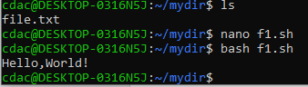

Question 2: Declare a variable named "name" and assign the value "CDAC Mumbai" to it. Print the value of the variable.

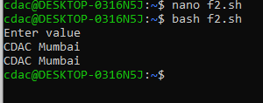

Question 3: Write a shell script that takes a number as input from the user and prints it.  
  


Question 4: Write a shell script that performs addition of two numbers (e.g., 5 and 3) and prints the result.  
  
o/p=>  
echo Enter num1

read num1

echo Enter num2

read num2

sum=$(($num1 + $num2))

echo "sum:$sum"

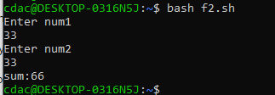

Question 5: Write a shell script that takes a number as input and prints "Even" if it is even, otherwise prints "Odd".  
  
o/p=>

echo Enter no

read no

if [ $((num%2)) -eq 0 ];

then

echo "$num is even"

else

echo "$num is odd"

fi

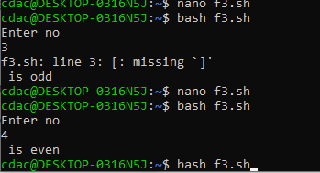

Question 6: Write a shell script that uses a for loop to print numbers from 1 to 5.

o/p=>

a=0

for a in {1..5}

do

echo $a

done

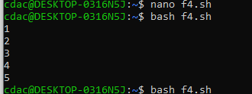

Question 7: Write a shell script that uses a while loop to print numbers from 1 to 5.

a=1

while [ $a -le 5 ]

do

echo "$a"

a=$((a + 1))

done

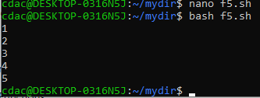

Question 8: Write a shell script that checks if a file named "file.txt" exists in the current directory. If it does, print "File exists", otherwise, print "File does not exist".

o/p=> if [ -f "f1.sh" ];

then

echo "file exists"

else

echo "file is not exits"

fi

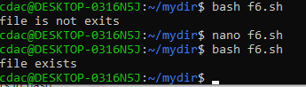

Question 9: Write a shell script that uses the if statement to check if a number is greater than 10 and prints a message accordingly.

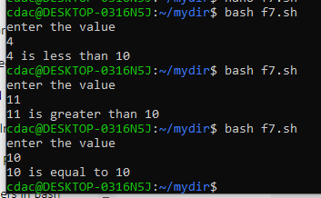

echo "enter the value"

read n

if [ $n -lt 10 ]

then

echo "$n is less than 10";

elif [ $n -gt 10 ]

then

echo "$n is greater than 10";

elif [ $n -eq 10 ]

then

echo "$n is equal to 10";

fi

Question 10: Write a shell script that uses nested for loops to print a multiplication table for numbers from 1 to 5. The output should be formatted nicely, with each row representing a number and each column representing the multiplication result for that number.

for((i=1; i<=5; i++))

do

for((j=1; j<=5;j++))

do

echo $j*$i =$((i * j))

done

done

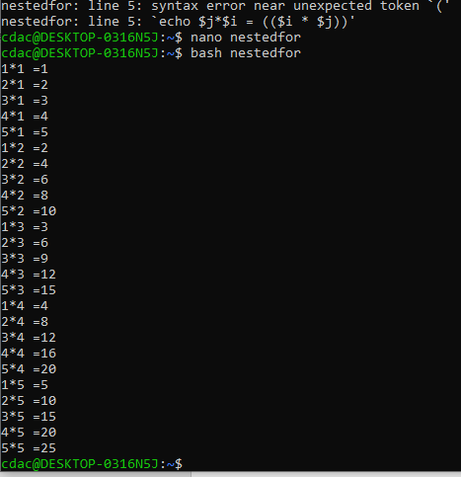

Question 11: Write a shell script that uses a while loop to read numbers from the user until the user enters a negative number. For each positive number entered, print its square. Use the break statement to exit the loop when a negative number is entered.



