**DAILY ONLINE ACTIVITIES SUMMARY**

|  |  |  |  |  |  |  |  |  |
| --- | --- | --- | --- | --- | --- | --- | --- | --- |
| **Date:** | **18-5-2020** | | | | | **Name:** | **poojashree** | |
| **Sem & Sec** | **8th sem A sec** | | | | | **USN:** | **4al16cs065** | |
| **Online Test Summary** | | | | | | | | |
| **Subject** | | **sms** | | | | | | |
| **Max. Marks** | | **60** | | **Score** | | | **45** | |
| **Certification Course Summary** | | | | | | | | |
| **Course** | **Introduction to front end development** | | | | | | | |
| **Certificate Provider** | | | **Great learning academy** | | **Duration** | | | **3.5hr** |
| **Coding Challenges** | | | | | | | | |
| **Problem Statement:finding the freq of each character in string & to print even and odd series** | | | | | | | | |
| **Status:completed** | | | | | | | | |
| **Uploaded the report in Github** | | | | | **yes** | | | |
| **If yes Repository name** | | | | | **Poojashree1998** | | | |
| **Uploaded the report in slack** | | | | | **yes** | | | |

Online test

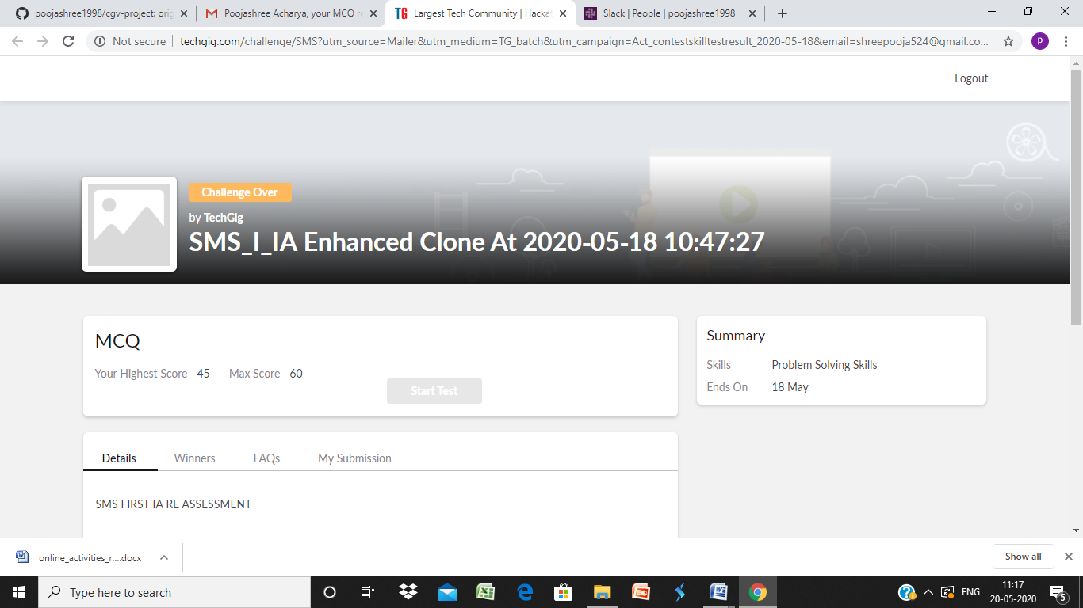

Certification course

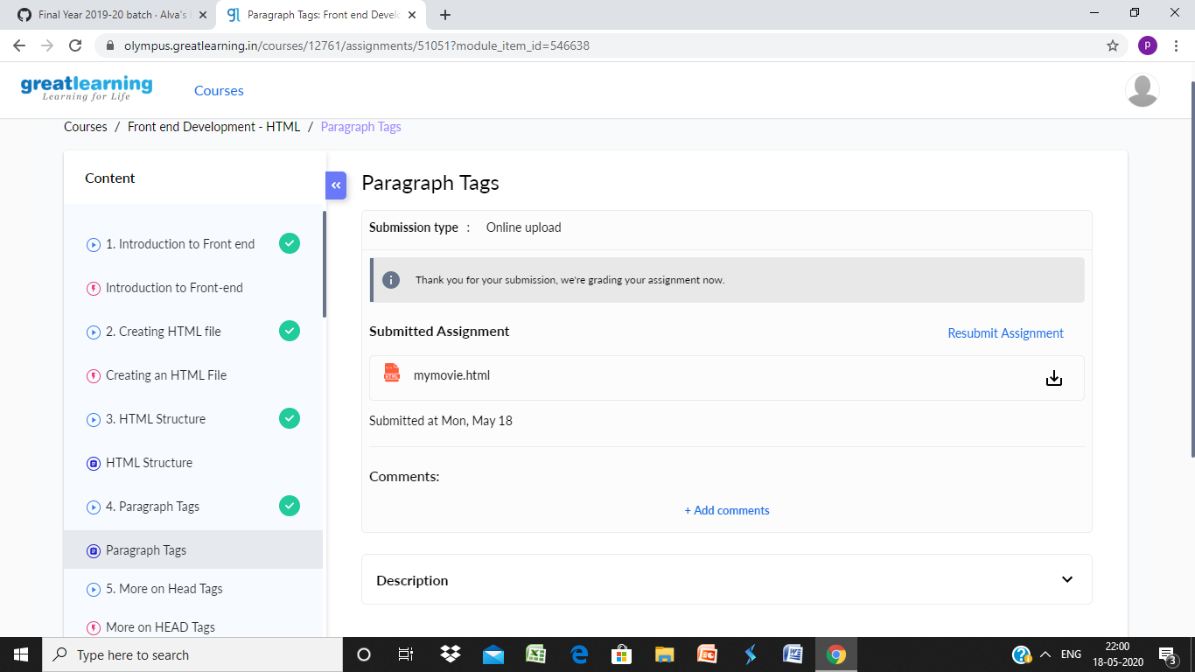

Coding

**program 1:**  
import java.util.Scanner;

public class Frequency1  
{  
public static void main(String args[])  
{  
int i;  
String str;

int counter[] = new int[256];

Scanner in = new Scanner(System.in);

System.out.print("Enter a String : ");

str=in.nextLine();

for (i = 0; i < str.length(); i++) {

counter[(int) str.charAt(i)]++;

}

// Print Frequency of characters

for (i = 0; i < 256; i++) {

if (counter[i] != 0) {

System.out.println( (char) i + ": " + counter[i]);

}

}

}  
}

**Program 2**  
  
public class PingPong extends Thread {  
static StringBuilder object = new StringBuilder("");

public static void main(String[] args) throws InterruptedException {

Thread t1 = new PingPong();  
Thread t2 = new PingPong();

t1.setName("\nping");  
t2.setName(" pong");

t1.start();  
t2.start();  
}

[**@override**](https://github.com/override)  
public void run() {  
working();  
}

void working() {  
while (true) {  
synchronized (object) {  
try {  
System.out.print(Thread.currentThread().getName());  
object.notify();  
object.wait();  
} catch (InterruptedException e) {  
e.printStackTrace();  
}  
}  
}}  
}