Contents

Execution Screenshots: 1

POST API 1

GET Location detail by POI 2

UPDATE Location by POI 2

DELETE DATA BASED ON POI 3

GET Location within Radius 4

Validation Failure Scenarios 5

POST API: Name is not provided 5

POST API: Latitude is not valid 6

GET API: Fetching non-existing POI 7

UPDATE API: Updating non existing POI 7

UPDATE API: Updating invalid latitude 7

DELETE API: Deleting non existing POI 8

# Execution Screenshots:

## POST API

URL: <http://localhost:8081/soarearth/api/pois>

Response structure has been enhanced

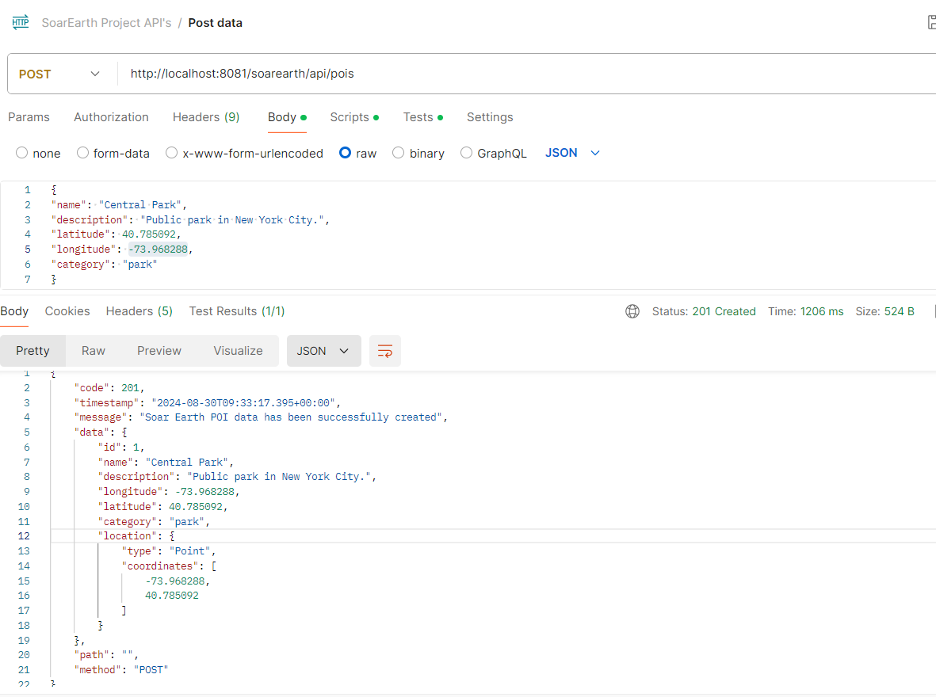

Geometry details would also be saved along with other details.

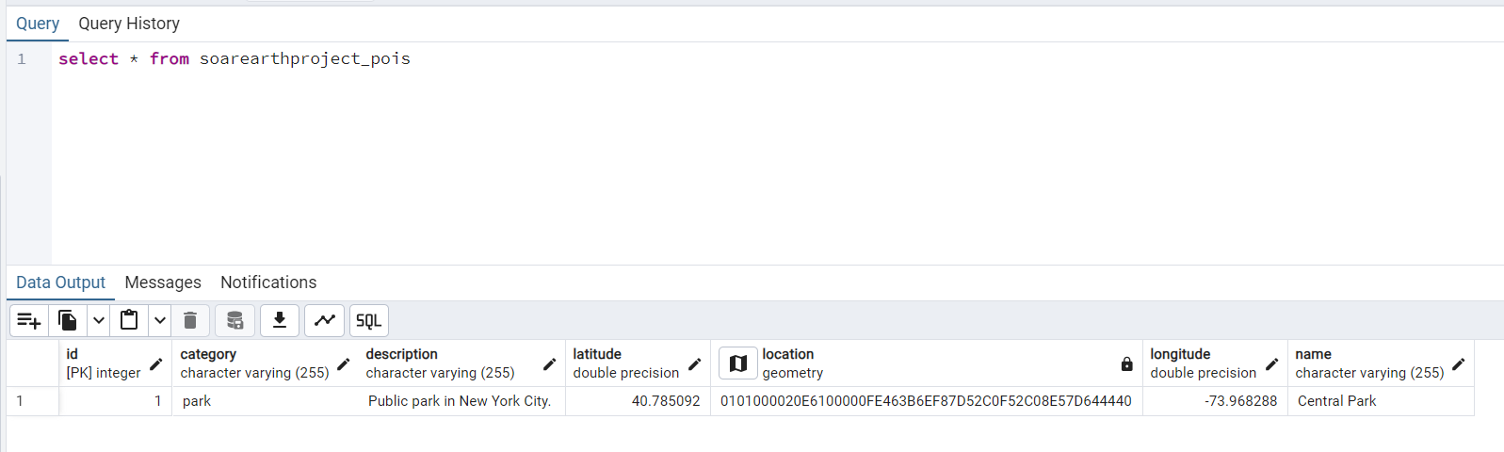

## GET Location detail by POI

URL: http://localhost:8081/soarearth/api/pois/1

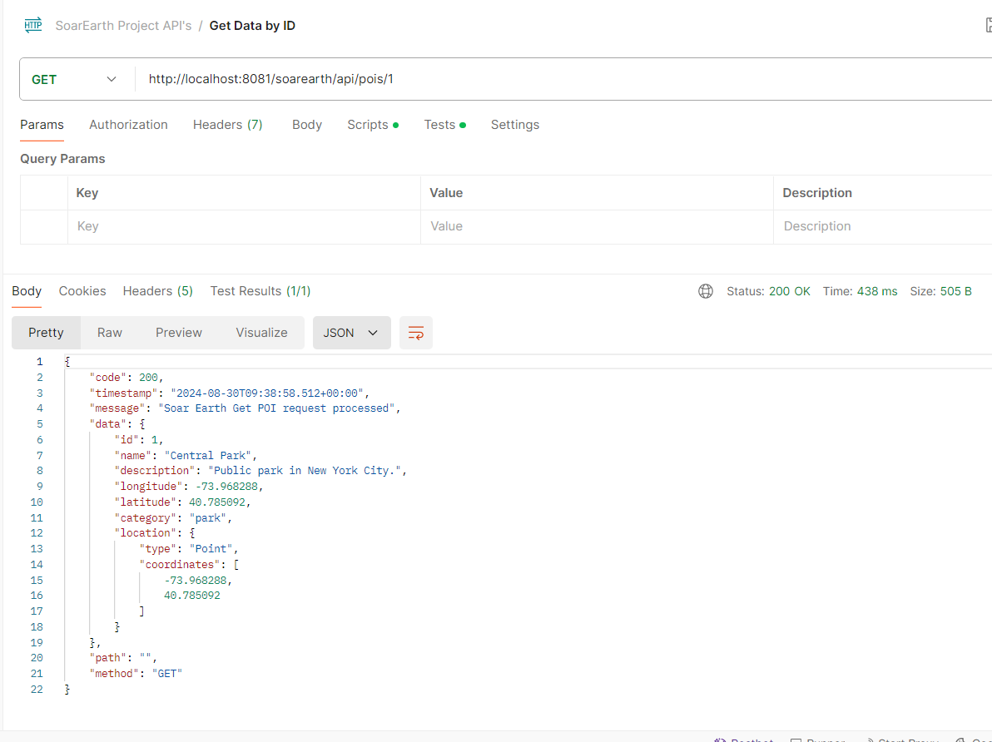

## UPDATE Location by POI

URL: <http://localhost:8081/soarearth/api/pois/1>

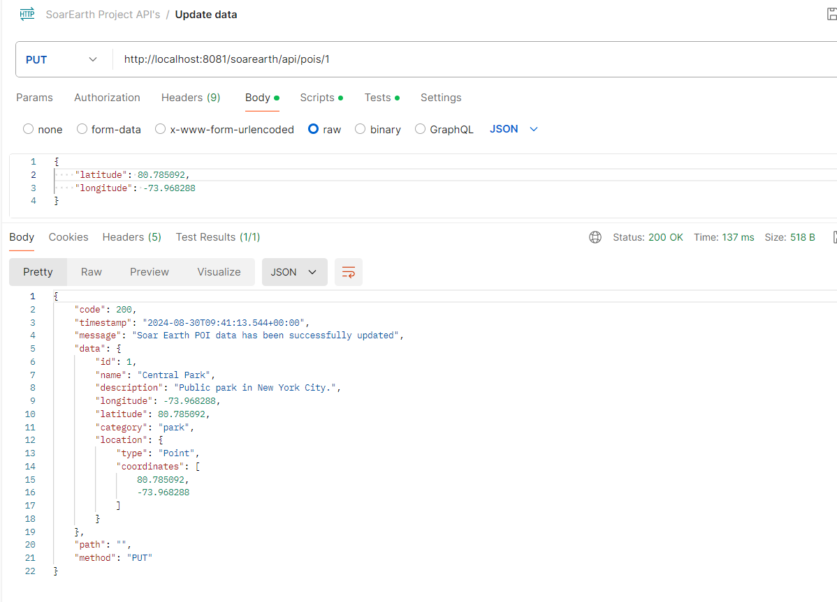

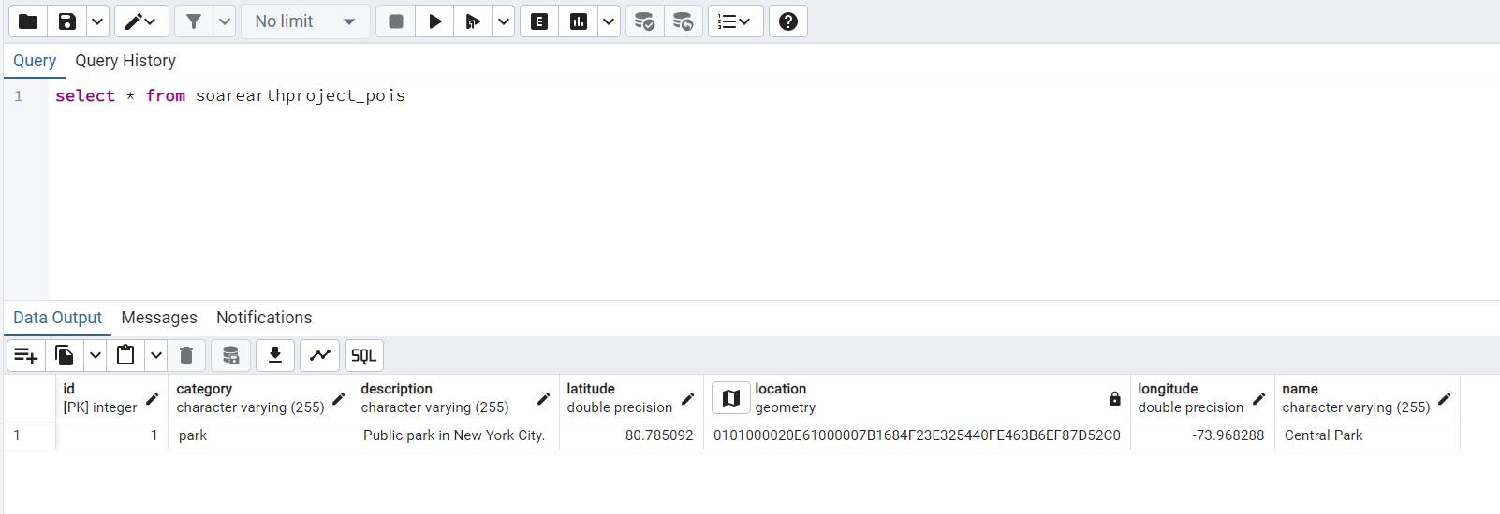

## DELETE DATA BASED ON POI

URL: <http://localhost:8081/soarearth/api/pois/1>

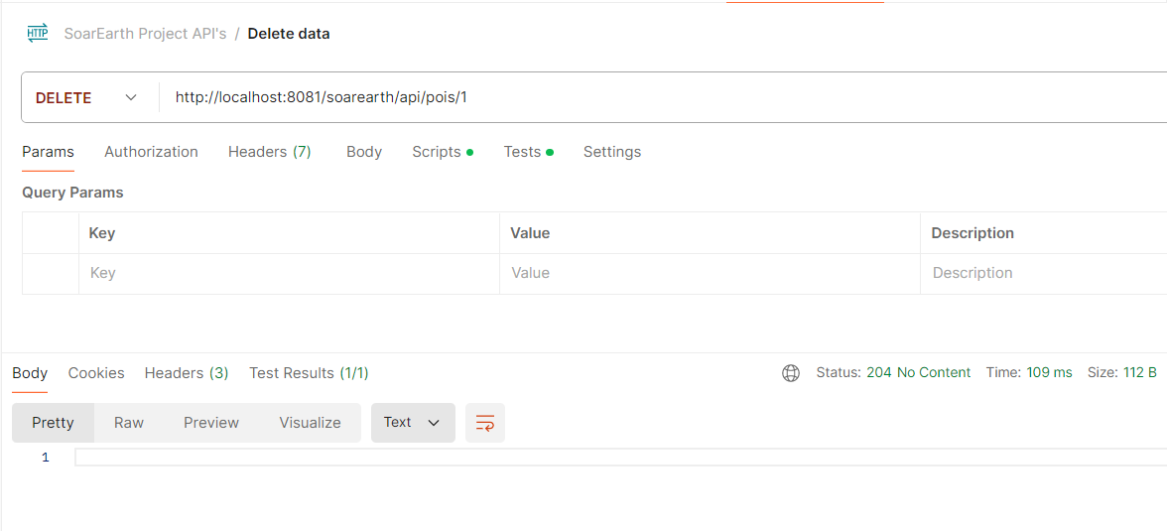

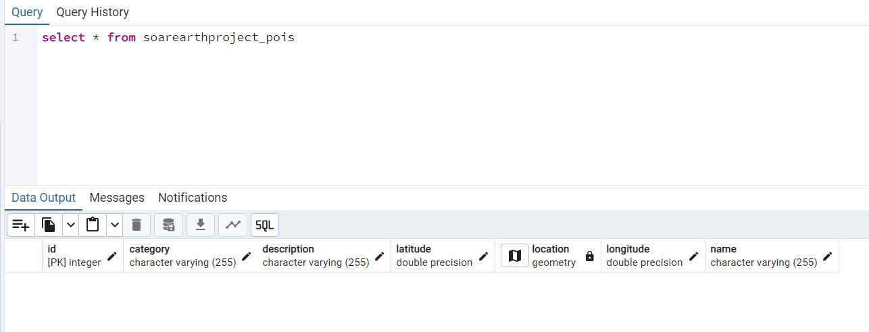

## GET Location within Radius

URL: <http://localhost:8081/soarearth/api/pois?latitude=80.785092&longitude=-93.968288&radius=6000>

Existing Data in Database

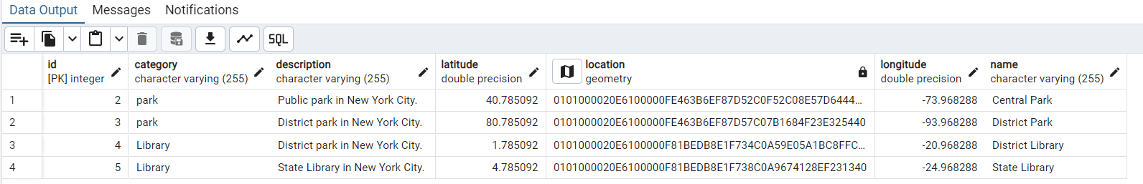

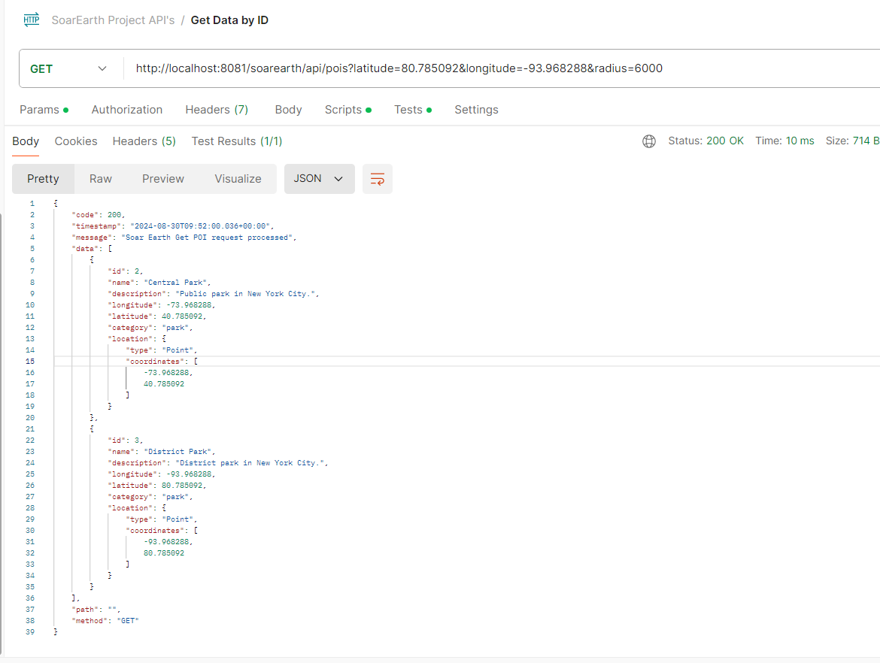

## Validation Failure Scenarios

### POST API: Name is not provided

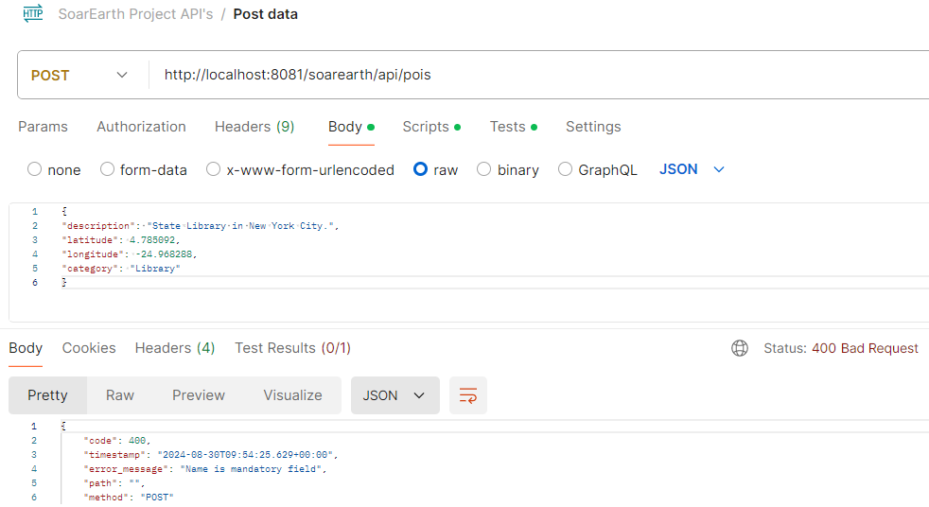

### POST API: Latitude is not valid

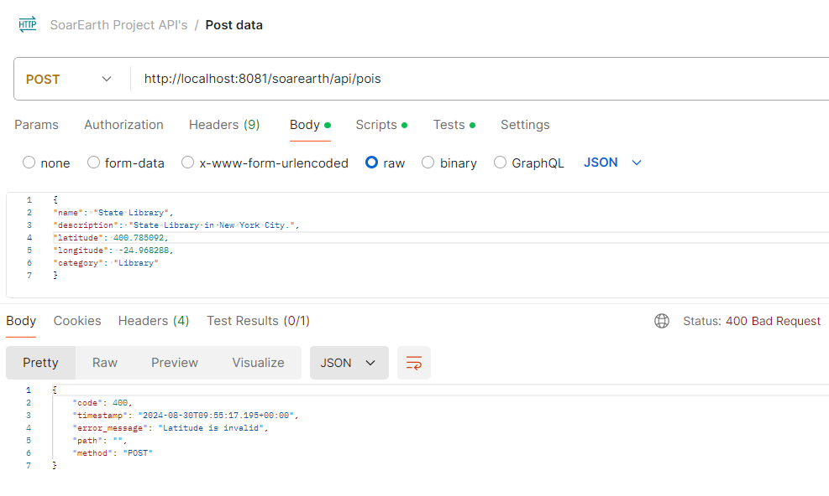

### GET API: Fetching non-existing POI

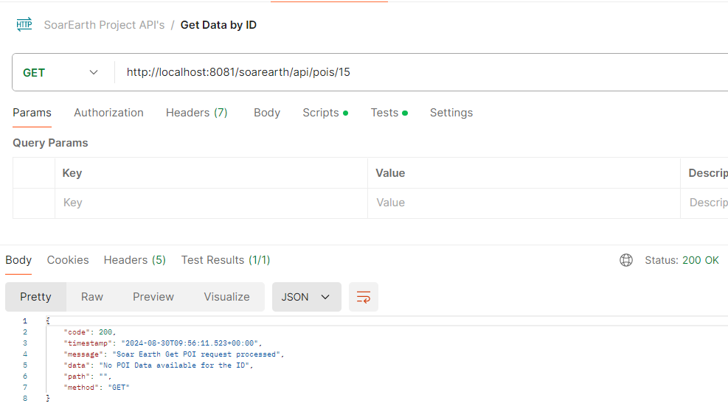

### UPDATE API: Updating non existing POI

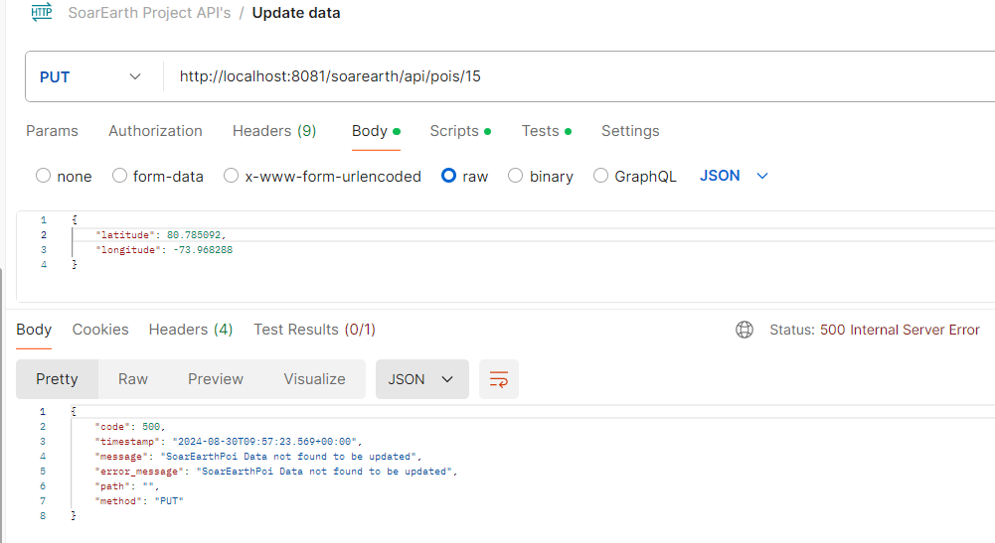

### UPDATE API: Updating invalid latitude

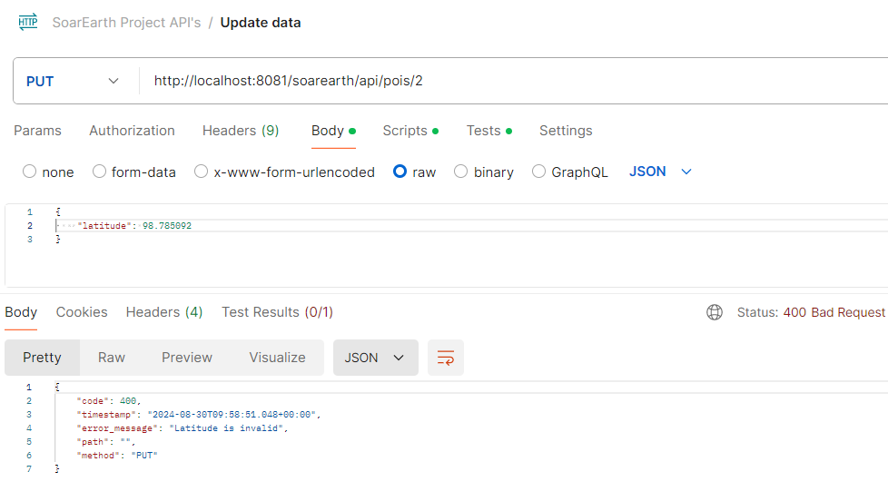

### DELETE API: Deleting non existing POI

