Contents

Monitoring Screenshots 2

Actuator API to know the list of available monitoring API’s 2

Swagger API 2

Logging using Log back using JSON Formatter 3

Performance Testing record on small load testing ran for 10mins with 20 Virtual Threads using Postman 3

Indexes Created 4

Docker Image Generated: 5

Docker-Compose file 5

# Monitoring Screenshots

### Actuator API to know the list of available monitoring API’s

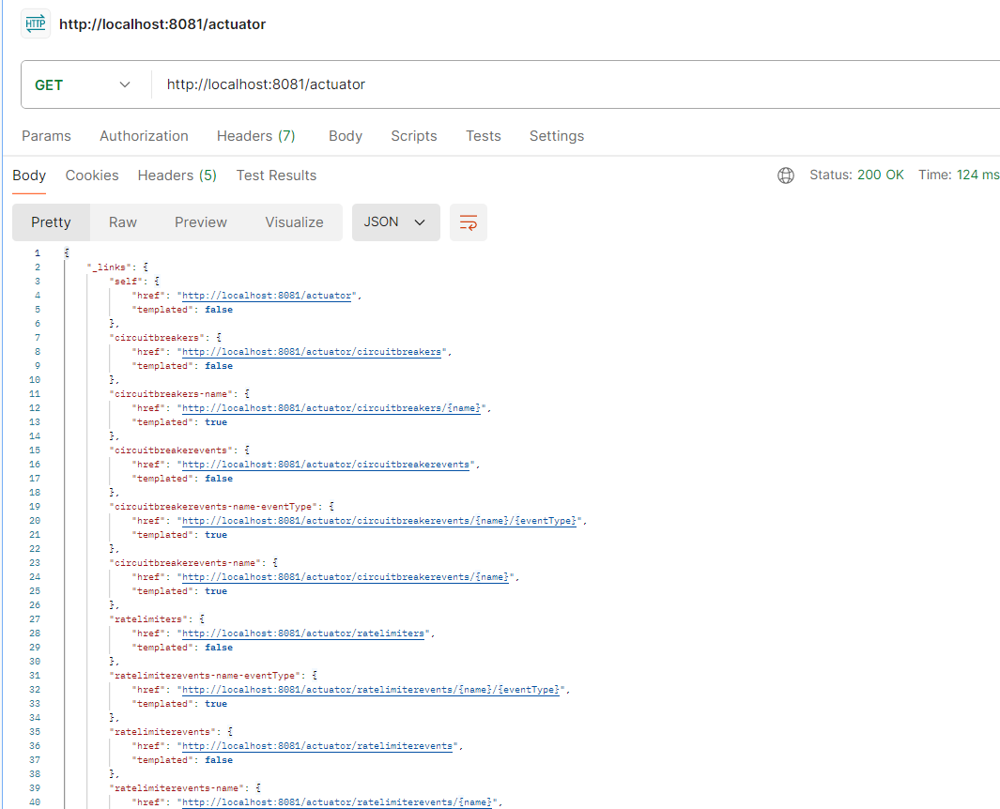

## Swagger API

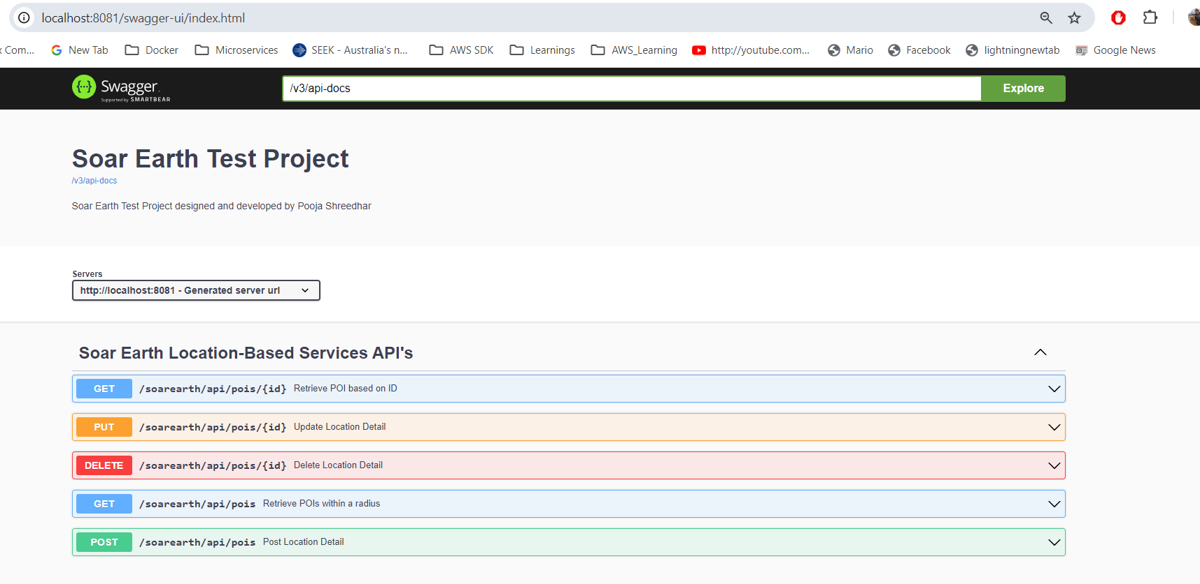

## Logging using Log back using JSON Formatter

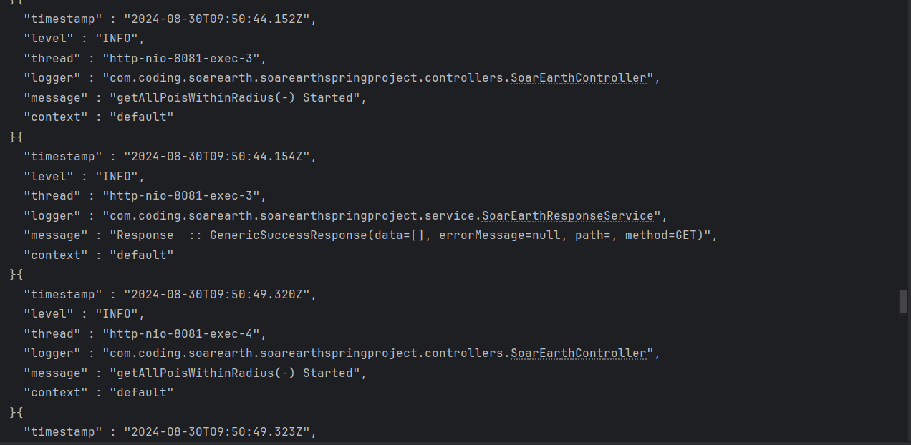

## Performance Testing record on small load testing ran for 10mins with 20 Virtual Threads using Postman

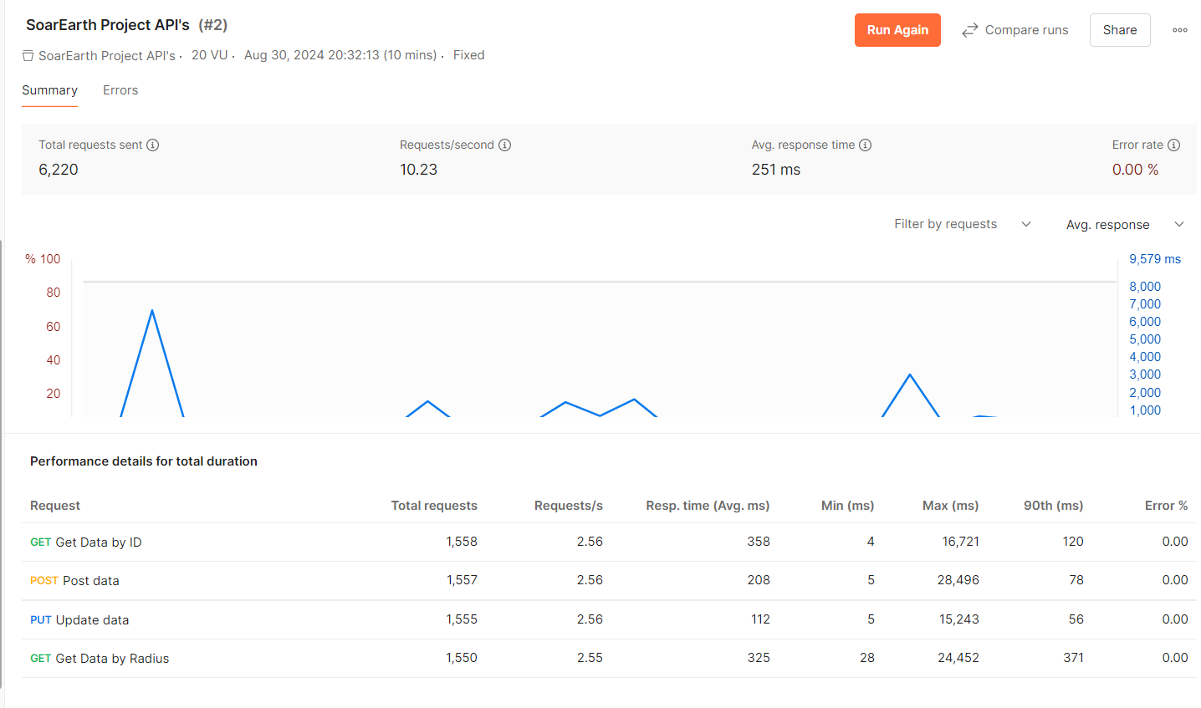

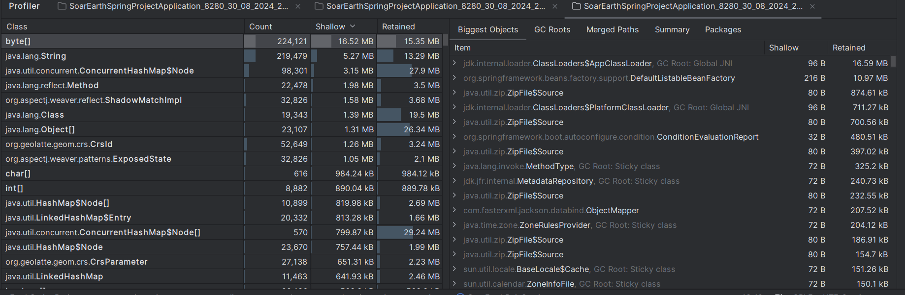

## Indexes Created

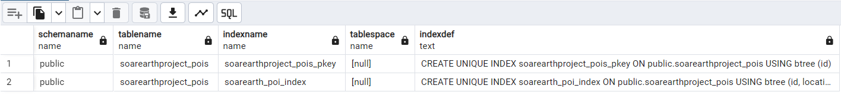

## Docker Image Generated:

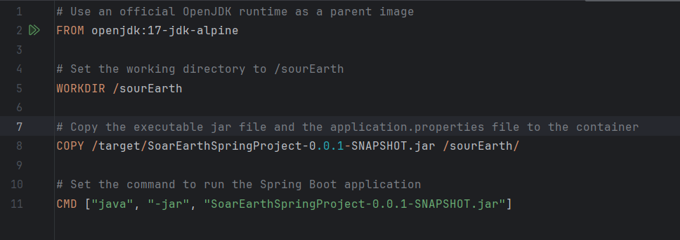

## Docker-Compose file

The PostgreSQL DB details needs to be passed based on different environments while deploying to bring up containers:

