CO-4 ASSESSMENT 02

NAME:POOJA.S SLOT:C
REG.NO.:192524326 COURSECODE:CSA0508

- An e-commerce company needs to store 10 million product records. Recommend a file organization strategy and justify your choice with cost analysis.
File Organization for 10 Million Product Records
For an e-commerce company with 10 million product records, B+ Tree indexed file organization is suitable.
- Store records using ProductID as the primary key.
- Create a B+ Tree index on ProductID.
- B+ Tree provides fast searching with approximately O(log n) cost.
- It also supports range queries, such as finding products between ₹500 and ₹1000.
- It supports efficient insertion and deletion and reduces disk I/O.
Cost comparison:
- Sequential search → O(n)
- B+ Tree search → O(log n)
Conclusion:
B+ Tree is preferred because it provides fast searching, range retrieval and efficient updates for a very large database.

- A banking system requires fast retrieval of transactions by account number and date range. Design an indexing strategy with appropriate index types.
Banking Transaction Indexing
For a banking system, transactions are frequently searched using AccountNumber and TransactionDate. Therefore, a composite B+ Tree index should be used.
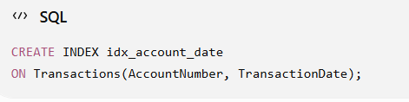
- AccountNumber is the first index key.
- TransactionDate is the second key.
- B+ Tree provides fast account-based searching.
- It efficiently supports date-range queries.
- Search cost is approximately O(log n).
For example:
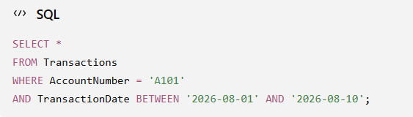
Conclusion:
A composite B+ Tree index on (AccountNumber, TransactionDate) is the best choice because it supports both account lookup and date-range retrieval.

- A healthcare system stores patient records accessed both by PatientID and by doctor name. Design a multi-level indexing solution.
Patient Records Multi-Level Indexing
Since patient records are accessed using both PatientID and DoctorName, two indexes should be created.
Index 1 – Primary Index
Create a B+ Tree index on PatientID.
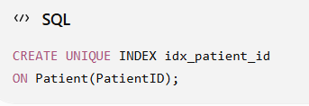
Index 2 – Secondary Index
Create a B+ Tree index on DoctorName.
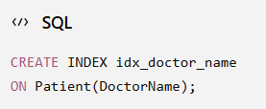
- PatientID index provides fast access to an individual patient.
- DoctorName index retrieves all patients treated by a doctor.
- B+ Tree provides approximately O(log n) search.
- Multiple index levels reduce disk access.
Conclusion:
A primary B+ Tree on PatientID and secondary B+ Tree on DoctorName provides efficient access through both search fields.

- A logistics company needs to efficiently handle dynamic insertions and deletions of shipment records. Analyze whether B-Tree or B+ Tree is more suitable.
B-Tree vs B+ Tree for Logistics
For a logistics company with frequent insertions and deletions, B+ Tree is more suitable than B-Tree.
B-Tree | B+ Tree
Data can be in internal and leaf nodes | Data is stored at leaf level
Leaf nodes are generally not linked | Leaf nodes are linked
Lower fan-out | Higher fan-out
Range search is less efficient | Range search is highly efficient
Advantages of B+ Tree:
- Efficient insertion and deletion.
- Search cost is approximately O(log n).
- High fan-out reduces tree height.
- Linked leaf nodes make range queries faster.
- Suitable for disk-based databases.
Conclusion:
B+ Tree should be selected because it handles dynamic insertion/deletion efficiently and provides better range-search performance.

- Design a hashing scheme for an HR system with 5000 employees. Evaluate static hashing vs. extendible hashing for your scenario.
Hashing for 5000 Employees
For an HR system with 5000 employees, EmployeeID can be used as the hashing key.
A simple hash function is:
Thus, approximately 50 buckets can initially be used.
Static Hashing
- Fixed number of buckets.
- Simple and fast.
- Average search is approximately O(1).
- Overflow can occur when employee records increase.
Extendible Hashing
- Number of buckets can grow dynamically.
- Uses a directory and bucket splitting.
- Reduces overflow.
- Suitable when the number of employees changes.
Conclusion:
For a fixed 5000 employees, static hashing is simple and sufficient. If the number of employees changes frequently, extendible hashing is better.

- An airline reservation system must support point queries by flight number and range queries by date. Propose a combined index structure.
Combined Index for Airline Reservation System
The system requires two types of queries:
- Point query: Search by FlightNumber
- Range query: Search by Date
Therefore, a composite B+ Tree index can be used.
Proposed Index
Create a composite index on:
For example:
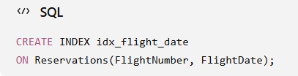
The B+ Tree first organizes records by FlightNumber and then by FlightDate.
Example:
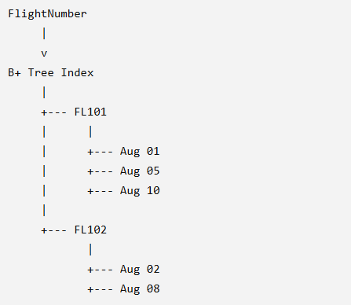
Advantages
- Fast point search using FlightNumber.
- Efficient date-range search for a particular flight.
- B+ Tree has search cost approximately O(log n).
- Linked leaf nodes make range queries efficient.
- Reduces disk I/O compared with sequential searching.
Conclusion
A composite B+ Tree index on (FlightNumber, FlightDate) is suitable because it supports fast flight-number lookup and efficient date-range queries.

- For a university student database, design the file organization and secondary indexing to support fast queries by department and CGPA range.
University Student Database – File Organization and Secondary Indexing
For a student database, records can be stored using heap file organization and secondary B+ Tree indexes can be created on Department and CGPA.
File Organization
Use Heap File Organization because student records may be frequently inserted and updated.
Secondary Indexes
Create:
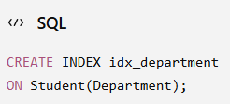
And
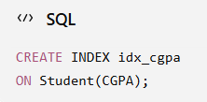
The Department index provides fast searching for students belonging to a particular department.
The CGPA B+ Tree index supports range queries such as:
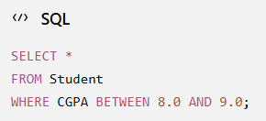
Why B+ Tree?
- Supports equality searches.
- Supports range queries.
- Search cost is approximately O(log n).
- Leaf nodes are linked for efficient sequential/range access.
Conclusion
Heap file + secondary B+ Tree indexes on Department and CGPA is a suitable design. It provides fast department searches and efficient CGPA range queries.

- Analyze the disk block utilization for Heap, Sorted, and Hashed file organizations given 100,000 records with 50 bytes each and 4KB blocks.
Disk Block Utilization
Given:
- Records = 100,000
- Record size = 50 bytes
- Block size = 4 KB = 4096 bytes
Calculation
So, 81 records fit in one block.
Block utilization:
Comparison
- Heap: Simple storage; approximately 98.88% utilization.
- Sorted: Records maintained in order; approximately 98.88% utilization.
- Hashed: Records distributed into buckets; utilization may decrease due to overflow.
Conclusion:
All three can have similar basic block utilization, but their search and update performance differs.

- A social media platform needs to index 500 million posts by user_id, timestamp, and hashtag. Design a composite indexing strategy.
Composite Indexing for 500 Million Posts
For 500 million posts, use B+ Tree indexes.
Index 1
Create a composite index on:
(user_id, timestamp)
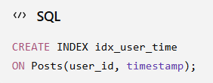
This supports:
- Fast search by user_id.
- Efficient date/time range queries.
- Search cost approximately O(log n).
Index 2
Create an index on hashtag:
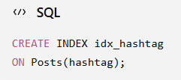
This provides fast hashtag searches.
Conclusion:
Use B+ Tree (user_id, timestamp) + hashtag index for efficient searching of 500 million posts.
- Compare the performance (insert, delete, search time) of Heap File, Sorted File, and Hashed File for a supermarket billing system with 1 million daily transactions.
Heap vs Sorted vs Hashed File — 5 Marks
Operation | Heap | Sorted | Hashed
Search | Slow | Fast | Very fast
Insert | Very fast | Slow | Fast
Delete | Moderate | Slow | Fast
Range Search | Poor | Excellent | Poor

Heap File
Records are stored without a specific order. It provides fast insertion but slow searching.
Sorted File
Records are maintained in sorted order. It provides fast search and excellent range queries, but insertion and deletion are slower.
Hashed File
A hash function determines the record location. It provides very fast exact-match search and insertion.
Conclusion:
For supermarket billing with frequent transaction-ID searches, Hashed File is the best choice. For range queries, Sorted File/B+ Tree is better.

