ASSESSMENT TOOL 1

COURSE NAME: Database Management Systems NAME: Pooja.S
COURSE CODE: CSA05 REG.NO.:192524326

- Apply relational algebra operations (σ, π, ∪, -, ×, ⋈) on the given Employee and Department relations to retrieve required records.

Assume:
Employee(EmpID, EmpName, DeptID)
Department(DeptID, DeptName)
(a) Selection (σ)
Employees in HR department.
σ DeptID='D1' (Employee)

(b) Projection (π)
Display employee names.
π EmpName (Employee)

(c) Union (∪)
Employees in HR or IT.
σ DeptID='D1'(Employee)
∪
σ DeptID='D2'(Employee)

(d) Difference (−)
Employees in HR but not in IT.
σ DeptID='D1'(Employee)
−
σ DeptID='D2'(Employee)

(e) Cartesian Product (×)
Employee × Department

(f) Join (⋈)
Employee with Department details.
Employee ⋈ Employee.DeptID=Department.DeptID Department

- Write SQL DDL statements to create STUDENT(SID, Name, DOB, DeptID) and DEPARTMENT(DeptID, DeptName) tables with all appropriate constraints.

CREATE TABLE Department(
DeptID INT PRIMARY KEY,
DeptName VARCHAR(30) NOT NULL
);

CREATE TABLE Student(
SID INT PRIMARY KEY,
Name VARCHAR(30) NOT NULL,
DOB DATE,
DeptID INT,
FOREIGN KEY(DeptID)
REFERENCES Department(DeptID)
);

- Formulate SQL queries using GROUP BY, HAVING, and aggregate functions (COUNT, SUM, AVG, MAX, MIN) on a given Sales dataset.

SELECT Category,
COUNT(*) AS TotalItems,
SUM(Amount) AS TotalSales,
AVG(Amount) AS Average,
MAX(Amount) AS Maximum,
MIN(Amount) AS Minimum
FROM Sales
GROUP BY Category
HAVING SUM(Amount)>10000;

Output

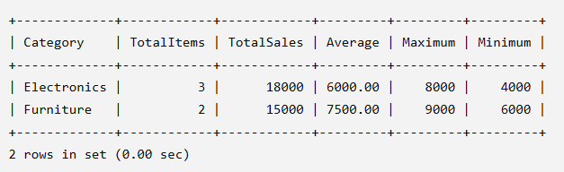

- Write a correlated sub-query to find employees earning more than the average salary of their own department.

SELECT *
FROM Employee e
WHERE Salary>
(
SELECT AVG(Salary)
FROM Employee
WHERE DeptID=e.DeptID
);

Output

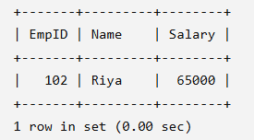

- Apply all types of JOIN operations (INNER, LEFT OUTER, RIGHT OUTER, FULL OUTER, CROSS) on Employee and Project tables.

JOIN Operations

INNER JOIN
SELECT *
FROM Employee
INNER JOIN Project
ON Employee.EmpID=Project.EmpID;

LEFT JOIN
SELECT *
FROM Employee
LEFT JOIN Project
ON Employee.EmpID=Project.EmpID;

RIGHT JOIN
SELECT *
FROM Employee
RIGHT JOIN Project
ON Employee.EmpID=Project.EmpID;

FULL OUTER JOIN
SELECT *
FROM Employee
LEFT JOIN Project
ON Employee.EmpID=Project.EmpID
UNION
SELECT *
FROM Employee
RIGHT JOIN Project
ON Employee.EmpID=Project.EmpID;

CROSS JOIN
SELECT *
FROM Employee
CROSS JOIN Project;

- Create a view ‘DeptSalaryView’ that displays department name, total employees, and average salary. Write a query on this view.

Create View 'DeptSalaryView'

CREATE VIEW DeptSalaryView AS
SELECT Department.DeptName,
COUNT(Employee.EmpID) AS TotalEmployees,
AVG(Employee.Salary) AS AverageSalary
FROM Employee
JOIN Department
ON Employee.DeptID=Department.DeptID
GROUP BY Department.DeptName;

Output

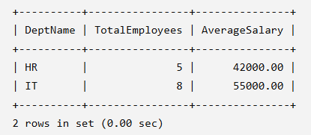

- Construct a relational algebra expression for the following: Find names of students who are enrolled in all courses offered.

Relational Algebra
Find students enrolled in all courses.
Using Division (÷):
πSID(Enrollment)
÷
πCID(Course)

- Write SQL DML statements (INSERT, UPDATE, DELETE) with integrity constraint enforcement for a given scenario.

SQL DML Statements
INSERT
INSERT INTO Student
VALUES(101,'Amit','2004-05-10',1);

Output

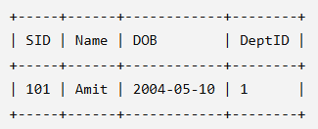

UPDATE
UPDATE Student
SET Name='Rahul'
WHERE SID=101;

Output

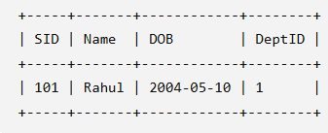

DELETE
DELETE FROM Student
WHERE SID=101;

Output

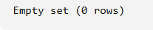

- Apply tuple relational calculus to express a query: Find all employees who work in the ‘IT’ department and earn more than 50000.

Tuple Relational Calculus (TRC)

Employee(EmpID, EmpName, Department, Salary)

{ E.EmpName |
Employee€ ∧
E.Department = ‘IT’ ∧
E.Salary > 50000
}

SQL Query

SELECT *
FROM Employee
WHERE Department='IT'
AND Salary>50000;

Output

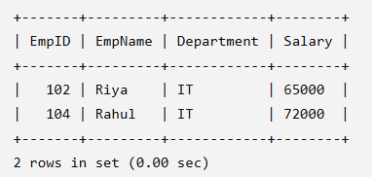

- Design a relational schema for an Airline Reservation System and write 5 SQL queries demonstrating joins, sub-queries, and views.

Relational Schema

Passenger(PassengerID, PassengerName)

Flight(FlightID, FlightName, Source, Destination)

Reservation(ReservationID, PassengerID, FlightID, SeatNo)

Query 1 – INNER JOIN

SELECT p.PassengerName, f.FlightName
FROM Passenger p
JOIN Reservation r
ON p.PassengerID=r.PassengerID
JOIN Flight f
ON r.FlightID=f.FlightID;

Query 2 – LEFT JOIN

SELECT p.PassengerName, r.SeatNo
FROM Passenger p
LEFT JOIN Reservation r
ON p.PassengerID=r.PassengerID;

Query 3 – Subquery

Find passengers who booked Flight ID = 101.
SELECT PassengerName
FROM Passenger
WHERE PassengerID IN
(
SELECT PassengerID
FROM Reservation
WHERE FlightID=101
);

Query 4 – Create View

CREATE VIEW FlightDetails AS
SELECT p.PassengerName,
f.FlightName,
r.SeatNo
FROM Passenger p
JOIN Reservation r
ON p.PassengerID=r.PassengerID
JOIN Flight f
ON r.FlightID=f.FlightID;

Query 5 – Display View

SELECT * FROM FlightDetails;

Output

