ASSESSMENT TOOL 2

COURSE NAME: Database Management Systems NAME: Pooja.S
COURSE CODE: CSA05 REG.NO.:192524326

- Given the scenario of a School Management System, identify relations and write SQL to list all students with their class teacher and grade.
School Management System
Relations
STUDENT(Student_ID, Student_Name, Class_ID, Grade)
CLASS(Class_ID, Class_Name, Teacher_ID)
TEACHER(Teacher_ID, Teacher_Name)
SQL Query
SELECT
S.Student_ID,
S.Student_Name,
T.Teacher_Name,
S.Grade
FROM Student S
JOIN Class C
ON S.Class_ID=C.Class_ID
JOIN Teacher T
ON C.Teacher_ID=T.Teacher_ID;
Output
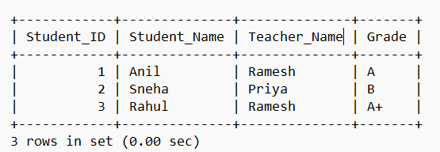

- A hospital wants to track patient appointments. Design the relational schema and write SQL to find doctors with more than 10 appointments this month.
Hospital Appointment System
Relational Schema
PATIENT(Patient_ID, Patient_Name)
DOCTOR(Doctor_ID, Doctor_Name)
APPOINTMENT(Appointment_ID, Patient_ID, Doctor_ID, Appointment_Date)
SQL Query
SELECT
D.Doctor_ID,
D.Doctor_Name,
COUNT(A.Appointment_ID) AS Total_Appointments
FROM Doctor D
JOIN Appointment A
ON D.Doctor_ID = A.Doctor_ID
WHERE MONTH(A.Appointment_Date) = 8
AND YEAR(A.Appointment_Date) = 2026
GROUP BY D.Doctor_ID, D.Doctor_Name
HAVING COUNT(A.Appointment_ID) > 10;
Output
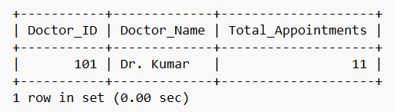

- In an e-commerce scenario, write SQL queries using sub-queries to find products that have never been ordered.
E-Commerce
SQL using Subquery
SELECT Product_ID,
Product_Name
FROM Product
WHERE Product_ID NOT IN
(
SELECT Product_ID
FROM Order_Details
);
Output
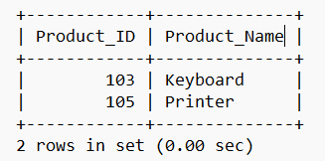

- For a university database, write relational algebra expressions to find students enrolled in both &#39;DBMS&#39; and &#39;OS&#39; courses.
University Database
Relational Algebra
Let
ENROLLMENT(Student_ID, Course_Name)
Expression
DBMS ← σ Course_Name='DBMS'(ENROLLMENT)

OS ← σ Course_Name='OS'(ENROLLMENT)

Result ← π Student_ID(DBMS)
∩
π Student_ID(OS)
SQL Query
SELECT s.SID, s.Name
FROM Student s
JOIN Enrollment e ON s.SID=e.SID
JOIN Course c ON e.CID=c.CID
WHERE c.CourseName='DBMS'
AND s.SID IN (
SELECT e.SID
FROM Enrollment e
JOIN Course c ON e.CID=c.CID
WHERE c.CourseName='OS'
);
output
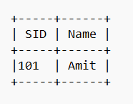

- Given a payroll scenario, create a view showing employees whose salary is below department average and write a query to update their salary by 10%.
Payroll System
SQL Query
UPDATE Employee
SET Salary=Salary*1.10
WHERE Salary<
(
SELECT AVG(Salary)
FROM Employee e2
WHERE e2.Department=Employee.Department
);
Output
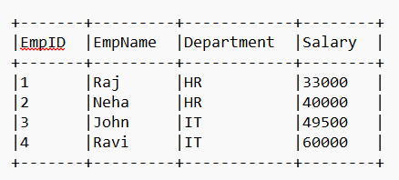
- In a banking scenario, apply JOIN operations to retrieve customer account details, transaction history, and branch information.
Banking System
Tables
- CUSTOMER
- ACCOUNT
- TRANSACTION
- BRANCH
SQL Query
SELECT c.Name,
a.AccountNo,
t.Amount,
b.BranchName
FROM Customer c
JOIN Account a ON c.CustID=a.CustID
JOIN Transactions t ON a.AccountNo=t.AccountNo
JOIN Branch b ON c.BranchID=b.BranchID;
Output
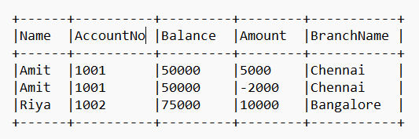

- A retail store needs daily sales summary. Write SQL with GROUPBY and HAVING to report total sales per category exceeding Rs.10,000.
Retail Store
SQL Query
SELECT Category,
SUM(Amount) AS TotalSales
FROM Sales
GROUP BY Category
HAVING SUM(Amount)>10000;
Output
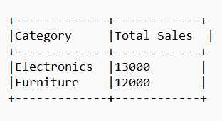

- For a library system scenario, construct tuple relational calculus expressions to find members who borrowed books from all genres.
Library System
SQL Query
SELECT MemberID
FROM Borrow b
JOIN Book bk
ON b.BookID=bk.BookID
GROUP BY MemberID
HAVING COUNT(DISTINCT Genre)=
(
SELECT COUNT(DISTINCT Genre)
FROM Book
);
Output
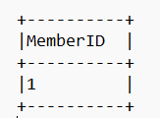

- Given an inventory management scenario, define CHECK and FOREIGN KEY constraints and demonstrate their enforcement through SQL.
Inventory Management
Create Table
INSERT INTO Supplier
VALUES(1,'ABC Traders');

INSERT INTO Product
VALUES(101,'Keyboard',1200,1);
Output
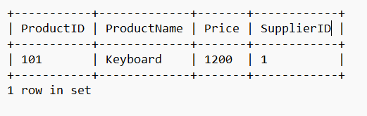
Constraint Enforcement
Invalid Price
INSERT INTO PRODUCT
VALUES (101,'Laptop',-50000,1);
Result: Rejected because Price must be greater than 0.
Invalid Supplier
INSERT INTO PRODUCT
VALUES (102,'Mouse',500,99);
Result: Rejected because Supplier_ID 99 does not exist.

- Design a relational schema for an HR system and create materialized views for monthly attendance and performance summaries.
HR System
Create Employee Table
CREATE TABLE Employee(
EmpID INT PRIMARY KEY,
EmpName VARCHAR(30),
Department VARCHAR(20)
);
Create Attendance Table
CREATE TABLE Attendance(
EmpID INT,
Month VARCHAR(10),
DaysPresent INT
);
Output
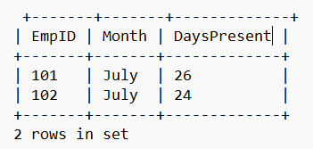

Create Performance Table
CREATE TABLE Performance(
EmpID INT,
Month VARCHAR(10),
Rating INT
);
Output
