ASSESSMENT TOOL 3

COURSE NAME: Database Management Systems NAME: Pooja.S
COURSE CODE: CSA0508 REG.NO.:192524326

- Identify and fix the error in the given SQL query that uses incorrect JOIN syntax and returns duplicate results.

Given Query:

SELECT s.Name, d.DeptName
FROM Student s, Department d;
-- Intent: list each student with their own
department&#39;s name

Correct SQL Query

SELECT s.Name, d.DeptName
FROM Student s
INNER JOIN Department d
ON s.DeptID = d.DeptID;

Output

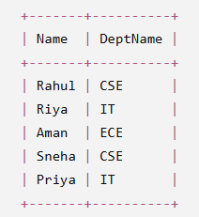

- The following sub-query returns incorrect results due to a missing correlation. Debug and rewrite it correctly.

Given Query:

SELECT s.Name, s.DeptID, s.Marks
FROM Student s
WHERE s.Marks &gt; (SELECT AVG(Marks) FROM Student);
-- Intent: list students who score above their OWN
department&#39;s average
Correct SQL Query

SELECT s.Name, s.DeptID, s.Marks
FROM Student s
WHERE s.Marks >
(
SELECT AVG(s2.Marks)
FROM Student s2
WHERE s2.DeptID = s.DeptID
);

Output

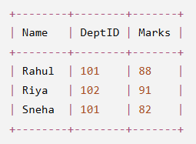

- A given SQL view definition causes errors when queried. Identify the issue and rewrite a correct and optimized view.

Given Query:

CREATE VIEW DeptAvgMarks AS
SELECT Name, DeptID, AVG(Marks) AS AvgMarks
FROM Student
GROUP BY DeptID;
SELECT * FROM DeptAvgMarks;

Correct SQL Query

CREATE VIEW DeptAvgMarks AS
SELECT DeptID, AVG(Marks) AS AvgMarks
FROM Student
GROUP BY DeptID;

SELECT * FROM DeptAvgMarks;

Output

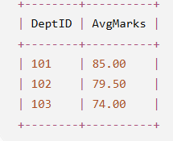

- Debug the given relational algebra expression that produces incorrect output for a natural join operation.

Given Query:

π(Name, Age) (Student) ⋈ Department
-- Intent: natural join of Student and Department on
DeptID

Correct Query

π(Name, Age) (Student ⋈ Department)

Output

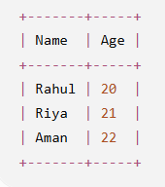

- The SQL query below violates referential integrity. Identify the violation and modify the statements to enforce proper constraints.

Given Query:

CREATE TABLE Student (
RollNo INT PRIMARY KEY,
Name VARCHAR(50),
DeptID INT,
Age INT,
Marks INT
);
-- Department table only has DeptID values 1, 2, 3
INSERT INTO Student (RollNo, Name, DeptID, Age, Marks)
VALUES (110, &#39;Arun&#39;, 9, 20, 78);

Correct Query

CREATE TABLE Student (
RollNo INT PRIMARY KEY,
Name VARCHAR(50),
DeptID INT,
Age INT,
Marks INT,
FOREIGN KEY (DeptID) REFERENCES Department(DeptID)
);

INSERT INTO Student (RollNo, Name, DeptID, Age, Marks)
VALUES (110, 'Arun', 2, 20, 78);

Output

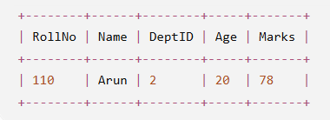

- Given an inefficient SQL query with nested loops, rewrite it using JOIN to optimize performance.

Given Query:

SELECT s.Name,
(SELECT d.DeptName FROM Department d WHERE
d.DeptID = s.DeptID) AS DeptName
FROM Student s;

Correct Query

SELECT s.Name, d.DeptName
FROM Student s
JOIN Department d
ON s.DeptID = d.DeptID;

Output

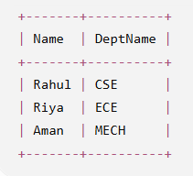

- The GROUP BY query below produces wrong aggregation results. Debug the query and explain the error.

Given Query:

SELECT DeptID, AVG(Marks) AS AvgMarks
FROM Student
GROUP BY RollNo;

Correct Query

SELECT DeptID, AVG(Marks) AS AvgMarks
FROM Student
GROUP BY DeptID;

Output

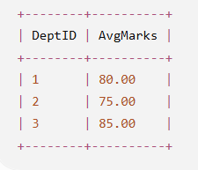

- Identify and fix the logical error in a given SQL UPDATE statement that unintentionally modifies all rows in the table.

Given Query:

-- Intent: give 5 bonus marks to students in
Department 2 only
UPDATE Student
SET Marks = Marks + 5;

Correct Query

UPDATE Student
SET Marks = Marks + 5
WHERE DeptID = 2;

Output

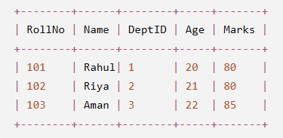

- Optimize the given multi-table SQL query by restructuring sub-queries into JOINs and using appropriate indexes.

Given Query:

SELECT s.Name, s.Marks,
(SELECT DeptName FROM Department WHERE DeptID =
s.DeptID) AS DeptName,
(SELECT HOD FROM Department WHERE DeptID =
s.DeptID) AS HeadOfDept
FROM Student s
WHERE s.DeptID IN (
SELECT DeptID FROM Department WHERE DeptName IN
(&#39;Computer Science&#39;, &#39;Electronics&#39;)
);

Correct Query

SELECT s.Name, s.Marks, d.DeptName, d.HOD
FROM Student s
JOIN Department d
ON s.DeptID = d.DeptID
WHERE d.DeptName IN ('Computer Science', 'Electronics');

CREATE INDEX idx_student_deptid ON Student(DeptID);
CREATE INDEX idx_department_deptid ON Department(DeptID);

Output

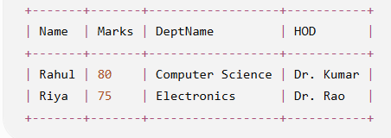

- Debug a given relational calculus expression that returns an empty result set due to incorrect quantifier usage.

Given Query:

-- Intent: students who scored more than AT LEAST ONE
student in Department 2
{ s.Name | Student(s) ∧ (∀ t) (Student(t) ∧ t.DeptID =
2 → s.Marks &gt; t.Marks) }

Correct Query

{ s.Name |
Student(s) ∧
∃ t ( Student(t) ∧ t.DeptID = 2 ∧ s.Marks > t.Marks )
}

Output

