**COURSERA CAPSTONE**

**IBM Data Science Capstone**

Opening a new shopping mall in Kuala Lumpur, Malaysia

By: Pooja S

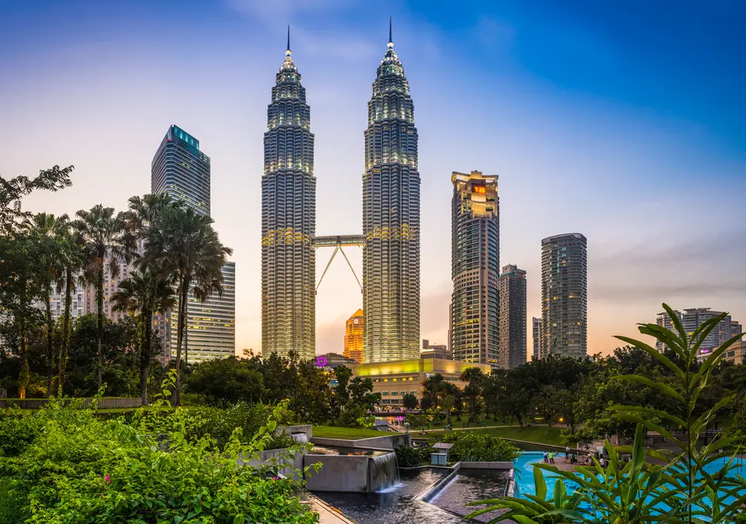

**Introduction**

For many shoppers, visiting shopping malls is a great way to relax and enjoy themselves during weekends and holidays. They can do grocery shopping, dine at restaurants, shop at the various fashion outlets, watch movies and perform many more activities. Shopping malls are like a one-stop destination for all types of shoppers. For retailers, the central location and the large crowd at the shopping malls provides a great distribution channel to market their products and services. Property developers are also taking advantage of this trend to build more shopping malls to cater to the demand. As a result, there are many shopping malls in the city of Kuala Lumpur and many more are being built. Opening shopping malls allows property developers to earn consistent rental income. Of course, as with any business decision, opening a new shopping mall requires serious consideration and is a lot more complicated than it seems. Particularly, the location of the shopping mall is one of the most important decisions that will determine whether the mall will be a success or a failure.

**Business Problem**

The objective of this capstone project is to analyse and select the best locations in the city of Kuala Lumpur, Malaysia to open a new shopping mall. Using data science methodology and machine learning techniques like clustering, this project aims to provide solutions to answer the business question: In the city of Kuala Lumpur, Malaysia, if a property developer is looking to open a new shopping mall, where would you recommend that they open it?

**Target Audience of this project**

This project is particularly useful to property developers and investors looking to open or invest in new shopping malls in the capital city of Malaysia i.e. Kuala Lumpur. This project is timely as the city is currently suffering from oversupply of shopping malls. Data from the National Property Information Centre (NAPIC) released last year showed that an additional 15 per cent will be added to existing mall space, and the agency predicted that total occupancy may dip below 86 per cent. The local newspaper The Malay Mail also reported in March last year that the true occupancy rates in malls may be as low as 40 per cent in some areas, quoting a Financial Times (FT) article cataloguing the country's continued obsession with building more shopping space despite chronic oversupply.

**Data**

**To solve the problem, we will need the following data:**

• List of neighbourhoods in Kuala Lumpur. This defines the scope of this project which is confined to the city of Kuala Lumpur, the capital city of the country of Malaysia in South East Asia.

• Latitude and longitude coordinates of those neighbourhoods. This is required in order to plot the map and also to get the venue data.

• Venue data, particularly data related to shopping malls. We will use this data to perform clustering on the neighbourhoods.

**Sources of data and methods to extract them**

This Wikipedia page (<https://en.wikipedia.org/wiki/Category:Suburbs_in_Kuala_Lumpur>) contains a list of neighbourhoods in Kuala Lumpur, with a total of 70 neighbourhoods. We will use web scraping techniques to extract the data from the Wikipedia page, with the help of Python requests and beautiful soup packages. Then we will get the geographical coordinates of the neighbourhoods using Python Geocoder package which will give us the latitude and longitude coordinates of the neighbourhoods.

After that, we will use Foursquare API to get the venue data for those neighbourhoods. Foursquare has one of the largest databases of 105+ million places and is used by over 125,000 developers. Foursquare API will provide many categories of the venue data, we are particularly interested in the Shopping Mall category in order to help us to solve the business problem put forward. This is a project that will make use of many data science skills, from web scraping (Wikipedia), working with API (Foursquare), data cleaning, data wrangling, to machine learning (K-means clustering) and map visualization (Folium). In the next section, we will present the Methodology section where we will discuss the steps taken in this project, the data analysis that we did and the machine learning technique that was used.

**Results**

The results from the k-means clustering show that we can categorize the neighbourhoods into 3 clusters based on the frequency of occurrence for “Shopping Mall”:

• Cluster 0: Neighbourhoods with moderate number of shopping malls

• Cluster 1: Neighbourhoods has no existence of shopping malls

• Cluster 2: Neighbourhoods with high concentration of shopping malls The results of the clustering are visualized in the map below with cluster 0 in green colour, cluster 1 in red colour, and cluster 2 in purple colour.

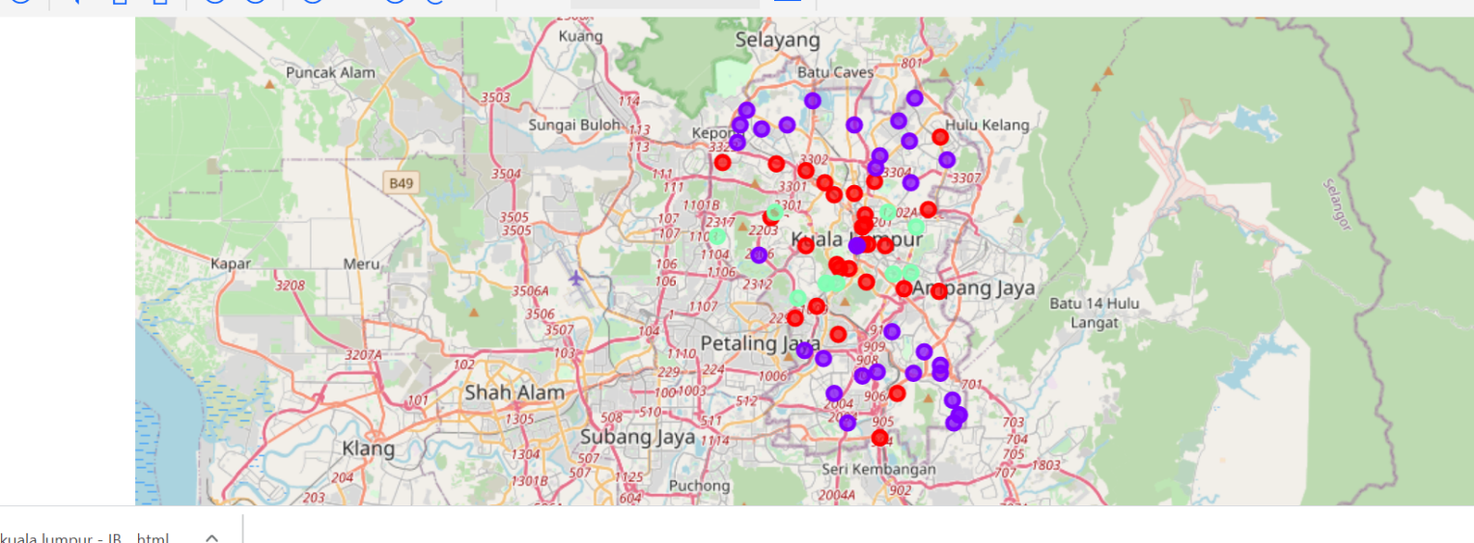

**Discussion**

Most of the shopping malls are concentrated in the central area of Kuala Lumpur city, with the highest number in cluster 2 and moderate number in cluster 0. On the other hand, cluster 1 has no shopping mall in the neighborhoods. This represents a great opportunity and high potential areas to open new shopping malls as there is very little to no competition from existing malls. Meanwhile, shopping malls in cluster 2 are likely suffering from intense competition due to oversupply and high concentration of shopping malls. From another perspective, this also shows that the oversupply of shopping malls mostly happened in the central area of the city, with the suburb area still have very few shopping malls. Therefore, this project recommends property developers to capitalize on these findings to open new shopping malls in neighborhoods in cluster 1 with little to no competition. Property developers with unique selling propositions to stand out from the competition can also open new shopping malls in neighborhoods in cluster 0 with moderate competition. Lastly, property developers are advised to avoid neighborhoods in cluster 2 which already have high concentration of shopping malls and suffering from intense competition.

**Limitations and Suggestions for Future Research**

In this project, we only consider one factor i.e. frequency of occurrence of shopping malls, there are other factors such as population and income of residents that could influence the location decision of a new shopping mall. However, to the best knowledge of this researcher such data are not available to the neighbourhood level required by this project. Future research could devise a methodology to estimate such data to be used in the clustering algorithm to determine the preferred locations to open a new shopping mall. In addition, this project made use of the free Sandbox Tier Account of Foursquare API that came with limitations as to the number of API calls and results returned. Future research could make use of paid account to bypass these limitations and obtain more results.

**Conclusion**

In this project, we have gone through the process of identifying the business problem, specifying the data required, extracting and preparing the data, performing machine learning by clustering the data into 3 clusters based on their similarities, and lastly providing recommendations to the relevant stakeholders i.e. property developers and investors regarding the best locations to open a new shopping mall. To answer the business question that was raised in the introduction section, the answer proposed by this project is: The neighbourhoods in cluster 1 are the most preferred locations to open a new shopping mall. The findings of this project will help the relevant stakeholders to capitalize on the opportunities on high potential locations while avoiding overcrowded areas in their decisions to open a new shopping mall.