**Inclass Programming Assignment - 1**

**Github Link:** [**https://github.com/poojasrinivas29/icp1**](https://github.com/poojasrinivas29/icp1)

**Video Explanation :** [**clickhere**](https://drive.google.com/file/d/1AU9A7vCVhOScDg_-j4KrJHmyWnlFXS71/view?usp=sharing)

**Problem 1:** To take two strings from the user: first_name, last_name. Pass these variables to the fullname function that should return the (full name).

**Input:** 2 Strings

**Output:** String

**Solution:**

1. The user strings are taken, stored in the "first_name" and "last_name" variables, then sent to the "full_name" function, which concatenates them into a single string using the '+' operator.

2. The user string is extracted, stored in the "original_string" variable, and passed to the function "string_alternative".

3. The function returns alternate characters using the slicing operator with a step of 2.

**Code:**

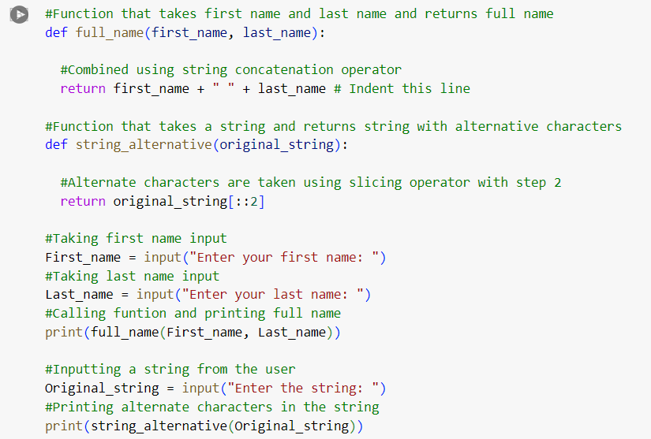

**Output:**

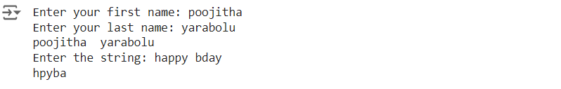

**Problem 2:** To find the word count in a file (input.txt) for each line and then print the output.

**Input:** input.txt file

**Output:** output.txt file

**Solution:**

1. The input.txt file is uploaded to the Jupyter Notebook and accessed using the open() method in read-only mode.   
2. The contents of the file are accessed and stored in a list called "contents".  
3. The words in the list count are stored in a dictionary and used to write the output to a file.   
  
4. The open() function is used to create a file named "output.txt", and the contents of the dictionary are copied to it and downloaded to the local.

**Code:**

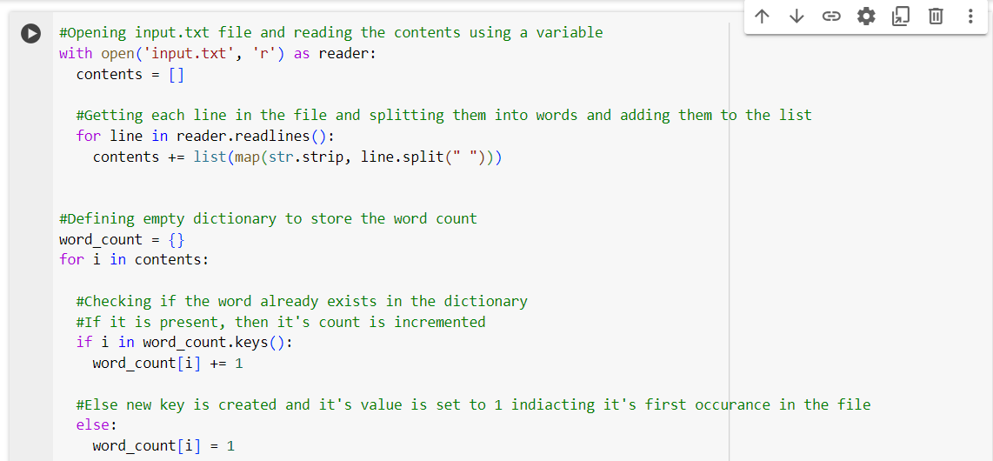

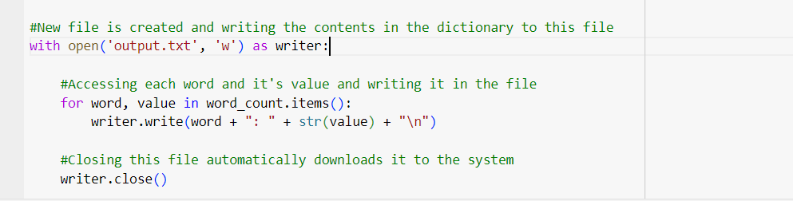

**Output:**

**input.txt:**

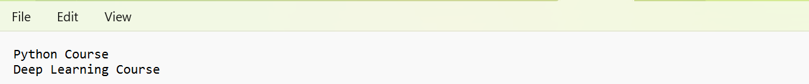

**Output.txt:**

**Problem 3:** To read heights (inches.) of customers into a list and convert these heights to centimeters in a separate list using: 1) Nested Interactive loop 2) List comprehensions

**Input:** List

**Output:** List

**Solution:**

1. The program accepts a series of heights in centimeters from the user.

2. First, the heights are converted to inches with a loop. Second, heights are converted to inches through list comprehension.

3. The resulting lists are printed to the console.

**Code:**

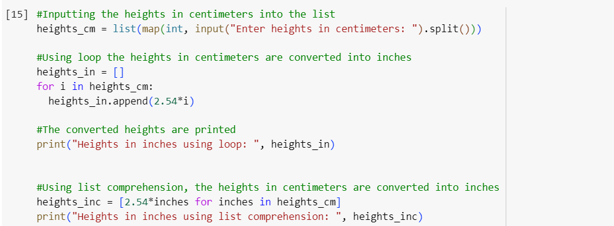

**Output:**

