1. I have created a tea set with a vadi (stirring stick) using Blender. The design showcases a blend of traditional elements and 3D modeling techniques.

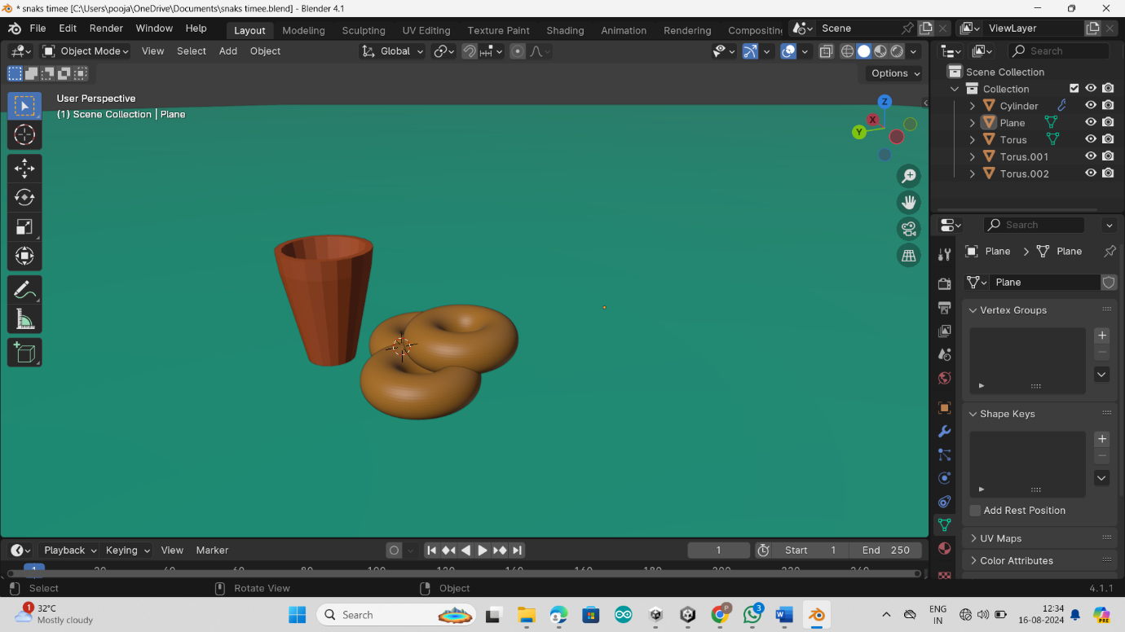

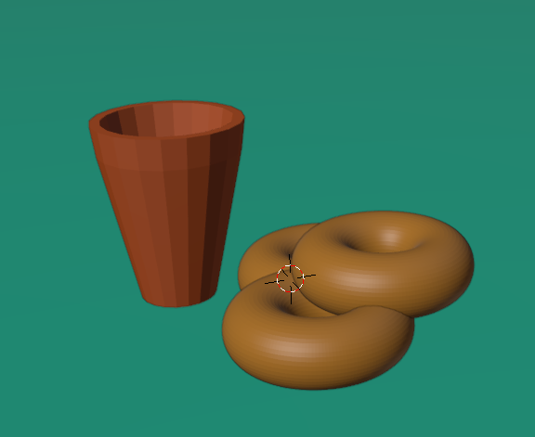

1. I have created a spongy fern in Blender, showcasing detailed texture and realistic softness.

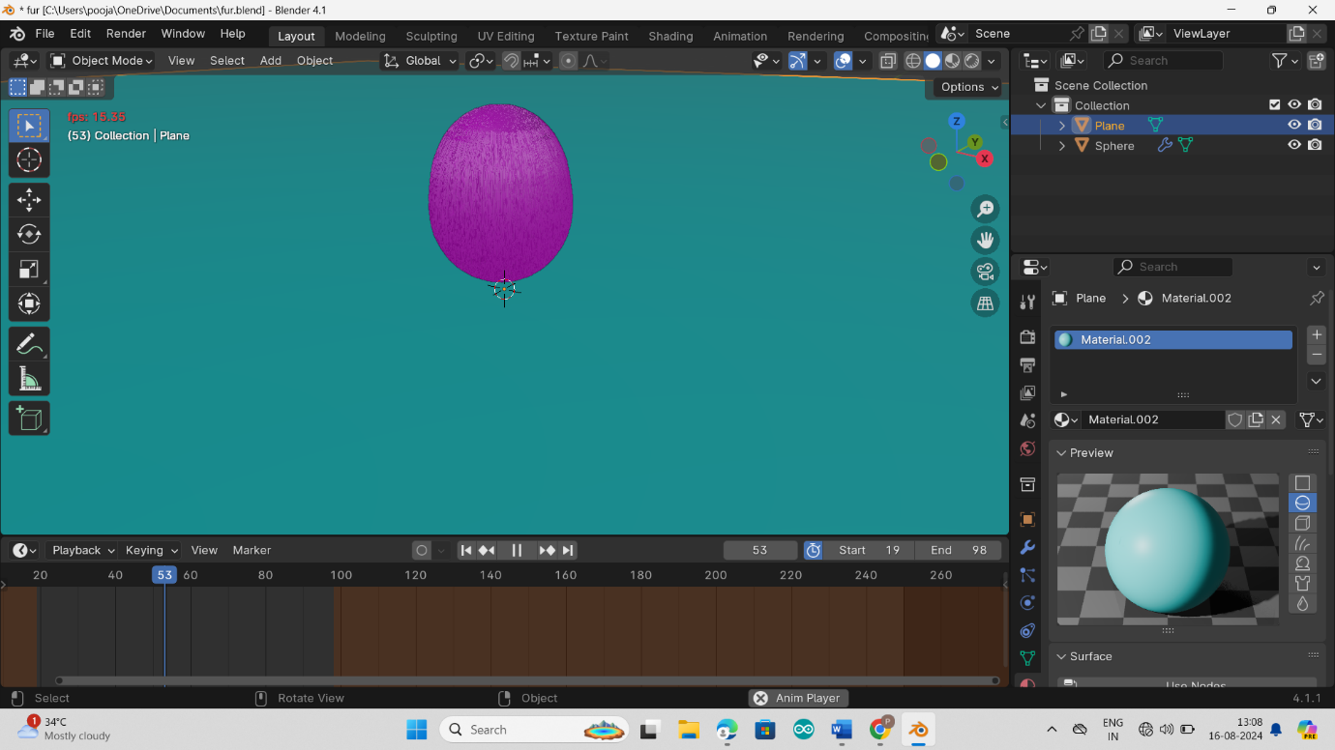

1. I have created a donation model in Blender, highlighting the concept of giving through 3D design elements.

