1. SOS emergency:

<https://www.figma.com/proto/0OEdn1vDN5dzLKY1AiWhIR/Untitled?node-id=1-2&node-type=canvas&t=6UWQA9ckoBmVRFn0-1&scaling=scale-down&content-scaling=fixed&page-id=0%3A1&starting-point-node-id=1%3A2&show-proto-sidebar=1>

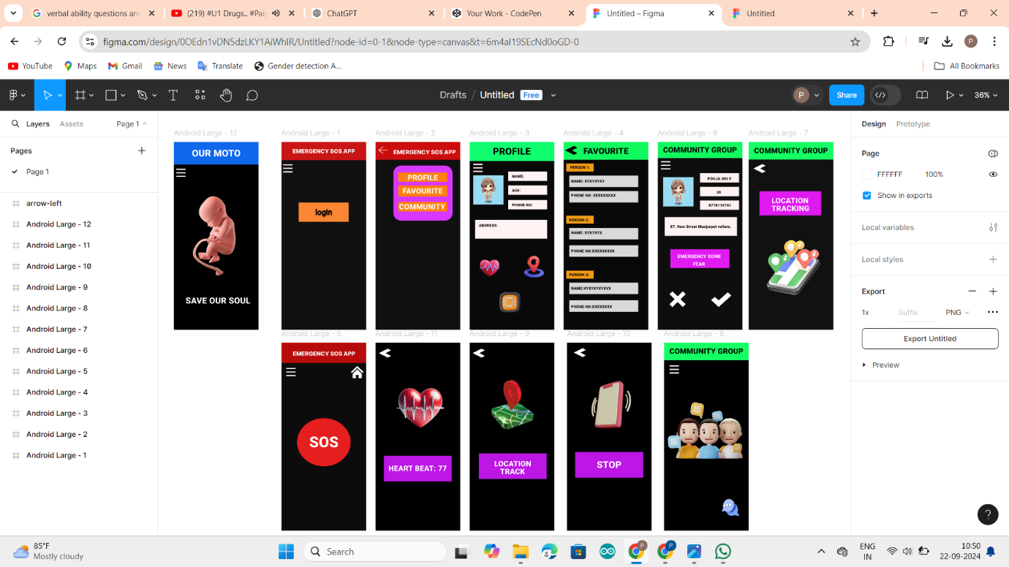

1. I’ve started creating customized resin keychains, offering unique, handcrafted designs catering to personal preferences and special occasions.

