**Exp. No.: 20**

**Date:**

**MYSQL STRING FUNCTIONS- REPLACE, REPEAT, REVERSE, RIGHT, LEFT, RPAD, LPAD**

**AIM:**

To implement Replace, Repeat, Reverse, Right, Left, Rpad and Lpad String Functions using MySQL.

**REPLACE()**

MySQL REPLACE() replaces all the occurrences of a substring within a string.  
Syntax : REPLACE(str,from_str,to_str)  
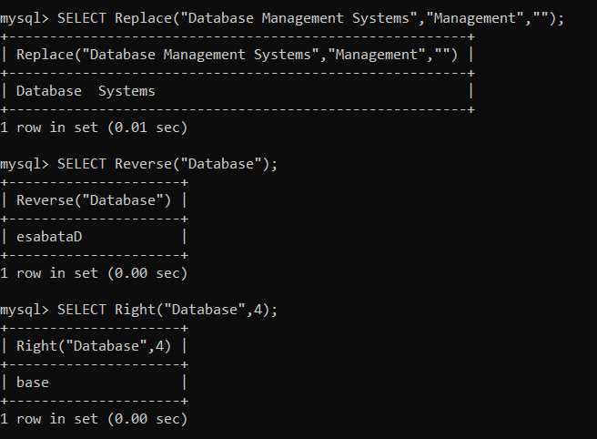

**REPEAT()**

MySQL REPEAT() repeats a string for a specified number of times.  
The function returns NULL either any either of the arguments are NULL.  
Syntax : REPEAT(str,count)  
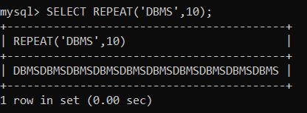

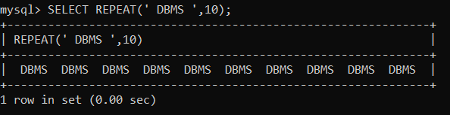

**REVERSE()**

Returns a given string with the order of the characters reversed.  
Syntax : REVERSE(str)  


**RIGHT()**

MySQL RIGHT() extracts a specified number of characters from the right side of a given string.  
Syntax : RIGHT(str,len)



**LEFT()**

MySQL LEFT() returns a specified number of characters from the left of a given string. Both the number and the string are supplied in the arguments as str and len of the function.  
Syntax : LEFT(str,len)  
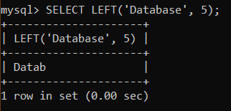

**RPAD()**

MySQL RPAD() function pads strings from right. The actual string which is to be padded as str, length of the string returned after padding as len and string which is used for padding as padstr is used as a parameters within the argument.

Syntax : RPAD(str,len,padstr)  
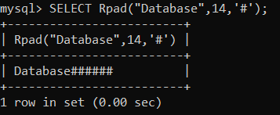

**LPAD()**

MySQL LPAD() left pads a string with another string. The actual string, a number indicating the length of the padding in characters (optional) and the string to be used for left padding - all are passed as arguments.  
Syntax : LPAD(str,len,padstr)  
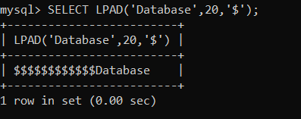

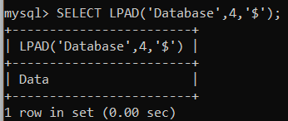

**ASCII()**

This function returns the numeric value of the leftmost character of the string str. Returns 0 if str is the empty string. Returns NULL if str is NULL  
Syntax : ASCII(str)  
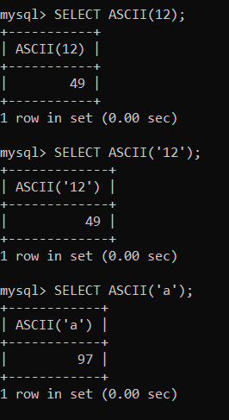

**BIN()**

Returns a string representation of the binary value of N, where N is a longlong (BIGINT) number. Returns NULL if N is NULL.  
Syntax : BIN(N)  
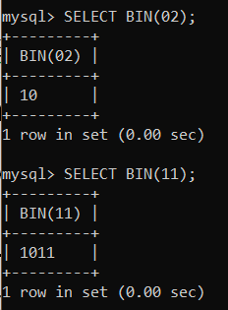

**OCT()**

Returns a string representation of the octal value of N, where N is a longlong (BIGINT) number. Returns NULL if N is NULL.  
Syntax : OCT(N)  
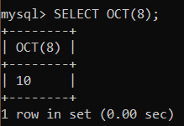

**RESULT:** Thus the String Functions such as Replace, Repeat, Reverse, Right, Left, Rpad and Lpad are executed successfully.